**SMARTANGLER:**

**AUTOMATED FISHING TOURNAMENT SYSTEM**

**ALVINA ALPHONSUS**

**FACULTY OF COMPUTING AND INFORMATICS**

**UNIVERSITI MALAYSIA SABAH**

**2026**

**SMARTANGLER:**

**AUTOMATED FISHING TOURNAMENT SYSTEM**

**ALVINA ALPHONSUS**

**THESIS SUBMITTED IN PARTIAL FULFILLMENT FOR THE DEGREE OF BACHELOR OF COMPUTER SCIENCE WITH HONOURS**

**(SOFTWARE ENGINEERING)**

**FACULTY OF COMPUTING AND INFORMATICS**

**UNIVERSITI MALAYSIA SABAH**

**2026**

**NAME :** ALVINA ALPHONSUS

**MATRIC NUMBER :** BI22110003

**TITLE :** SMARTANGLER: AUTOMATED FISHING TOURNAMENT

SYSTEM

**DEGREE :** BACHELOR OF COMPUTER SCIENCE WITH HONOURS

(SOFTWARE ENGINEERING)

**VIVA’S DATE :** 15 JANUARY 2026

**CERTIFIED BY;**

1. **SUPERVISOR**  Signature

Professor Madya Dr. Azali Bin Saudi

# 

# DECLARATION

I hereby declare that the material in this thesis is my own except for quotations, equations, summaries and references, which have been duly acknowledged.

15 JANUARY 2026 ALVINA ALPHONSUS

BI22110003

# ACKNOWLEDGEMENT

I would like to express my sincere gratitude to my supervisor, Professor Madya Dr. Azali Bin Saudi, for the continuous guidance, valuable advice and encouragement provided throughout the completion of this Final Year Project. His constructive feedback and encouragement played an important role in helping me improve and complete this project successfully.

I would also like to extend my appreciation to my examiners Ts. Dr Chin Pei Yee and Dr Zaidatol Haslinda Abdullah Sani for their helpful comments, suggestions and constructive feedback during the evaluation process. Their insights and opinions have greatly contributed to improving the quality and outcome of this project.

Last but not least, I am truly grateful to my family and friends for their unwavering support, understanding and encouragement throughout this project development journey. Their motivation has been a constant source of strength and inspiration. Without the kind assistance and support of all these individuals, the successful completion of this project would not have been possible. Their guidance, encouragement and contributions are deeply appreciated. Through this project, I have gained invaluable experiences and opportunities for personal and professional growth, for which I am truly grateful.

ALVINA ALPHONSUS

15 JANUARY 2026

# ABSTRACT

Fishing tournaments event have become one of a growing recreational activity in Malaysia and it has drawing interest from both local and international anglers. Most of these events are however still operated manually in which key activities like advertising of tournament, registering of participants, logging of fish catch and generation of results are done manually. These traditional methods may result in inefficiency, human error and delays in announcement of results. Hence, this may impact the entire experience of both organizers and participants. In order to address these issues, this project propose SmartAngler which is an automated web-based fishing tournament management system that will help to digitalize and simplify the process of organizing tournaments. The system was developed using the Waterfall Development Model which provides a structured and systematic approach to software development. In the analysis phase, the organizers and anglers were asked to participate in interviews and surveys to determine the main requirements of the system, and the usability testing was performed using the System Usability Scale (SUS) to measure the level of user satisfaction and system functionality. The SmartAngler system was develop to integrates key modules such as tournament advertisement, participant registration, fish catch logging and live leaderboard updates with aim on improving the fishing tournament management. Overall, the system improves efficiency of the tournament, reduces administrative workload and ensures greater accuracy of official result and transparency for the tournament. This offers a more organized, fair and engaging fishing tournament experience for both organizers and participants.

**Keywords:** SmartAngler, Fishing Tournament Management, System Usability Scale (SUS), efficiency, transparency

***ABSTRAK***

***SMARTANGLER: SISTEM AUTOMASI PERTANDINGAN MEMANCING***

*Pertandingan memancing kini menjadi aktiviti rekreasi yang semakin popular di Malaysia dan menarik penyertaan daripada pemancing tempatan serta antarabangsa. Namun begitu, kebanyakan pertandingan masih diuruskan secara manual di mana tugas penting seperti pengiklanan, pendaftaran peserta, rekod tangkapan ikan dan penjanaan keputusan dilakukan secara tradisional. Kaedah ini sering menyebabkan ketidakcekapan, kesilapan manusia dan kelewatan dalam pengumuman keputusan yang menjejaskan pengalaman penganjur serta peserta. Bagi mengatasi masalah ini, projek ini mereka bentuk dan membina SmartAngler, iaitu sistem pengurusan pertandingan memancing berasaskan web yang bertujuan mendigitalkan dan memperkemas proses pengurusan pertandingan. Sistem ini menggunakan Model Pembangunan Air Terjun yang menyediakan pendekatan yang tersusun dan sistematik dalam pembangunan perisian. Dalam fasa analisis, temu bual dan soal selidik telah dijalankan bersama penganjur serta pemancing bagi mengenal pasti keperluan utama sistem, manakala ujian kebolehgunaan menggunakan Skala Kebolehgunaan Sistem (SUS) telah dijalankan bagi menilai tahap kepuasan pengguna dan keberkesanan sistem. SmartAngler menggabungkan modul utama seperti pengiklanan pertandingan, pendaftaran peserta, rekod tangkapan ikan digital dan papan kedudukan langsung. Secara keseluruhannya, sistem ini meningkatkan kecekapan, mengurangkan beban pentadbiran serta memastikan ketepatan dan ketelusan dalam pengurusan pertandingan, sekali gus memberikan pengalaman yang lebih tersusun, adil dan menarik kepada penganjur dan peserta.*

***Kata Kunci:*** *SmartAngler, Pengurusan Pertandingan Memancing, Skala Kebolehgunaan Sistem (SUS), Kecekapan, Ketelusan*

TABLE OF CONTENTS

DECLARATION i

ACKNOWLEDGEMENT ii

ABSTRACT iii

LIST OF TABLES iv

LIST OF FIGURES v

CHAPTER 1: INTRODUCTION 1

1.1 Introduction 1

1.2 Problem Background 2

1.3 Problem Statements 5

1.4 Project Objectives 7

1.5 Project Scope 8

1.6 Organizational Report 10

1.7 Conclusion 11

CHAPTER 2: LITERATURE REVIEW 12

2.1 Introduction 12

2.2 An Overview of SmartAngler Automated Fishing Tournament System 12

2.3 The Growth and Evolution of Fishing Tournaments 13

2.3.1 Evolution of Fishing Tournament 14

2.3.2 The Impact on the Growth and Popularity of Fishing Tournaments 15

2.4 The Impact of Digital Solutions on Fishing Tournament Efficiency 16

2.4.1 Automation of Fishing Tournament Operations 17

2.5 Review of Existing Fishing Tournament System 18

2.5.1 TourneyX 18

2.5.2 WeighBook 26

2.5.3 FishPal 30

2.5.4 KeepNet 34

2.5.5 Reel LiveWell 38

2.6 Comparison of Existing Fishing Tournament System 40

2.7 Research Gap 41

2.8 Summary of Literature Review 42

CHAPTER 3: METHODOLOGY 43

3.1 Introduction 43

3.2 Project Methodology for SmartAngler 43

3.2.1 Planning 44

3.2.2 Analysis 45

3.2.3 Design 45

3.2.4 Implementation 46

3.2.5 Testing 46

3.2.6 Project Closure 47

3.3 Conclusion 47

CHAPTER 4: SYSTEM DESIGN 48

4.1 Introduction 48

4.2 Interview Findings 48

4.3 Survey Questionnaire Analysis 51

4.4 System Design 58

4.4.1 System Architecture 58

4.4.2 Context Diagram 59

4.4.3 Data Flow Diagram (DFD) Level 0 60

4.4.4 Data Flow Diagram (DFD) Level 1 61

4.4.5 Entity Relationship Diagram (ERD) 66

4.4.6 Data Dictionary 67

4.5 User Interface 76

4.6 Conclusion 87

CHAPTER 5: IMPLEMENTATION 88

5.1 Introduction 88

5.2 Tools for Development 88

5.2.1 Visual Studio Code 89

5.2.2 XAMPP 91

5.2.3 GitHub 92

5.3 System Implementation 92

5.3.1 Admin Interface 93

5.3.2 User Interface 108

5.5 Database Implementation 117

5.6 Conclusion 119

CHAPTER 6: TESTING AND EVALUATION 120

6.1 Introduction 120

6.2 Unit Testing 120

6.3 Integration Testing 133

6.4 System Usability Scale (SUS) 135

6.4.1 SUS Questionnaire 135

6.4.2 SUS Calculation 143

6.5 Conclusion 144

CHAPTER 7: CONCLUSION 145

7.1 Introduction 145

7.2 Project Summary 145

7.3 Project Limitation 146

7.4 Future Work 147

REFERENCES 148

APPENDICES 151

# LIST OF TABLES

Table 1.1: Modules for SmartAngler System 8

Table 2.1: Comparison Between SmartAngler system with The Existing System 40

Table 4.1: USER Table 67

Table 4.2: TOURNAMENT Table 68

Table 4.3: WEIGHING_STATION Table 69

Table 4.4: ZONE Table 70

Table 4.5: FISHING_SPOT Table 70

Table 4.6: TOURNAMENT_REGISTRATION Table 71

Table 4.7: CATEGORY Table 71

Table 4.8: FISH_CATCH Table 72

Table 4.9: CALENDAR Table 72

Table 4.10: RESULT Table 73

Table 4.11: SAVED Table 73

Table 4.12: REVIEW Table 74

Table 4.13: NOTIFICATION Table 74

Table 4.14: SPONSOR Table 75

Table 4.15: TOURNAMENT_PRIZE Table 75

Table 5.1: Description of SmartAngler Database Table Relationships 117

Table 6.1: Unit Testing for User Authentication Module 121

Table 6.2: Unit Testing for Tournament Advertisement Module 122

Table 6.3: Unit Testing for Participant Registration Module 124

Table 6.4: Unit Testing for Fishing Spot Booking Module 125

Table 6.5: Unit Testing for Notification and Announcement Module 126

Table 6.6: Unit Testing for Catch Fish Log Module 127

Table 6.7: Unit Testing for Sponsorship and Prize Management Module 129

Table 6.8: Unit Testing for Result Management Module 130

Table 6.9: Unit Testing for Review Module 131

Table 6.10: Integration Testing for SmartAnlger System. 133

Table 6.11: System Usability Scale (SUS) Scale Table 143

# LIST OF FIGURES

Figure 1.1: An Angler Won Cash prize in Fishing Tournament in Sipitang 2

Figure 1.2: Fishing Tournament Advertisement Through WhatsApp Chat 3

Figure 1.3: Angler Inquiring About Advertisement Flyers 4

Figure 1.4: Fishing Tournament Result Generation Using Microsoft Excel 4

Figure 1.5: Official Competition Results Posted via WhatsApp 5

Figure 2.1: TourneyX Tournament Advertisement 18

Figure 2.2: TourneyX Angler Tournament Registration 19

Figure 2.3: TourneyX User Dashboard with Tournament Features 19

Figure 2.4: TourneyX Angler Fish Catch Submission Form 20

Figure 2.5: TourneyX List of Catch Records 20

Figure 2.6: TourneyX Fish Catch Submission Map 21

Figure 2.7: TourneyX Tournament Live Result 22

Figure 2.8: TourneyX Admin Tournament Management Dasboard 23

Figure 2.9: TourneyX List of Catch Fish Submission 24

Figure 2.10: TourneyX Admin Verification of Angler Catch Submission 24

Figure 2.11: WeighBook Tournament Advertisement List 26

Figure 2.12: WeighBook Tournament Result 27

Figure 2.13: WeighBook Administrator Dashboard 27

Figure 2.14: WeighBook Tournament Creation and Management 28

Figure 2.15: WeighBook Fish Catch Logging 29

Figure 2.16: WeighBook Tournament Result Management 29

Figure 2.17: FishPal Main Interface 30

Figure 2.18: Fishpal List of Available Book Fishing 31

Figure 2.19: FishPal Detailed Information of the Fishing Activities 32

Figure 2.20: FishPal Fish Catch Analysis 32

Figure 2.21: FishPal Anglers’ Reviews 33

Figure 2.22: KeepNet Competition List Dashboard 34

Figure 2.23: KeepNet Fishing Tournament Details 35

Figure 2.24: KeepNet Live Results Leaderboard 36

Figure 2.25: KeepNet Sponsorship Page 37

Figure 2.26: Real-Time Leaderboard of Fishing Competition Results 38

Figure 2.27: List of Available Fishing Competitions 39

Figure 3.1: Waterfall Model Phases for SmartAngler System Development 44

Figure 4.1: Booking and Registration Record on Paper 49

Figure 4.2: Paper Based Fish Catch Logging Record 50

Figure 4.3: Percentage of Angler Age Group 51

Figure 4.4: Angler Participation in Fishing Tournament 52

Figure 4.5: Percentage of Digital Platform Usage for Fishing Tournaments 52

Figure 4.6: Participants Who Missed Tournaments Due Poor Advertisement 53

Figure 4.7: Issues Faced When Booking a Fishing Spot 53

Figure 4.8: Percentage of Angler Facing Issue in Tracking Tournament Dates 54

Figure 4.9: Number of Angler Able to Track Performance via Live Updates 55

Figure 4.10: Overall Satisfaction with Current Fishing Competition Experience 55

Figure 4.11 Anglers’ Perceived Importance of SmartAngler Features for Enhancing Fishing Competition Experience. 56

Figure 4.12 Aspects Rated by Anglers for an Ideal Fishing Tournament Website 57

Figure 4.13: Anglers’ Preference Between SmartAngler and Current Manual Methods for Fishing Tournaments 57

Figure 4.14 System Architecture of SmartAngler 58

Figure 4.15 Context Diagram of SmartAngler System 59

Figure 4.16: Data Flow Diagram (DFD) Level 0 of SmartAngler 60

Figure 4.17: DFD Level 1 for Account Management 61

Figure 4.18: DFD Level 1 for Tournament Management 61

Figure 4.19: DFD Level 1 for Tournament Registration 62

Figure 4.20: DFD Level 1 for Fishing Spot Creation 62

Figure 4.21: DFD Level 1 for Fish Catch Record 63

Figure 4.22: DFD Level 1 for Result Management 63

Figure 4.23: DFD Level 1 for Sponsor Management 64

Figure 4.24: DFD Level 1 for Review Management 64

Figure 4.25: DFD Level 1 for Notification Management 65

Figure 4.26: Entity Relationship Diagram (ERD) of SmartAngler 66

Figure 4.27: SmartAngler Prototype Log in Page 76

Figure 4.28: SmartAngler Prototype Tournament List 77

Figure 4.29: SmartAngler Prototype Calendar 77

Figure 4.30: SmartAngler Prototype Tournament Registration 78

Figure 4.31: SmartAngler Prototype Reviews 78

Figure 4.32: SmartAngler Prototype Live Result 79

Figure 4.33: SmartAngler Prototype Admin Dashboard 80

Figure 4.34: SmartAngler Prototype Tournament Management 80

Figure 4.35: SmartAngler Prototype Tournament Creation Form 81

Figure 4.36: SmartAngler Prototype Tournament Details 81

Figure 4.37: SmartAngler Prototype Participant Registration Approval 82

Figure 4.38: SmartAngler Prototype Result Management 82

Figure 4.39: SmartAngler Prototype Categories Selection 83

Figure 4.40: SmartAngler Prototype Spot Management 83

Figure 4.41: SmartAngler Prototype Fish Catch Record Management 84

Figure 4.42: SmartAngler Prototype Prize Management 84

Figure 4.43: SmartAngler Prototype Sponsor Management 85

Figure 4.44: SmartAngler Prototype Add Sponsor Details 85

Figure 4.45: SmartAngler Prototype Send Notifications 86

Figure 4.46: Prototype User Flow for SmartAngler 86

Figure 5.1: XAMPP Control Panel 91

Figure 5.2: SmartAngler Database Management Interface in phpMyAdmin 91

Figure 5.3: SmartAngler Source Code Repository on GitHub 92

Figure 5.4: SmartAngler Admin Request Admin Access Page 93

Figure 5.5: SmartAngler Admin Dashboard 94

Figure 5.6: SmartAngler Tournament Management Page 94

Figure 5.7: SmartAngler Create Tournament Page (Tournament Information) 95

Figure 5.8: SmartAngler Create Tournament Page (Payment Information) 95

Figure 5.9: SmartAngler Create Tournament Page (Tournament Fishing Zone) 96

Figure 5.10: SmartAngler Create Tournament Page (Sponsor Information) 96

Figure 5.11: SmartAngler Create Tournament Page (Prize Information) 97

Figure 5.12: SmartAngler Create Tournament Page (Confirmation Page) 97

Figure 5.13: SmartAngler Admin Tournament Details Page (Tournament Details) 98

Figure 5.14: SmartAngler Admin Tournament Details Page (Payment Details) 98

Figure 5.15: SmartAngler Admin Tournament Details Page (Editable Details) 99

Figure 5.16: SmartAngler Admin Tournament Details Page (Editable Payment Details) 99

Figure 5.17: SmartAngler Sponsor Management Details Page 100

Figure 5.18: SmartAngler Add Sponsor Details Page 100

Figure 5.19: SmartAngler Prize Management Details Page 101

Figure 5.20: SmartAngler Add Prize Details Page 101

Figure 5.21: SmartAngler Fishing Zone Management Page 102

Figure 5.22: SmartAngler Edit Zone Page 102

Figure 5.23: SmartAngler Add Fishing Spot Page 103

Figure 5.24: SmartAngler Fishing Spot Availability Management Page 103

Figure 5.25: SmartAngler Edit Fishing Spot Page 104

Figure 5.26: SmartAngler Weighing Station Management Page 104

Figure 5.27: SmartAngler Create Weighing Station Page 105

Figure 5.28: SmartAngler Edit Weighing Station Details Page 105

Figure 5.29: SmartAngler Fish Catch Record Page 106

Figure 5.30: SmartAngler Fish Catch Record List and Analytic Page 106

Figure 5.31: SmartAngler Edit Fish Catch Record Page 107

Figure 5.32: SmartAngler Notification Management Page 107

Figure 5.33: SmartAngler Profile Management Page 108

Figure 5.34: SmartAngler User Registration Page 109

Figure 5.35: SmartAngler User Login Page 109

Figure 5.36: SmartAngler Homepage 110

Figure 5.37: SmartAngler Fishing Tournament Advertisement List 111

Figure 5.38: SmartAngler Tournament Details Page 111

Figure 5.39: SmartAngler Tournament Registration Page (Information Details) 112

Figure 5.40: SmartAngler Tournament Registration Page (Payment Proof) 112

Figure 5.41: SmartAngler Tournament Registration Page (Spot Selection) 113

Figure 5.42: SmartAngler Tournament Calendar Page 114

Figure 5.43: SmartAngler Saved Tournament Advertisement Page 114

Figure 5.44: SmartAngler User Notification Page 115

Figure 5.45: SmartAngler User Profile Management Page 115

Figure 5.46: SmartAngler User Dashboard 116

Figure 5.47: SmartAngler Table Relationship in MySQL 117

Figure 6.1: System Usability Scale (SUS) Questionnaire Question 1 136

Figure 6.2: System Usability Scale (SUS) Questionnaire Question 2 136

Figure 6.3: System Usability Scale (SUS) Questionnaire Question 3 137

Figure 6.4: System Usability Scale (SUS) Questionnaire Question 4 138

Figure 6.5: System Usability Scale (SUS) Questionnaire Question 5 138

Figure 6.6: System Usability Scale (SUS) Questionnaire Question 6 139

Figure 6.7: System Usability Scale (SUS) Questionnaire Question 7 140

Figure 6.8: System Usability Scale (SUS) Questionnaire Question 8 140

Figure 6.9: System Usability Scale (SUS) Questionnaire Question 9 141

Figure 6.10: System Usability Scale (SUS) Questionnaire Question 10 142

Figure 6.11: Result of the Questionnaire for System Usability Scale (SUS) 144

# CHAPTER 1

**INTRODUCTION**

## Introduction

The evolution of digital technologies has transformed the way events are planned and organized across many fields including recreational activity. According to Hamid, the integration of automated and digitalized systems in event management have improved these sectors by enhancing operational tasks and reducing error while creating better user experiences (Hamid, 2023). However, in some cases for recreational activities such as fishing competitions, especially those that been held on private ponds are still remain unaffected by such advanced technologies to automate the fishing tournament system.

In recent years, fishing competitions in Malaysia has experienced growing popularity since its now attracting hundreds or even thousands of anglers from both local and international anglers. This rise in popularity reflects a growing interest in recreational fishing tournaments, not only as a casual leisure activity but also as an organised and competitive sport with a varied range of participants. Although fishing tournaments are growing in popularity, most of the task during the fishing tournament are still managed manually including registration, spot booking, fish logging and result recording. The increasing number of angler participants makes these manual management process slower, prone to error and creating confusion to both organizer and participants.

To address these challenges, the SmartAngler system has been developed as a user-friendly web-based solution that automates important task involved in managing fishing competition. The system is specifically developed for the use in fishing tournament and aims to enhance the overall visibility and efficiency in fishing competition management. At the same time, it offers more organized and fairer tournament experience for both participants and organizers.

## Problem Background

Fishing tournaments are popular events that are usually organized in public lakes, coastal waters and privately owned fishing ponds. These fishing tournaments provide opportunities for anglers to compete and showcase their skills.

Over the years, Malaysia has become a main destination for hosting fishing tournaments due to its numerous fishing sites. For example, the Royal Pahang Billfish International Challenge 2025 which is hosted in Kuala Rompin has once again positioned Malaysia as a global hotspot for sport fishing. The tournament attracted 64 participants from six countries including Italy, Japan, China, Singapore, Australia and the United Kingdom highlighting Kuala Rompin’s reputation as one of the most preferred destinations for fishing in Asia. (Zainuddin, 2025). This shows that Malaysia is appeal in the fishing tournament sector.

Fishing tournament often features multiple fishing categories and offers attractive prizes which including cash prizes, trophies and fishing equipment or vouchers. For example, in Figure 1.1, the 2025 edition of one fishing tournament in Sipitang, Sabah awarded up to RM50,000 in cash and trophies (Sabah News, 2025).

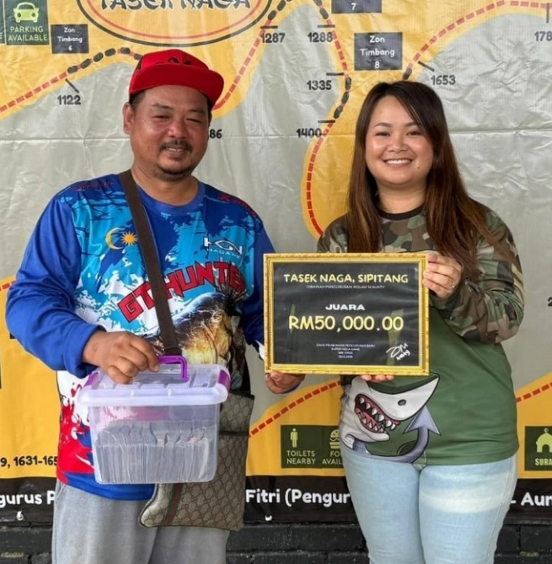

Figure 1.1: An Angler Won Cash prize in Fishing Tournament in Sipitang

Source: Sabah News, 2025.

Despite the popularity and rising number of angler competitors in fishing tournament, many of these events still rely on manual process. The main task for this tournament including participant registration, fishing spot booking, fish logging and result generation are still managed manually using paper-based method. This manual process might work well for small-scale fishing tournament, however, when it comes to larger events with larger participants, it becomes challenging and confusing to manage. These manual processes are not only time-consuming and error-prone, but they also reduce the overall experience for both organizers and participants.

Moreover, advertisement of fishing tournaments is often done through social media platforms such as WhatsApp and Facebook. For instance, as illustrated in Figure 1.2, promotional ads for the Super Mega Game were shared via WhatsApp. Meanwhile, in Figure 1.3, it highlights a problem faced by an angler who is seen inquiring about the availability of fishing tournament advertisement which highlighting the lack of easy access to event information. Hence, this indicates a lack of centralized digital platforms for advertisement sharing and notification announcement for any changes of information in fishing tournaments. The dependence on word-of-mouth and messaging apps can result in missed information, confusion and limited reach for anglers especially for large-scale tournament.

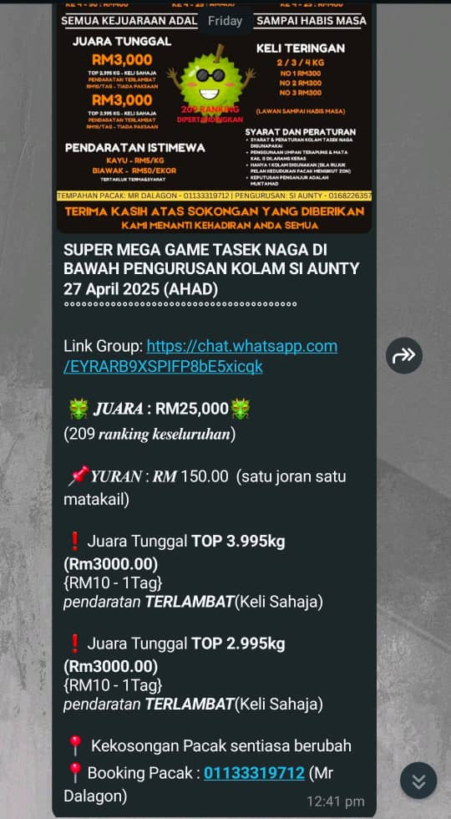

Figure 1.2: Fishing Tournament Advertisement Through WhatsApp Chat

Source: Kolam Rekreasi Pupuluton Valley WhatsApp Group.

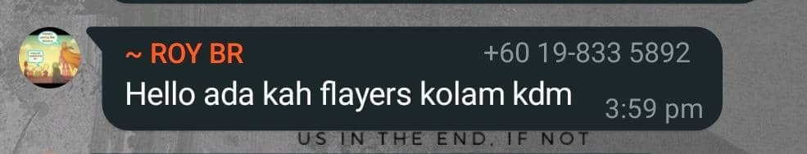

Figure 1.3: Angler Inquiring About Advertisement Flyers

Source: Kolam Rekreasi Pupuluton Valley WhatsApp Group.

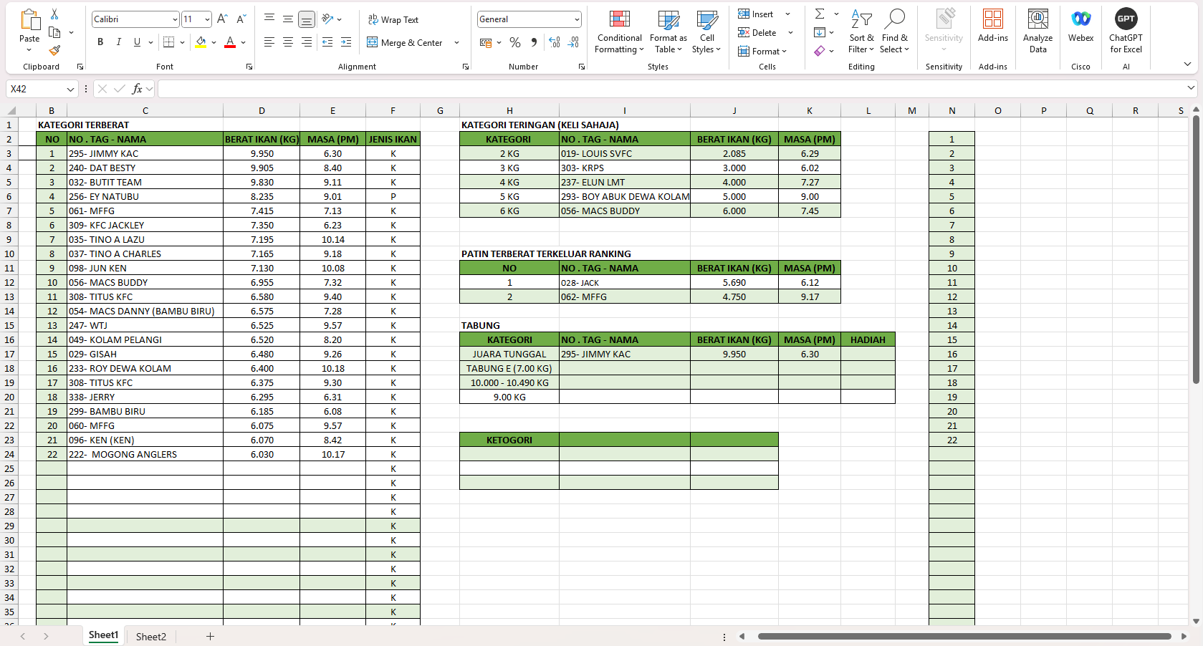In addition, the generation and management of tournament results is also one of a key concern in fishing tournament since most of the event organizers still rely on Microsoft Excel spreadsheets to manually insert fish catch data, participant details and final scores. Without automation in this process, it often led to delays in announcing winners, inconsistent rankings and disagreement over final results which can make participant to lose trust and question the fairness of the event.

Figure 1.4: Fishing Tournament Result Generation Using Microsoft ExcelSource*:* Alphonsus Ongkudon, personal interview, April 2025.

After the tournament has ended, the final official results are usually shared through WhatsApp and Facebook after the tournament ends. However, as shown in Figure 1.5, the organizer often posts the results few hours or a day after the tournament ends. This delay not only reduces participant engagement but also reflects a lack of professionalism in tournament management. Moreover, real-time ranking and official tournament result cannot be available to the angler and may result to frustration and confusion.

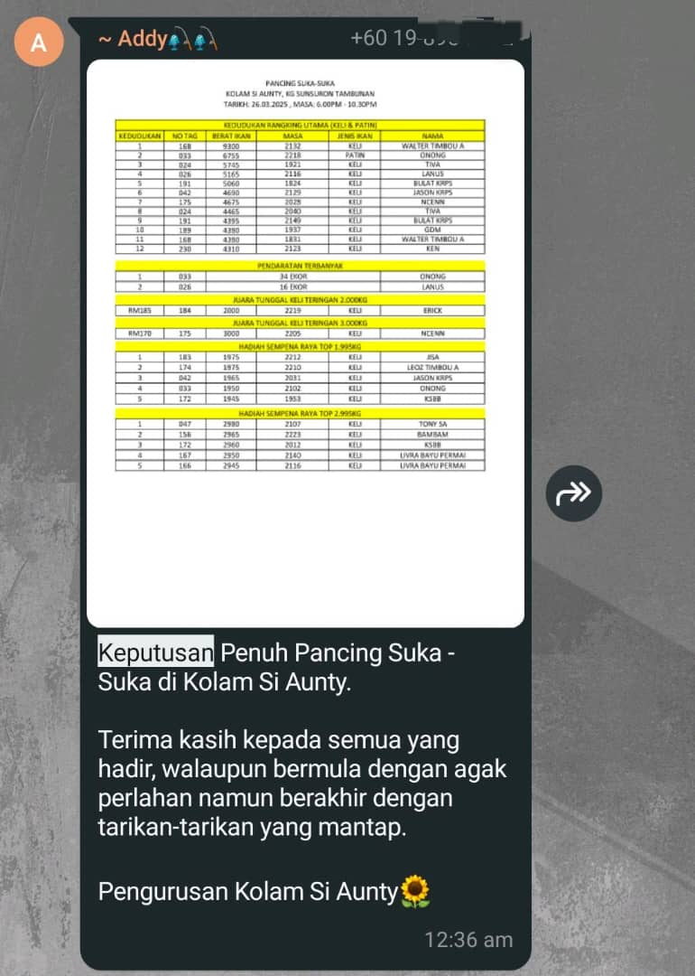

Figure 1.5: Official Competition Results Posted via WhatsApp

Source: Kolam Rekreasi Pupuluton Valley WhatsApp Group.

With the rise in the significance of technology in event management in any industry, there is the need to modernise fishing competitions management. Through the development of the SmartAngler web-based system, these tournaments will operate more efficiently and offer a better experience for both organisers and participants.

## Problem Statements

Fishing tournaments in Malaysia are becoming more popular and is now attracting a large number of participants. However, most of these tournaments still rely on outdated and manual processes for managing main tasks. This causes several problems that affect the overall experience for both organizers and participants.

One major issue in fishing tournament event is the way competitions are advertised. The primary platform for advertising fishing tournament is using social media like Facebook and WhatsApp. These platforms have a wide reach of audiences, however it limits the reach and accessibility of event information. As a result, potential angler participants may miss out on tournament announcements and also struggle to access complete and up-to-date information about upcoming tournaments.

Additionally, the current method of booking fishing spots remains a problem during tournament management. Most tournaments still rely on manual methods where participants book their preferred spots via text messages, phone calls or self-booking and the organizers will record the details on paper. This process often leads to double bookings, confusion about spot availability and a lack of real-time spots availability updates.

Registration for tournament is also inefficient. To register for the tournament anglers must wait in line at registration counter where they are required to manually fill out forms with their personal information. This does not only make the waiting lines long but also making the chances of keying in the wrong personal data very high. Such errors may lead to delays and confusion in the future of this competition especially in the results checking.

Furthermore, the logging data of the fish catch by the angler are done manually. Based on the interview, the organizers are still using paper logs to record and track catches. This is not only time-consuming but also prone to human error. The more the participants and catches, the harder it becomes to manage and verify the data and this results in error generation of results and delays in result announcement.

Beyond that, competition results generation is performed through the use of spreadsheet whereby event staff have to manually input data. The manual result generation may is subject to human error and this will directly interfere with the accuracy of the tournament result. The delay in processing the results may lead to complaints, dissatisfaction or mistrust among the participants, particularly when the mistake is later realized when the winners are declared.

In addition, the absence of live leaderboard is a significant drawback of the modern fishing tournaments. Lack of live monitoring of ranking of participants and leads to confusion and prevents participants from adapting their strategies effectively during the event. The same questions about rankings are issued constantly to the organizers and last-minute checks have to be conducted by the organizers to verify final scores, which is what makes the award process slower and puts extra pressure on all those involved.

Lastly, sponsorship and prize management are still a challenge in most of the fishing tournaments. Most of the organizers continue to rely on manual processes such as spreadsheets or handwritten notes to handle sponsor details and awarding of prizes. This makes it hard to track sponsor commitments, prizes and update. Poor management of sponsors can cause mistakes in prize distribution or sponsors not getting proper recognition. Thus, it is difficult for organizers to keep transparency and provide sponsors with the visibility they deserve during and after the tournament without a proper system.

## Project Objectives

The main purpose of this project is to create SmartAngler, an Automated Fishing Competition System which is an innovative solution designed to address the challenges faced by organizers and participants in fishing tournaments. The following objectives outline the specific objectives to achieve in this project:

1. To gather requirements for the SmartAngler system through interviews and surveys with fishing tournament organizers and participants, ensuring the system is designed to meet user needs.
2. To develop the SmartAngler system using Waterfall methodology, ensuring that each phase is completed within a defined timeline and meets functional and non-functional requirements.
3. To evaluate the performance and usability of the developed SmartAngler system by conducting System Usability Scale (SUS).

## Project Scope

The project scope outlines what the system will cover and what it aims to achieve. It specifies the modules, functions and the users involved the development of SmartAngler system.

In this project, there are two main users in the SmartAngler System which is Admin (Organizer) and User (Anglers).

Table 1.1: Modules for SmartAngler System

|  |  |  |  |
| --- | --- | --- | --- |
| **No.** | **Module** | **User** | **Description** |
| **1** | User Authentication | Admin | Can log in securely, manage user accounts, reset passwords and assign roles. |
| User | Users can register for the system and securely log in to have access to the system. Users can update their personal details as needed. |
| **2** | Tournament Advertisement | Admin | Admins can create, manage and update tournament advertisements. Admins can delete or achieve outdated or cancelled event advertisement. |
| User | Anglers can view tournament advertisements to stay updated on upcoming events. The advertisements allow them to get important information like dates of events, details of registration and prize. |
| **3** | Participant Registration | Admin | Admins can manage participant registrations, approve or reject participant and update or delete registration details. |
| User | Users can register for tournaments by providing necessary details. They can also update their registration details if necessary, allowing for easy management of their participation. |
| **4** | Fishing Spot Booking | Admin | Admins can manage the availability of fishing spots, update the list of available spots and delete bookings. |
| User | Anglers can browse available fishing spots, book their preferred spots and view booking details. Users can also cancel or modify their bookings if required. |
| **5** | Notification and Announcement | Admin | Admins send notifications such as updates, reminders and urgent alerts. |
| User | Users will receive email notifications regarding tournaments, registration verification and results. |
| **6** | Catch Fish Log | Admin | Admins can log fish catches details during the tournament. Admin can edit, update or delete the data if necessary to ensure accuracy. |
| User | User can view the fish caught and their corresponding data. |
| **7** | Sponsorship and Prize Management | Admin | Admins will manage sponsor information, prize allocations and updates. |
| User | User can view sponsor details and prize breakdowns for tournaments. |
| **8** | Result Management | Admin | Admins manage the overall result process, including selecting categories and ensuring accurate data entry. They handle the verification of results and update tournament rankings. |
| **9** | Review | Admin | Admins can view and manage participant feedback and reviews. |
| User | Angler can submit and delete their own feedback and reviews. |

## Organizational Report

This section provides an overview of each chapter in the report to give a clear outline of its structure. The Final Year Project report is divided into seven chapters where each chapter is focusing on a different type of aspect in the SmartAngler system. Each of the chapter are builds upon the previous one which expanding on the project’s development and key findings.

1. Chapter 1: Introduction

Chapter 1 provides a general overview of the SmartAngler system which including the problem background and the problem statement of the proposed system. It outlines the objectives that need to be achieved by the end of the project and defines the project scope. Additionally, this chapter introduces the main modules of the system and explaining each of their functions and how they contribute to solving the identified problems.

1. Chapter 2: Literature Review

The Literature Review chapter reviews existing research and systems related to fishing tournament management and the role of technology in improving such events. This chapter also reviews relevant theories, methodologies and technologies that are used in similar projects. Additionally, this chapter compares five systems that are almost similar to SmartAngler and providing insights into how they address similar challenges and what can be learned from their design and implementation.

1. Chapter 3: Methodology

The Methodology chapter explains the method that were used to develop the SmartAngler system. This chapter describes the Waterfall approach adopted in the project and elaborates on the specifics of each phase of the system development. Additionally, this chapter describes the data collection techniques applied in acquiring requirements of users and tools and technologies applied in developing a system.

1. Chapter 4: System Design

The System Design chapter covers both the system analysis and design of the SmartAngler system. The system analysis is a process of gathering the requirement and insight from the users, whereas the system design focuses on developing detailed analytical representations. This chapter includes the architectural and technical design of the system which contains diagrams such as Data Flow Diagrams (DFD), Entity Relationship Diagrams (ERD) and user interface designs which are presented through high-fidelity prototypes using Figma.

1. Chapter 5: Implementation

The Implementation chapter focuses on the development process of the SmartAngler system. This involves the coding and programming parts of the system which entails development of the back end logic, front-end user interface and binding the database to the actual system of SmartAngler.

1. Chapter 6: Testing and Evaluation

Chapter 6 focuses on the testing and evaluation of the SmartAngler system It describes the use of various testing techniques like unit test, integration testing and System Usability Scale (SUS) to evaluate the system performance and usability. The chapter gives a summary of the findings of these tests on the functionality of the system and their ease of use. This chapter aims to make sure that the system fulfills the needs of the users and provides a smooth experience for users.

1. Chapter 7: Conclusion

The Conclusion chapter provides a summary of the overall outcomes for SmartAngler project, reflecting on the objectives outlined in the introduction and evaluating how effectively they were achieved. It provides a final evaluation of the system’s effectiveness in solving the problems identified in the earlier stage. The chapter also discusses the limitations of the project and provides suggestions for potential improvements and future developments.

## Conclusion

In summary, the SmartAngler system aims to solve the challenges that faced by tournament organizer and participant in managing fishing tournaments. This can be done by automating main tasks that are typically handled manually. The system includes features like tournament advertisement, participant registration, fishing spot booking, fish logging, result management and live leaderboards. The system will be aimed at enhancing efficiency, error minimization and enhance the experience for both organizers and participants.

# CHAPTER 2

**LITERATURE REVIEW**

## 2.1 Introduction

This chapter gives an overview of the key topics and technologies involved in automating fishing tournament management. Its purpose is to provide essential background information and show why this project is important. By examining existing systems and technologies used in similar areas, this study aims to support the development of the SmartAngler system. The following sections will analyse the existing systems, compare their functionality, and highlight their weaknesses, thereby offering the basis of advocacy of the development and application of the SmartAngler automated fishing tournament system.

## 2.2 An Overview of SmartAngler Automated Fishing Tournament System

SmartAngler is a web-based platform which were developed to modernize the management of fishing tournament. It was developed to solve the main issue that encountered by most organizers and the participants in the process of the present fishing tournament where most of the work is still done manually. Main task such as spot booking, registration and result management is typically managed manually. Therefore, these processes may be time-consuming, error-prone and inefficient as the size of the tournaments increases. Hence, SmartAngler has presented an option of making these activities automated to make the tournament more productive to the organizers and participants.

One of the main features of SmartAngler is its automated registration and fishing spot booking system. The participants will no longer have to line up long queues to register for a tournament since they will be able to register online through SmartAngler. This not only accelerates the process of registration but also reduces errors that often happen because of manual data entry during registration process.

SmartAngler also replaces the paper-based method of recording fish catches. By using this system, organizer can enter catch data directly into the platform. This makes the information easier to manage and keeps everything organized in one place. Once the catches are recorded into the system, it will automatically calculate the rankings and updates the leaderboard. This process is much quicker and more accurate. Thus, this will help to ensure that the tournament results are fair and reliable. This helps build confidence and trust in the accuracy and fairness of the tournament outcomes.

In summary, SmartAngler is developed to simplify and improved the process of tournament management, enhance its efficiency and the overall experience of organizers and participants.

## 2.3 The Growth and Evolution of Fishing Tournaments

The popular recreational activity of fishing tournaments allows professional anglers and hobbyists to compete by demonstrating their skills while building friendships with others who share their fishing passion. The fishing tournament event has undergone massive growth in popularity and development of the tournament system over the last few decades. The increased popularity of the sport has also resulted in more standardization and professionalization of tournaments and embracing new technology solutions that have expanded participation base and financial influence. As the industry continues to grow, it is important to understand these trends in order to adapt and improve the experience for participants and organizers.

### 2.3.1 Evolution of Fishing Tournament

The origins of recreational fishing as a sport can be traced back to ancient civilizations where was not only a method of survival but also a kind of leisure sport. In ancient China, sport fishing was called *zhuo* which means involved catching fish and then releasing them back into the water (SportFishing, 2024a). This is similar to today’s catch-and-release method. Greek and Roman civilizations also recognized the recreational value of fishing using methods such as angling, trapping and spearfishing for sport. They even held fishing tournament to determine who could catch the largest or most fish. This highlights the early competitive nature of fishing (SportFishing, 2024a).

In the late of 19th century, the first formalized fishing tournaments began to develop in United States (Aftco Social, 2024). An official fishing competition system started to develop during this period although its format remained basic and lacked formal rules. In the early 20th century associations like Game Fish Association (IGFA) began to establish official rules for these tournaments. These guidelines included catch limits, fishing techniques and species identification (IGFA, n.d.). These rules were introduced in response to several factors, such as the growing popularity of fishing as a recreational activity, the rise of fishing clubs and associations and the introduction of prizes and sponsorships. The aim of this guideline was to promote ethical angling practices, form a standard rules and guidelines for fishing tournaments.

Fishing tournaments were significantly transformed as the world shifted towards technological advancement. With the rise of technologies and the growing interest in recreational activities, fishing tournaments has become public attention especially in Malaysia. The popularity assisted in making fishing not an activity but an international sport. The introduction of media coverage such as Facebook sharing and television broadcast has helps increased the public interest in fishing competitions since it has offer huge prize pools. This leads to transformation of fishing tournament into professional events that will need a proper management.

In conclusion, fishing tournaments have grown in popularity over time where it evolves from informal events to professional tournaments. With increase of popularity, fishing has become a major sport that attracting participants from all over the world.

### 2.3.2 The Impact on the Growth and Popularity of Fishing Tournaments

The three factors that led to the development of fishing tournament are diversification of the fishing towards more sustainable activities, the rise of international fishing contests and the growing popularity of fishing as a sport. The evolution of fishing contest has made fishing a professional activity and generated gains to the local communities in terms of economic development and health enhancement and enhanced social bonding.

One of the main impacts on the growth of fishing tournament can be seen in the practice of catch-and-release fishing which traces its roots back to ancient traditions like *zhuo* in China (SportFishing, 2024b). This method involves catching fish and then releasing them back into the water. The practice enabled the tournaments to proceed without reducing the fish populations and render it a more sustainable practice. It helps align fishing with ethical and environmental values. As environmental concerns increased, catch-and-release fishing system in fishing competition became more common. This evolution allowed fishing to grow from a recreational hobby into a globally recognized sport.

As fishing tournament has gained popularity, this has resulted in organized international fishing competitions. Tournaments like the IGFA World Championship became a major global tournament which has drawn top anglers from all over the world (Cabo, 2025). These tournaments led fishing tournaments to become a globally accepted sport with many professional anglers becoming fulltime anglers through it. With the increased of prize money, big brands started to sponsor this fishing tournament, which made fishing a significant and professional industry with a high impact on the economy.

Another impact of the growth and popularity fishing tournaments is it increase the local economic. To give an example, when fishing tournaments are held in areas such as Lake Champlain, those tournaments produce millions of dollars of local expenditure that aids other industries including restaurants and accommodation and retail because thousands of anglers are visiting the area every year. In 2023, these tournament brought more than 2 million dollars to the local economy in about 30 to 40 tournaments with repeated participants each year leading into an increase in visitation during off seasons ([Land,](https://www.roostadk.com/fishing-tournaments-land-economic-boost-for-the-lake-champlain-region?utm_source=chatgpt.com) 2024). At the national level, recreational fishing had almost $100 billion worth of spending in 2022, with more than 1 million jobs and generating over $230 billion in total economic impact ([ASA Fishing](https://asafishing.org/wp-content/uploads/2021/03/Sportfishing-in-America-economics-report.pdf), 2020). Overall, fishing tournaments are not just about competition, it also significantly boosts local economies.

The growth of fishing tournaments also leads to positive health and wellness among participants. Such events are a way of promoting outdoor activities that help in promoting physical health since people spend hours fishing outdoors. Fishing is a very good form of exercise because it involves movement, balance as well as adaptability to the weather conditions. To most of the angllers, fishing is a good relief out of the daily stress and it offers a relaxing and clear atmosphere, which enhances an individual’s psychological health. Participation in fishing tournaments also provides an opportunity to spend time away from technology while enjoying nature which delivers advantages to health both mentally and physically.

Fishing tournaments are significant in the development of community and networking. It unites the angler community in a way that they can share their experiences and also have a friendship that persists even after the tournament has been completed. For local communities, fishing tournaments can create a sense of pride and unity which may connect people together from different backgrounds.

In conclusion, fishing tournaments are very influential not only to the sport but also to the communities where they are held. It might enhance the local economies, increase sustainability and create benefits to the health and well-being of participants. Fishing tournaments also promote social interaction which aid in building stronger local communities. As the sport expands, it keeps on producing beneficial effects to the sportspeople, local people and nature.

## 2.4 The Impact of Digital Solutions on Fishing Tournament Efficiency

In recent years, the digital transformation has had a drastic influence on the organization of fishing tournaments management. Like most of the other sports and recreational activities, fishing tournaments are also taking on a rising trend of embracing an approach of using more and more technology to increase efficiency, transparency and overall participant engagement. The automated fishing tournament process has assisted in streamlining the operations of the tournament as well as making the user experience more favorable. The digital solutions are not only making the task of organizers less demanding, but they are also increasing competitiveness levels of the tournament.

### 2.4.1 Automation of Fishing Tournament Operations

The introduction of automated fishing tournament system has fundamentally transformed the way these tournaments are being organized and managed. Traditionally, everything was done manually including the promotion of the tournament, registration of participants, log of catches and result management. These methods were time-consuming, error-prone and limited in scalability. Hence, with the integration of digital tools and platforms, many of these core functions are now automated. As a result, it leads to greater efficiency, accuracy and participant satisfaction.

One of the areas impacted by automation is tournament advertisement. Rather than relying on printed flyers and word-of-mouth to advertise the tournament, organizers can now use digital platforms like dedicated tournament websites and social media to reach wider audiences. According to Harris, the technology has significantly broadened the sport’s appeal, leading to its growing popularity and accessibility (Harris, 2025). Therefore, by posting tournament details on social media or dedicated fishing tournament website, organizers can attract more diverse range of participants especially from the younger generation who are highly active online. This automation of fishing tournament enhances outreach as well as it enhances participant involvement and assists the organizers to perfect their strategies over the years.

Other than that, the registration process has been streamlined through automation. Participants can register online, fill out forms digitally and select their preferred fishing spots during signup. What is important is that automated spot allocation will be fair enough and will introduce less logistic conflicts without the necessity to supervise the manual allocation. Also, online registration platforms often validate and confirm entries instantly. This can save the organizer time to verify registration one by one.

Another significant advancement in fishing tournament is catch-logging and real-time scoring. Organizer is able to record the catch of angler fish and time stamping. These submissions are automatically checked on a system which updates leaderboards and generates results without needing to do the calculations. According to Combs of Bassmaster, these systems reduce mistakes and the need to have paper records and personal verification as well. More importantly, satellite connection services such as Starlink or inReach can also be used to transmit data into the system in real-time even when the user is in a remote fishing destination (Combs, 2024).

## 2.5 Review of Existing Fishing Tournament System

In this review, several existing fishing tournament management systems will be assessed, which serve as crucial tools for organizing and streamlining the operations of competitive fishing events. This review explores existing systems dedicated to fishing tournament management, including TourneyX, WeighBook, FishPal, KeepNet and Reel LiveWell, highlighting their features, strengths and limitations.

### 2.5.1 TourneyX

One of the most popularly used platforms for managing fishing tournaments is TourneyX. This system is a fully online fishing tournament system for both anglers and tournament organizers. It includes all the main activities that happen before, during and after a fishing tournament, such as registration, fish catch submission, live result updates and catch verification. The primary objective of TourneyX is to simplify the process of managing fishing tournaments by using a fully digital approach instead of relying on manual management.

When users first visit the TourneyX homepage, they are greeted with a list of available and upcoming tournaments as shown in Figure 2.1. This homepage acts as an advertisement board that advertises fishing tournament and encourages anglers to register and participate.

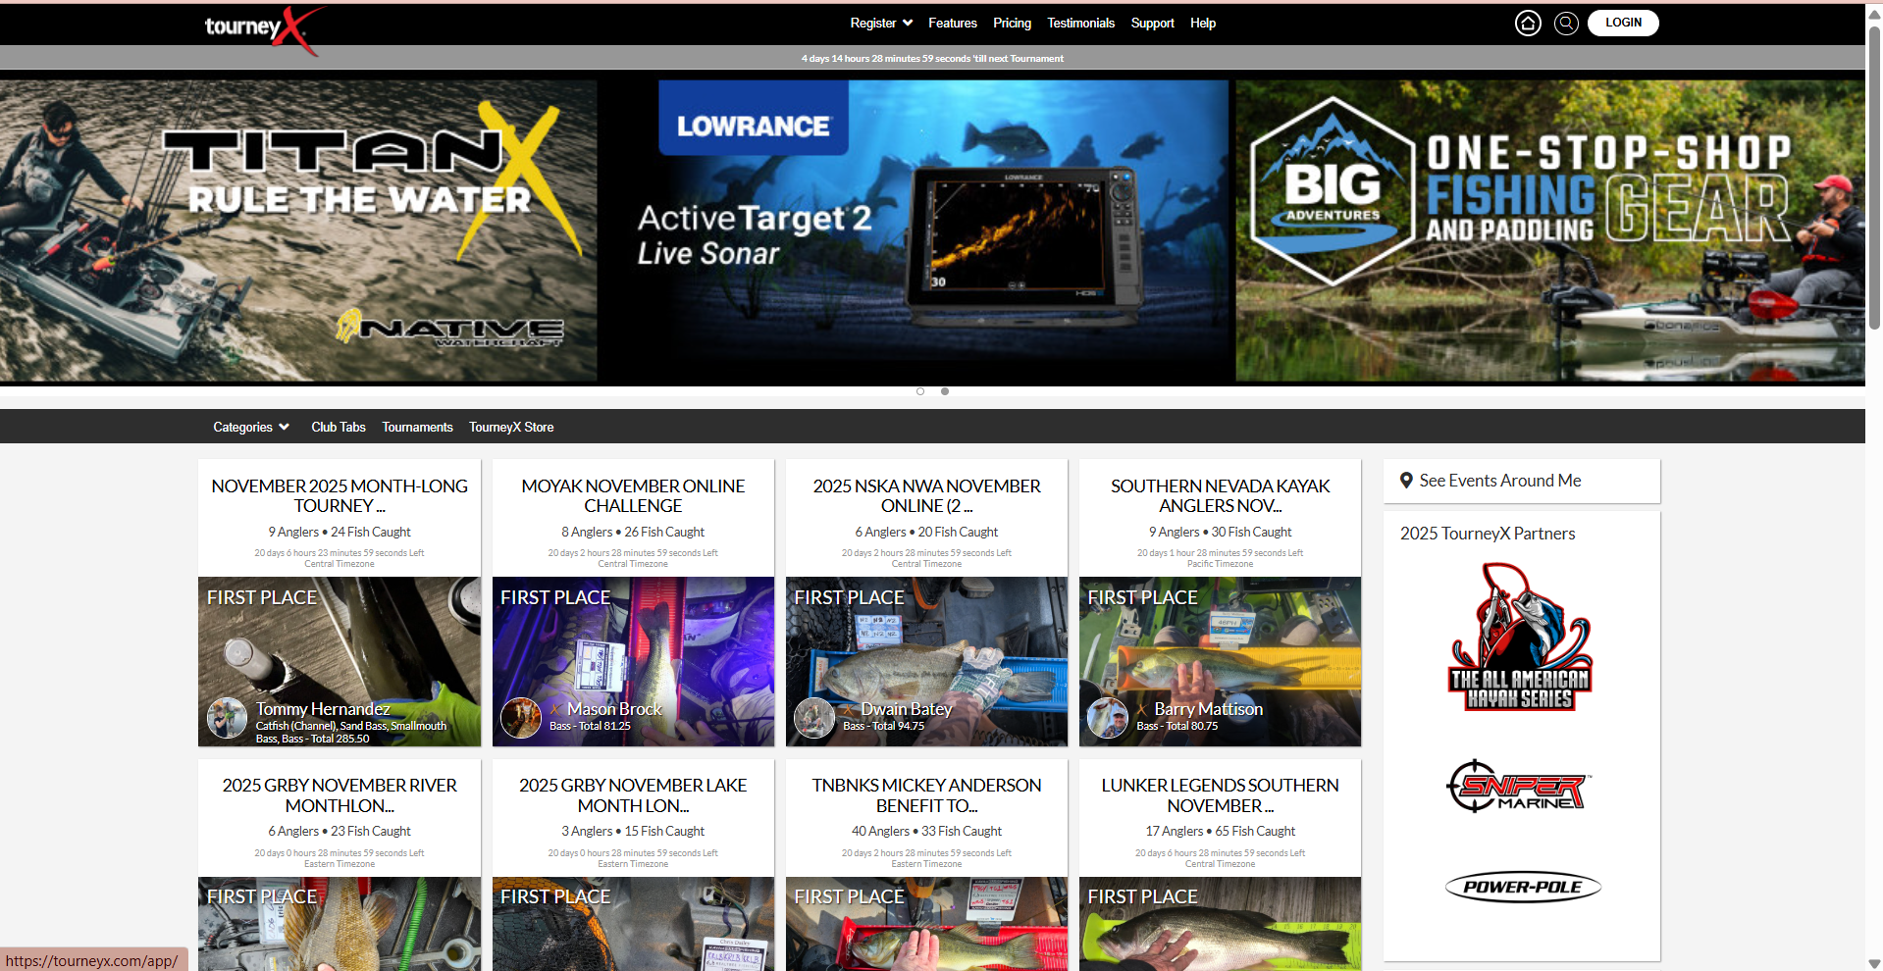

Figure 2.1: TourneyX Tournament Advertisement

Source: TourneyX, n.d.

1. **User Dashboard Management**

Anglers will be required to create an account before they can register for a tournament. As shown in Figure 2.2, users may select the event they interested in and can fill in the registration form and complete payment to register sucessfully.

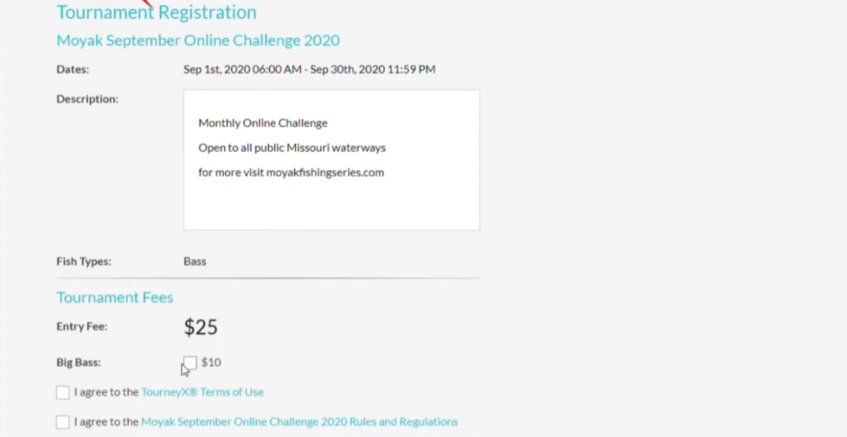

Figure 2.2: TourneyX Angler Tournament Registration

Source: TourneyX, n.d.

Upon registration, new members will get access to the personal dashboard (Figure 2.3) that features important features such as reporting fish catches, live ranking positions, team management, altering fishing days, check in as well as club details. This feature helps anglers in keeping track of everything they need and have all their tournament data in one easy place.

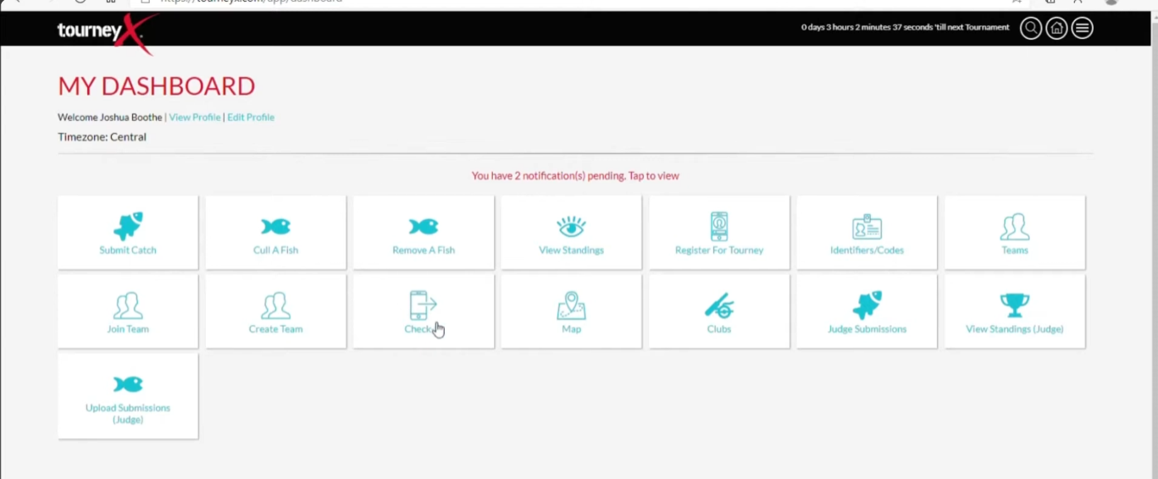

Figure 2.3: TourneyX User Dashboard with Tournament Features

Source: TourneyX, n.d.

1. **Fish Catch Submission**

The fish catch submission system is considered one of the most important functions in TourneyX system. The anglers are able to submit their catch directly via the submission form provided in Figure 2.4. The form allows anglers to upload a clear photo of their fish placed on a measuring board along with the fish species, length and date. The system also records the time, date and GPS location of the catch automatically to ensure fairness.

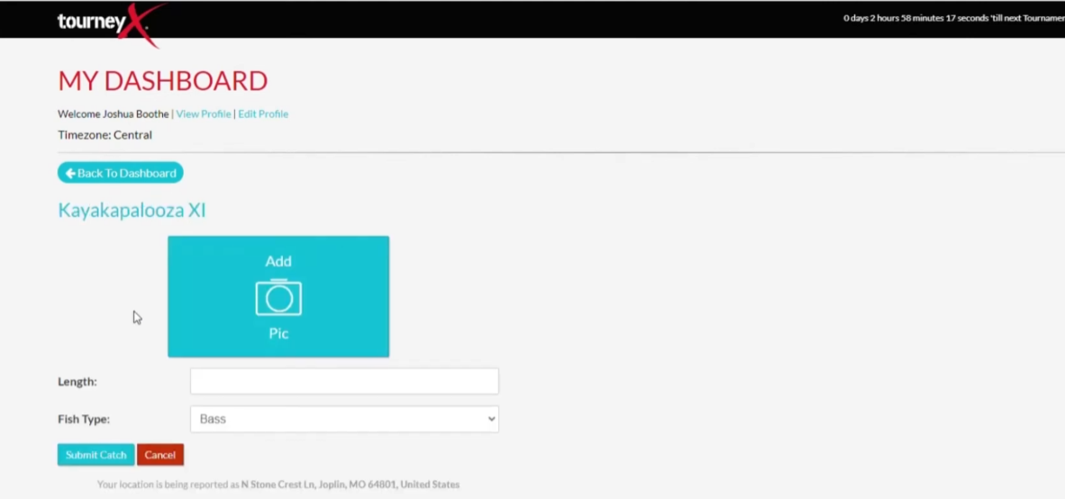

Figure 2.4: TourneyX Angler Fish Catch Submission Form

Source: TourneyX, n.d.

Once submitted all the catch records will be presented in a list format as in Figure 2.5 and both the angler and the organizer will be able to easily review and monitor all the entries.

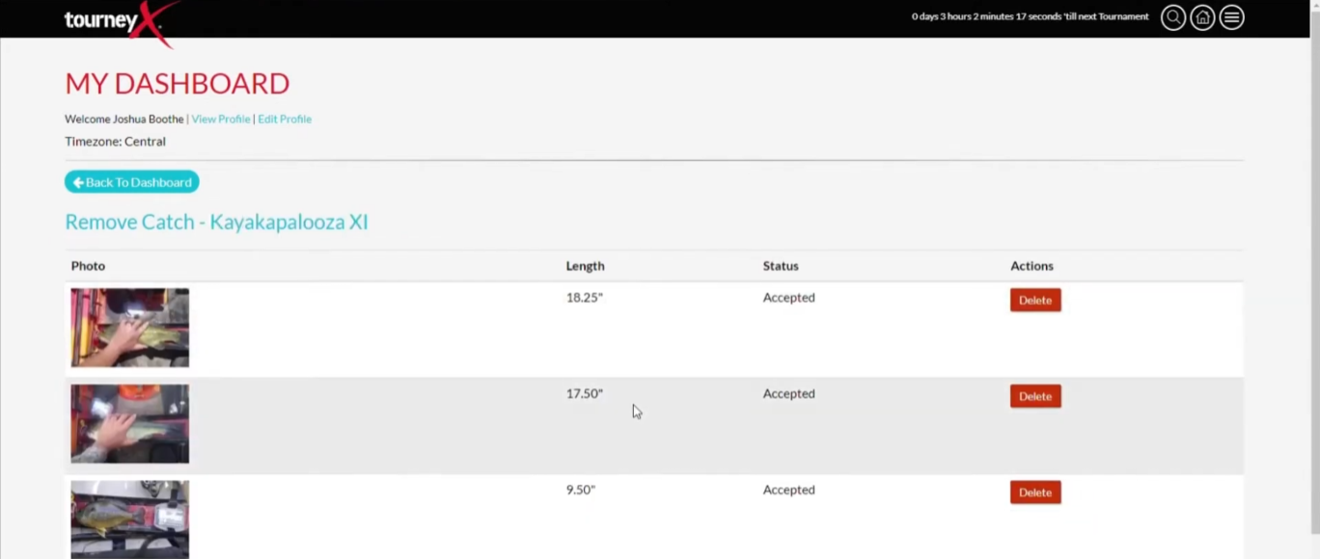

Figure 2.5: TourneyX List of Catch Records

Source: TourneyX, n.d.

The platform also includes a map feature (Figure 2.6) that displays the fishing spots where the catches were made. This makes the process transparent and easy to monitor.

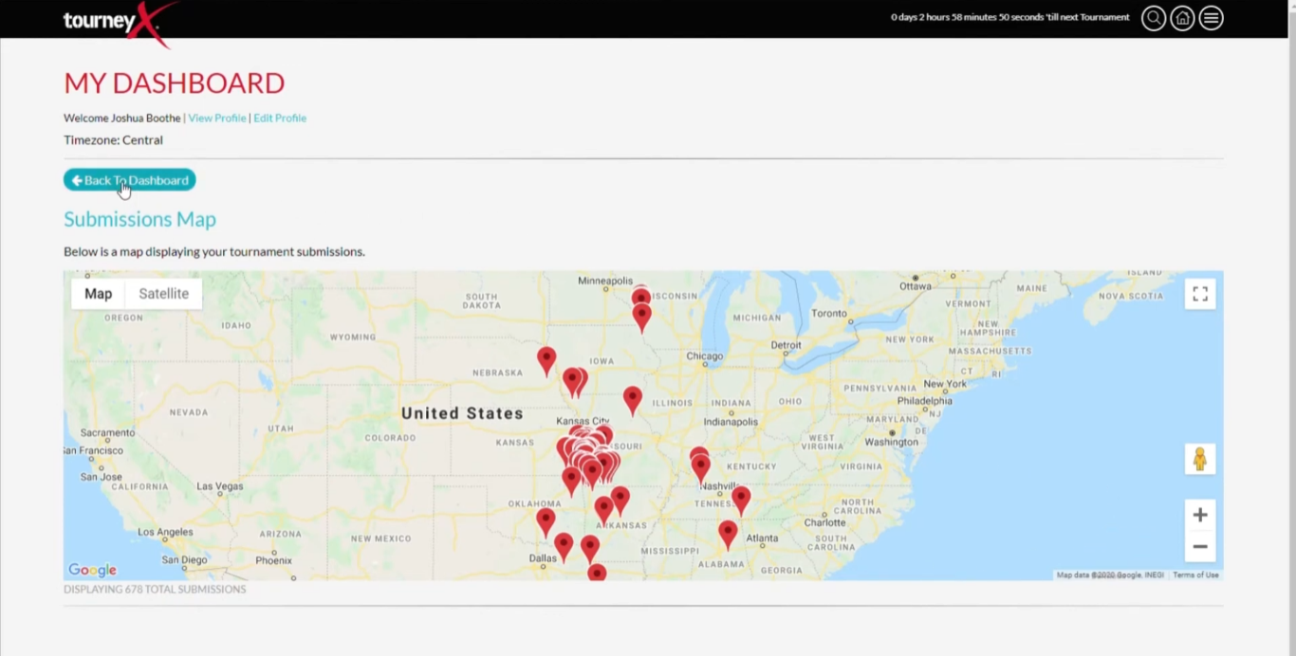

Figure 2.6: TourneyX Fish Catch Submission Map

Source: TourneyX, n.d.

This digital approach to fish submission has replaced the traditional weigh-in process that was once common in fishing tournaments. TourneyX facilitates a sustainable approach to catch, photo and release so that the fish population and the environment can be preserved by enabling the angler to take photos and release the fish immediately.

This tournament management system of fish submission helps in increasing the precision and openness of the contest besides making the whole process more enjoyable to the participants and the event organizers. The system will reduce the risk of fake entries and human errors since it will automate the data collection process and will also have the capability of verification like timestamp and GPS tracking. Furthermore, anglers can easily access and see their previous entries at any time, with the administrators being able to confirm and certify catches in the administrative section.

1. **Live Result Standing**

TourneyX also has live results system whereby new catches are automatically updated and confirmed. As illustrated in Figure 2.7, the live leaderboard shows the name of every angler, their score and ranking in real time. This makes the competition transparent and allows both participants and administration to track the tournament progress in real time.

The live result feature helps to create a more interactive and engaging experience. Anglers can see how they are performing compared to others without waiting for manual result updates. It also gives the angler a sense of excitement as they can monitor who is leading the tournament any time.

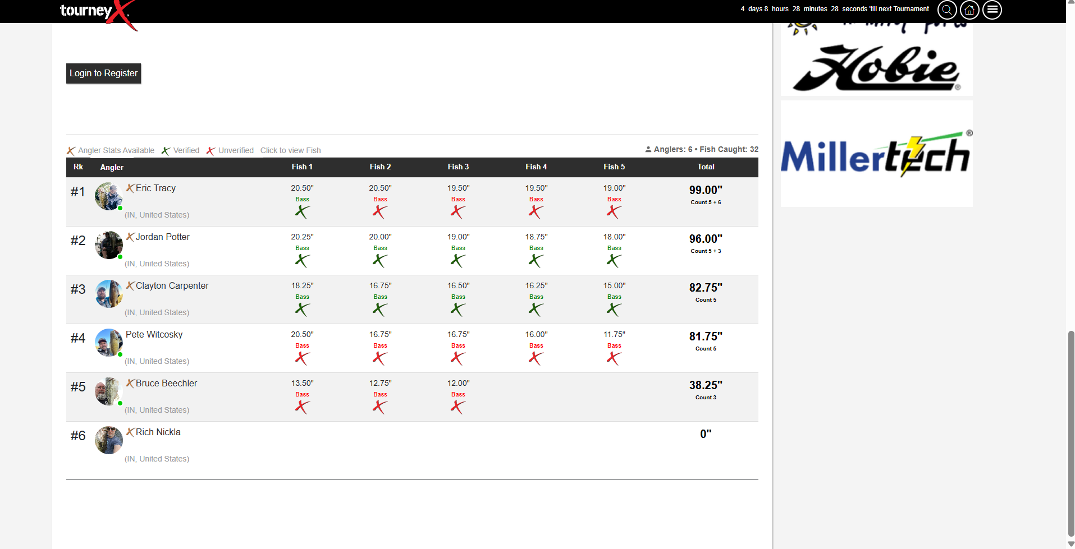

Figure 2.7: TourneyX Tournament Live Result

Source: TourneyX, n.d.

1. **Admin Management Dashboard**

For tournament organizers, TourneyX provides a complete admin management dashboard that simplifies the entire process of organizing a tournament. As shown in Figure 2.8, the admin dashboard includes several tools that allow organizers to create new tournaments, manage fish submissions, send notifications or emails to participants and also handle payments.

The dashboard is designed to give administrators full control over every aspect of the tournament. They can easily check on ongoing tournament, monitor angler activity, update tournament information and ensure everything runs smoothly. The system enables the organizers to save time and prevents confusion by centralizing all the management functions.

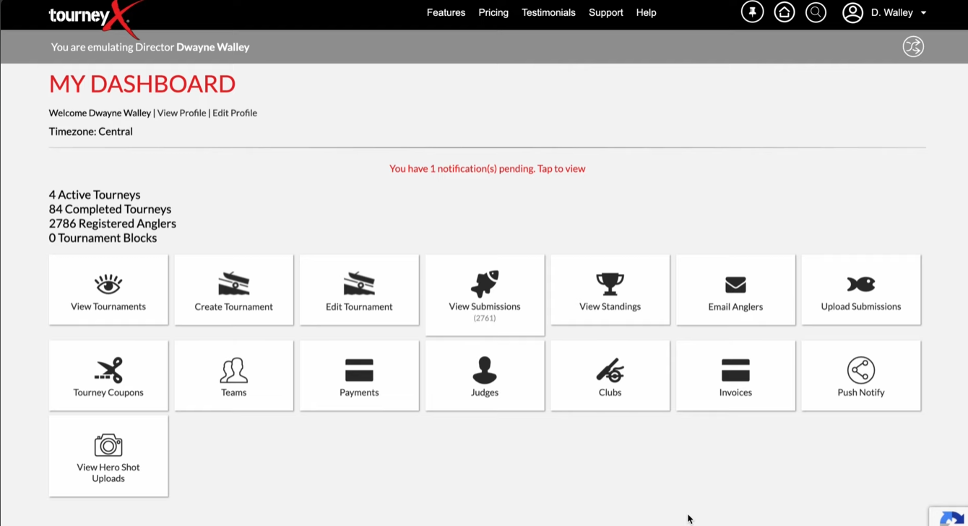

Figure 2.8: TourneyX Admin Tournament Management Dasboard

Source: TourneyX, n.d.

1. **Catch Fish Management and Verification**

The verification of catch fish is one of the most important steps in ensuring fairness and accuracy in fishing tournaments. The TourneyX platform has a specific area where administrators may check and approve fish submissions. As shown in Figure 2.9, all catches submitted by anglers are listed in one pages and this allow organizers to check each entry carefully before approving the catches.

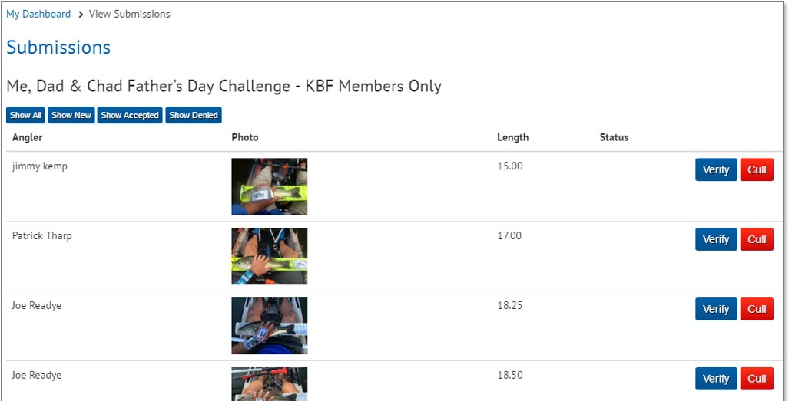

Figure 2.9: TourneyX List of Catch Fish Submission

Source: TourneyX, n.d.

Figure 2.10 depicts a verification interface where administrators would view the uploaded fish photos, validate the measurements and make sure that the submission is done according to tournament rules. The catch will only be displayed in the official leaderboard after having been validated. This verification process helps maintain trust and fairness throughout the tournament by preventing cheating or false reporting.

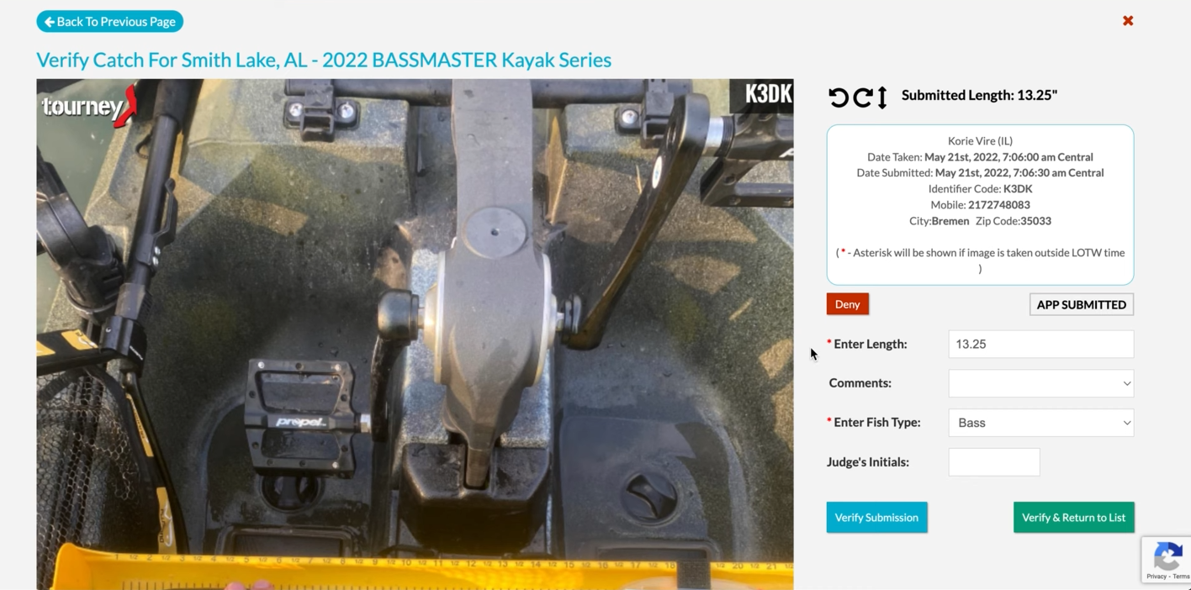  
**Figure 2.10: TourneyX Admin Verification of Angler Catch Submission**

Source: TourneyX, n.d.

Overall, TourneyX shows that digital technology can be used to enhance the process of managing fishing tournaments. The platform provides a fair and transparent platform to both angler and organizers of the tournament. TourneyX saves much time to both participants and administrators by automating most of its processes including registration, submission of fish catches, live scores and verifications. Moreover, the system is sustainable because it improves on a catch-photo-release method of catching fish in which they are not harmed, unlike the weigh-ins which are stressful and harmful to fish.

TourneyX has a number of limitations which influence its applicability in some cases. The primary weakness is that fish catches are reported and registered by the angler himself. This may result in some errors including wrong measurements, wrong species identification or even deliberate misreporting. Although the system has photo checking and GPS tagging to minimize errors, there is still chances of fallacy or cheating entries to the system thereby compromising the quality and equity of the tournament outcomes.

The other major weakness is the interface of the platform that has been found by some users to be not very user-friendly. Managing between various features such as catches, ranking or teams may not be very easy to new users or those who are not as proficient with the digital technologies. These requirements may at times lower the total user experience and impose a hurdle to effective participation in tournaments.

Recognizing these limitations, SmartAngler aims to develop upon the strengths of TourneyX while addressing its weaknesses. The system will also concentrate on developing user friendly interface with easy navigation, easy menu and step-by-step instructions so that the interface can be easily used by all the people irrespective of whether they are technical users or not. In addition, SmartAngler will also offer advanced data analytics to both the angler and organizers, such as advanced performance analysis, history and statistics which can be used to plan strategically and enhance overall management of a tournament.

### 2.5.2 WeighBook

WeighBook is another popular platform used for managing fishing tournaments, but it focuses more on traditional weigh-in systems where organizer will weigh the total fish the angler catches and record in the system. The platform provides tools for both anglers and tournament organizers in helping them manage tournaments, record catches and handle results efficiently. While it is not fully digital like some other platforms, it simplifies many manual processes that were once time-consuming and prone to errors.

1. **Tournament Advertisement List**

WeighBook allows anglers to search for tournaments easily using the advertisement list shown in Figure 2.11. Users can filter tournaments by city or zip code and also by entry fee range. This makes it simple for anglers to find the exact events that match their location and budget. This search and filtering feature makes browsing tournaments simple, saves time and ensures anglers can quickly find the right competitions for them.

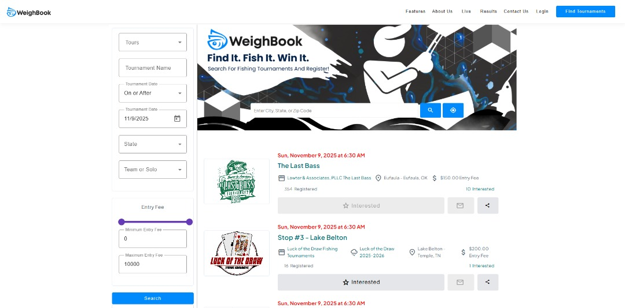

Figure 2.11: WeighBook Tournament Advertisement List

Source: WeighBook, n.d.

1. **Tournament Result**

The platform offers a clear and organized tournament results. As seen in Figure 2.12, it showcases the lists of each participant’s name, the total weight of fish they caught and their ranking. This enables the angler to view their performance easily and also the organizers to view ranking standings in real time. The presentation of the results in a systematic manner is also effective in ensuring transparency and fairness during the tournament.

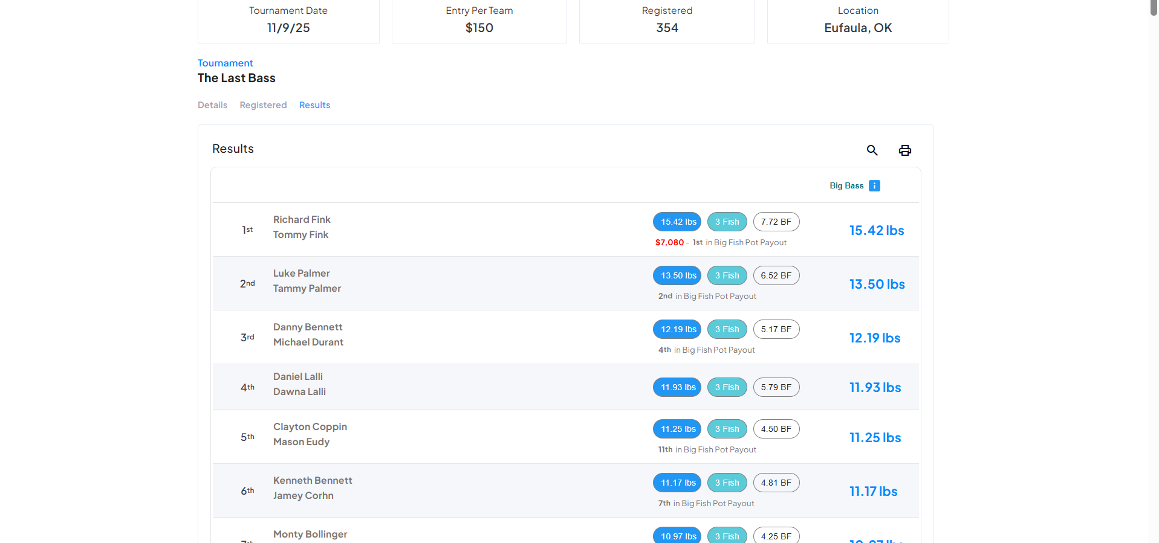

Figure 2.12: WeighBook Tournament Result

Source: WeighBook, n.d.

**iii. Administration Management**

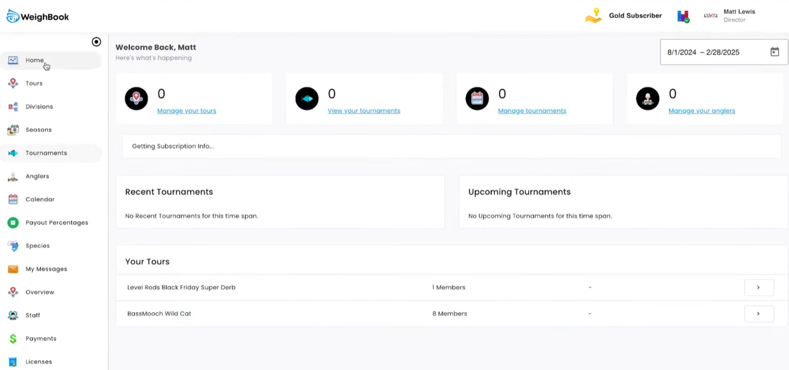

Figure 2.13: WeighBook Administrator Dashboard

Source: WeighBook, n.d.

WeighBook also offers a comprehensive dashboard for tournament organizers. As Figure 2.13 demonstrates, the admin dashboard contains a sidebar which has numerous functions connected to managing tournaments, angler registration, calendrical arrangements of events, and various messages as well as making payments and so forth. This centralized system helps organizers manage multiple tasks in one place and reducing the chance of errors and confusion.

Creating and managing tournaments on WeighBook is designed to be clear and organized for administrators. Administrators can fill in all the basic tournament details, rules, entry fees and payout structures through the form illustrated in Figure 2.14. This ensures that every tournament is properly prepared from the very beginning. It also helps participants understand exactly what to expect including the rules they need to follow, the fees they must pay to join and the prizes they could win. Having all this information clearly entered and displayed will reduces anglers’ confusion and prevents mistakes.

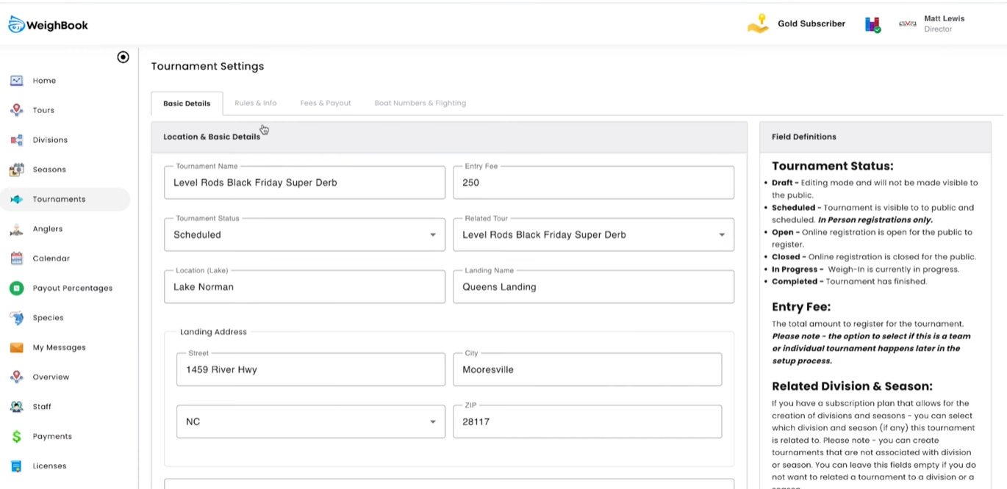

Figure 2.14: WeighBook Tournament Creation and Management

Source: WeighBook, n.d.

Fish catch logging is handled carefully through the system. Figure 2.15 shows that administrators can enter records directly into the system and the recors are printable. Each entry includes total fish caught, total weight and any penalties if applicable. Administrators can approve, remove or adjust entries as needed to ensure accuracy.

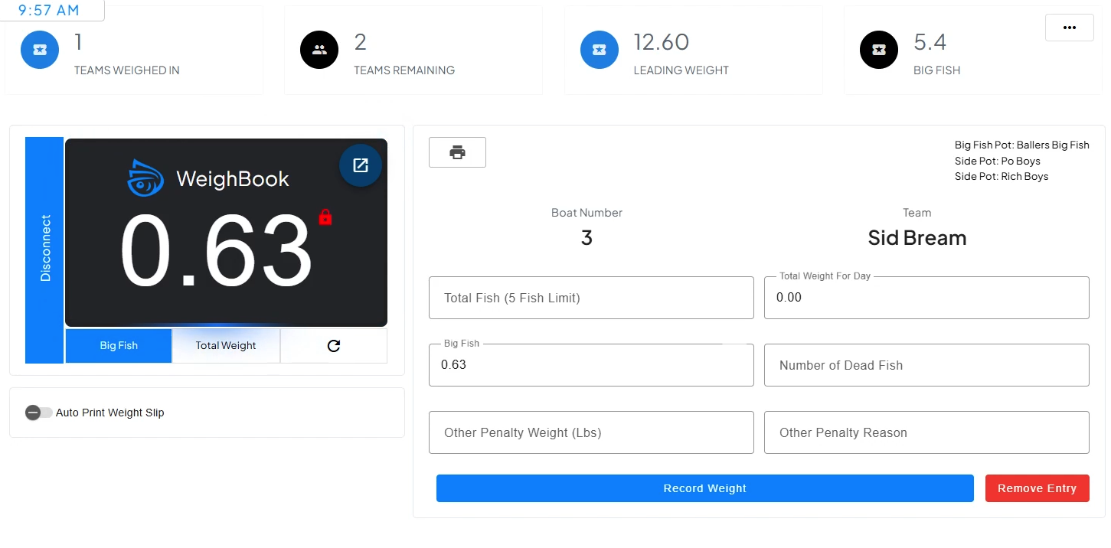

Figure 2.15: WeighBook Fish Catch Logging

Source: WeighBook, n.d.

Finally, the platform provides a tournament result management feature which as shown in Figure 2.16. This lists all winners, their results and the prizes they won, and the results are also easily shared and it is easy to access and find final official results.

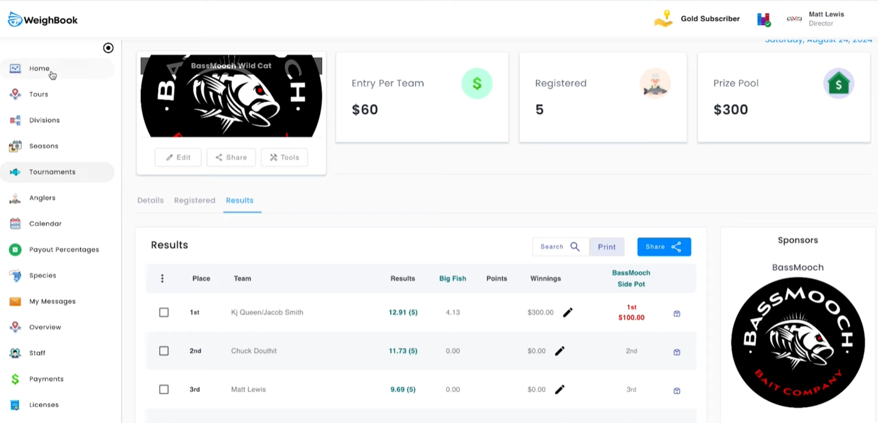

Figure 2.16: WeighBook Tournament Result Management

Source: WeighBook, n.d.

In conclusion, WeighBook is a decent site to organize and manage the fishing competitions based on the physical weigh-ins and data entered by the administrator. It is an online tool that offers search capabilities of tournaments, results, fish catches and all other event management capabilities under a single system. The system assists organizers to keep things in order in the tournaments, and it minimizes paperwork and the official tournament results are clear and transparent to all users.

### 2.5.3 FishPal

FishPal is a online-based system that makes it easy to book fly fishing trips in the UK and Ireland by linking fishery owners and angler together. It simplifies the process of finding fishing locations, check availability and make reservations online by the anglers. By automating these processes, the platform makes the work of the fishery owners less complex and provides the anglers with an easy and convenient method of organizing their fishing trips.

Figure shown in Figure 2.17 demonstrate how anglers can quickly search for and reserve their fishing spots, making the entire process smooth and efficient. Overall, FishPal benefits both anglers and fishery owners by saving time, reducing workload and providing a convenient and organized way to manage fishing trips.

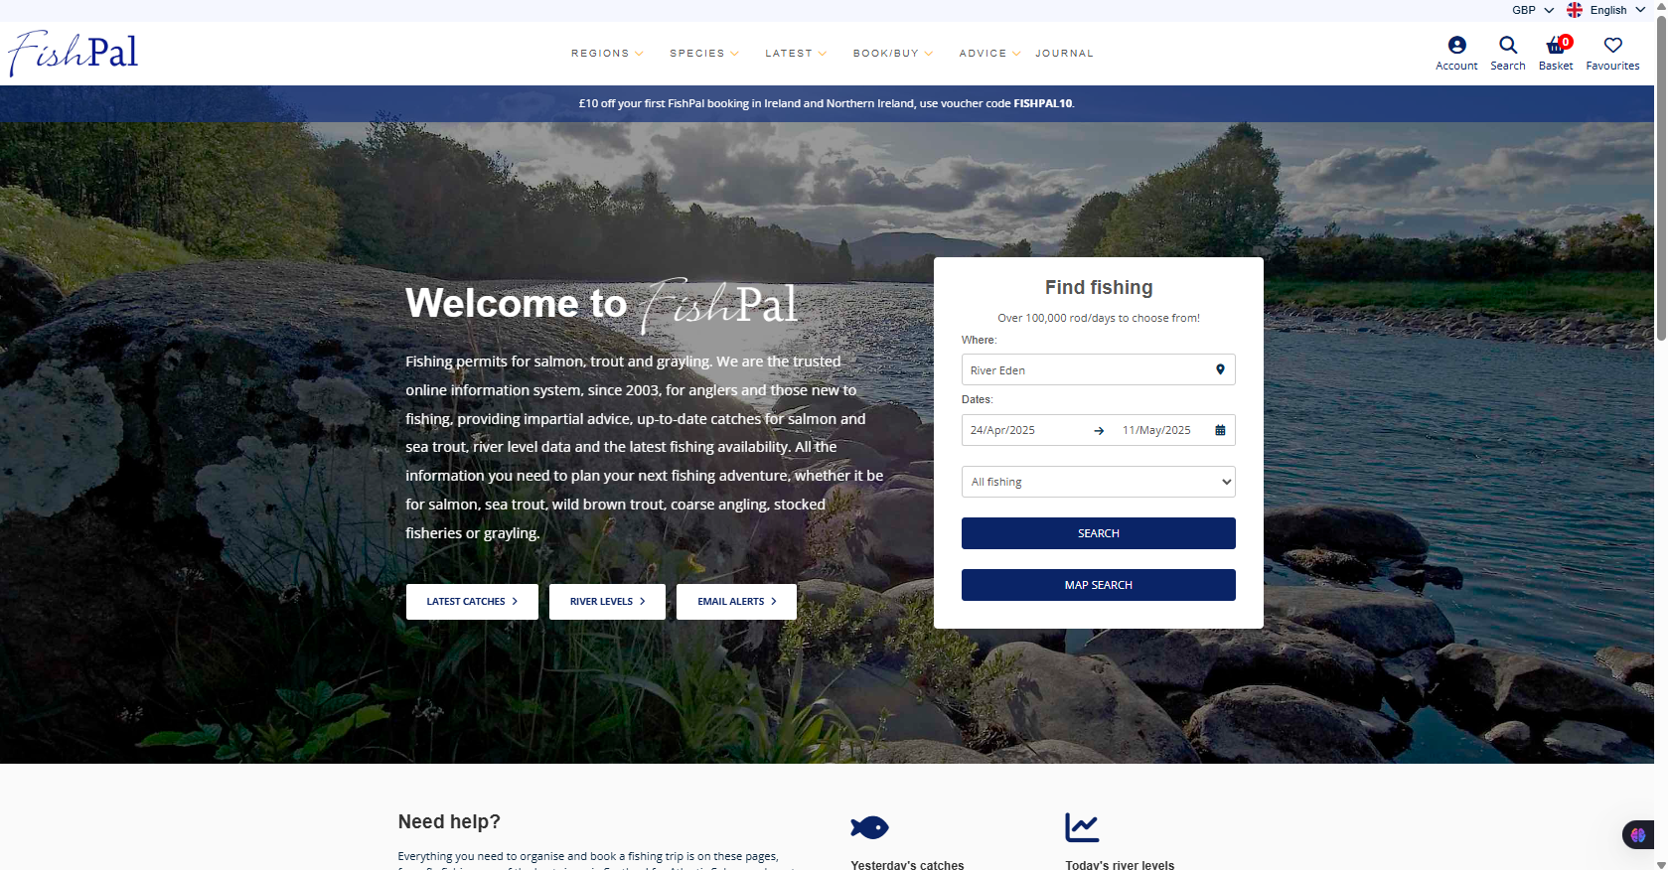

Figure 2.17: FishPal Main Interface

Source: FishPal, n.d.

1. **Booking System**

The effective booking system is one of the key strengths of FishPal that enables the angler to find the fishing location within a very short period, find out the possible dates and bookings within a few clicks. This will allow users to plan their trips more quickly without calling the phone or sending e-mails. Moreover, the site offers a list of the most popular fishing locations as it can be seen in Figure 2.18 that give an angler the opportunity to look at all the possibilities in a particular area. This facilitates the ease with which they can choose the spots that suit them say in terms of type of fish, convenience or accessibility of location. With all options being presented, the angler makes better decisions and the experience of planning a trip is organized better.

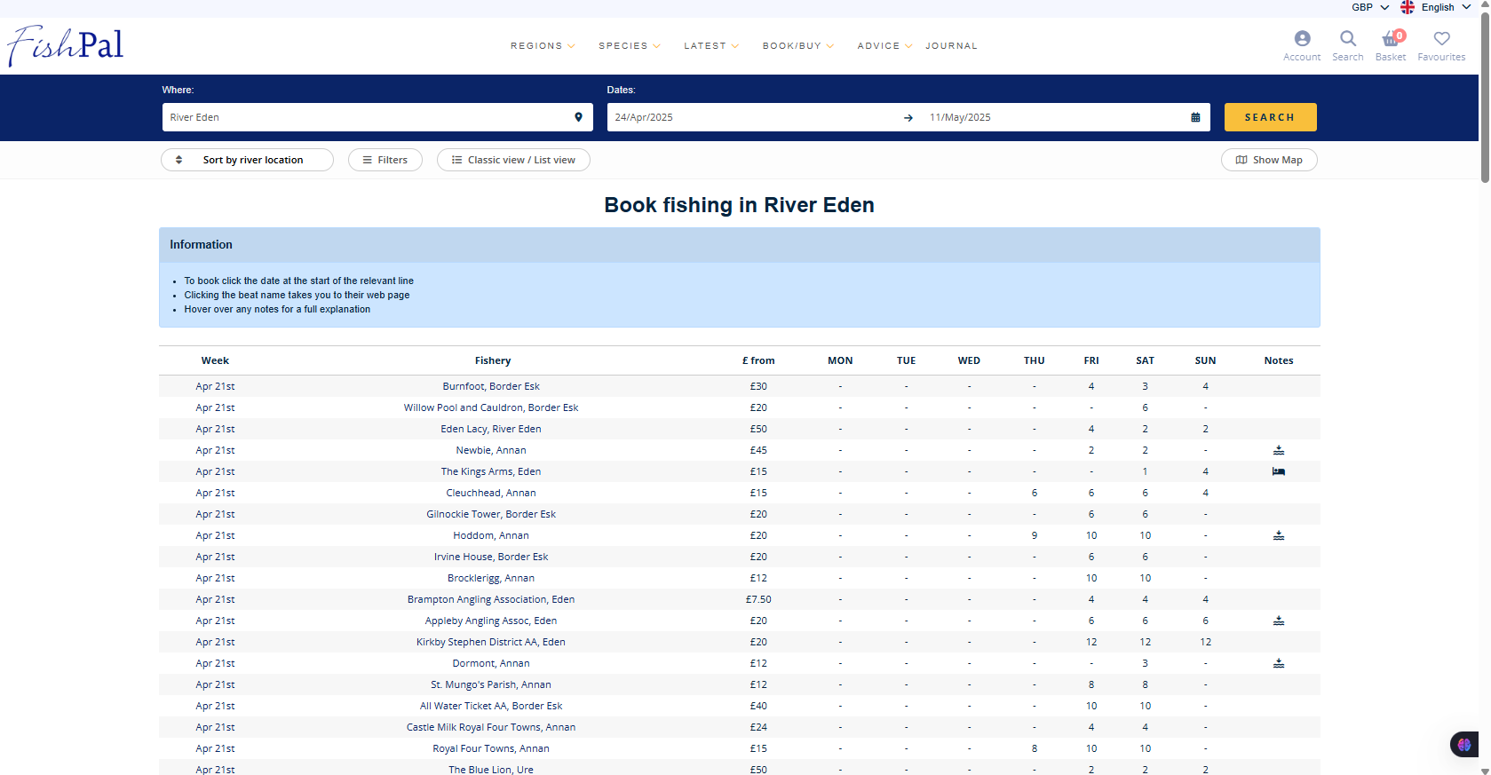

Figure 2.18: Fishpal List of Available Book Fishing

Source: FishPal, n.d.

1. **Detailed Fishing Advertisement Information**

FishPal also provides detailed information about each fishing location, as seen in Figure 2.19. This includes the types of species available, fishing conditions, opening hours and other important details for the locations. This information can be utilized to enable users make informed decision and ensure that the angler is well equipped to meet the environment they will be exposed to. Through detailed information on the front end, the platform helps reduce the level of uncertainty and improves the entire experience of the user.

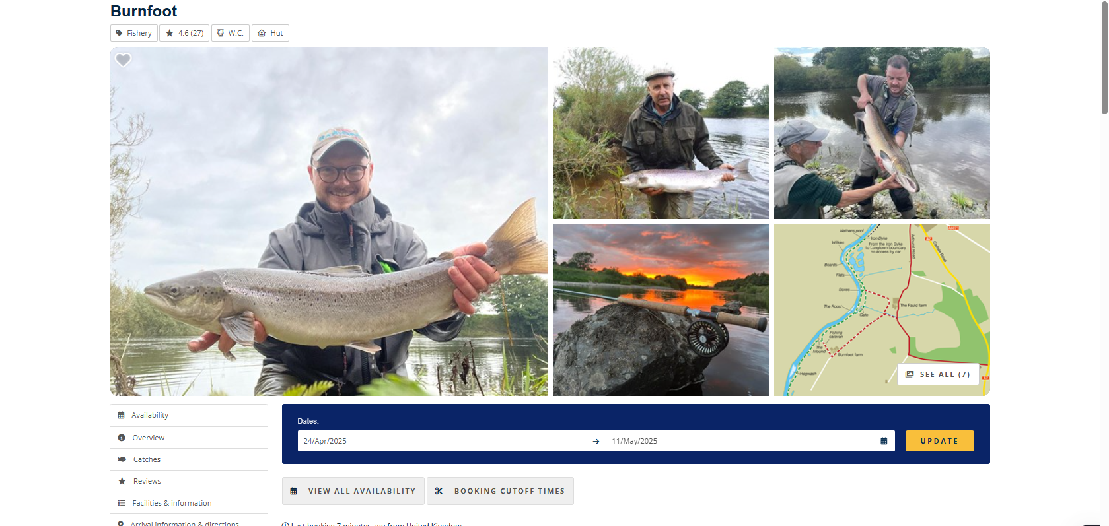

Figure 2.19: FishPal Detailed Information of the Fishing Activities

Source: FishPal, n.d.

1. **Fish Catch Analysis**

Moreover, FishPal integrate tools such as fish catch analysis which were presented in Figure 2.20. It provides information on the current fishing trends and patterns. This enables the angler to make informed decisions about their trips and increases their probability of a rewarding fishing trip. By offering evidence-based insights, FishPal helps users make informed decisions rather than relying solely on guesswork or previous experience.

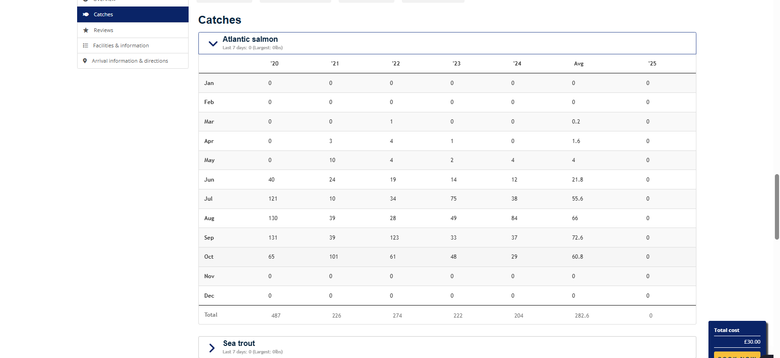

Figure 2.20: FishPal Fish Catch Analysis

Source: FishPal, n.d.

1. **Angler Reviews**

The platform also includes reviews from other anglers as illustrated in Figure 2.21. Those reviews enable new user to read reviews on various locations and get to know what other people went through. This reviews aid in creating trust in the platform and it helps the users have a better idea of what is at every fishing location by giving personal experience and ratings. This aspect also promotes transparency and assists the angler to make decisions on the location they wanted to go.

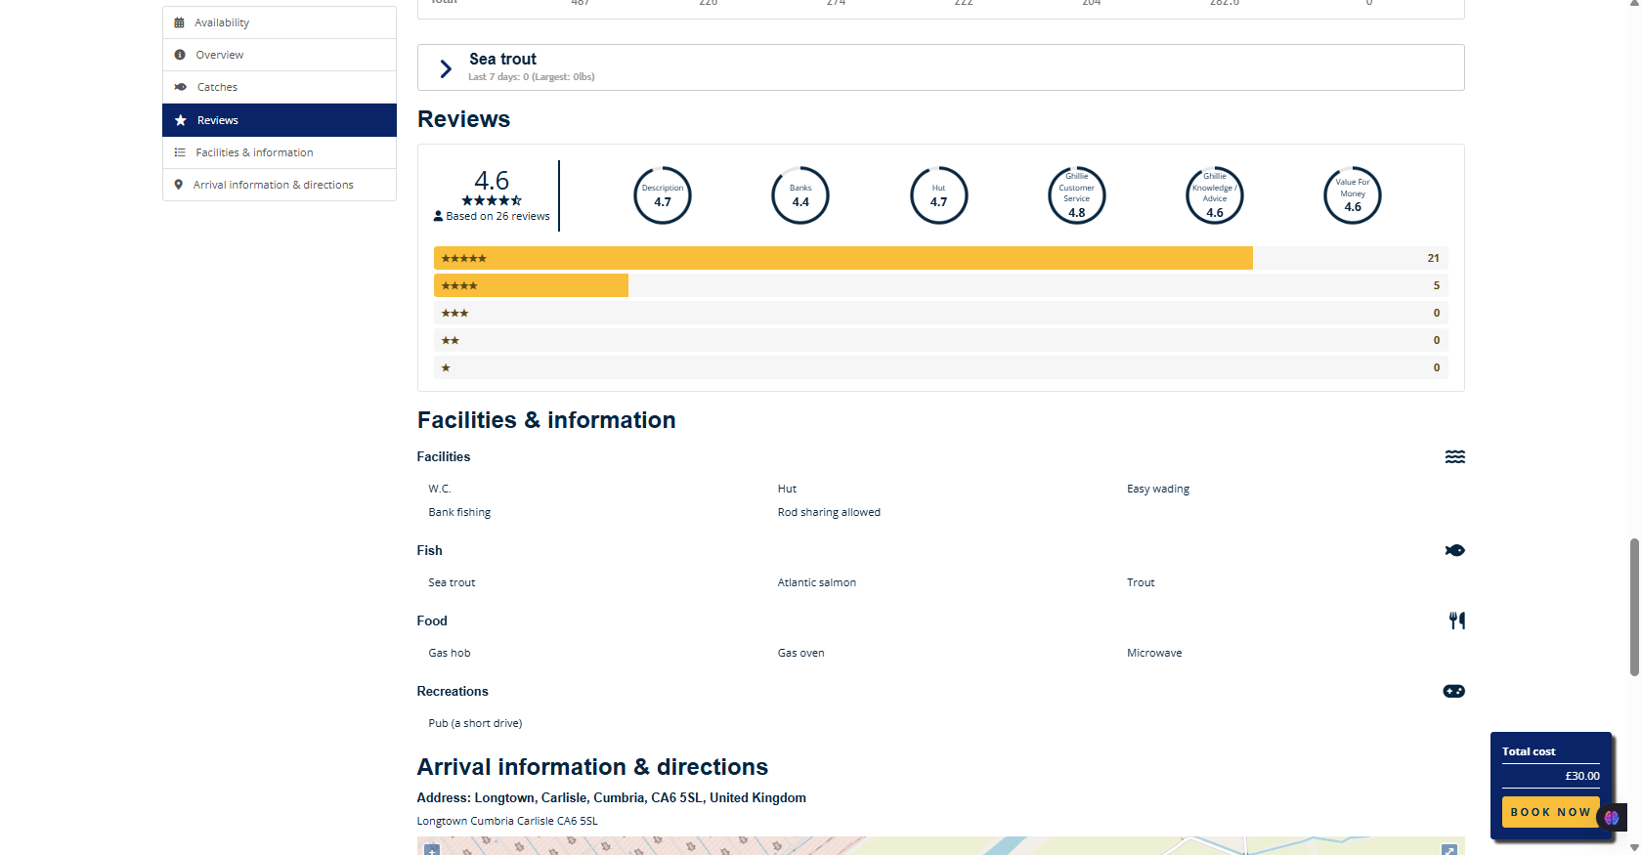

Figure 2.21: FishPal Anglers’ Reviews

This system however merely concentrates on fly-fishing in the UK and Ireland. Although it gives a wide coverage of fishing sites in these areas, it is not conducive to fishing in other countries and territories other than the UK and Ireland. This means anglers looking to book trips abroad or explore different types of fishing will need to find another platform. As a result, FishPal can only cover a certain geographical region that might not suffice to serve the interests of angler who want wider or international fishing exposures.

### 2.5.4 KeepNet

KeepNet is an online platform designed to simplify the process of organizing and participating in fishing tournaments. It offers features that are useful to both the tournament organizers and the angler making the event management simple and enhancing the overall experience of the participants. With its user-friendly interface, KeepNet allows organizers to promote their events, allow for participant registration and track the progress of fishing tournaments.

For anglers, KeepNet provides a simple way to discover tournament ads, join the tournament and compete in fishing tournaments across various locations. As shown in Figure 2.22, the competition list dashboard can showcase a large variety of available tournaments so that the user can browse the events easily and choose the one that is the most optimal solution to their interests.

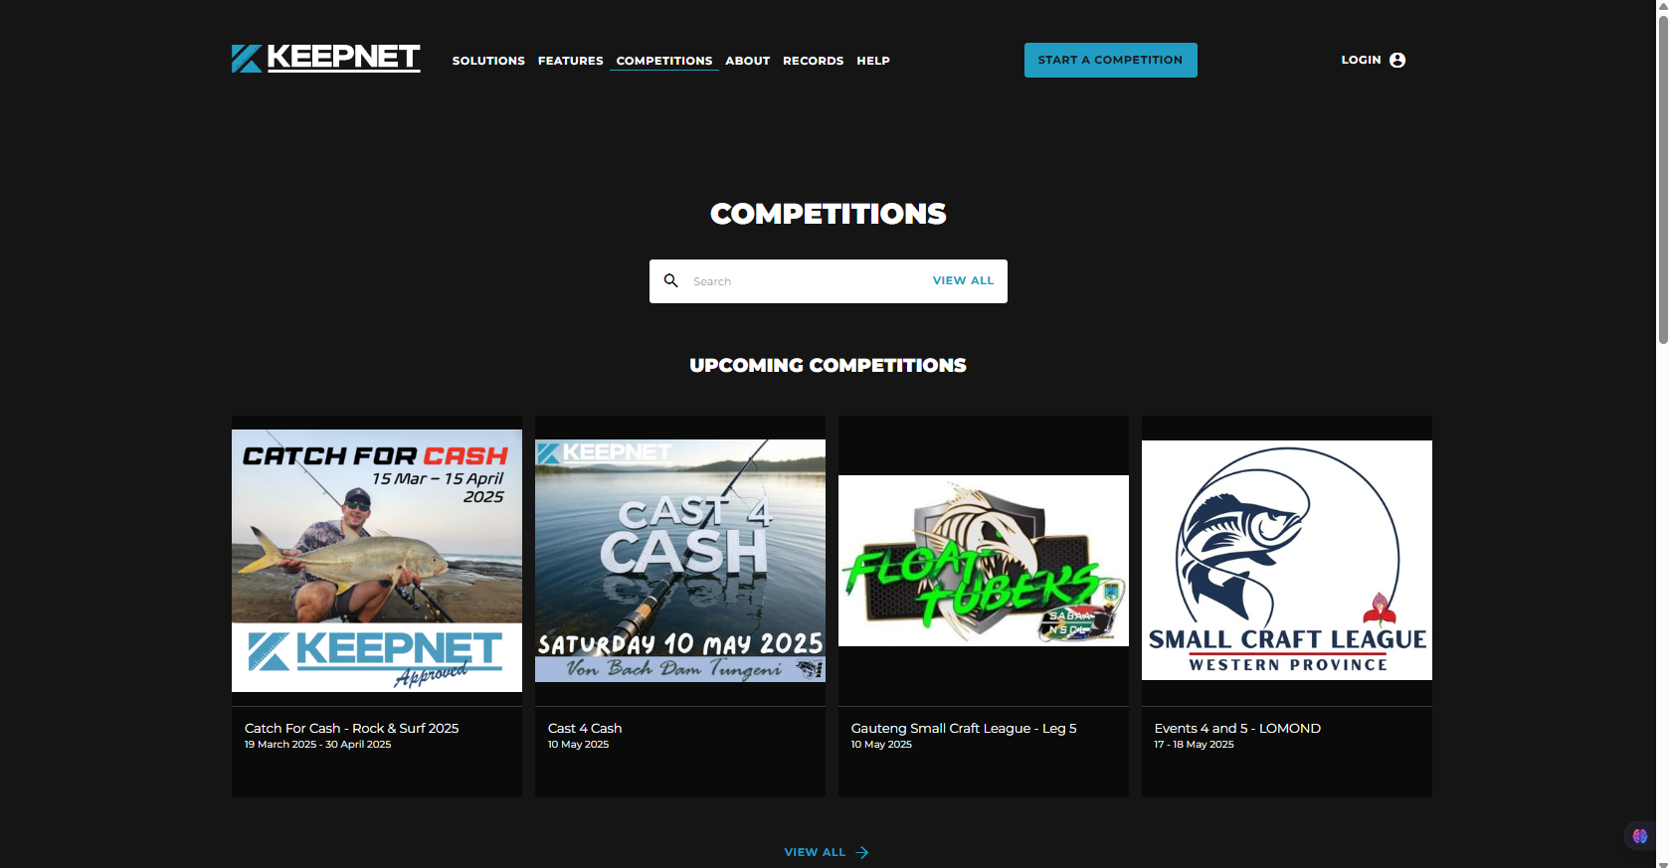

Figure 2.22: KeepNet Competition List Dashboard

Source: KeepNet, n.d.

1. **Tournament Advertisement and Promotion**

One of the key features of KeepNet is its ability to help organizers promote their fishing tournaments efficiently. The site enables the event organizers to update advertisements on each tournament that incorporates essential details like dates, venues, regulations, registration procedures and entry fee.

The digital strategy is a substitute to the manual advertising and making sure that events will reach more people of the angler industry. The listings are directly represented on the site, and it is convenient to users to explore and register in upcoming events. The tournament details page as illustrated in Figure 2.23 gives potential participants the ability to see all the information regarding the events in a single page and continues with the registration process smoothly. This feature not only increases visibility for local and national tournaments but also encourages higher participation rates which helping organizers attract more anglers to their events.

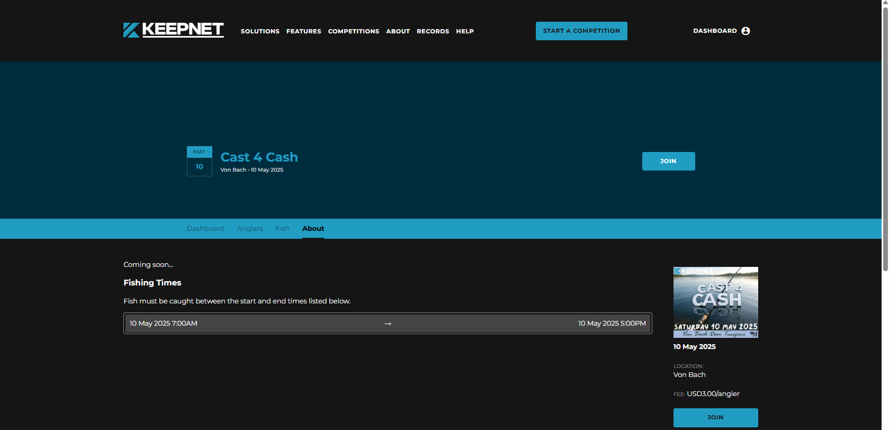

Figure 2.23: KeepNet Fishing Tournament Details

Source: KeepNet, n.d.

1. **Simplified Registration Process**

KeepNet also simplifies the process of registration of the angler. It provides an easy and convenient method of participating in tournaments. Once a tournament is published, users can easily browse through the list of available events and explore details such as dates, locations, and rules and register directly through the platform. It does not require the use of the old-fashioned paper forms or external registration systems that may take time and may be subject to human error.

KeepNet enables both the organization and the participant to have a faster and more precise and user-friendly experience by digitalizing the entire registration workflow. Anglers will be able to complete their registration in with just a few clicks. While organizers will be able to track their participants automatically and have a lesser workload to handle. This simple process encourages higher participation and helps maintain an organized and transparent tournament environment.

1. **Live Leaderboard and Real-Time Results**

KeepNet also has another valuable feature like a live leaderboard that enables the participants to keep track of their performance during the tournament in real time. The leaderboard will automatically be updated with the recent results and position of each angler as the event progresses displaying the total catch and overall position relative to others. This real-time feedback keeps the participants active and encouraged to do better since they can instantly see the effects of their catches on their ranking in the competition.

The live leaderboard also enhances the excitement of the event for both anglers and organizers by making it more dynamic and interactive. Anglers are able to track how they are doing and remain informed about results as they change. Not only does this provide the overall enhancement but also transparency and fairness to the tournament process as seen in Figure 2.24 which shows the live results leaderboard.

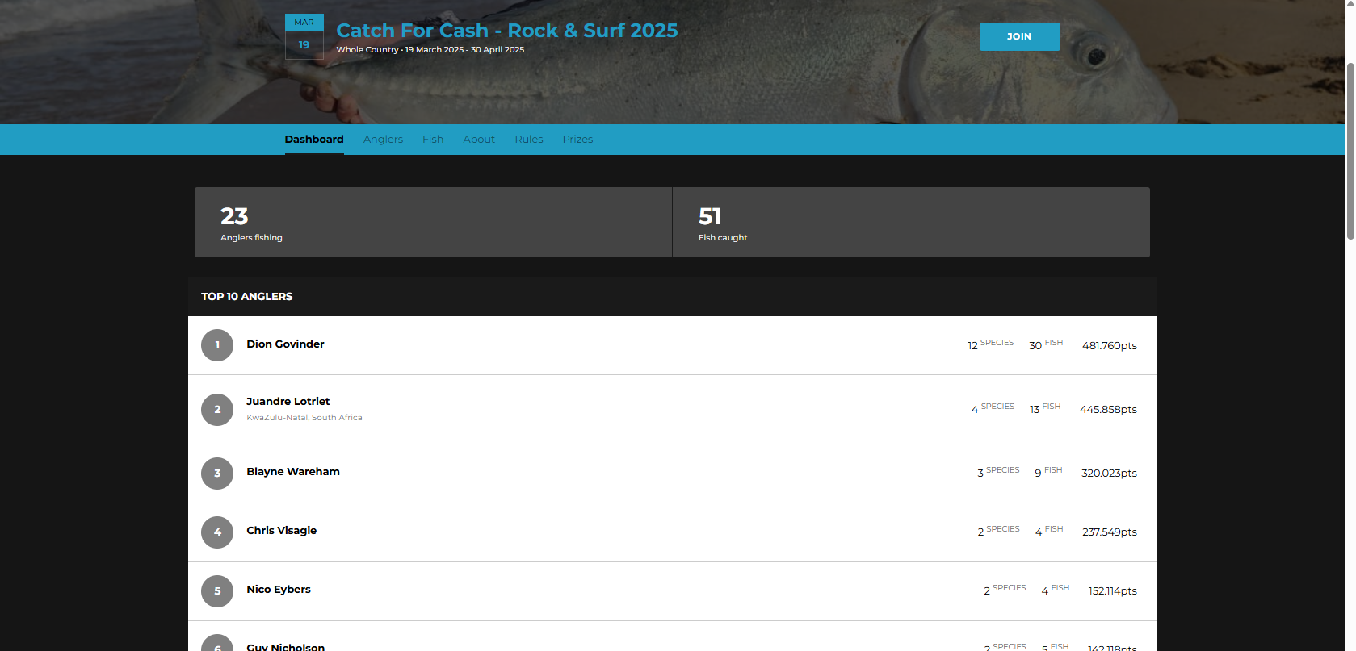

Figure 2.24: KeepNet Live Results Leaderboard

Source: KeepNet, n.d.

1. **Sponsorship and Community Engagement**

In addition, KeepNet also includes features for sponsorship promotion as illustrated in Figure 2.25. Organizers may showcase sponsors directly on the platform which will allow partnering brands to gain exposure and form collaboration. This not only assists in generating financial support and sponsorship to tournaments, but also enhances the fishing community with a common digital ecosystem that connects the organizers, sponsors and participants.



Figure 2.25: KeepNet Sponsorship Page

Source: KeepNet, n.d.

KeepNet demonstrates that digital technology can make significant advances in the organization and experience of fishing tournaments. The platform unites event promotion, participant registration, live result tracking and sponsorship management tools so that the entire process can become more efficient and enjoyable to both organizers and the participants which are the anglers. Its user-friendly interface as well as real time updates can facilitate a smoother and transparent tournament experience. KeepNet not only saves time and reduces manual work but also adds excitement and fairness to competitive fishing events.

### 2.5.5 Reel LiveWell

Reel LiveWell is an application that enhances the process of catch-record-release (CRR) by simplifying it. The app was originally developed in 2019 to serve the Classic Bass Champions Tour but has also been used in other events such as Student Angler Tournament Organization (SATO) and Minnesota Student Angler Tournament Trail (MNSATT). The app provides a complete solution for both tournament organizers and participants where it focus on sustainability, real-time tracking and a user-friendly experience.

One of the main features of Reel LiveWell is its customization options for tournament organizers. The application allows them to organize events according to various criteria, which include species, weight, length and the quantity of fish that are caught. This is because it is flexible to single-species and multi-species events. It also allows posting of tournament advertisements by the organizers, and this is helpful in attracting the angler to join it and also in making the events more visible as seen in Figure 2.26 where a list of available competitions are displayed.

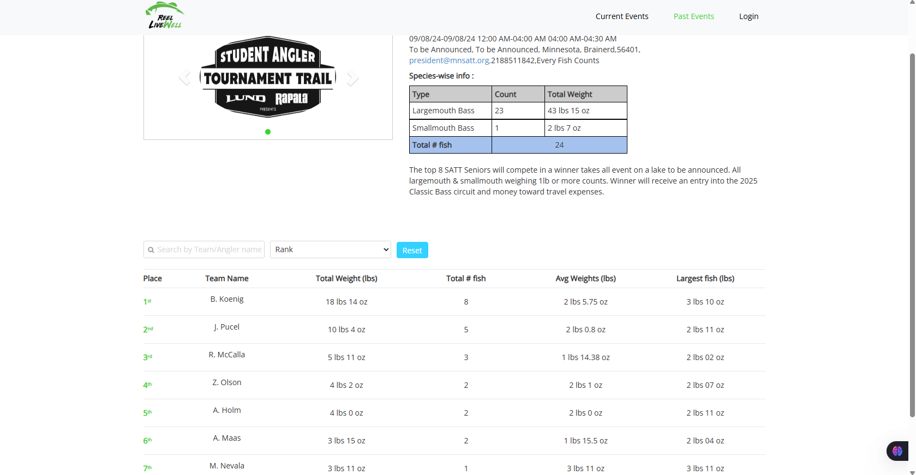

Figure 2.26: Real-Time Leaderboard of Fishing Competition Results

Source: Reel LiveWell, n.d.

Reel LiveWell also allows real-time updates which enabling participants to track catches and view live results throughout the event. This aspect brings excitement and interaction and makes the tournament much more interactive to all. Figure 2.21 shows the real-time leaderboard where participants can view their catches and their ranking in the competition as it progresses.

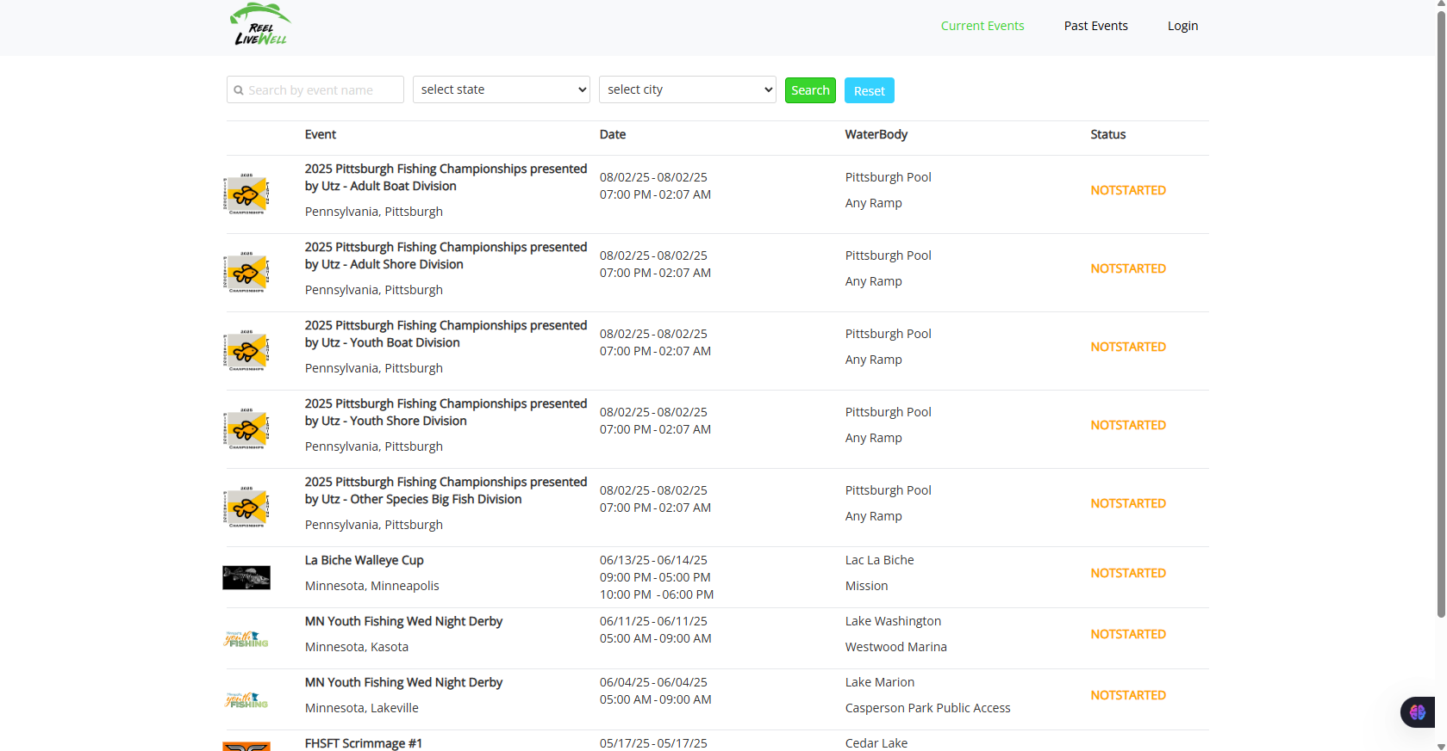

Figure 2.27: List of Available Fishing Competitions

Source: Reel LiveWell, n.d.

In conclusion, Reel LiveWell provides a modern and efficient platform for managing fishing tournaments since it is focusing on features like real-time tracking, customizable settings for advertisement and sustainability. The fact that it can assist both the organizers and the participants with live leaderboards, event advertisements and customizable tournament settings makes it a comprehensive system to support digital fishing competitions.

Compared to SmartAngler, Reel LiveWell shares similar goals in promoting eco-friendly and efficient tournament management through digital methods. However, SmartAngler would be smaller-scale and specific to the Malaysian fishing tournaments that prioritize simplicity, accessibility and automation of both visitors and the organizers. Whereas Reel LiveWell is focused on large-scale professional or educational events in the Western parts of the country, SmartAngler focuses on smaller, localized platforms that are more flexible and welcoming to the community to local fishing practices and tournament activities.

## 2.6 **Comparison of Existing Fishing Tournament System**

The System Comparison Table gives a summary of the advantages and disadvantages of the different fishing tournament management systems such as the TourneyX, WeighBook, FishPal, KeepNet, Reel LiveWell and the proposed SmartAngler system. It compares their key features like user authentication, tournament advertisement, participant registration, fishing spot booking, notification and announcement, fish catch log, sponsorship and prize management, result management and reviews. This comparison will assist in outlining the advantages and disadvantages of each system and give us an idea of how they assist organizers and participants of tournaments.

Table 2.1: Comparison Between SmartAngler system with The Existing System

|  |  |  |  |  |  |  |
| --- | --- | --- | --- | --- | --- | --- |
| **Features** | **SmartAngler** | **TourneyX** | **WeighBook** | **Fishpal** | **KeepNet** | **Reel LiveWell** |
| User Authentication | Yes | Yes | Yes | Yes | Yes | Yes |
| Tournament Advertisement | Yes | Yes | Yes | Yes | Yes | Yes |
| Participant Registration | Yes | Yes | Yes | Yes | Yes | No |
| Fishing Spot Booking | Yes | No | No | Yes | No | No |
| Notification and Announcement | Yes | No | Yes | No | No | No |
| Catch Fish  Log | Yes | Yes | Yes | No | No | No |
| Sponsorship & Prize Management | Yes | No | Yes | No | Yes | No |
| Result Management | Yes | Yes | Yes | Yes | Yes | Yes |
| Review | Yes | No | No | Yes | No | No |

Based on the finding in Table 2.1, it shows that SmartAngler system is designed to bring together the best features from all these systems and add more advanced capabilities. It will provide features that might not have in other system such as online tournament registration and spot booking, live leaderboards and participant reviews. By filling the gaps that exist in the existing systems, SmartAngler will serve as an addition to the tournament experience and therefore, will be the more comprehensive and available alternative in the modern approach to the organization of the fishing tournament.

## 2.7 Research Gap Summary

Based on a review of the current fishing tournament management systems, it is obvious that numerous platforms, including TourneyX, WeighBook, KeepNet, FishPal and Reel LiveWell, have already contributed to the enhancement of how tournaments are being conducted. It has automated most of the main management task like participant registration, catch logging and result management. Other systems like FishPal and Reel LiveWell are also easier to use to book fishing spots and sustainability and real-time tracking provided by other systems which prove the potential of technology to enhance the tournament experience.

However, these systems also have several limitations that could negatively impact the organizer or the anglers. Some of the system is depends on anglers to log their own catches, which can lead to errors or even deliberate misreporting. There are also platforms that are limited to specific areas thus not as useful in tournaments in different countries like Malaysia. Some have made their interfaces complex or have heavy features dashboard that can be overwhelming to a first-time user or to one who is not as environmentally computer savvy. Moreover, other features such as booking of fishing spots online, notifications to participants or reviews are usually not available.

Thus, SmartAngler was introduced to address these gaps. It allows organizers to directly manage catch logging, helping to minimize errors and maintain fairness throughout the tournament. The interface is simple and intuitive making it accessible to users of all technical abilities. SmartAngler is also a platform that integrates multiple features commonly found on different other systems, including tournament registration, booking fishing spots, live leaderboard, notifications, sponsorship support and reviews into one and unified system. By prioritizing usability, local relevance and comprehensive functionality, SmartAngler provides a practical and effective solution that supports both organizers and participants. This making fishing tournaments easier, fairer and more enjoyable for everyone involved.

## 2.8 **Summary of Literature Review**

In short, the literature review represents an in-depth analysis of fishing tournament management systems. It focuses on the evolution of the fishing tournament and the role of technology in modernizing the fishing tournament key processes. The review also notes the influence of fishing tournaments including improving local economies, promoting healthy outdoor activities and strengthening the existence of angler communities. Comparisons of the existing systems such as TourneyX, WeighBook, FishPal, KeepNet and Reel LiveWell were also undertaken in the review, and the strengths and limitations of these systems were identified. Overall, the review supports the development of SmartAngler as a modern solution to improve fishing tournament management for both organizers and participants.

# CHAPTER 3

**METHODOLOGY**

## 3.1 Introduction

The project methodology describes the stages and steps that will be applied in developing the SmartAngler system. It outlines the Software Development Life Cycle (SDLC) which is the process that will guide the entire project. The SDLC consists of five main stages like planning, analysis, design, implementation and testing. All these stages are significant so that the system should be created efficiently and to fulfill the objectives of the project. This chapter gives a clear picture of what process will be applied during the development of SmartAngler and makes the project successful within the defined timeline.

## 3.2 Project Methodology for SmartAngler

This project applied the Waterfall Development Model, a linear and sequential approach to system development. As shown in Figure 3, this model consists of six well defined phases which are Planning, Analysis, Design, Implementation, Testing and Project Closure. Each of these phases are clearly defined and must be completed before moving on to the next phase.

According to the research of Abdul et al., the Waterfall Model is especially appropriate in the projects when the requirements are clear, consistent, and have minimal chances of alteration during the development cycle (Abdul et al., 2024). This model is sequential and linear whereby each phase is develop based on the previous one. ne stage should be accomplished before proceeding to the next stage to ensure that planning and analysis is fully done before any development is done. In doing so, the risk of change and revision at later stages of development are minimized which makes it suitable to the projects, where requirements are clearly defined.

In the context of SmartAngler, the project has clear and defined requirements, especially regarding its main functionalities such as tournament advertisement, participant registration, fishing spot booking, fish logging and result management. These requirements rely on the needs of the organizers and participants of the tournament which were collected during interviews and surveys. Since these core requirements are unlikely to change drastically throughout the development cycle, the Waterfall Model is a suitable choice for this project.

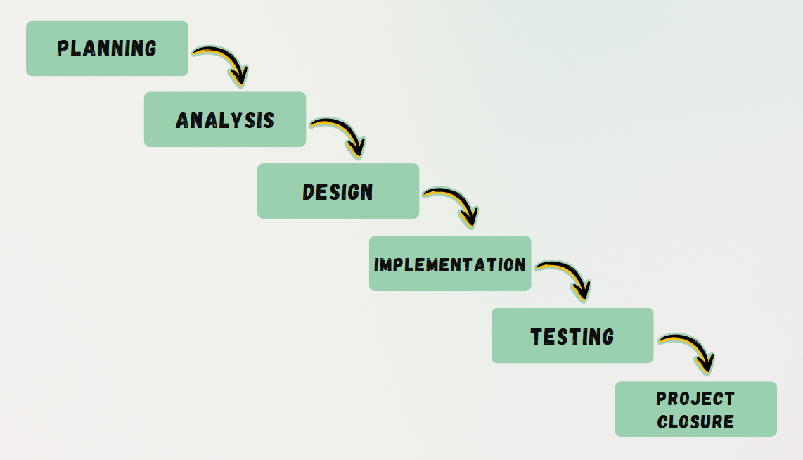

Figure 3.1: Waterfall Model Phases for SmartAngler System Development

### 3.2.1 Planning

The Planning phase of the SmartAngler project will be initiated by determining the main issues of the organizers and participant in fishing tournaments. This is by researching and analyzing the current systems which run the fishing tournaments with knowing their limitations and challenges. Through these limitations and challenges, the existing problems can be understood clearly. Thus, the area of improvement can be established. Once the challenges are identified, the project’s objectives and scope are established. This involves finding out how the system would work and making sure that it meets the requirements of the fishing tournament organizers and the participants.

In order to support an effective project management, a detailed Gantt chart is created where it serves as a planning tool. This chart outlines tasks, deadlines and milestones while showing how each task depends on the others. The Gantt chart is used to ensure that every step of the development is properly planned and tracked to enable the efficient allocation of resources and alignment with the project objectives.

### 3.2.2 Analysis

The Analysis phase focuses on gathering requirements from the users regarding the required functions or features of the SmartAngler system to solve the problems in the Planning phase. This stage involves direct interaction with key users to have a full picture of their needs and expectations of the automated fishing tournament management system.

In order to collect insights, questionnaires are handed out to the angler to seek feedback on their experience with the existing tournament processes as well as the areas of their pain. Additionally, organizers of the tournaments are interviewed to learn about the administrative issues that they encountered.

Once all feedback is gathered, the requirements are categorized into functional and non-functional requirements. Functional requirements describe the core features and operations of the system. On the other hand, non-functional requirements specify the quality characteristics of the system like performance, usability, reliability and data security. These clear requirements are a strong base that can inform the design phase to ensure that the type of SmartAngler system fulfils the user requirements and expectations.

### 3.2.3 Design

The Design stage of SmartAngler system is the stage that helps in designing the functionality of the system and how the system will appear to the user. This step involves the development of the front and back-end of the system. To build the front-end, the high-fidelity prototypes will be developed in Figma to see the visual picture of the layout with the functionality of the interface. This enables the users to view the navigation of the system. The idea is to make the design easy to understand and user friendly as well as one that will satisfy the needs of the organizers and participants of the tournament.

For the back-end design, it focuses on how the system will process and manage data, ensuring smooth operations like storing participant information, logging fish catches and generating results. It involves the establishment of the database system and how the system will process various kinds of data. Additionally, key diagrams are created which including use case diagrams, Data Flow Diagrams (DFD) and Entity Relationship Diagrams (ERD). These diagrams are a graphical representation of how the components of the system will interact with one another and how data will flow through the system giving a clear view of the architecture of the system.

### 3.2.4 Implementation

The Implementation phase is the actual development where the SmartAngler system is built based on the user requirements that was defined in earlier phases. At this stage, the modules of the system are coded and put together to form a complete web-based application.

For the front-end development, the system are developed by using HTML (HyperText Markup Language) for structuring content, JavaScript for interactive elements and CSS (Cascading Style Sheets) for styling the user interface. These technologies will help in the development of a clean and easy to use interface that will be easy to navigate by the organizers and the participants.

To develop the back-end, the system will be developed on PHP (Hypertext Preprocessor) which is a server-side scripting language to manage the logic of the system and the communication with the database. The database management will be based on MySQL which will allow effective storage, retrieval and modification of data connected to the participants, tournament details, fish logs and results.

### 3.2.5 Testing

During this phase, the functionality of the SmartAngler system will be thoroughly tested to ensure it meets the defined requirements and performs as expected. Unit testing will be conducted on each module to verify that every component of the system works independently and integrates smoothly with the others. These tests are performed in order to find bugs at early stages, logical errors and misconfiguration of the basic parts of the system.

After the unit testing, the usability and user satisfaction of the system is measured by using the System Usability Scale (SUS). SUS is a standardized questionnaire and it assesses how users experience the ease of use of the system, ease of use, efficiency and satisfaction as a whole. The key user will try to use the system and feedback will be collected which including tournament organizers and participants to measure the clarity of the interface and the overall user experience. The SUS data are analysed to identify strengths and areas that need to improve.

### 3.2.6 Project Closure

The last phase in the development of SmartAngler system is the project closure phase, and it is aimed at completing the full documentation. This is the stage after the entire system has been developed and tested, now the development of a comprehensive final report explaining all aspects of the project, including the problem identification, requirement analysis, design, implementation and testing of the whole system. This step will make sure that the entire project is well written and is ready to present and thus, this will end SmartAngler Final Year Project.

## 3.3 Conclusion

To conclude, this chapter has provided an insightful overview of the methodology used in the development of the SmartAngler system. The Waterfall Model was selected as the most suitable approach for this project because it offers a structured and step-by-step process that will ensures each phase including planning, analysis, design, implementation, testing and project closure is completed in systematic order. This methodology allows for clear progress tracking, minimizes risks and ensures that all requirements are met, which will eventually help the successful development of a user-friendly and efficient system for managing fishing tournaments.

# CHAPTER 4

**SYSTEM DESIGN**

## 4.1 Introduction

In this chapter, the analysis and design of the SmartAngler system are thoroughly discussed. It starts with the analysis of the data gathered using the surveys involving angler (participants of fishing tournaments) and interviews with the organizers of fishing tournaments. The insights gained from these interactions help guide the system’s design that will ensure it meets the users’ needs and addresses the challenges identified earlier in the project. The chapter further explores the architectural and technical design of the system which including key diagrams such as System Architecture, Context Diagram, Data Flow Diagrams (DFD), Entity Relationship Diagrams (ERD) and user interface designs using high-fidelity prototype. These diagrams and prototype will help to illustrate how the system will function, how data will flow and how users will interact with the SmartAngler system.

## 4.2 Interview Findings

An interview was conducted with Mr. Alphonsus Raymond Ongkudon, the owner and fishing tournament organizer of Kolam Rekreasi Pupuluton Valley (KRPV), located in Tambunan, Sabah. With over 12 years of experience in organizing fishing tournaments, Mr. Alphonsus had shared valuable insights into the challenges and current methods used for managing the fishing tournament.

During the interview with Mr. Alphonsus, he explained that the main tasks involved in organizing fishing tournaments still managed using a manual process. The registration of participants is made manually in paper forms that leads to the long queues and possible errors in the information input. Additionally, fishing spot bookings are also handled manually, either by phone or in person and recorded on paper (shown on Figure 4.1) which sometimes leads to double bookings or confusion about available spots.

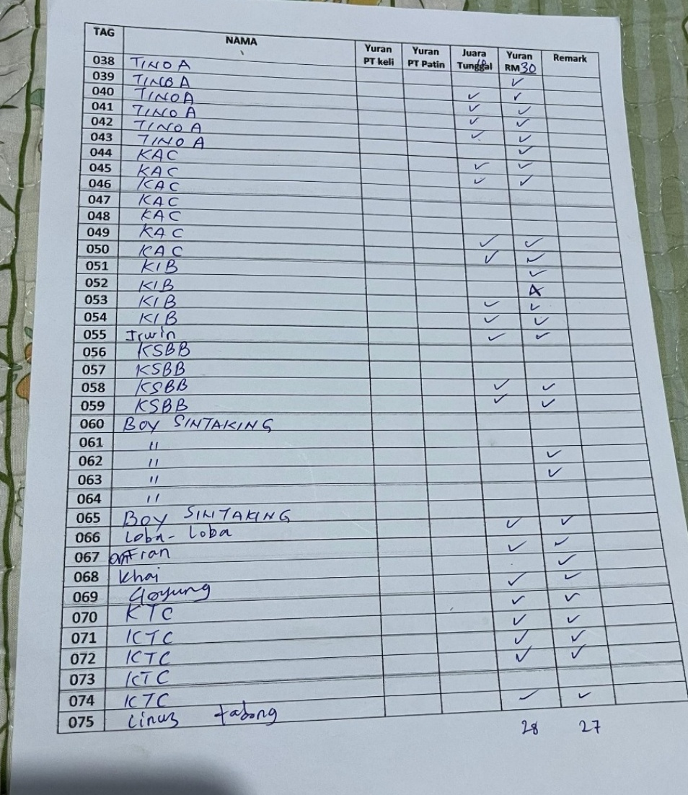

Figure 4.1: Booking and Registration Record on Paper

Mr. Alphonsus also discussed the difficulties in advertising tournaments. They primarily use social media platforms like Facebook and WhatsApp to advertise fishing tournament flyers and share updates. He however recognized the shortfalls of using these platforms since not everyone makes regular checks on them hence leading to missed information or confusion about event details.

Regarding tracking fish catches and results, Mr. Alphonsus stated that the process was done manually using paper logs (shown in Figure 4.2) which are later inserted into Excel spreadsheets. It is a time-consuming process and there are chances of error particularly in case of high numbers of fish caught in the tournament. He also highlighted the delays in generating and announcing results as they are manually generated and often updated late which leading to participant frustration.

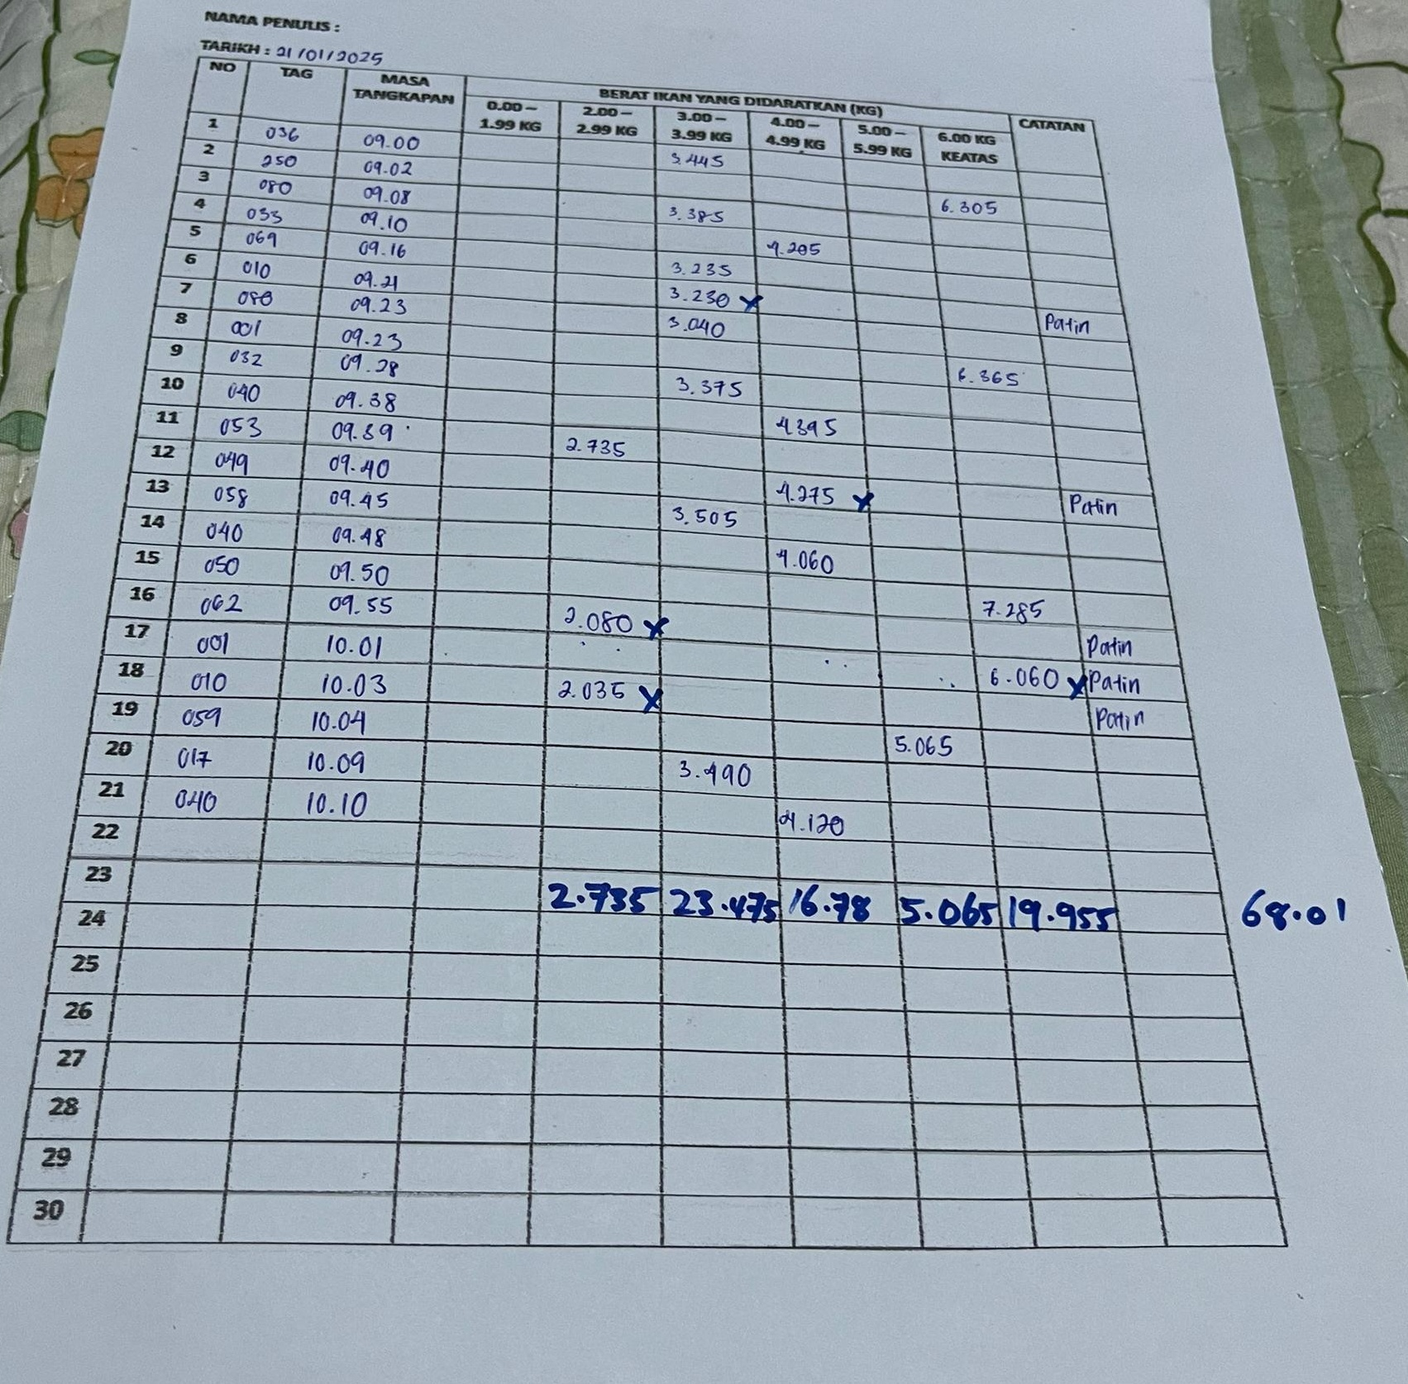

Figure 4.2: Paper Based Fish Catch Logging Record

According to Mr. Alphonsus, the best overall fishing tournament system must incorporate features that can automate registration, real time booking of fishing spots, live leader boards and enable easy advertising of the tournaments. He points out that automation would aid to decrease the amount of work done by organizers and minimize errors. It will also accelerate work like participant registration and generation of results, therefore improving the overall experience of both the organizers and participants.

The interview showed that the existing manual processes are not effective enough to support the increasing number of angler participants and the complexity of the tournaments. Hence, an automated system like SmartAngler would address these challenges by streamlining registration, spot booking, fish logging and result management. This will making the tournament experience more organized and efficient for both organizers and participants.

## 4.3 Survey Questionnaire Analysis

The SmartAngler system survey was conducted on the angler community specifically the angler from around Tambunan, Keningau and nearby participants to gain information on 50 respondents. In order to reach a wider population, the survey was sent via WhatsApp group chats and updates of fishing club in the status messages to ensure accessibility and engagement within the angler community. The survey was conducted between June 14 until June 18, 2025, and ended up with a total of 53 responses which is more than the initial target.

The aim of the survey was to collect the feedback on the current fishing tournament, identify pain points and evaluate the possible need in the automatized the management of fishing tournament system. The responses collected provided valuable insights into the preferences, challenges and expectations of the angler community regarding the fishing tournament management. This analysis is important in shaping the design and functionality of the system hence making it possible to design a system that meets the actual needs of the system users and their expectations. The following section gives the main findings of the questionnaire analysis which highlights the insights and responses gathered from the anglers.

1. **Demographic Information of Respondents.**

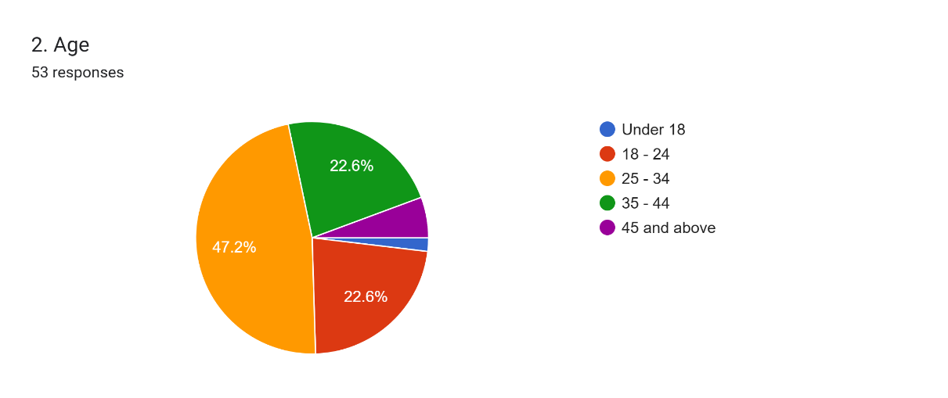

Figure 4.3: Percentage of Angler Age Group

The findings of the survey data on the age distribution indicates that most respondents were between the ages of 25 and 34 years representing 45.5%, 12 persons (22.6%) were aged between 18-24 years, and 12 respondents (22.6%) aged between 35-44. A total of 3 respondents (5.7%) were 45 and older and only 1 respondent (1.9%) is below 18 years old. This age distribution indicates that SmartAngler is likely to target a tech-savvy users with the majority of participants ranging between the ages of 25 and 34. Hence, the design of the system must focus on user-friendliness and compatibility in the mobile format because these generations are more prone to the use of the digital platform to participate in tournaments.

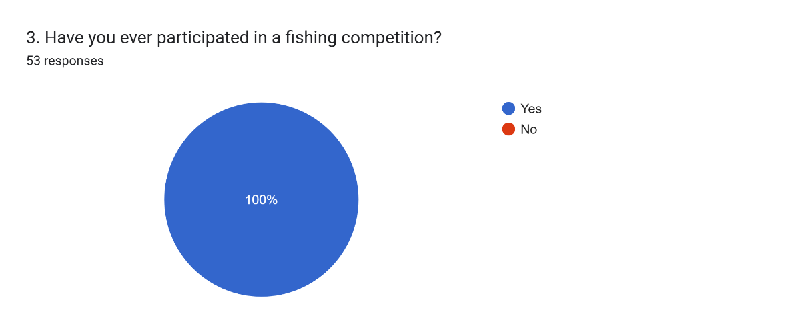

Figure 4.4: Angler Participation in Fishing Tournament

According to the results of the survey in Figure 4.4, all the respondents have participated in a fishing competition before, which means that they are familiar with the current processes involved in fishing tournament. This is important for the development of SmartAngler, as it suggests that the users have a clear understanding of the challenges and frustrations that can arise during tournament. Through this understanding, the development of SmartAngler can focus in solving these problems by providing such features such as easy registration, real-time results updates, fish-logging and more features which aim at enhancing the entire tournament experience regardless of whether the user is already familiar with current tournament processes.

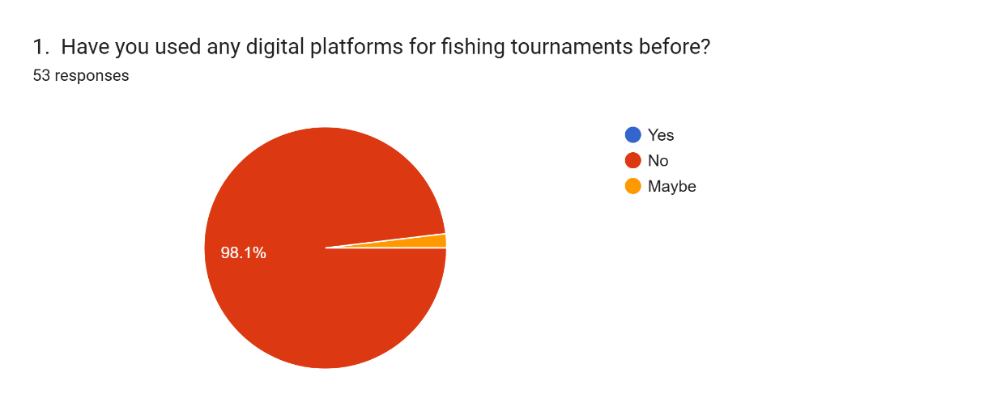

Figure 4.5: Percentage of Digital Platform Usage for Fishing Tournaments

The survey results in Figure 4.5 indicate that out of the 53 people that filled in the survey, none had used a digital platform for fishing tournaments previously, with 52 of the respondents (98.1%) stating that they have not used such a platform and 1 of the respondents (1.9%) expressing uncertainty. This implies that SmartAngler will be presenting a new idea to the fishing community and this the angler’s opportunity to enhance management of the tournaments using technology. Since most participants are not used to using digital platform in the processes of tournaments, SmartAngler will need to focus on user-friendly features and simple tournament processes to ensure a smooth transition.

1. **Challenges Faced by Anglers in The Current Fishing Tournament Process.**

Based upon the insights gained from the respondents’ familiarity of the current tournament process, the survey also revealed a major challenge regarding tournaments and their dissatisfaction with the current processes of tournaments management.

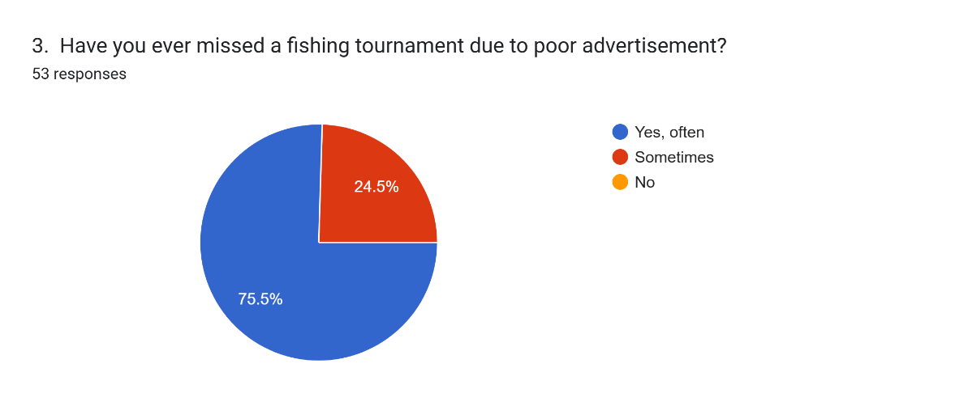

Figure 4.6: Participants Who Missed Tournaments Due Poor Advertisement

The survey results in Figure 4.6 indicate that 40 of the 53 respondents have often missed a fishing tournament due to poor tournament advertisement, whereas 13 responds have sometimes missed tournaments. This shows a major problem that can be solved by SmartAngler in offering a more centralized platform on effective advertisement of tournaments. By using this system, organizers can easily post and update tournament information and ensuring that anglers can get updated information of the tournament details effectively. This can reduce the likelihood of missed tournaments due to poor promotion.

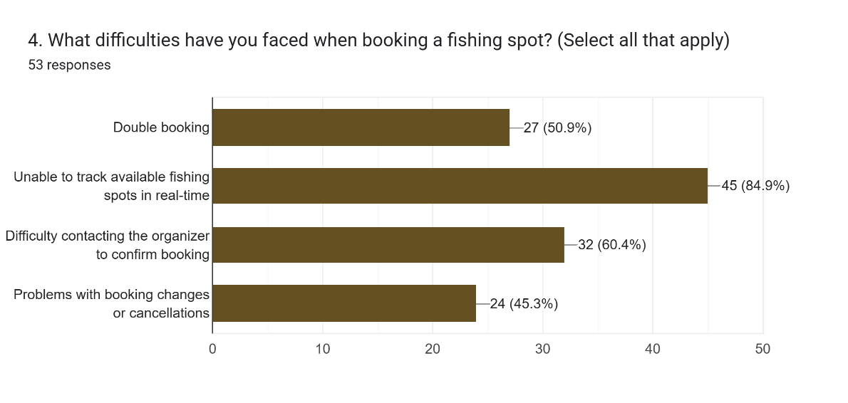

Figure 4.7: Issues Faced When Booking a Fishing Spot

Figure 4.7 shows the survey results on several issues participants face when booking fishing spots. The most common problem faced by the angler is the inability to view available spots in real-time which leading to confusion and missed opportunities to book spots. Additionally, 32 respondents had trouble contacting the organizer to confirm bookings. Another concern in spot booking is double bookings which causes confusion in the tournament. Finally, 24 respondents faced issues with booking changes or cancellations. These findings highlight the need for SmartAngler to provide a more efficient system that allows real-time tracking and easier management of spots bookings.

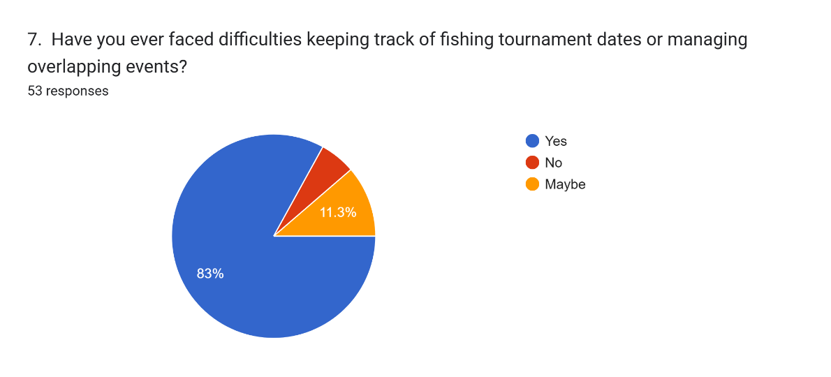

Figure 4.8: Percentage of Angler Facing Issue in Tracking Tournament Dates

As illustrated in Figure 4.8, the results of the survey revealed that 44 survey respondents have faced difficulties in keeping track of fishing tournament dates. Only 3 respondents (5.7%) reported not experiencing any issues, while 6 respondents (11.3%) were uncertain about this issue. This suggests that keeping track of multiple tournaments can be a challenge for participants. Hence, this highlights the need for SmartAngler to include a centralized tournament calendar feature in the system. This feature could help users to easily track upcoming fishing tournament and avoid tournament dates confusion.

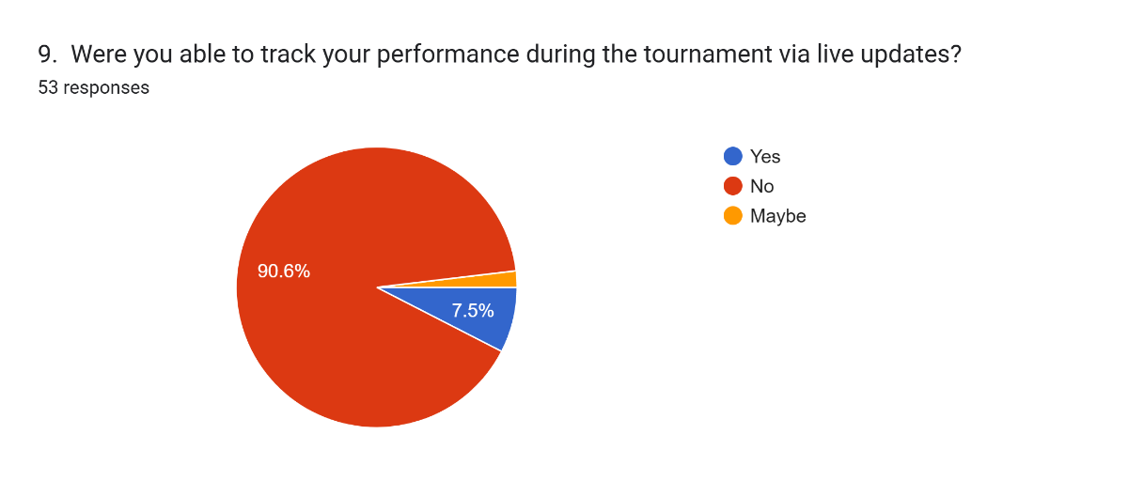

Figure 4.9: Number of Angler Able to Track Performance via Live Updates

The survey results shown in Figure 4.9 showing that the majority of respondents which is 48 out of 53 (90.6%) were unable to track their current ranking during the ongoing tournament via live updates. Only 4 respondents (7.5%) reported being able to do so, while 1 respondent (1.9%) was uncertain. This shows an evident lack in real-time monitoring of current ranking used in existing tournament systems. To solve this problem, SmartAngler will implement a live leaderboard feature which allowing participants to monitor their standings ranking and progress throughout the tournament. This might enhance engagement and improving the overall experience for users.

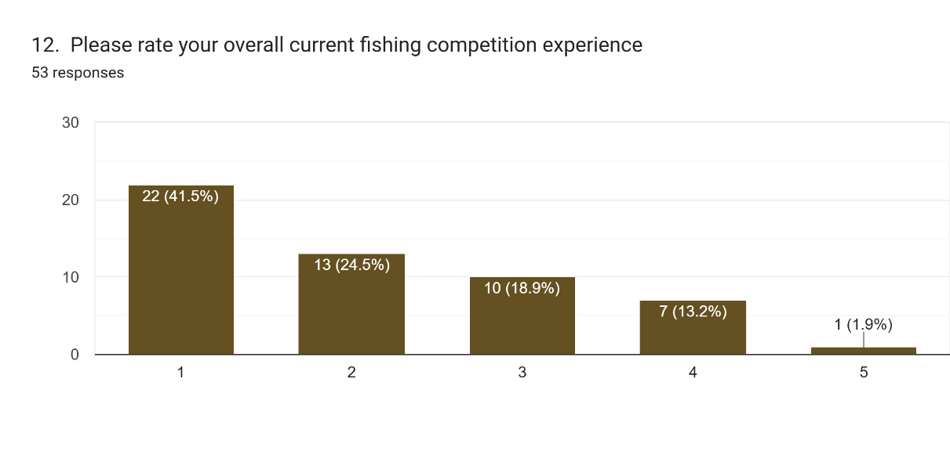

Figure 4.10: Overall Satisfaction with Current Fishing Competition Experience

The results of the survey presented in Figure 4.10 showing that the overall experience of participants in fishing competitions is rated quite low with an average rating of 2.09 out of 5 stars. Specifically, 22 respondents (41.5%) gave a rating of 1 star, 13 respondents (24.5%) rated it 2 stars and 10 respondents (18.9%) rated it 3 stars. Only 7 respondents (13.2%) gave a rating of 4 stars and just 1 respondent (1.9%) rated the experience 5 stars. These low ratings highlight a strong dissatisfaction of anglers with the current fishing tournament experience. To resolve this, SmartAngler can introduce features that streamline processes such as registration, spot booking, fish catch logging and result generation. This can improve the overall participant experience and improve angler satisfaction regarding the tournament.

1. **Angler Preferences for SmartAngler Features and User Requirements**

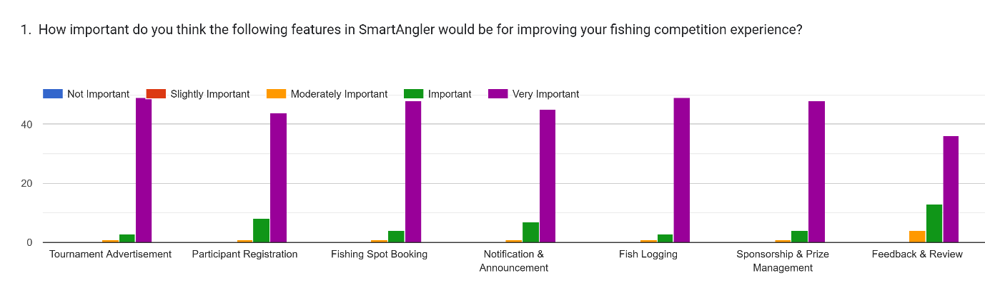

Figure 4.11 Anglers’ Perceived Importance of SmartAngler Features for Enhancing Fishing Competition Experience.

According to the survey results represented in the Figure 4.11, all suggested SmartAngler features are highly valued by anglers to improve their experience of fishing competition. A majority percentage of people rated every feature like Tournament Advertisement, Participant Registration, Fishing Spot Booking, Calendar, Fish Logging, Live Leaderboard and Review as "Very Important". This highlights a strong demand for comprehensive digital support in organizing and participating in fishing tournament. Particularly, such functions as Tournament Advertisement, Fish Logging, and Live Leaderboard have been rated extremely high which indicates that users are extremely focused on real-time updates and exposure during the competitions. Overall, the data highlight the need for SmartAngler to include efficient and user-friendly functionalities that support both preparation and live tournament management.

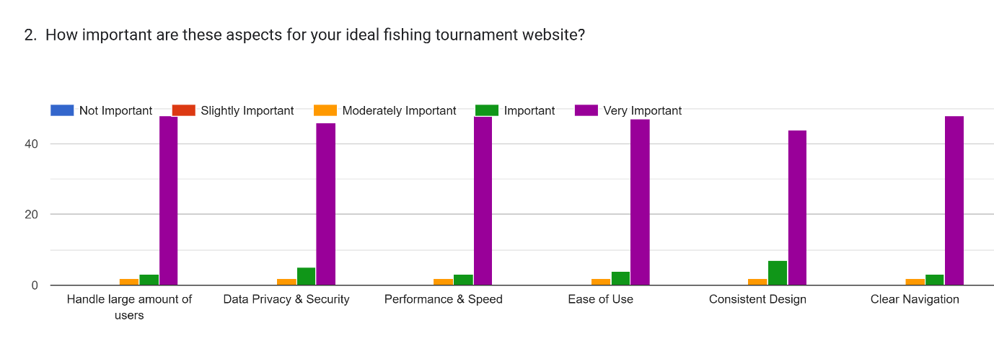

Figure 4.12 Aspects Rated by Anglers for an Ideal Fishing Tournament Website

The survey findings in Figure 4.12 shows the non-functional requirement of the users. It shows that anglers place high importance on core technical and design aspects when considering their ideal fishing tournament website. Most respondents rated all included aspects like the ability to support a high number of users, data privacy and security, ease of use, consistency of design and clear navigation in the range of Very Important. This indicates that users expect a platform that is not only secure and fast but also intuitive and visually consistent. Clear navigation and ease of use were particularly emphasized which reflecting a strong preference for a seamless and user-friendly experience during tournament.

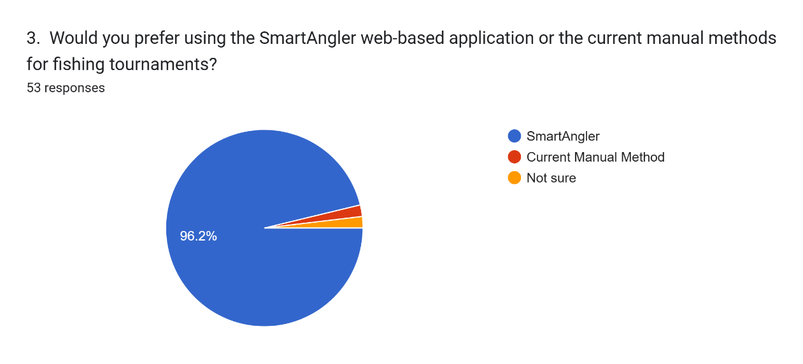

Figure 4.13: Anglers’ Preference Between SmartAngler and Current Manual Methods for Fishing Tournaments

The survey in Figure 4.13 results show a strong preference for using the SmartAngler web-based application, with 51 out of 53 respondents (96.2%) choosing it over the current manual methods. Only 1 respondent (1.9%) preferred the traditional manual method, and 1 respondent (1.9%) was unsure. This overwhelming support indicates that participants are eager for a more efficient and automated solution like SmartAngler, suggesting that the system will be well-received and likely improve the overall tournament experience by reducing the complexities of manual processes.

## 4.4 System Design

The System Design phase of the SmartAngler project focuses on planning how the system will work and how users will interact with it. During this stage based on the data within the previous stage of analysis, the structure of both front-end and back-end part of the system will be developed. The key diagrams such as System Architecture, Context Diagram, Data Flow Diagrams (DFD) and Entity Relationship Diagrams (ERD) will be created to map out how data will flow and how different parts of the system will connect. Additionally, user interface prototypes are designed to make sure the system is easy to use for both tournament organizers and participants. This phase sets the groundwork for the actual development of the SmartAngler system.

### 4.4.1 System Architecture

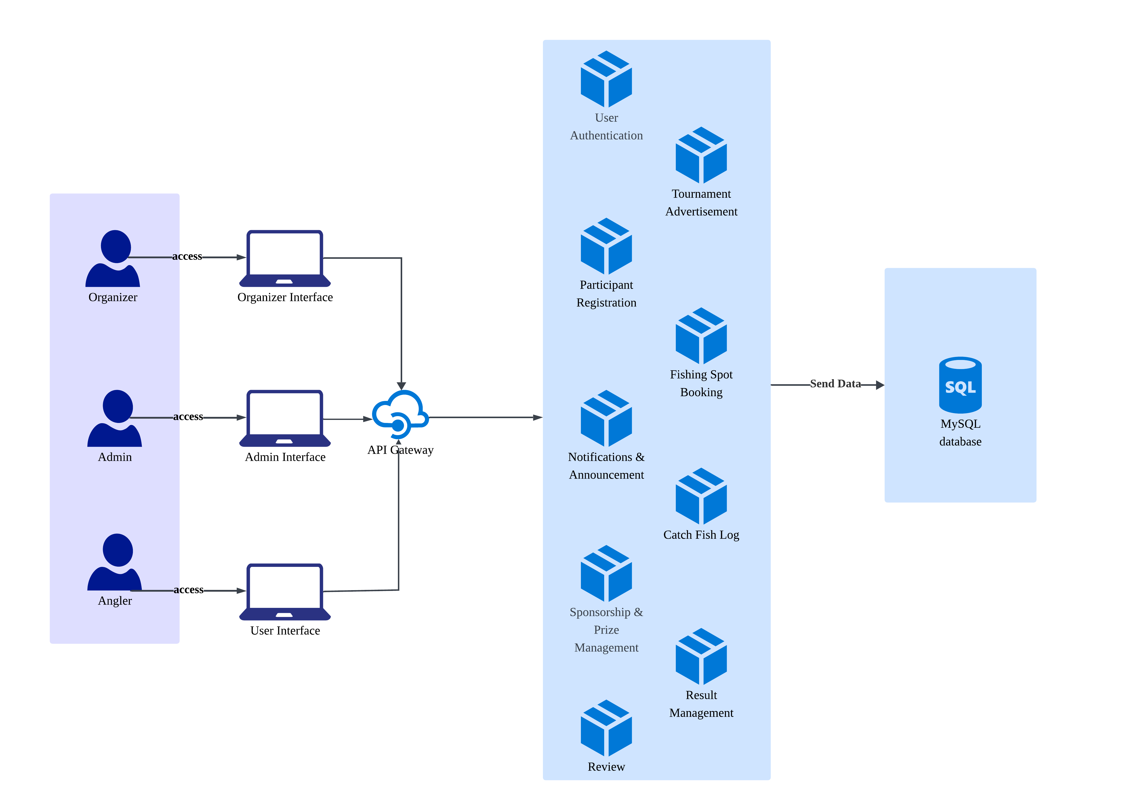

Figure 4.14 System Architecture of SmartAngler

SmartAngler system architecture is aimed at organizing fishing tournaments in the most efficient way by connecting users, features, and data storage in an organized form. There are three main types of users which is the organizer, admin and anglers. All the users may access the system through their devices, sending and receiving data via the internet. All such user requests are directed to a cloud server which connects to various functional modules.

Cloud server is the centre of the communication flow between the system and the users in the context of different modules of the system. These incorporate important functions like User Authentication, Participants Registration, Fishing Spot Booking, Catch Fish Logging, Tournament advertising, Live Leaderboard, Result Management, Calendar and Review. Each module is designed to handle specific tasks to ensure smooth tournament process and enhance user experience.

Each of the modules is also linked via a centralized SQL database which securely stores, manages and retrieves data as needed including user credentials, registration records, tournament scores, booking details and feedback. This architecture not only allows for seamless data flow and interaction but also supports scalability which ensuring that the system can handle multiple tournaments and users simultaneously. Overall, SmartAngler offers an effective, real-time system to organize fishing tournament in a more organized, transparent and user-friendly manner.

### 4.4.2 Context Diagram

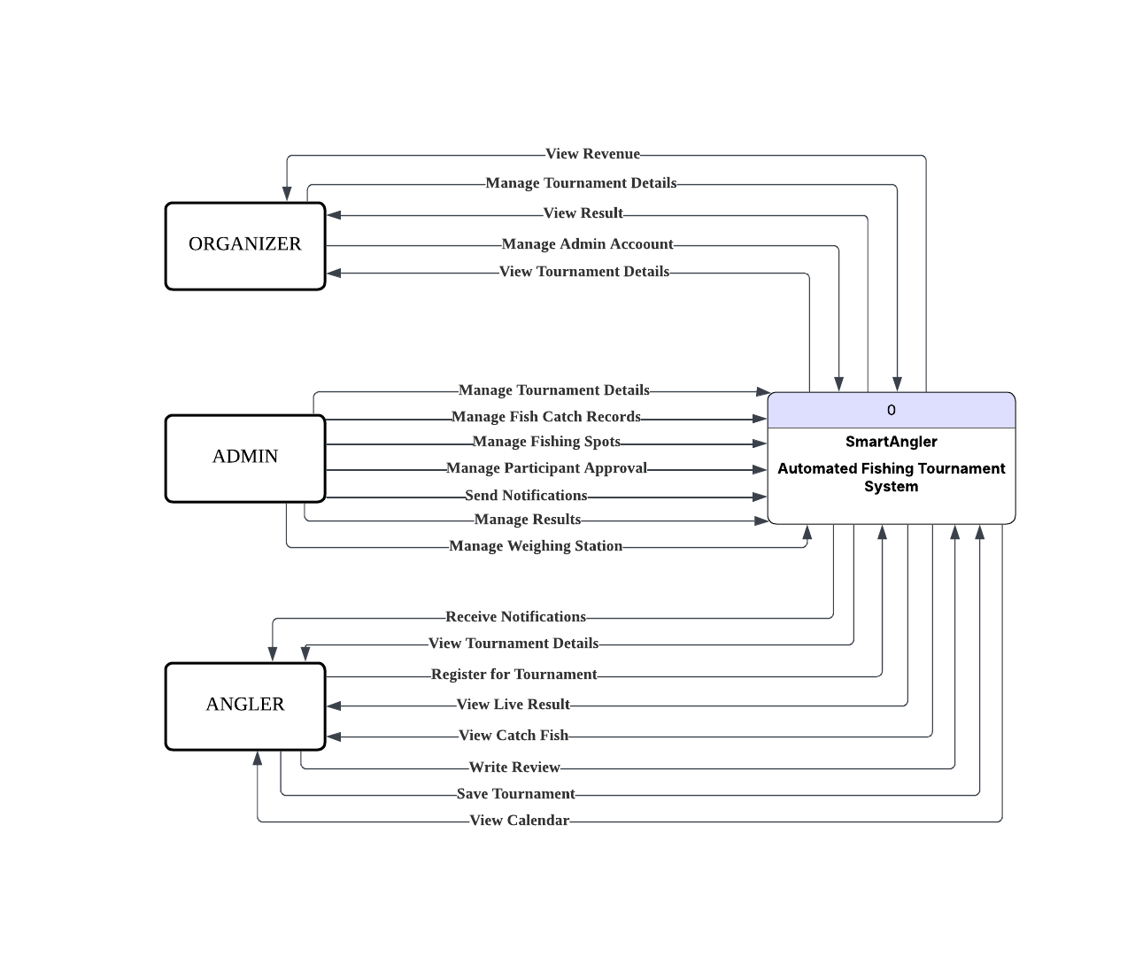

Figure 4.15 Context Diagram of SmartAngler System

Figure 4.15 shows the context diagram that illustrates the interactions between three external entities and the SmartAngler System. The organizer can manage high-level operations including viewing revenue, manage tournament details and results and also managing admin accounts. The admins will handle main tournament operations such as managing tournament advertisement, fish catch recording, fishing spots management, participant approvals, notifications and results management. The angler will interact with the system to receive notifications, view tournament details, register for tournaments, view live results and catch fish records, write reviews, save tournaments and view the calendar.

### 4.4.3 Data Flow Diagram (DFD) Level 0

### 

Figure 4.16: Data Flow Diagram (DFD) Level 0 of SmartAngler

Figure 5.15 above shows the overall data flow diagram (DFD) for the SmartAngler Automated Fishing Tournament System, which includes eleven main processes such as account management, tournament advertisement, fishing spot creation and booking, tournament registration, fish catch recording, result management, sponsorship management, review management and notification management. The system consists of 15 data stores like User, Tournament, Tournament_Registration, Zone, Fishing_Spot, Weighing_Station, Fish_Catch, Category, Result, Sponsor, Tournament_Prize, Calendar, Review, Saved and Notification. This data store is used to keep important data in the system. There are three main users in the system which are Organizers, Admins and Anglers.

### 4.4.4 Data Flow Diagram (DFD) Level 1

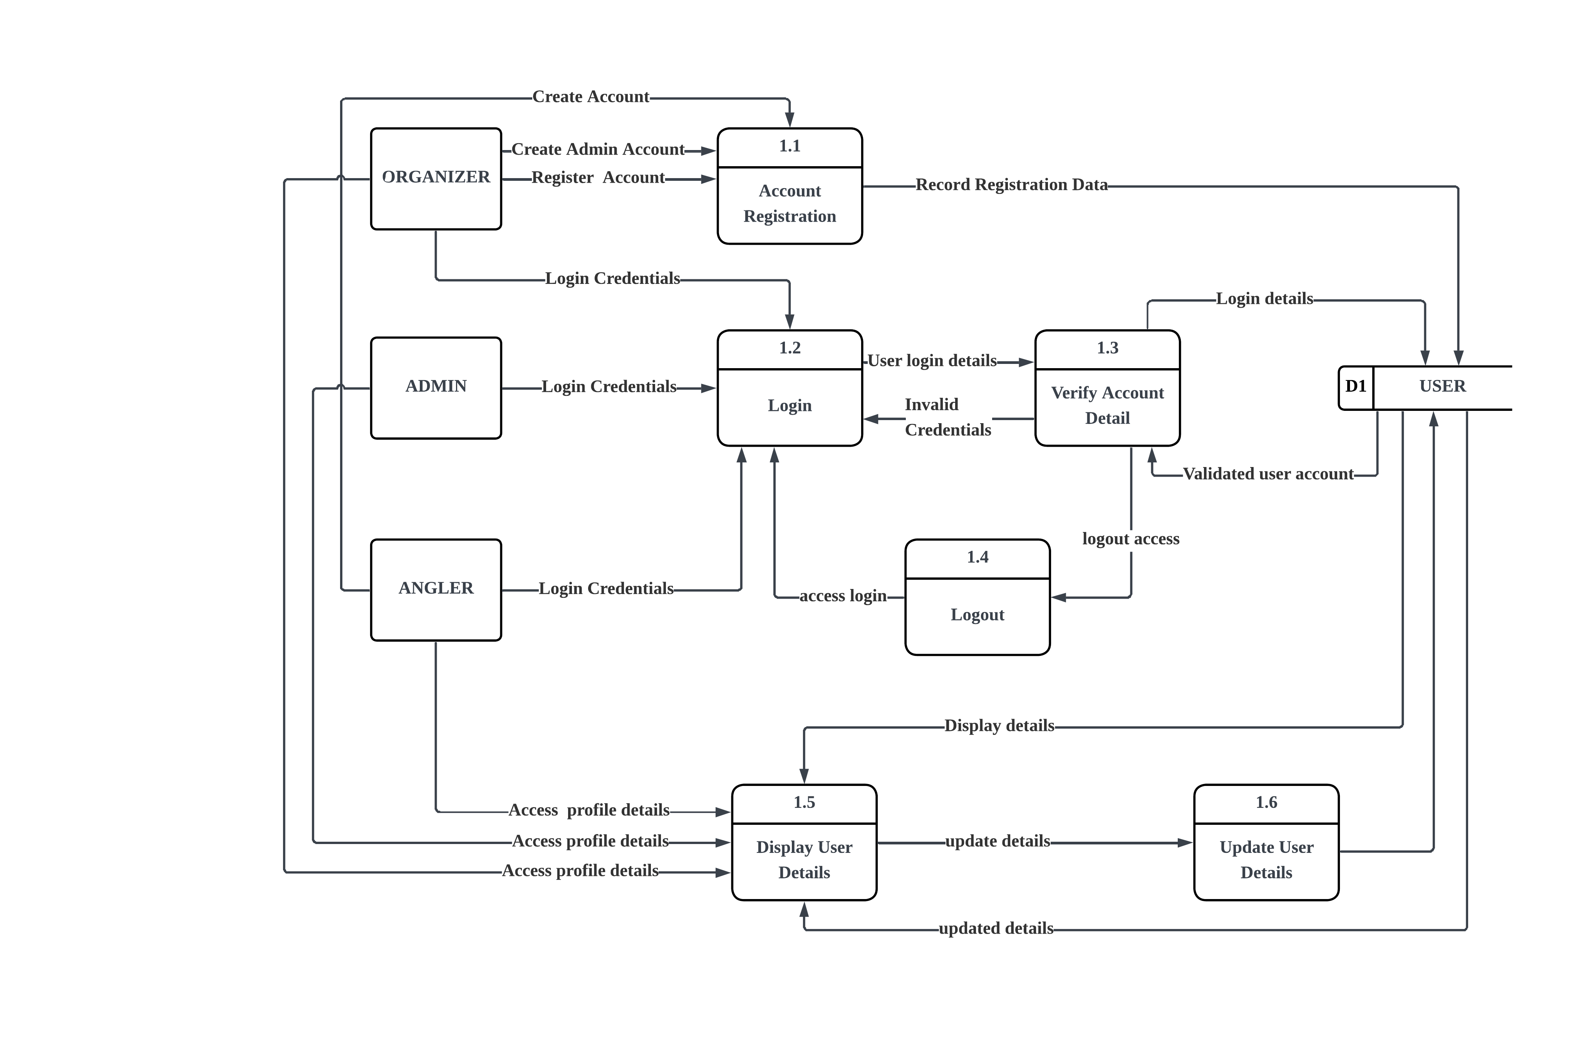

Figure 4.17: DFD Level 1 for Account Management

Diagram 4.17 shows the user account management process in the SmartAngler system. It begins with the Account Registration whereby the anglers and the organizers will be able to create and register their accounts. Admin accounts are created by the organizer they work with and are responsible for managing tournaments under that organizer. All registration details are then stored in the user database.

Once registered, all users can log in by entering their login credentials. The system will verify the details to check if they are valid. If the credentials are correct, the user is allowed to log into the system otherwise an invalid credentials message is displayed. Users can log out of the system at any time. Once logged in, users can view their profile details and update their information if needed. Any changes made are saved back into the user database.

Overall, this diagram explains how the system manages the data flow for user registration, login, logout and profile updates.

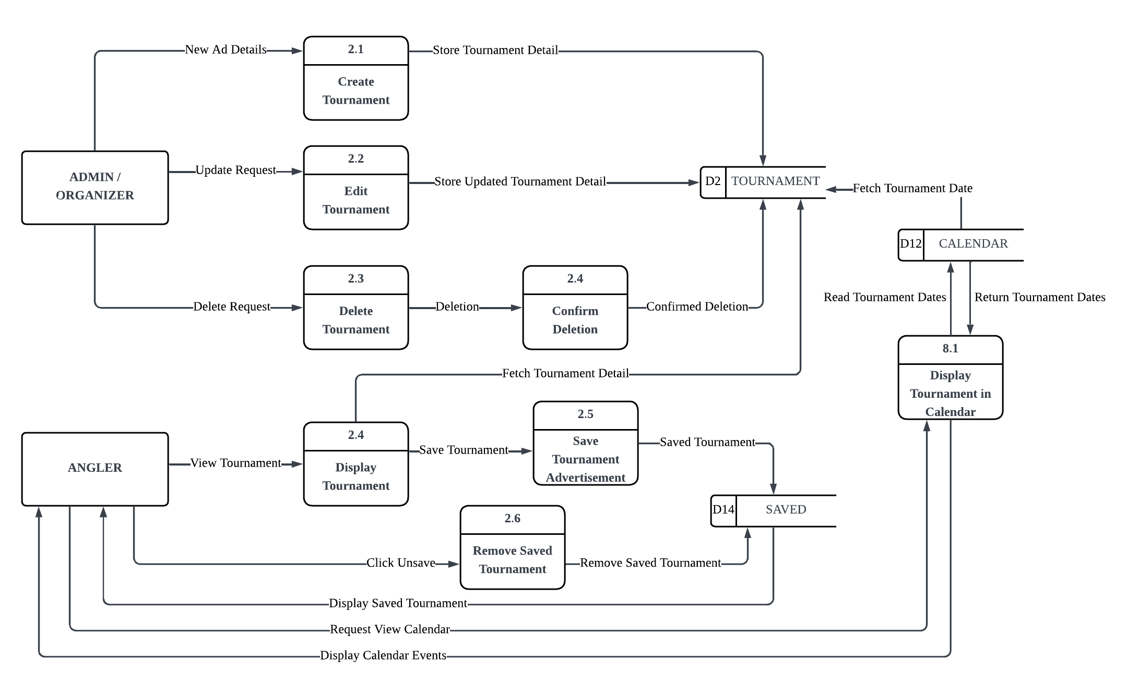

Figure 4.18: DFD Level 1 for Tournament Management

Figure 4.18 shows the tournament management process in the SmartAngler system. Both Admin and Organizer have access for managing tournaments by creating, editing and deleting tournaments. When a tournament is created or updated, the data is stored in the tournament database. If a tournament is deleted, the system confirms the deletion before removing the data from the database.

The Angler will be able to see the existing tournaments and their details. Anglers may also save tournaments they are interested in so they can search for it easily. Saved tournament information is stored in the saved tournament database. The tournament dates are fetched from the tournament details database and displayed in the system calendar. This allows anglers to view tournaments based on dates in simple view by using calendar.

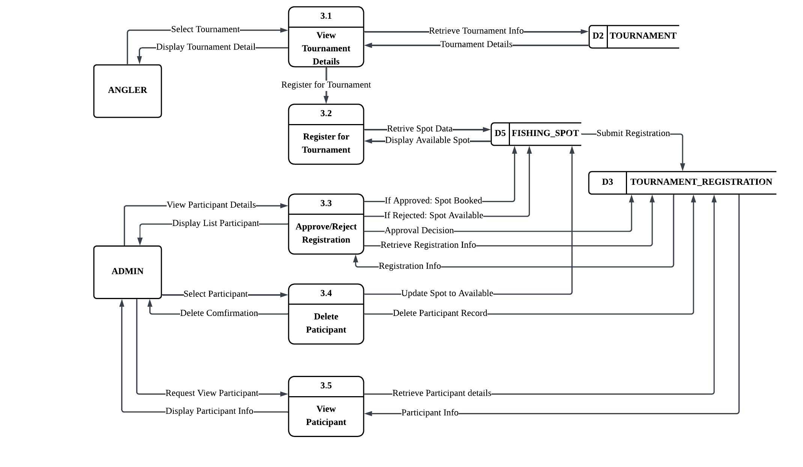

Figure 4.19: DFD Level 1 for Tournament Registration

Figure 4.19 shows the tournament registration process in the SmartAngler system. The angler will select a tournament to view its details, which are retrieved from the TOURNAMENT database. If the angler is interested in the selected tournament, they will proceed to registration. The system will retrieve the available fishing spot information from the FISHING_SPOT database and user may select the available fishing spot. The angler then submits the registration details along with the payment receipt. This data will be stored in the TOURNAMENT_REGISTRATION database while awaiting approval.

The admin reviews each registration through the approve or reject process. If the registration has a valid payment, the registration will be approved, and the selected fishing spot is marked as booked. If the registration is rejected, the fishing spot remains available for other anglers. The admin can also remove participants from a tournament in cases such as participant withdrawals. This will remove the registration of the participant and make the fishing spot available again. Admins can view participant details by accessing information from the TOURNAMENT_REGISTRATION database.

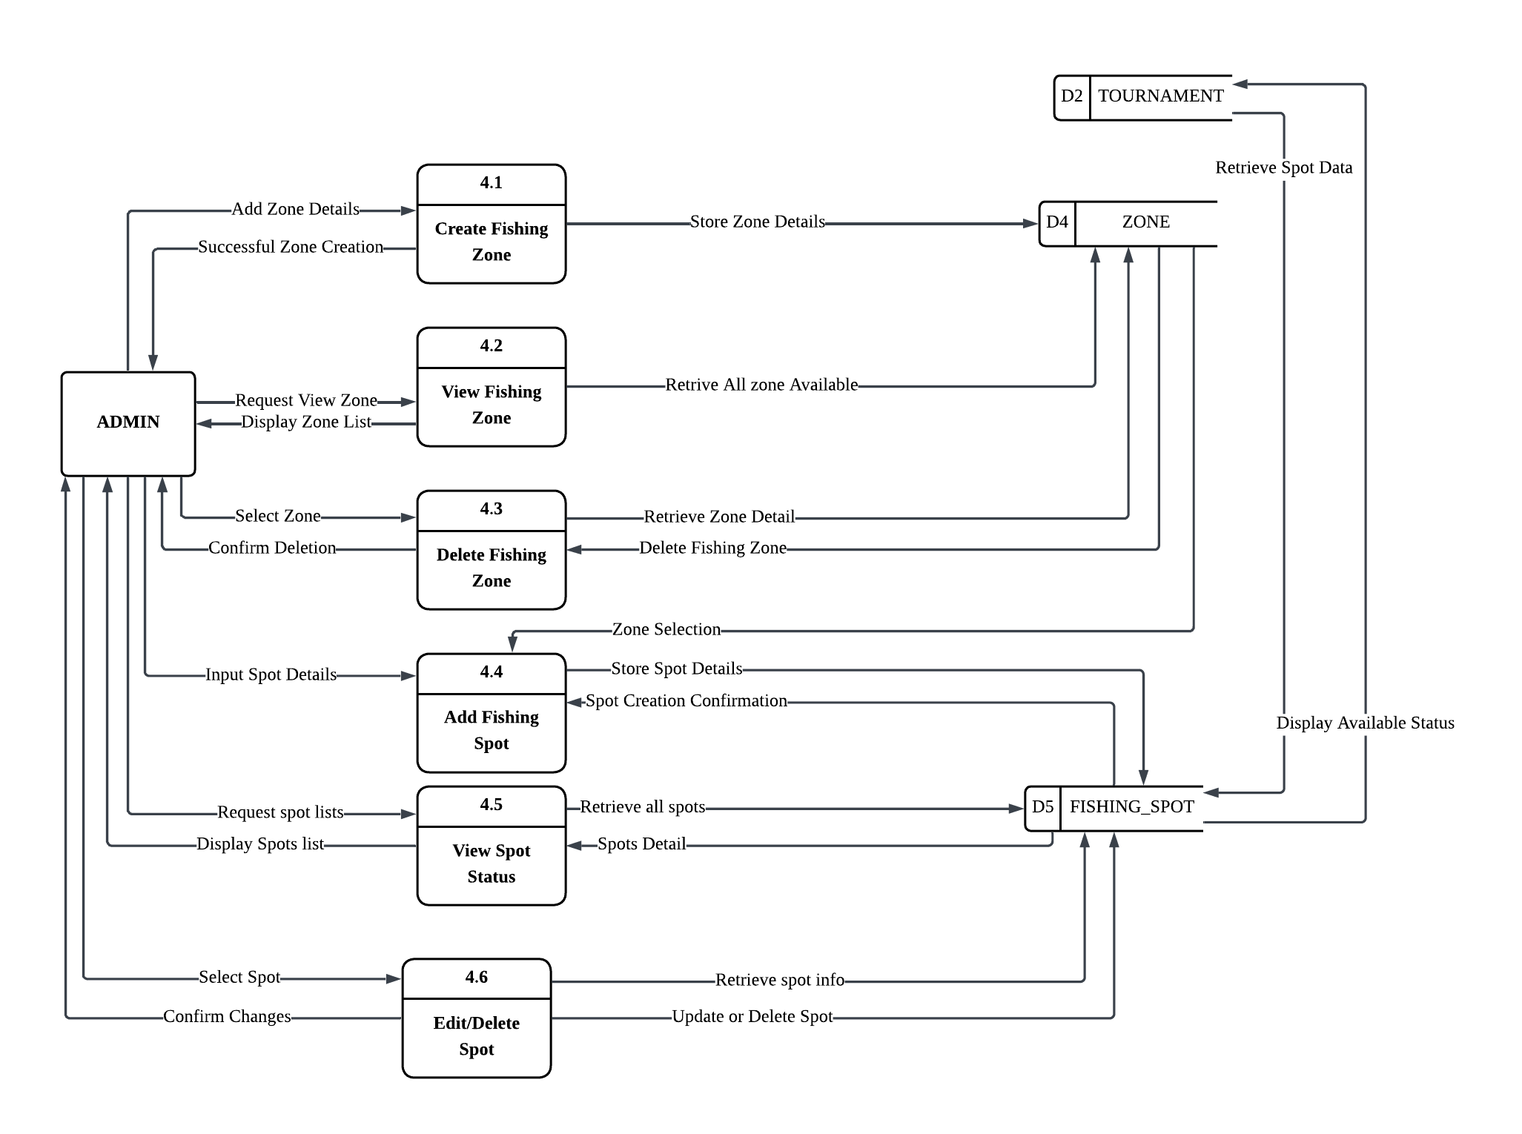

Figure 4.20: DFD Level 1 for Fishing Spot Management

Figure 4.20 shows the fishing spot management process in the SmartAngler system. Admin can create fishing zones by adding zone details,which are then stored in the ZONE database. Each of the zone may contain multiple fishing spots that will be added by the admin by selecting specific latitude and longitude coordinates on the map. The spot data is stored in the FISHING_SPOT database. The system obtains the spot data in the TOURNAMENT database to show the status of the availability of each spot. Admins are able to see the status of all fishing spots and allow the specific spots to be deleted in case there is necessity. This thorough process makes sure that the fishing zone and locations are well organized throughout the tournaments.

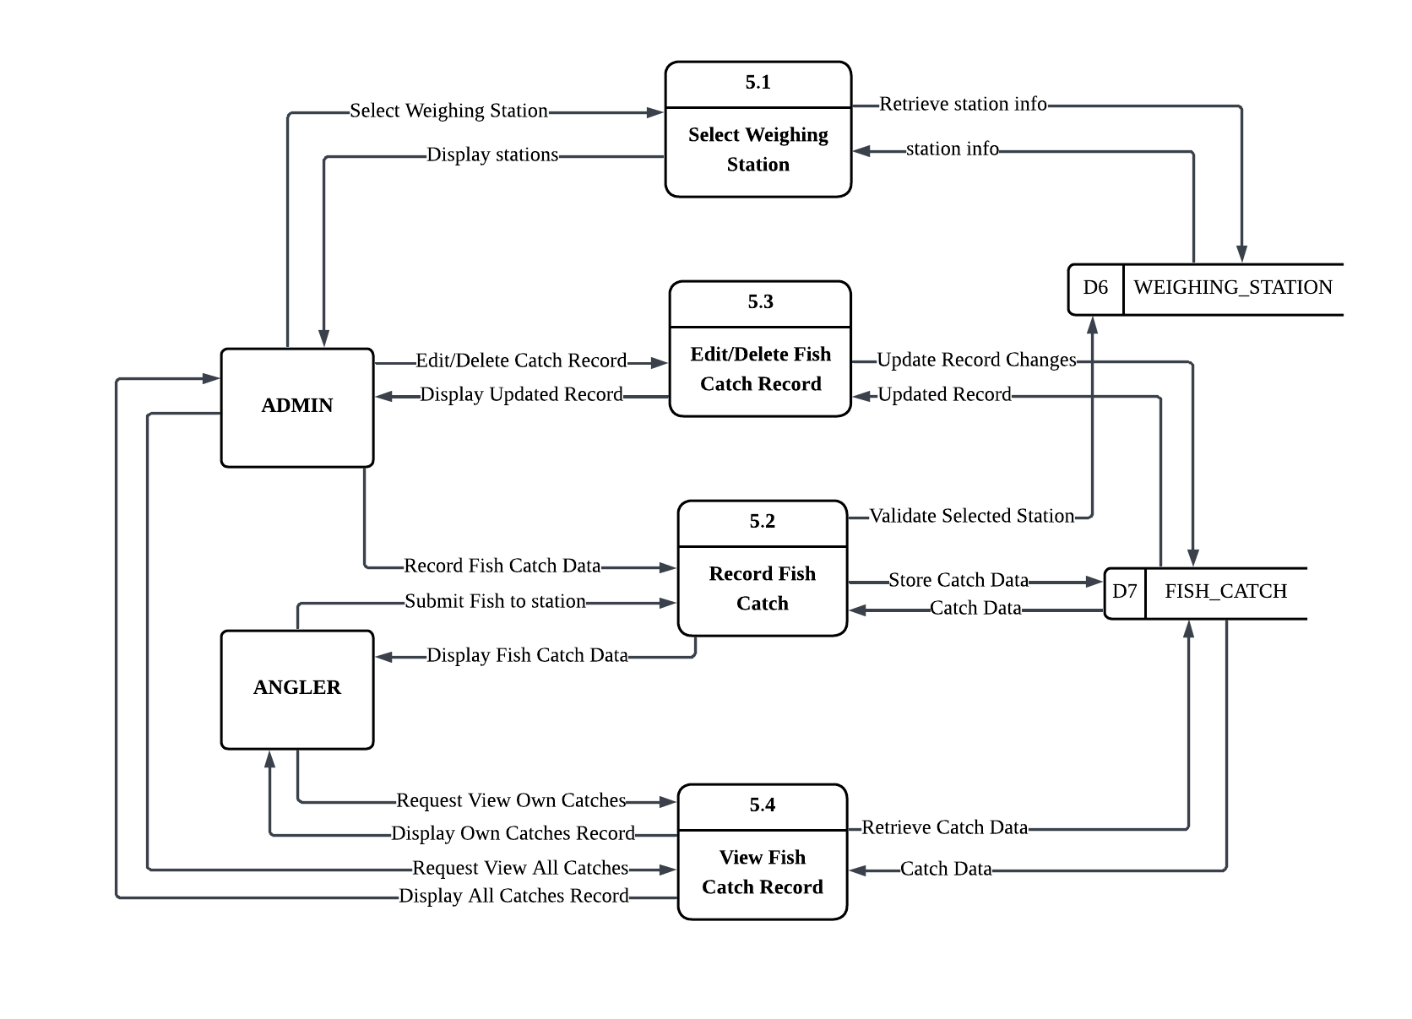

Figure 4.21: DFD Level 1 for Fish Catch Record

Figure 4.21 illustrates the fish catch recording process in the SmartAngler system. The Admin selects a weighing station from the WEIGHING_STATION database to begin the recording process. When an Angler catches a fish, they submit the catch data to the selected weighing station. The system validates the station and records the fish catch information, which is then stored in the FISH_CATCH database. The recorded catch data is displayed back to the Angler for confirmation.

The Admin has the ability to edit or delete catch records when necessary. Any modifications are updated in the FISH_CATCH database and the updated records are displayed to the Admin. Both Admin and Angler can view fish catch records by retrieving data from the FISH_CATCH database. Anglers can request to view their own catches, while Admins can view all catches or specific catch records. This process ensures accurate tracking and management of all fish catches throughout the tournament.

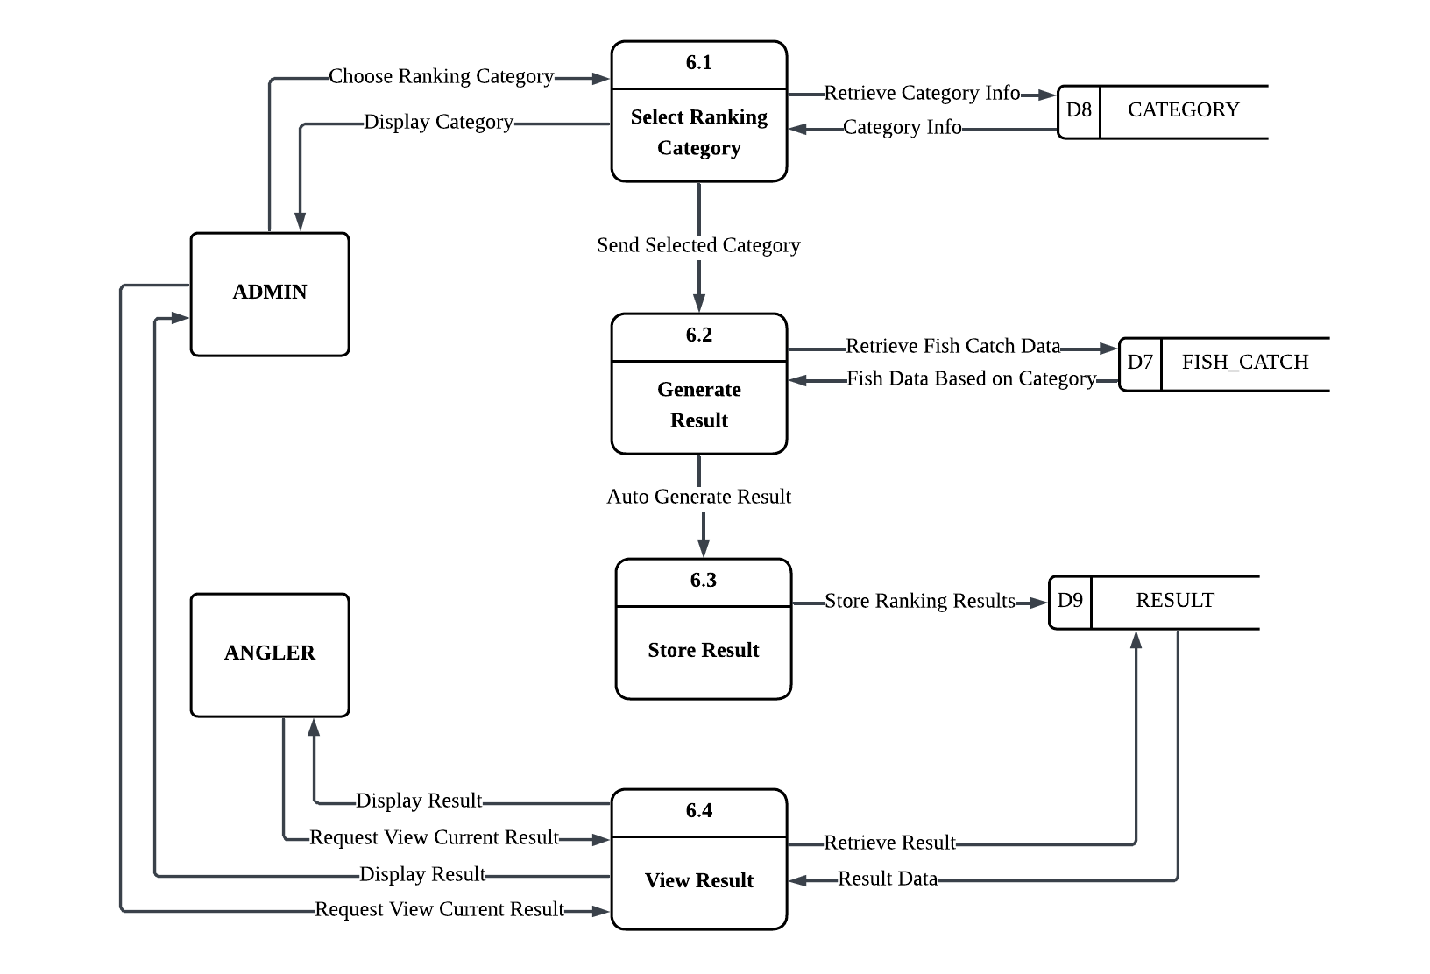

Figure 4.22: DFD Level 1 for Result Management

Figure 4.22 illustrates the result management process in the SmartAngler system. The Admin begins by selecting a ranking category from the CATEGORY database, which determines how tournament results will be calculated. Once the category is selected, the system automatically generates results by retrieving fish catch data from the FISH_CATCH database based on the chosen category criteria. The system calculates rankings and stores the results in the RESULT database.

Both Admin and Angler can view the tournament results by requesting current result data from the RESULT database. The system retrieves and displays the ranking results to both users. This automated process ensures accurate and efficient result calculation based on different tournament categories, allowing participants to view their standings and overall tournament rankings in real-time throughout the competition.

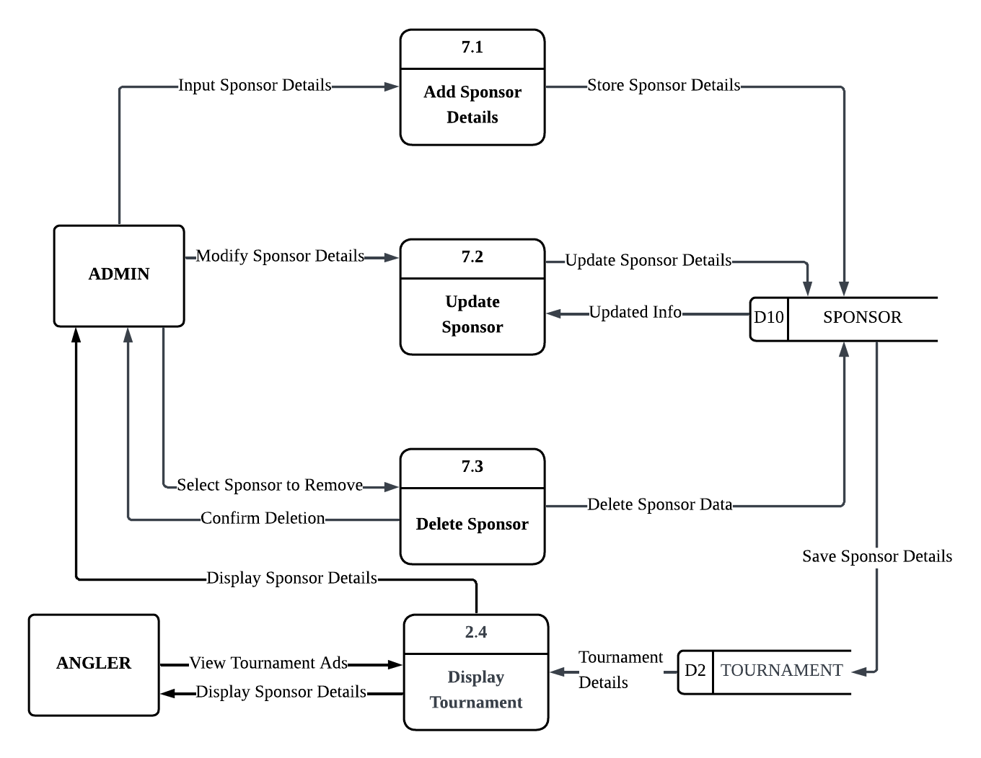

Figure 4.23: DFD Level 1 for Sponsor Management

Figure 4.23 illustrates the sponsor management process in the SmartAngler system. The Admin manages tournament sponsors by adding new sponsor details, which are stored in the SPONSOR database. When modifications are needed, the Admin can update existing sponsor information, and the changes are saved back to the SPONSOR database. The Admin can also remove sponsors by selecting them for deletion and confirming the action, which removes the sponsor data from the database.

Sponsor information is linked to tournament details and saved in the TOURNAMENT database. When Anglers view tournament advertisements and details through the Display Tournament process, they can see the associated sponsor information. The system retrieves both tournament details from the TOURNAMENT database and sponsor information from the SPONSOR database to display comprehensive tournament information including sponsorship details to participants. This process ensures proper management and visibility of tournament sponsors throughout the system.

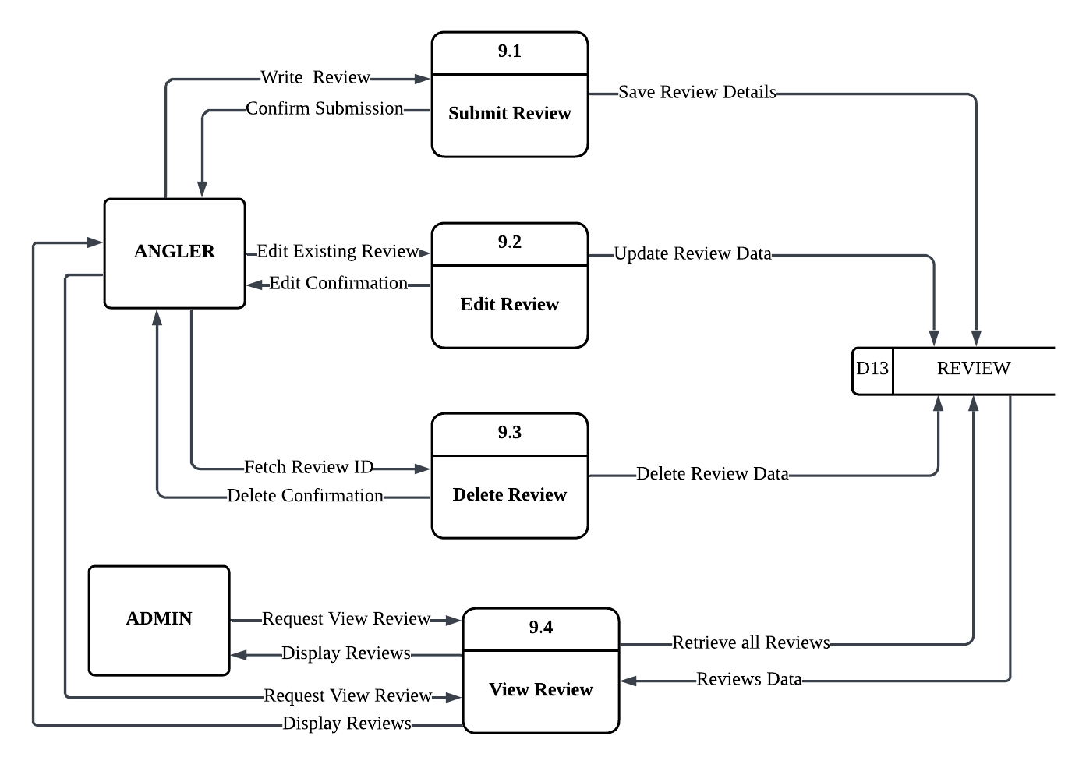

Figure 4.24: DFD Level 1 for Review Management

Figure 4.24 illustrates the review management process in the SmartAngler system. Anglers can write and submit reviews about tournaments, which are saved in the REVIEW database. If Anglers need to modify their feedback, they can edit existing reviews and update the review data in the database. Anglers also have the option to delete their reviews by fetching the review ID and confirming the deletion, which removes the review data from the REVIEW database.

The Admin can view all submitted reviews by requesting and retrieving review data from the REVIEW database. The system displays all reviews to the Admin for monitoring purposes. Similarly, Anglers can request to view reviews and the system retrieves and displays the review data from the database. This process allows participants to share their tournament experiences while giving administrators oversight of all feedback submitted within the system.

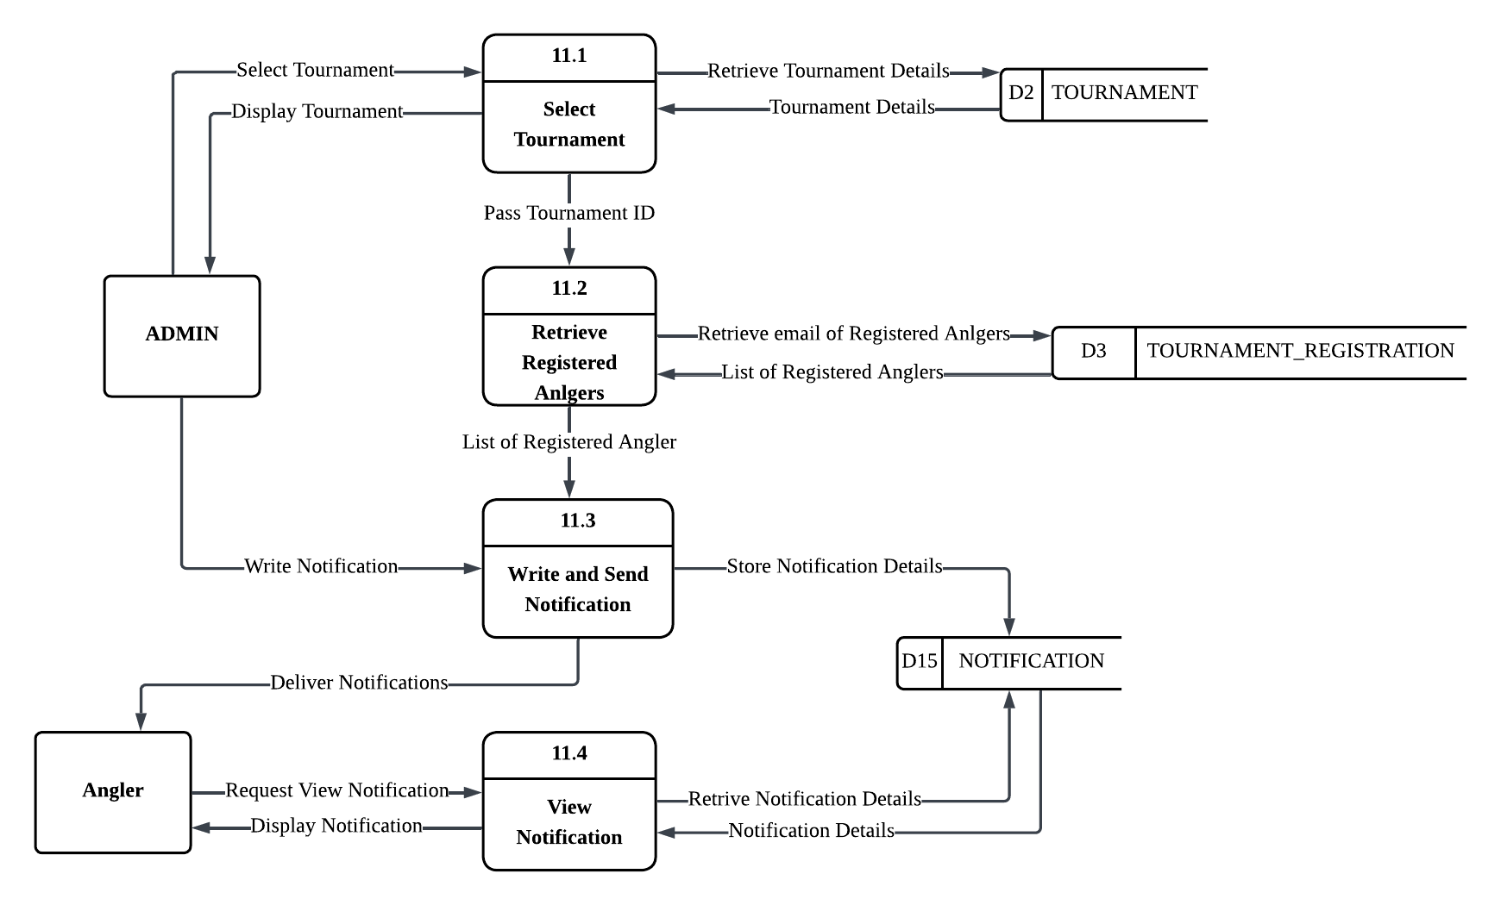

Figure 4.25: DFD Level 1 for Notification Management

Figure 4.25 illustrates the notification management process in the SmartAngler system. The Admin begins by selecting a tournament from the TOURNAMENT database to retrieve tournament details. Once selected, the system retrieves the list of registered anglers and their email addresses from the TOURNAMENT_REGISTRATION database. The Admin then writes a notification message and sends it through the system. The notification details are stored in the NOTIFICATION database and delivered to the registered anglers.

Anglers can request to view their notifications, and the system retrieves the notification details from the NOTIFICATION database to display them. This process ensures effective communication between tournament administrators and participants, allowing admins to send important updates, announcements, or reminders to all registered anglers for a specific tournament efficiently.

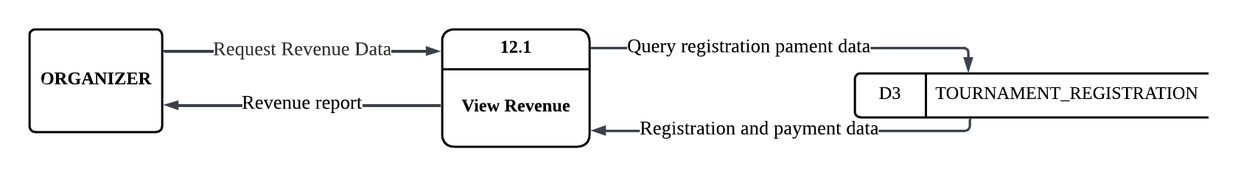

Figure 4.26: DFD Level 1 for Revenue Management

Figure 4.26 illustrates the revenue management process in the SmartAngler system. The Organizer requests revenue data from the system, which queries registration payment information from the TOURNAMENT_REGISTRATION database. The system retrieves all registration and payment data, calculates the total revenue collected from tournament entry fees, and generates a comprehensive revenue report. The revenue report is then displayed to the Organizer, providing financial insights and summaries of tournament income. This process enables organizers to monitor tournament profitability and track payment collections effectively.

The Data Flow Diagrams (DFDs) for the SmartAngler system provide a clear and structured illustration of how data moves throughout the SmartAngler system. Level 0 DFD provides a broad view of the system, which indicates how the Anglers and Organizers communicate with the system and how the key processes are facilitated by different data stores to maintain order, uniformity and easy availability of information. Meanwhile, the Level 1 DFDs go deeper into each main process showing how data flows step by step. Overall, these diagrams help explain the system in a clear, simple and visual way, making it easier to understand how information is handled and how the system ensures a smooth and efficient experience for both users and administrators.

### 4.4.5 Entity Relationship Diagram (ERD)

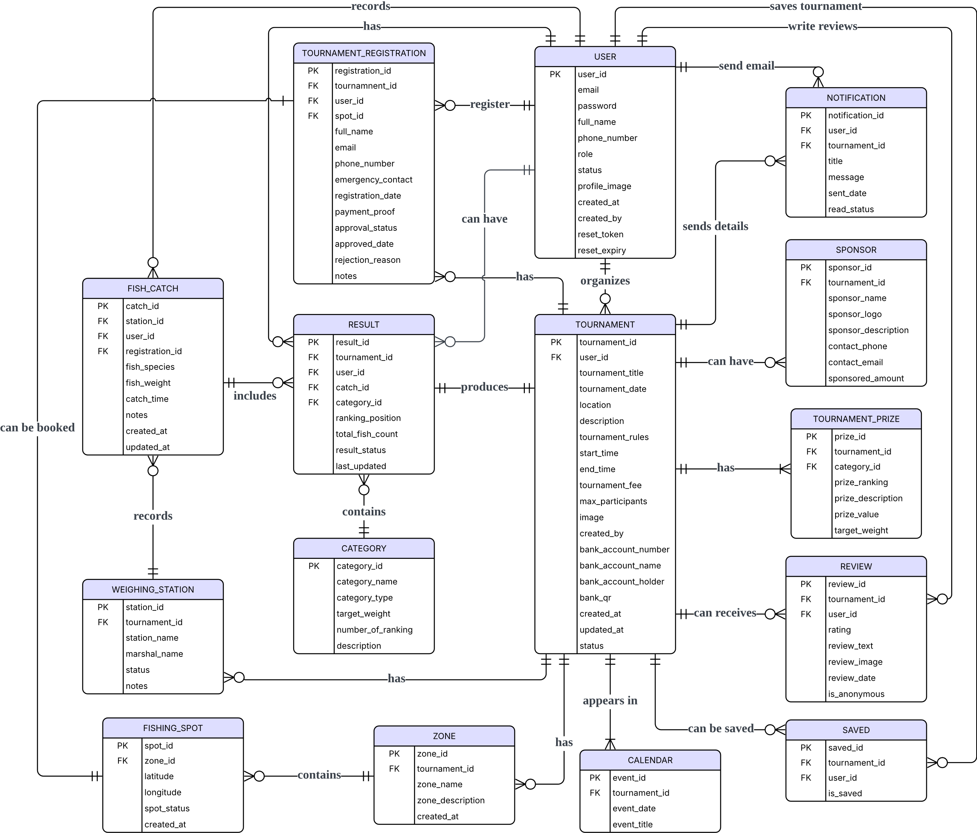

Figure 4.27: Entity Relationship Diagram (ERD) of SmartAngler

Figure 4.27 shows the Entity Relationship Diagram (ERD) for the SmartAngler Automated Fishing Tournament System. It shows an relationship between various data tables (entities) within the system. Each entity represents a major part of the system. All of these entities are connected through relationships which show how the data is linked. The ERD also defines the attributes stored in each table and how they are uniquely identified using primary keys. It can assist for the future development of SmartAngler by guiding how to build the database and show the flow of the database between different parts of the system to ensure everything is well-organized and connected.

### 4.4.6 Data Dictionary

The data dictionary provides a clear and detailed explanation of each table within the SmartAngler database. It contains important information such as the table name, attribute name, data type, constraints and a brief description of each attribute. This dictionary helps to explain the structure and characteristics of the data and the relationships between different tables. By using this data dictionary, SmartAngler can ensure that all data elements are clearly defined, consistently used and well-organized throughout the system. This makes it easier for the development of SmartAngler to build, manage and update the database accurately.

Table 4.1: USER Table

|  |  |  |  |  |
| --- | --- | --- | --- | --- |
| **No.** | **Attribute Name** | **Data Type** | **Constraint** | **Description** |
| **1** | user_id | INT | Primary Key | Unique identifier for each user |
| **2** | email | VARCHAR | UNIQUE, NOT NULL | User's email address |
| **3** | password | VARCHAR | NOT NULL | User's account password |
| **4** | full_name | VARCHAR |  | User's full name |
| **5** | phone_number | VARCHAR |  | User's phone number |
| **6** | role | ENUM | Default 'angler' | Role of the user:  1- admin or 2-angler |
| **7** | status | ENUM | Default 'active' | Account status:  active or inactive |
| **8** | profile_image | VARCHAR |  | User's profile image |
| **9** | created_at | DATETIME | Default CURRENT_TIMESTAMP | Date and time the user account was created |
| **10** | created_by |  |  |  |
| **11** | reset_token |  |  |  |
| **12** | reset_expiry |  |  |  |

Table 4.2: TOURNAMENT Table

|  |  |  |  |  |
| --- | --- | --- | --- | --- |
| **No.** | **Attribute Name** | **Data Type** | **Constraint** | **Description** |
| **1** | tournament_id | INT | Primary Key | Unique identifier for the tournament |
| **2** | user_id | INT | Foreign Key | Reference to admin user who created tournament |
| **3** | tournament_title | VARCHAR | NOT NULL | Name/title of the tournament |
| **4** | tournament_date | DATE | NOT NULL | Date of the tournament |
| **5** | location | VARCHAR |  | Location of the tournament |
| **6** | description | TEXT |  | Description of the tournament including prizes and rules. |
| **7** | tournament_rules |  |  |  |
| **8** | start_time | TIME |  | Start time of the tournament |
| **9** | end_time | TIME |  | End time of the tournament |
| **10** | tournament_fee | DECIMAL | Default 0.00 | Entry fee for participation |
| **11** | max_participants | INT |  | Maximum number of participants allowed |
| **12** | image | VARCHAR |  | Image representing the tournament |
| **13** | created_by | INT |  | Admin who created the tournament |
| **14** | bank_account_number | VARCHAR |  | Bank account number for payments |
| **15** | bank_account_name | VARCHAR |  | Name of the bank |
| **16** | bank_account_holder | VARCHAR |  | Account holder’s name |
| **17** | bank_qr | VARCHAR |  | QR image for faster payment |
| **18** | created_at | DATETIME | Default CURRENT_TIMESTAMP | Date of tournament creation |
| **19** | updated_at | DATETIME | ON UPDATE CURRENT_TIMESTAMP | Last updated date |
| **20** | status | ENUM |  | Tournament status: upcoming, ongoing, completed, cancelled |

Table 4.3: WEIGHING_STATION Table

|  |  |  |  |  |
| --- | --- | --- | --- | --- |
| **No.** | **Attribute Name** | **Data Type** | **Constraint** | **Description** |
| **1** | station_id | INT | Primary Key | Unique identifier for each weighing station |
| **2** | tournament_id | INT | Foreign Key | Associated tournament that using the weighing station |
| **3** | station_name | VARCHAR | NOT NULL | Station label or name |
| **4** | marshal_name | VARCHAR |  | Name of the marshal that working at this station |
| **5** | status | ENUM | Default 'active' | Status of the station: active or inactive |
| **6** | notes | TEXT |  | Additional remarks about the station |

Table 4.4: ZONE Table

|  |  |  |  |  |
| --- | --- | --- | --- | --- |
| **No.** | **Attribute Name** | **Data Type** | **Constraint** | **Description** |
| **1** | zone_id | INT | Primary Key | Unique identifier for each zone |
| **2** | tournament_id | INT | Foreign Key | Tournament associated with the zone |
| **3** | zone_name | VARCHAR | NOT NULL | Name of the fishing zone |
| **4** | zone_description | TEXT |  | Description or notes about the zone |
| **5** | created_at | DATETIME | Default CURRENT_TIMESTAMP | Creation date of the zone record |

Table 4.5: FISHING_SPOT Table

|  |  |  |  |  |
| --- | --- | --- | --- | --- |
| **No.** | **Attribute Name** | **Data Type** | **Constraint** | **Description** |
| **1** | spot_id | INT | Primary Key | Unique identifier for each fishing spot |
| **2** | zone_id | INT | Foreign Key | Reference to tournament this spot belongs to |
| **3** | latitude | DECIMAL (10,8) |  | GPS latitude |
| **4** | longitude | DECIMAL (11,8) |  | GPS longitude |
| **5** | spot_status | ENUM |  | Spot availability: available, booked, cancelled or under maintenance |
| **6** | Created_at | DATETIME | Default CURRENT_TIMESTAMP | Date spot was added |

Table 4.6: TOURNAMENT_REGISTRATION Table

|  |  |  |  |  |
| --- | --- | --- | --- | --- |
| **No.** | **Attribute Name** | **Data Type** | **Constraint** | **Description** |
| **1** | registration_id | INT | Primary Key | Unique identifier for the registration of angler in a tournament |
| **2** | tournament_id | INT | Foreign Key | Reference to tournament being registered for |
| **3** | user_id | INT | Foreign Key | User who registered |
| **4** | spot_id | INT | Foreign Key | Reference to assigned fishing spot |
| **5** | full_name |  |  |  |
| **6** | email |  |  |  |
| **7** | phone_number |  |  |  |
| **8** | emergency_contact |  |  |  |
| **9** | registration_date | DATETIME |  | Date and time of registration |
| **10** | payment_proof | VARCHAR |  | File path or link to uploaded proof of payment |
| **11** | approval_status | ENUM |  | Registration status: pending, approved, rejected, cancelled |
| **12** | approved_date | DATETIME |  | Date and time when registration was approved |
| **13** | rejection_reason |  |  |  |
| **14** | notes | TEXT |  | Remarks or admin notes |

Table 4.7: CATEGORY Table

|  |  |  |  |  |
| --- | --- | --- | --- | --- |
| **No.** | **Attribute Name** | **Data Type** | **Constraint** | **Description** |
| **1** | category_id | INT | Primary Key | Unique identifier for each category |
| **2** | category_name | VARCHAR | NOT NULL | Name of competition category |
| **3** | category_type |  |  |  |
| **4** | target_weight |  |  |  |
| **5** | number_of_ranking | INT |  | Number of ranking positions in the category |
| **6** | description | TEXT |  | Description of how category is judged |

Table 4.8: FISH_CATCH Table

|  |  |  |  |  |
| --- | --- | --- | --- | --- |
| **No.** | **Attribute Name** | **Data Type** | **Constraint** | **Description** |
| **1** | catch_id | INT | Primary Key | Unique identifier for each fish catch |
| **2** | station_id | INT | Foreign Key | Station where the fish was weighed |
| **3** | user_id | INT | Foreign Key | Reference to angler who caught the fish |
| **4** | registration_id |  |  |  |
| **5** | fish_species | VARCHAR | NOT NULL | Species of fish caught |
| **6** | fish_weight | DECIMAL | NOT NULL | Weight of the fish in specified unit |
| **7** | catch_time | TIME | NOT NULL | Time when fish was caught |
| **8** | notes | TEXT |  | Additional notes about the catch |
| **9** | created_at | DATETIME | Default CURRENT_TIMESTAMP | Record creation date and time |
| **10** | updated_at | DATETIME | ON UPDATE CURRENT_TIMESTAMP | Last modification date and time |

Table 4.9: CALENDAR Table

|  |  |  |  |  |
| --- | --- | --- | --- | --- |
| **No.** | **Attribute Name** | **Data Type** | **Constraint** | **Description** |
| **1** | event_id | INT | Primary Key | Unique identifier for each calendar event |
| **2** | tournament_id | INT | Foreign Key | Reference to tournament |
| **3** | event_date | DATE |  | Date of the event |
| **4** | event_title | VARCHAR |  | Title of the event |

Table 4.10: RESULT Table

|  |  |  |  |  |
| --- | --- | --- | --- | --- |
| **No.** | **Attribute Name** | **Data Type** | **Constraint** | **Description** |
| **1** | result_id | INT | Primary Key | Unique identifier for each result entry |
| **2** | tournament_id | INT | Foreign Key | Reference to tournament |
| **3** | user_id | INT | Foreign Key | Reference to angler’s result |
| **4** | catch_id | INT | Foreign Key | Reference to catch fish data |
| **5** | category_id | INT | Foreign Key | Category under which ranking applies |
| **6** | ranking_position | INT |  | Current ranking position of the angler |
| **7** | total_fish_count | INT | Default 0 | Total number of fish caught in the tournament |
| **8** | result_status | ENUM | Default 'ongoing' | Result status: ongoing or final |
| **9** | last_updated | DATETIME | ON UPDATE CURRENT_TIMESTAMP | Last update timestamp |

Table 4.11: SAVED Table

|  |  |  |  |  |
| --- | --- | --- | --- | --- |
| **No.** | **Attribute Name** | **Data Type** | **Constraint** | **Description** |
| **1** | saved_id | INT | Primary Key | Unique identifier for each saved advertisement |
| **2** | tournament_id | INT | Foreign Key | Reference to tournament being saved |
| **3** | user_id | INT | Foreign Key | Reference to user saving tournament |
| **4** | is_saved | BOOLEAN |  | Indicates whether the tournament is saved |

Table 4.12: REVIEW Table

|  |  |  |  |  |
| --- | --- | --- | --- | --- |
| **No.** | **Attribute Name** | **Data Type** | **Constraint** | **Description** |
| **1** | review_id | INT | Primary Key | Unique identifier for each review |
| **2** | tournament_id | INT | Foreign Key | Reference to tournament being reviewed |
| **3** | user_id | INT | Foreign Key | Reference to angler writing review |
| **4** | rating | INT | CHECK (1–5) | Rating from 1 to 5 stars |
| **5** | review_text | TEXT |  | Written review content |
| **6** | review_image | VARCHAR |  | Uploaded image related to the review (catch photo or event image) |
| **7** | review_date | DATETIME | Default CURRENT_TIMESTAMP | Date and time when review was submitted |
| **8** | is_anonymous | BOOLEAN |  | Indicates if the reviewer is anonymous |

Table 4.13: NOTIFICATION Table

|  |  |  |  |  |
| --- | --- | --- | --- | --- |
| **No.** | **Attribute Name** | **Data Type** | **Constraint** | **Description** |
| **1** | notification_id | INT | Primary Key | Unique identifier for each notification |
| **2** | user_id | INT | Foreign Key | Reference to user receiving the notification |
| **3** | tournament_id | INT | Foreign Key | Selected tournament |
| **4** | title | VARCHAR |  | Notification title or subject |
| **5** | message | TEXT |  | Full notification message content |
| **6** | sent_date | DATETIME | Default CURRENT_TIMESTAMP | Date and time notification was sent |
| **7** | read_status |  |  |  |

Table 4.14: SPONSOR Table

|  |  |  |  |  |
| --- | --- | --- | --- | --- |
| **No.** | **Attribute Name** | **Data Type** | **Constraint** | **Description** |
| **1** | sponsor_id | INT | Primary Key | Unique identifier for each sponsor |
| **2** | tournament_id | INT | Foreign Key | Sponsored tournament |
| **3** | sponsor_name | VARCHAR |  | Sponsor or company name |
| **4** | sponsor_logo | VARCHAR |  | File path or URL of sponsor logo |
| **5** | sponsor_description | TEXT |  | Short sponsor information |
| **6** | contact_phone | VARCHAR |  | Phone number for sponsor |
| **7** | contact_email | VARCHAR |  | Email contact for sponsor |
| **8** | sponsored_amount | DECIMAL |  | Amount contributed by sponsor |

Table 4.15: TOURNAMENT_PRIZE Table

|  |  |  |  |  |
| --- | --- | --- | --- | --- |
| **No.** | **Attribute Name** | **Data Type** | **Constraint** | **Description** |
| **1** | prize_id | INT | Primary Key | Unique identifier for each prize |
| **2** | tournament_id | INT | Foreign Key | Tournament associated with the prize |
| **3** | category_id | INT | Foreign Key | Sponsor providing the prize |
| **4** | prize_ranking | VARCHAR |  | Ranking placement for the prize |
| **5** | prize_description | TEXT |  | Description of prize |
| **6** | prize_value | DECIMAL |  | Monetary value or equivalent of the prize |
| **7** | target_weight |  |  |  |

## 4.5 User Interface

The user interface design for the SmartAngler Fishing Tournament Management System was developed using a collaborative interface design tool which is Figma. These high-fidelity prototype designs are the visual representation of the real system in its state with detailed layout, colour scheme, typography, icons and interactive elements. The layout is expected to offer clean and modern and user-friendly experience to both the angler and administrator to make navigation easy and user-friendly.

For anglers, the interface will allows users to easily register and log in into their account, view and registration for tournaments, book fishing spots, track scores through a live leaderboard, view event calendars and submit reviews. Meanwhile, the admin interface will facilitate easier management of the backend operations like managing tournaments, participant approval, bookings, fishing spots, catch records, result generation and general monitoring of the system operations.

These designs would be used not only as visual guides but rather as functional blueprints with which it would assist in creating the front-end more accurately and efficiently. The high-fidelity prototypes are also important in ensuring that the end system satisfies the users since the user flow is clearly based, and the elements of visual hierarchy and interaction are well defined.

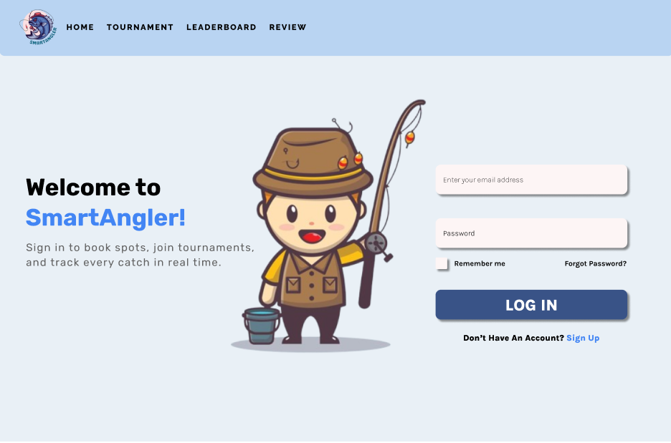

Figure 4.27: SmartAngler Prototype Log in Page

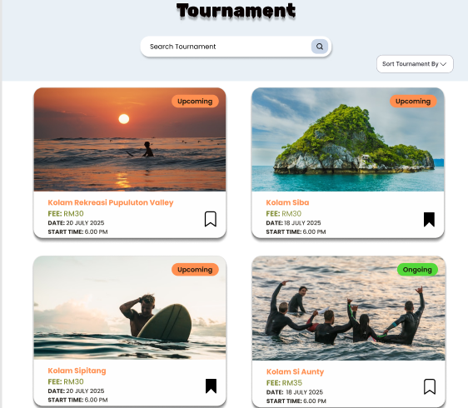

Figure 4.28: SmartAngler Prototype Tournament List

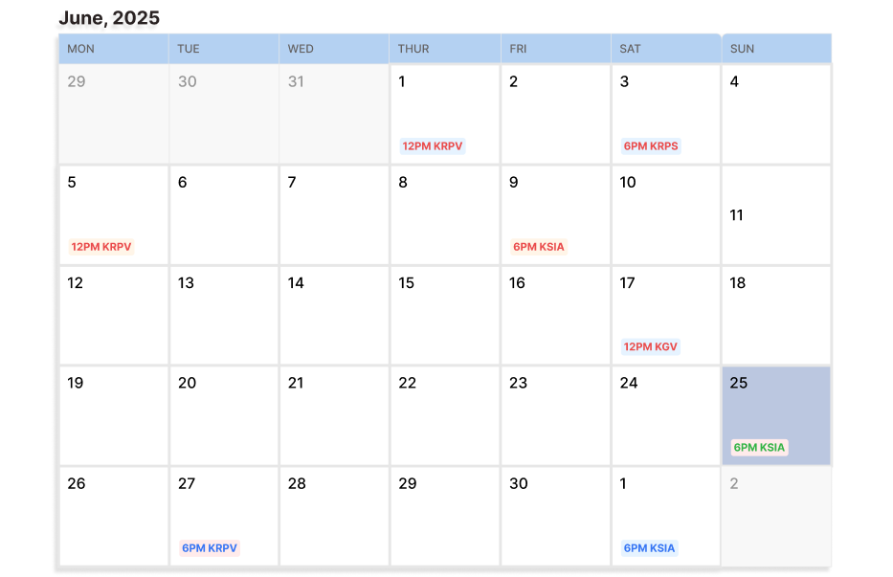

Figure 4.29: SmartAngler Prototype Calendar

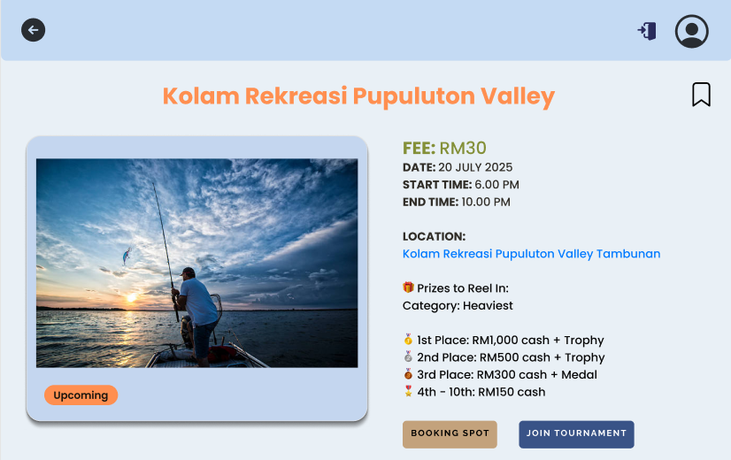

Figure 4.30: SmartAngler Prototype Tournament Registration

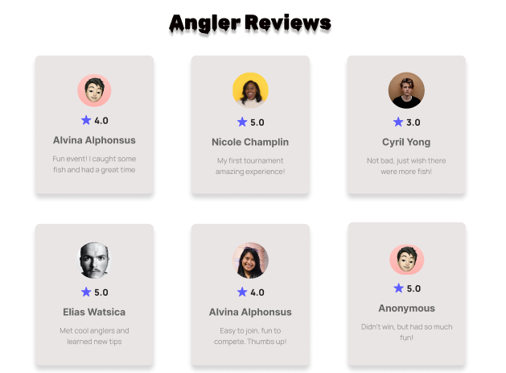

Figure 4.31: SmartAngler Prototype Reviews

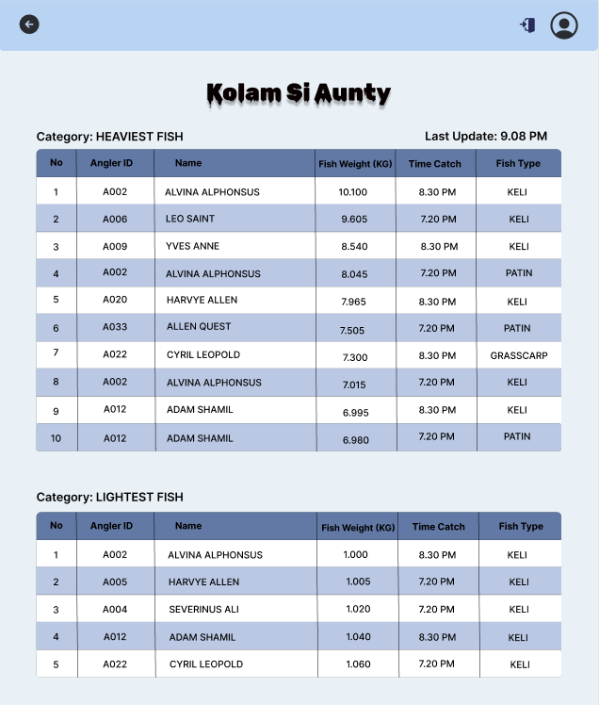

Figure 4.32: SmartAngler Prototype Live Result

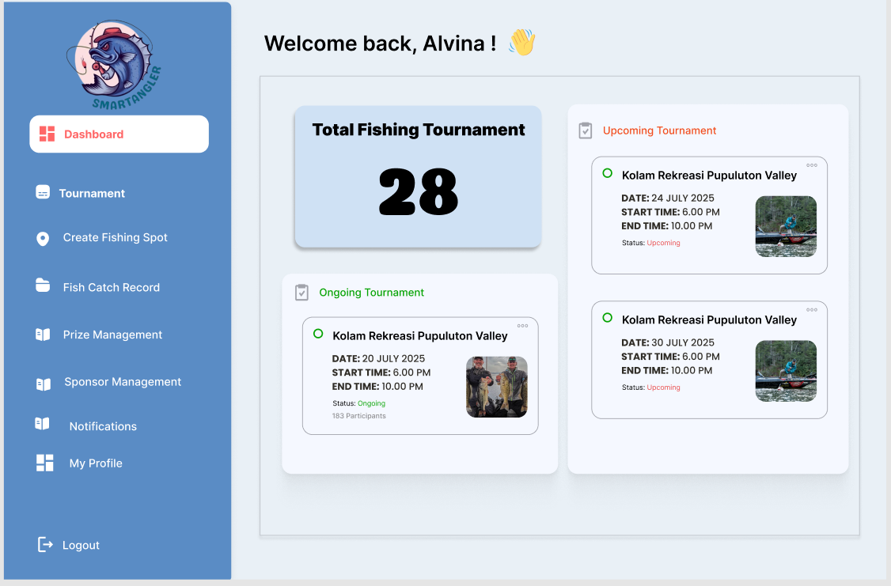

Figure 4.33: SmartAngler Prototype Admin Dashboard

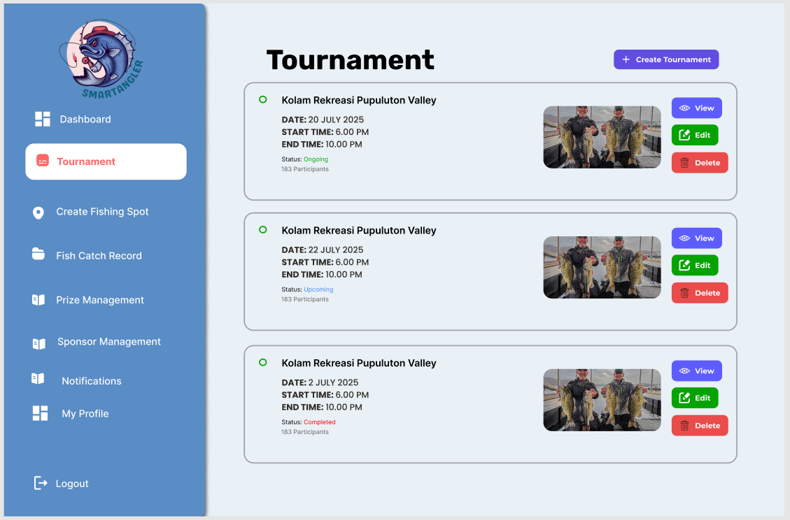

Figure 4.34: SmartAngler Prototype Tournament Management

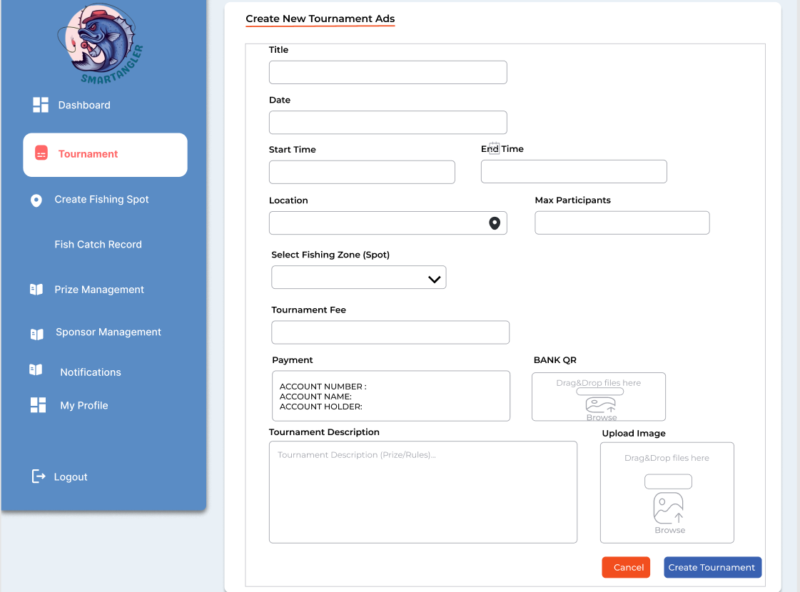

Figure 4.35: SmartAngler Prototype Tournament Creation Form

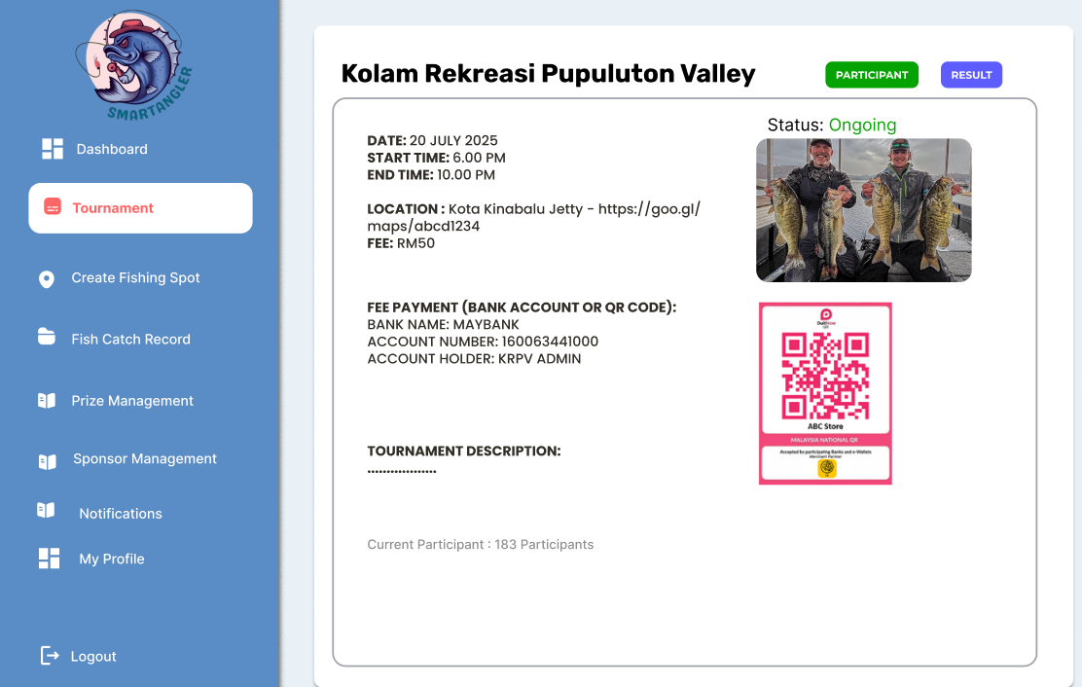

Figure 4.36: SmartAngler Prototype Tournament Details

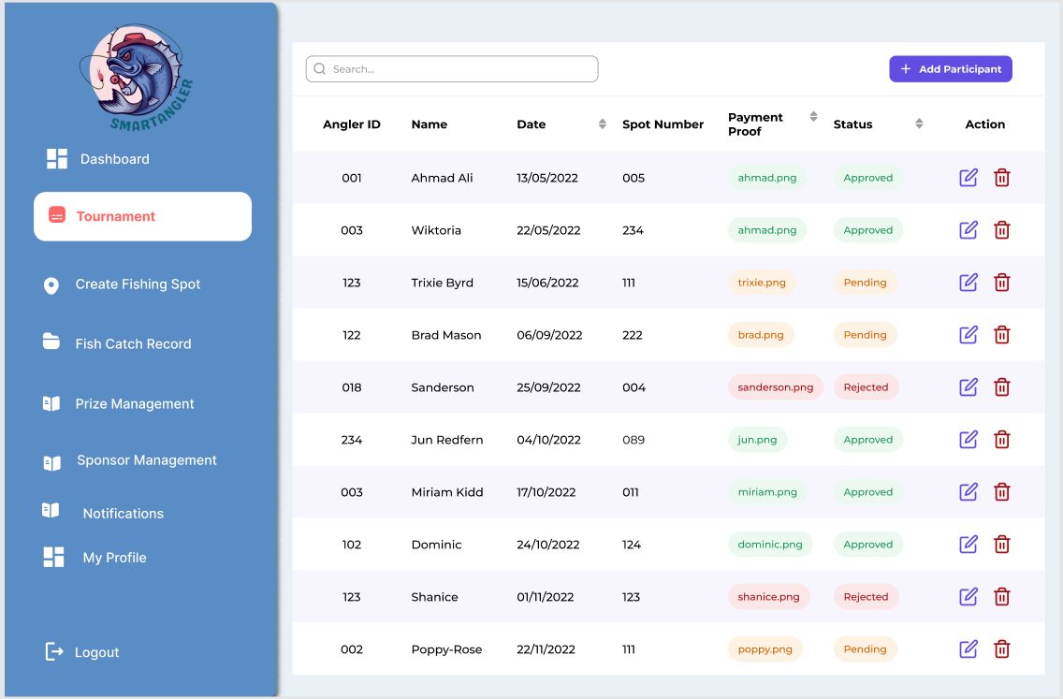

Figure 4.37: SmartAngler Prototype Participant Registration Approval

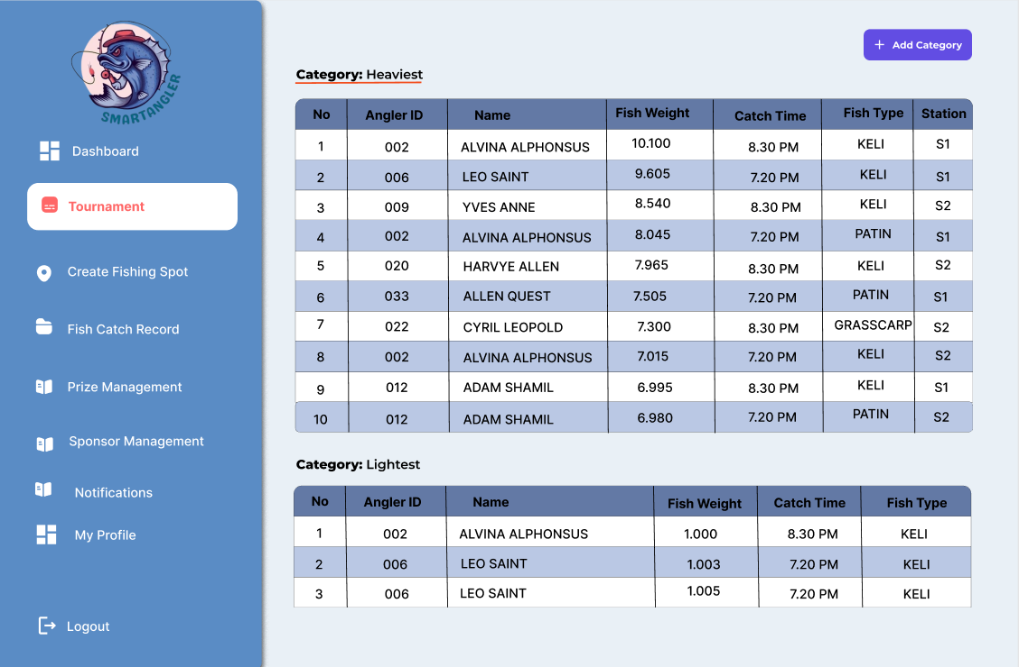

Figure 4.38: SmartAngler Prototype Result Management

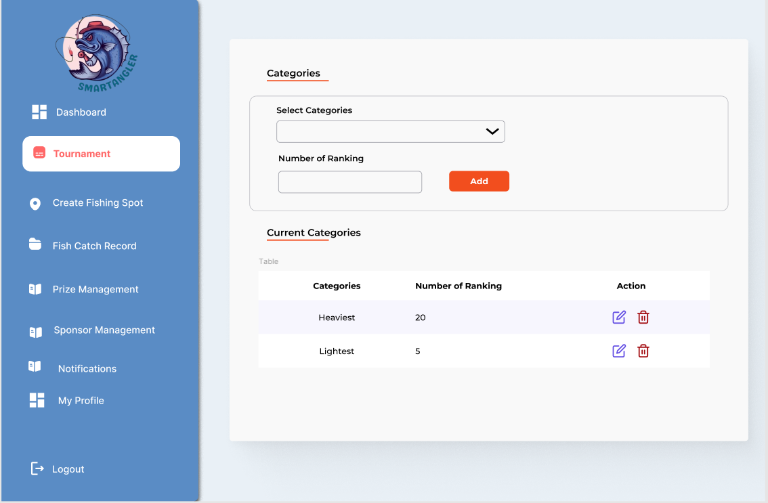

Figure 4.39: SmartAngler Prototype Categories Selection

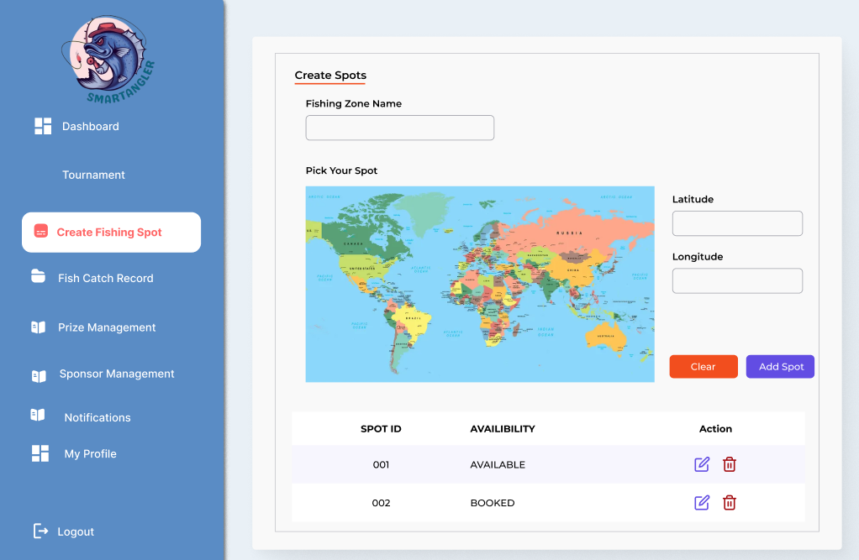

Figure 4.40: SmartAngler Prototype Spot Management

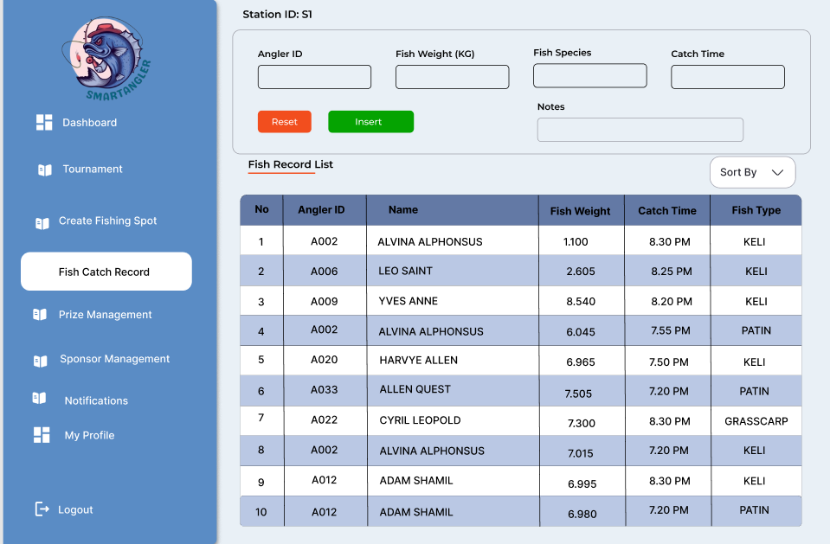

Figure 4.41: SmartAngler Prototype Fish Catch Record Management

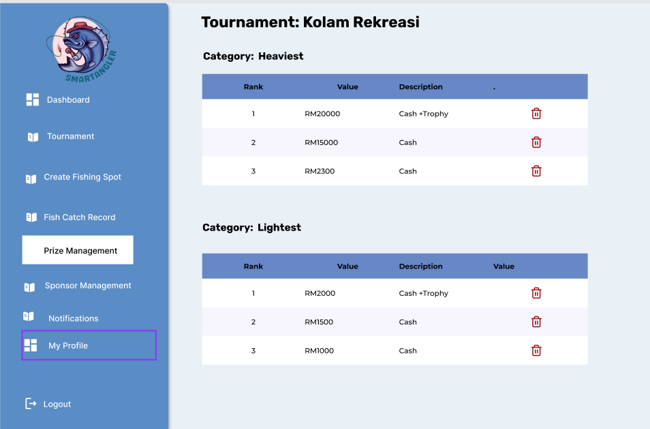

Figure 4.42: SmartAngler Prototype Prize Management

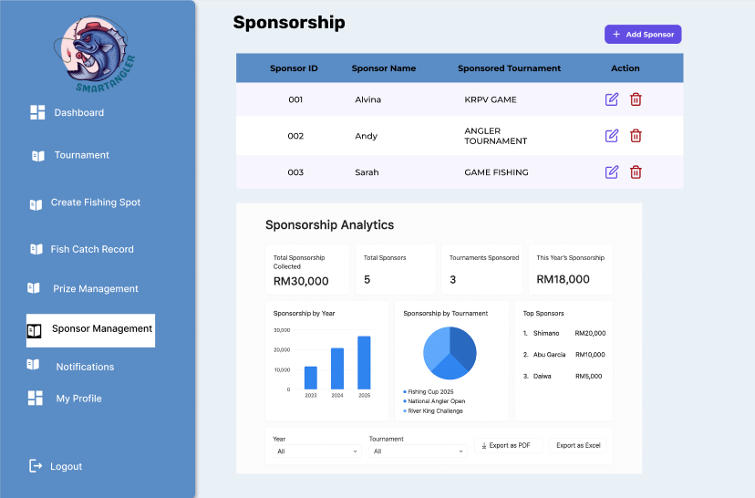

Figure 4.43: SmartAngler Prototype Sponsor Management

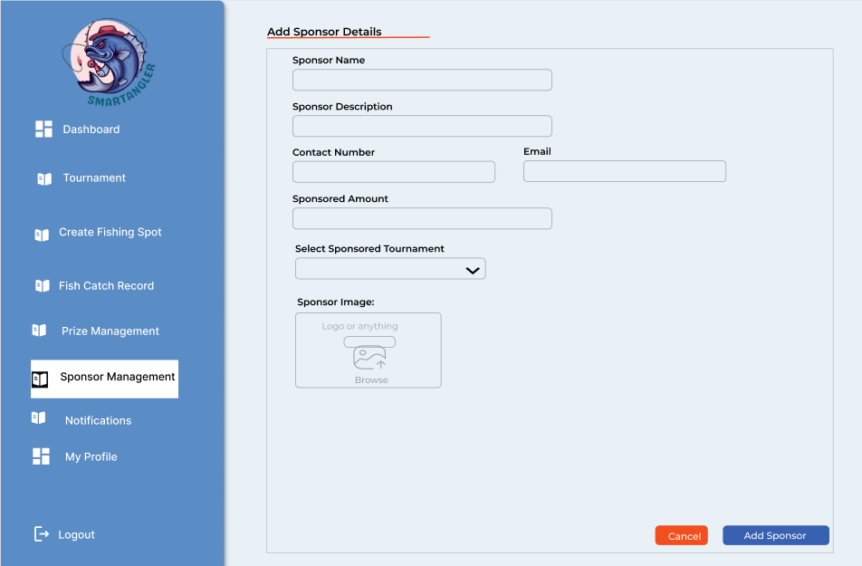

Figure 4.44: SmartAngler Prototype Add Sponsor Details

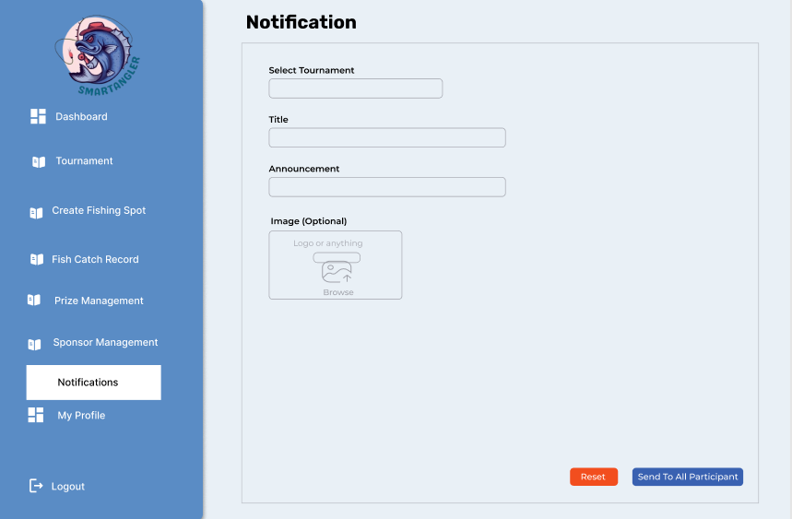

Figure 4.45: SmartAngler Prototype Send Notifications

* 1. **Prototype**

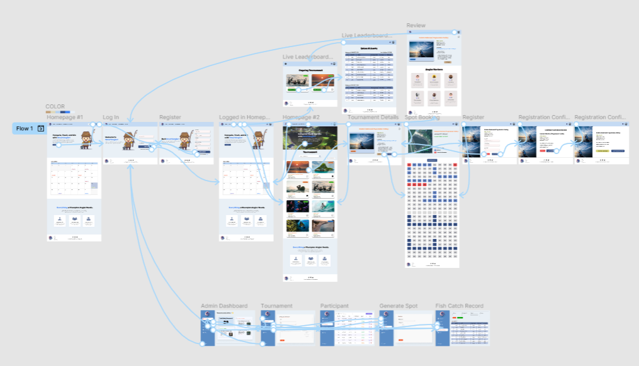

Figure 4.46: Prototype User Flow for SmartAngler

The design and the user requirements were used in developing the prototype of the SmartAngler Fishing Tournament Management System. The prototype is an operational prototype that illustrates the functionality of the system including the key features and user interface. It enables the users and developers to develop a visual representation of the system flow, test the interface and give comments before the final version is created. This helps ensure the system meets user needs and expectation and works as expected.

**Prototype Link:** <https://www.figma.com/proto/yEmPgAwKYAboHdAwZglBnJ/SmartAngler-Prototype?node-id=90-534&p=f&t=FDc1pkEIXfahTMpK-1&scaling=min-zoom&content-scaling=fixed&page-id=0%3A1&starting-point-node-id=1%3A7>

## 4.6 Conclusion

In conclusion, this chapter focused on the design phase of the SmartAngler Fishing Tournament Management System. The system design was designed based on some key elements including the system architecture, context diagram, data flow diagrams (DFD), and entity relationship diagram (ERD) when the requirement analysis process was completed. The data dictionary was also included in the form of defining how each piece of data would be structured and its meaning within the system. Additionally, a high-fidelity prototype was developed using Figma to show how the system will look and function for both anglers and admins. These design elements serve as a solid foundation for the next stage, which is the implementation of the system.

# CHAPTER 5

**IMPLEMENTATION**

## 5.1 Introduction

This chapter will discuss and explain the implementation phase of the SmartAngler system. It involves summary of the tools and technologies that will be applied in the development process, design and functionality of the system interfaces, and database structure that will be used to support system operations. The implementation stage transforms the design requirements into a working system that will allow administrators to conduct fishing tournaments and the anglers to be involved in the events effectively.

## 5.2 Tools for Development

The SmartAngler system was developed by using a mix of software tools and programming technologies. The primary coding environment was Visual Studio code (VS Code), the testing environment was a local server and database with XAMPP, and the source code was managed and changes tracked in GitHub. These tools were chosen to make development faster and easier, keep the system easy to maintain and ensure it works reliably. By using widely supported and well-documented technologies, the development of SmartAngler have reduce potential compatibility issues, simplify debugging and accelerate the implementation process. The tools used also enabled the development of an interactive and responsive web application that was cross-platform and cross-gadget capable.

### 5.2.1 Visual Studio Code

The main development environment was Visual Studio code (VS Code). VS Code offered syntax highlighting, code completion, debugging and integration with version control and thus making development easier. In VS Code, the programming languages and technologies used were as follows:

1. **Hypertext Preprocessor (PHP)**

The Hypertext Preprocessor (PHP) programming language is one of the most popular languages that are supported in the web servers today. This has made it very convenient in development of web-based applications. As a result, programmers do not need to perform extensive server customization or manual adjustments compared to other programming languages that require additional configuration (Niarman et al., 2023). This flexibility and ease of deployment made PHP the right choice in the development of the SmartAngler system. The primary server-side scripting language that was used in this project to develop the SmartAngler system backend logic was PHP. Some of the important functions that it dealt with included user authentication, tournaments management, creation and connection of fishing zones and spots to MySQL database.

1. **Hypertext Markup Language (HTML)**

HTML (Hypertext Markup Language) is the standard markup language used for creating webpages and web applications. As a markup language, HTML allows specifying the appearance of text, images, tables, links and other media in a web-based browser with the help of tags and elements (Roy et al., 2023). It enables web developers to design orderly and interactive web pages by regulating the positioning of different elements like navigation menus, buttons and forms. The use of HTML was essential in the design of all the web interfaces in the SmartAngler system among the administrators and the anglers. By defining the foundational framework for the web application, HTML ensured that all system components were displayed clearly and consistently across different browsers.

1. **Cascading Style Sheets (CSS)**

CSS ( Cascading Style sheets ) is a computer program that provides the visual style and structure of Webpages and it works together with HTML and controls colors, fonts, spacing, and the overall design. It allows developers to use classes and reusable style rules to maintain consistency across multiple pages and making interface design more efficient and organized (Cohen & Chugh, 2025). CSS played a huge role in development of the SmartAngler system, as it was required to produce a clean, user-friendliness, good looking interface. It has been applied in crafting responsive layouts among administrators and the angler and also in making sure that the interfaces are easy to use and that they are also aesthetically pleasing. The system may be able to keep a professional appearance and consistent design of all modules with the application of CSS classes and reusable style rules. This improved readability, enhanced user experience and contributed to the overall usability of the SmartAngler web application.

1. **JavaScript (JS)**

JavaScript (JS) is a high-level dynamic programming language and is used in the creation of interactive and responsive objects in web pages. It works on client side which enables it to refresh and enables a user to manipulate the page even though the page is not required to be reloaded. JavaScript is used in both cooperation with HTML and CSS to improve the user experience in response to events, validation of web page input forms, and on-demand updating of webpage content. In the SmartAngler system, JavaScript played a vital role in implementing interactivity and enhancing the functionality of various modules. It was employed to drive dynamic features like form validation, map interactions and responsive data updates to those shown on the interface. The example is that under the fishing zone creation module, JavaScript was applied along with Leaflet mapping library to allow the administrators to create or delete fishing spots on the interactive map. This provided a real-time and intuitive experience for users.

1. **PHPMailer**

PHPMailer is a famous open-source email dispatching library that allows an email to be dispatched directly by a PHP application. It makes email configuration and email transmission simple because it has inbuilt features of sending emails, attaching files as well as integration with different mail servers. PHPMailer was introduced in SmartAngler system to simplify the process of communication between the potential organizers and administrators. When a user expressed interest in becoming an event organizer, they were required to fill out an online form within the system. Once the form was submitted, PHPMailer would automatically forward the application details to the email of the administrator. This enabled the administrator to check the request and in case of approval, the administrator will provide the applicant with a registration link to enable the applicant for official organizer account creation. This verification process was designed to ensure authenticity and prevent the creation of fake organizer accounts, maintaining the system’s security and credibility.

### 5.2.2 XAMPP

XAMPP is an open-source cross-platform web server solution package that provides a complete and pre-configured set of web server components, including Apache, MySQL, PHP and Perl. XAMPP was employed in the SmartAngler project to introduce a local environment in which the system was to be tested and its database managed. Apache web server and MySQL database server were the primary components that were used. PhpMyAdmin was used through the XAMPP Control Panel to connect the web application to the database so as to effectively store and manage important data like user accounts, tournaments, fishing areas and organizer applications in the development process.

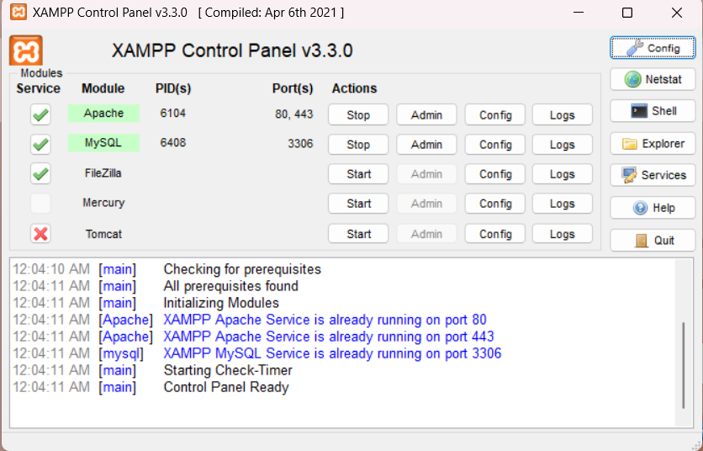

Figure 5.1: XAMPP Control Panel

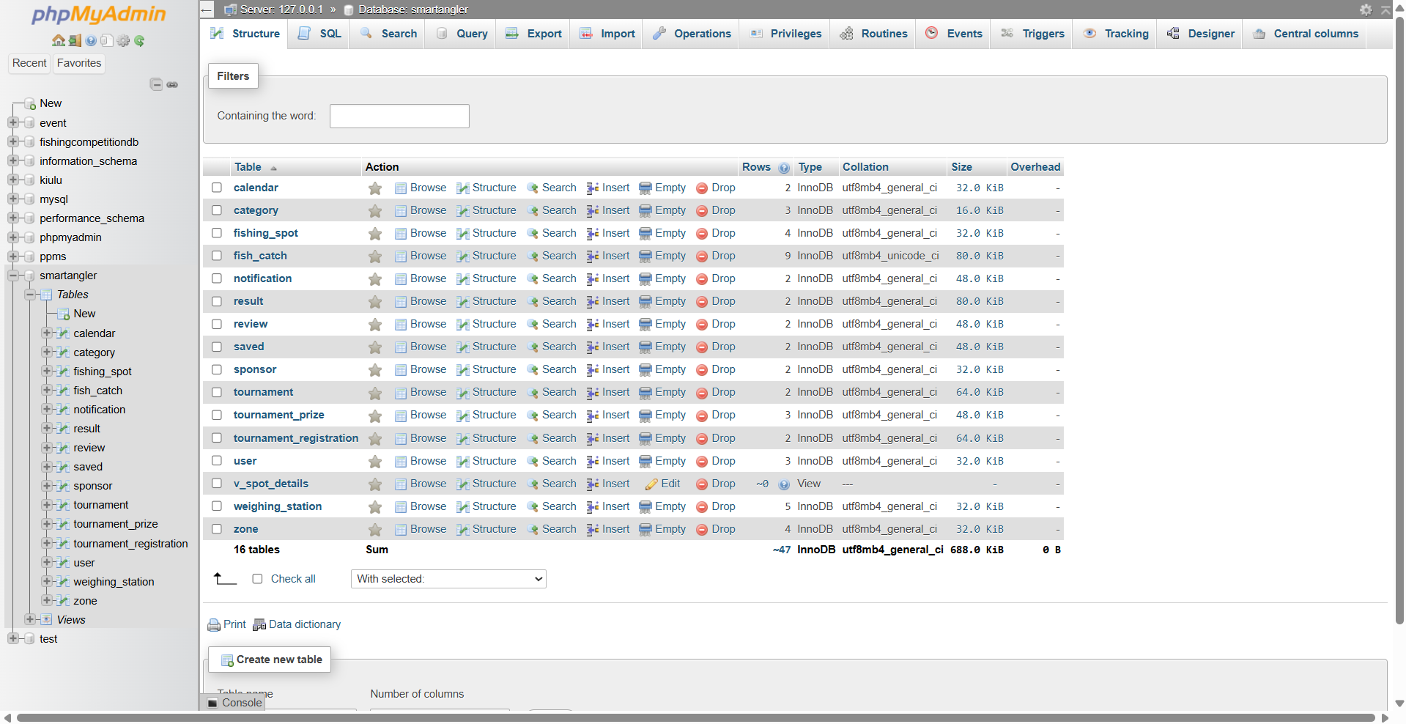

Figure 5.2: SmartAngler Database Management Interface in phpMyAdmin

### 5.2.3 GitHub

GitHub is a web-based platform for version control and code management that uses the Git system to track changes. In the SmartAngler project, GitHub was employed in SmartAngler project to organize the code, keep records of the version and track progress and enhancements during the development process. This made the code organized, the changes were documented and the entire development process became easy and manageable which led to a stable and well-structured code base in the system.

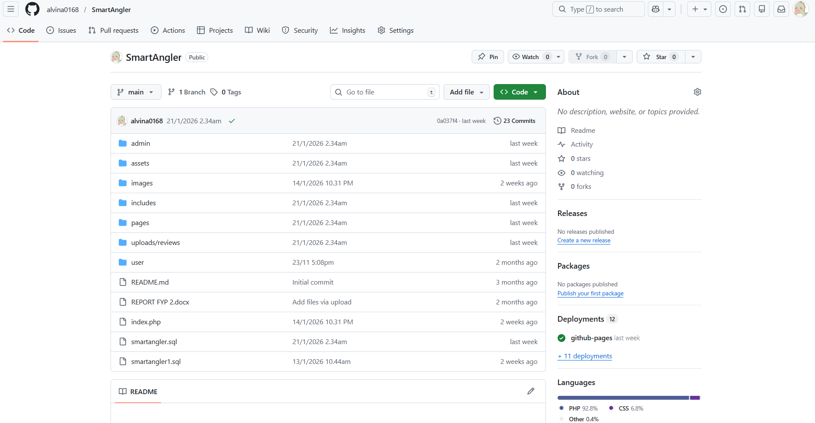

Figure 5.3: SmartAngler Source Code Repository on GitHub

Source: (alvina0168 Github, 2025)

## 5.3 System Implementation

The system implementation phase of SmartAngler focused on transforming the design into a fully working application. This included designing user friendly interfaces, linking them to the background logic and ensuring that all parts of the system work together smoothly. The goal was to make the system easy to use, reliable and efficient for both administrators and anglers. Thus, allowing them to manage and participate in fishing tournaments without any difficulties.

### 5.3.1 Organizer Interface

Organizer Interface was designed to provide the full control over the system to the administrators. With this interface, administrators are able to create and manage tournaments, manage admin accounts and view the revenue for tournaments. It offers well-organized dashboard to check the tournament progress, track the total revenue of tournaments and also to monitor the admin accounts.

1. Organizer Registration

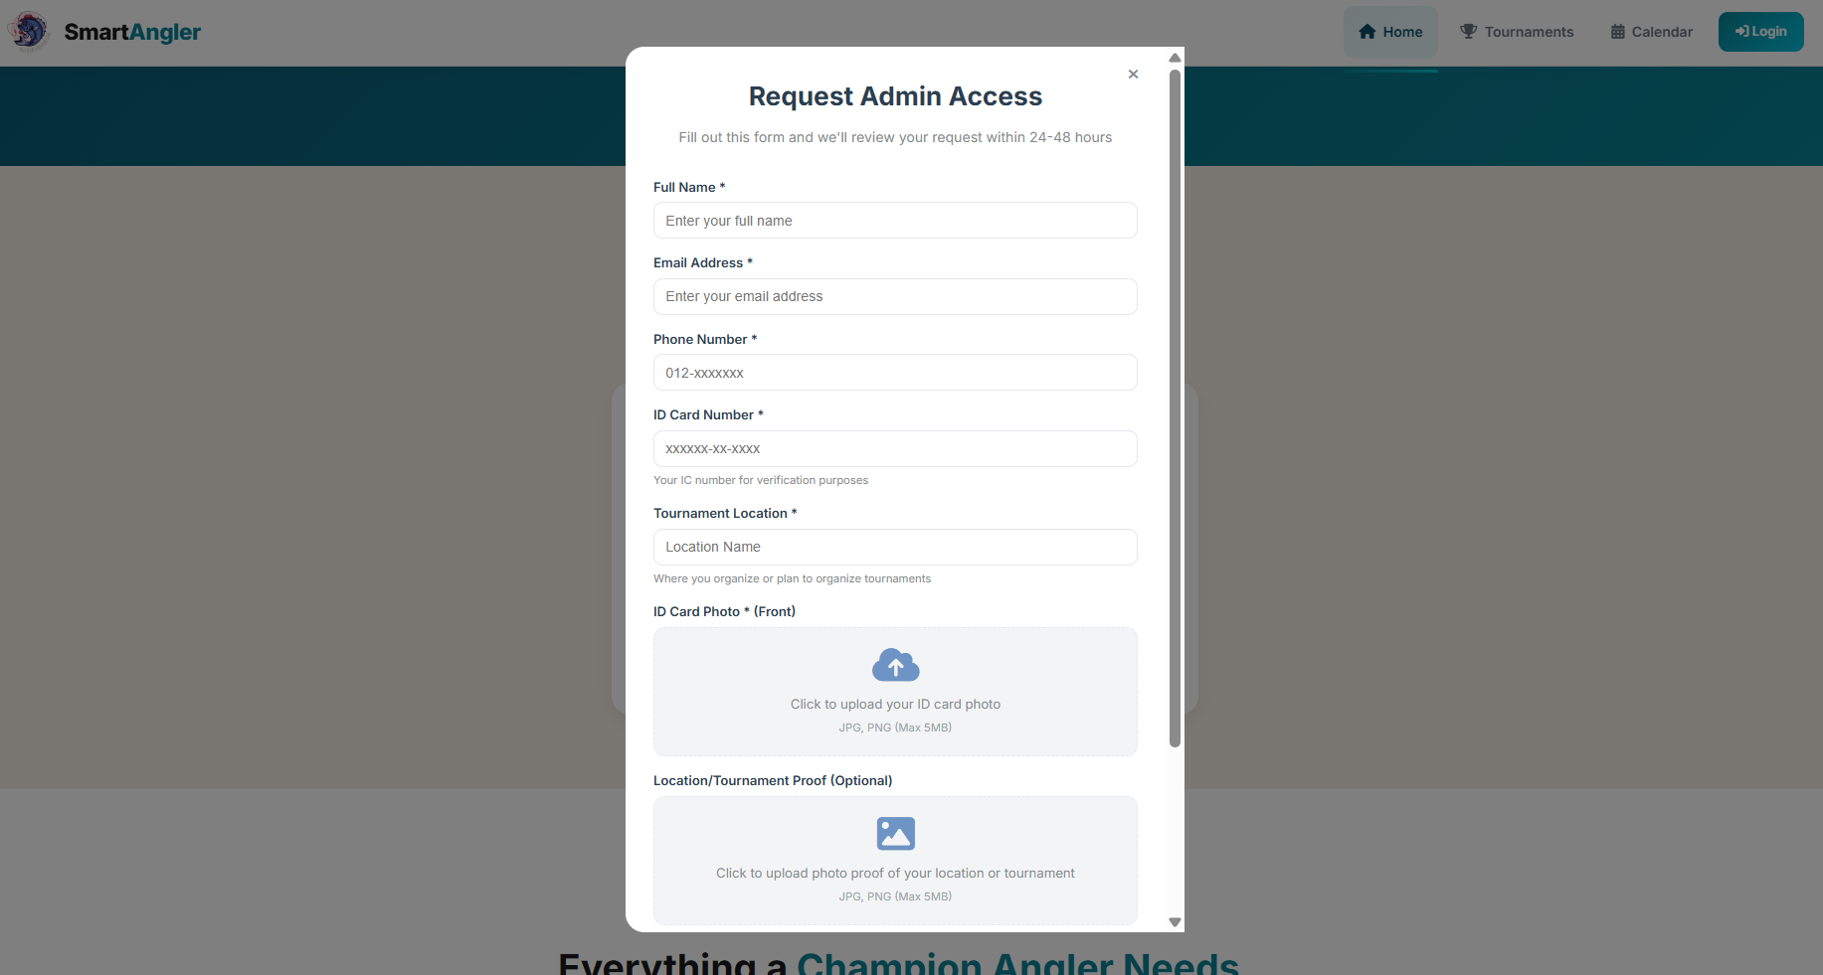

Figure 5.4: SmartAngler Organizer Request Create Account Access Page

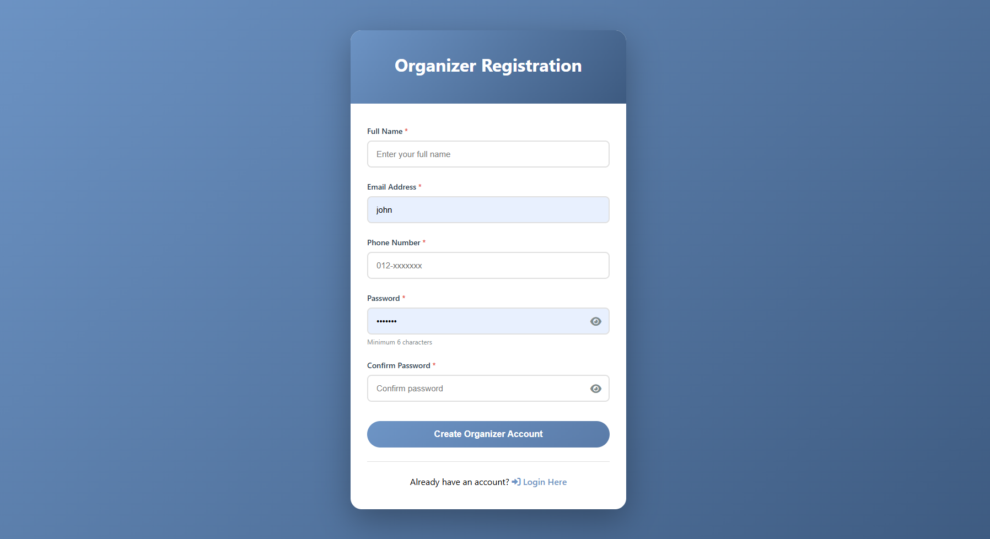

Figure 5.5: SmartAngler Organizer Registration Page

Figure 5.4 is the SmartAngler Organizer Request Access Page, which allows users to request access to become organizers in the SmartAngler system. The form collects important details of the applicant which including the afull name, email address, phone number, valid ID card number and tournament location. After submitting the request, the request is forwarded to the email of the system administrator to be reviewed. When approved, a link that will take the applicant to the registration page presented in Figure 5.5 is sent through email and the applicant can complete their account creation. This two-step authentication process will prevent the unauthorized users to create fake tournaments and only the legitimate individuals have access to the organizer privileges to manage fishing tournaments in the system.

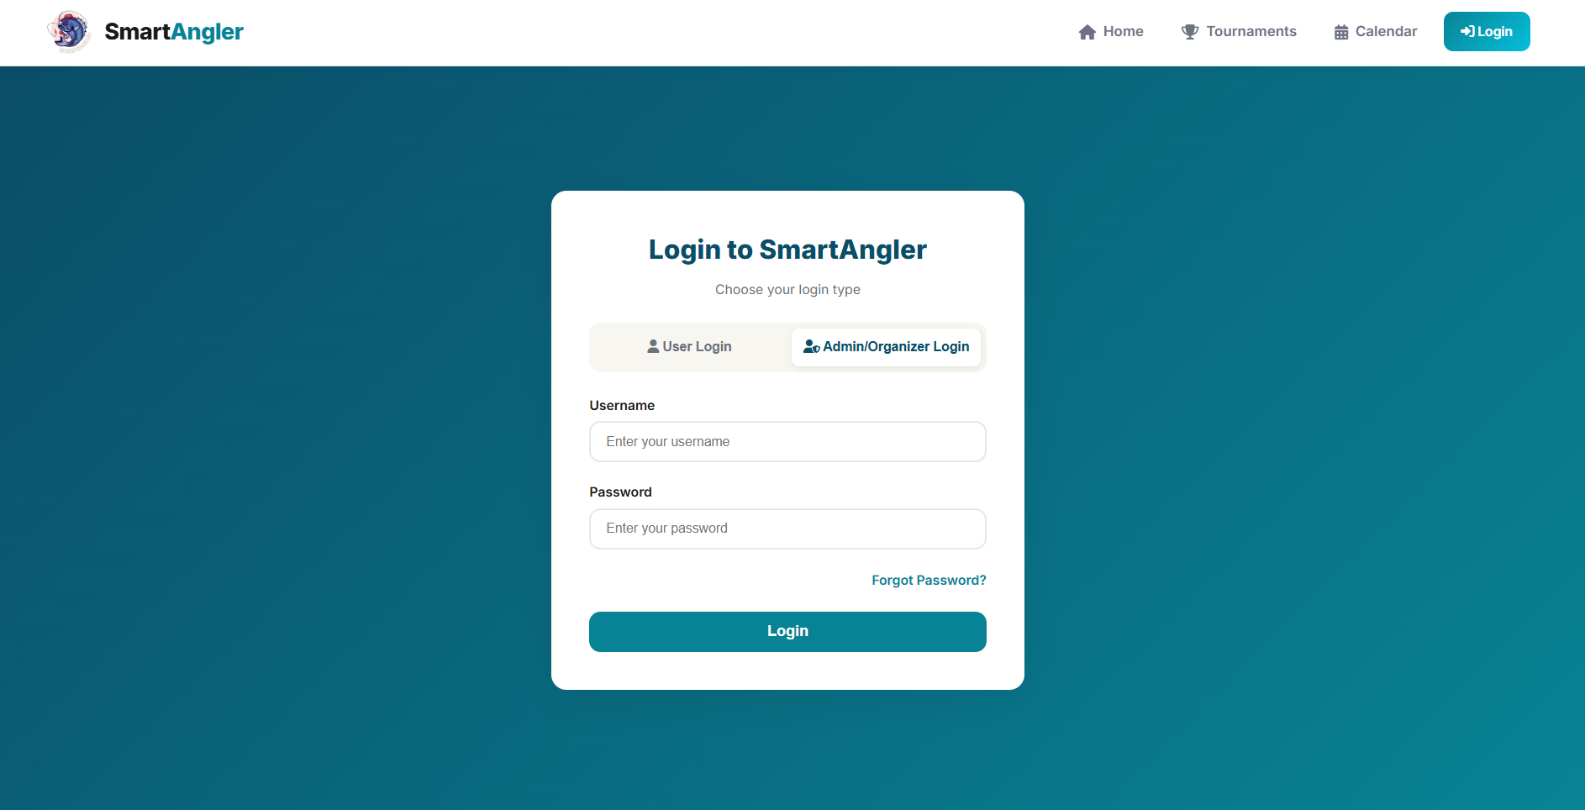

Figure 5.6: SmartAngler Organizer and Admin Login Page

Figure 5.6 shows the SmartAngler Organizer and Admin Login Page, which allows both organizers and system administrators to log in into their accounts on the platform. Users enter their registered email or username, and password to log in. This page provides a secure gateway, ensuring that only authorized organizers and admins can access the system to manage tournaments, view requests, and perform administrative tasks.

1. Revenue Management

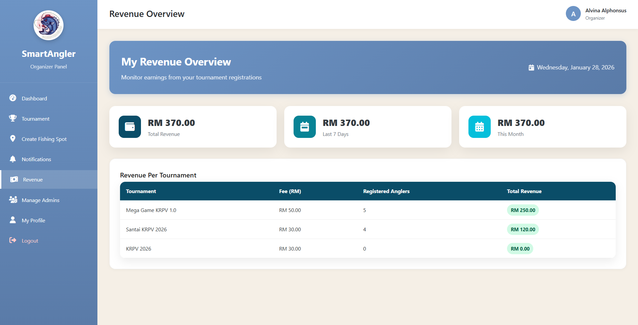

Figure 5.7: SmartAngler Organizer Revenue Overview Dashboard

Figure 5.7 shows the SmartAngler Organizer Revenue Overview Dashboard. This page allows organizers to track earnings from their tournaments. It displays the total revenue, revenue from the last 7 days, and revenue for the current month. Below that, a table breaks down revenue by tournament, showing the tournament name, registration fee, number of registered anglers, and total revenue earned from each event.

1. Admin Account Management

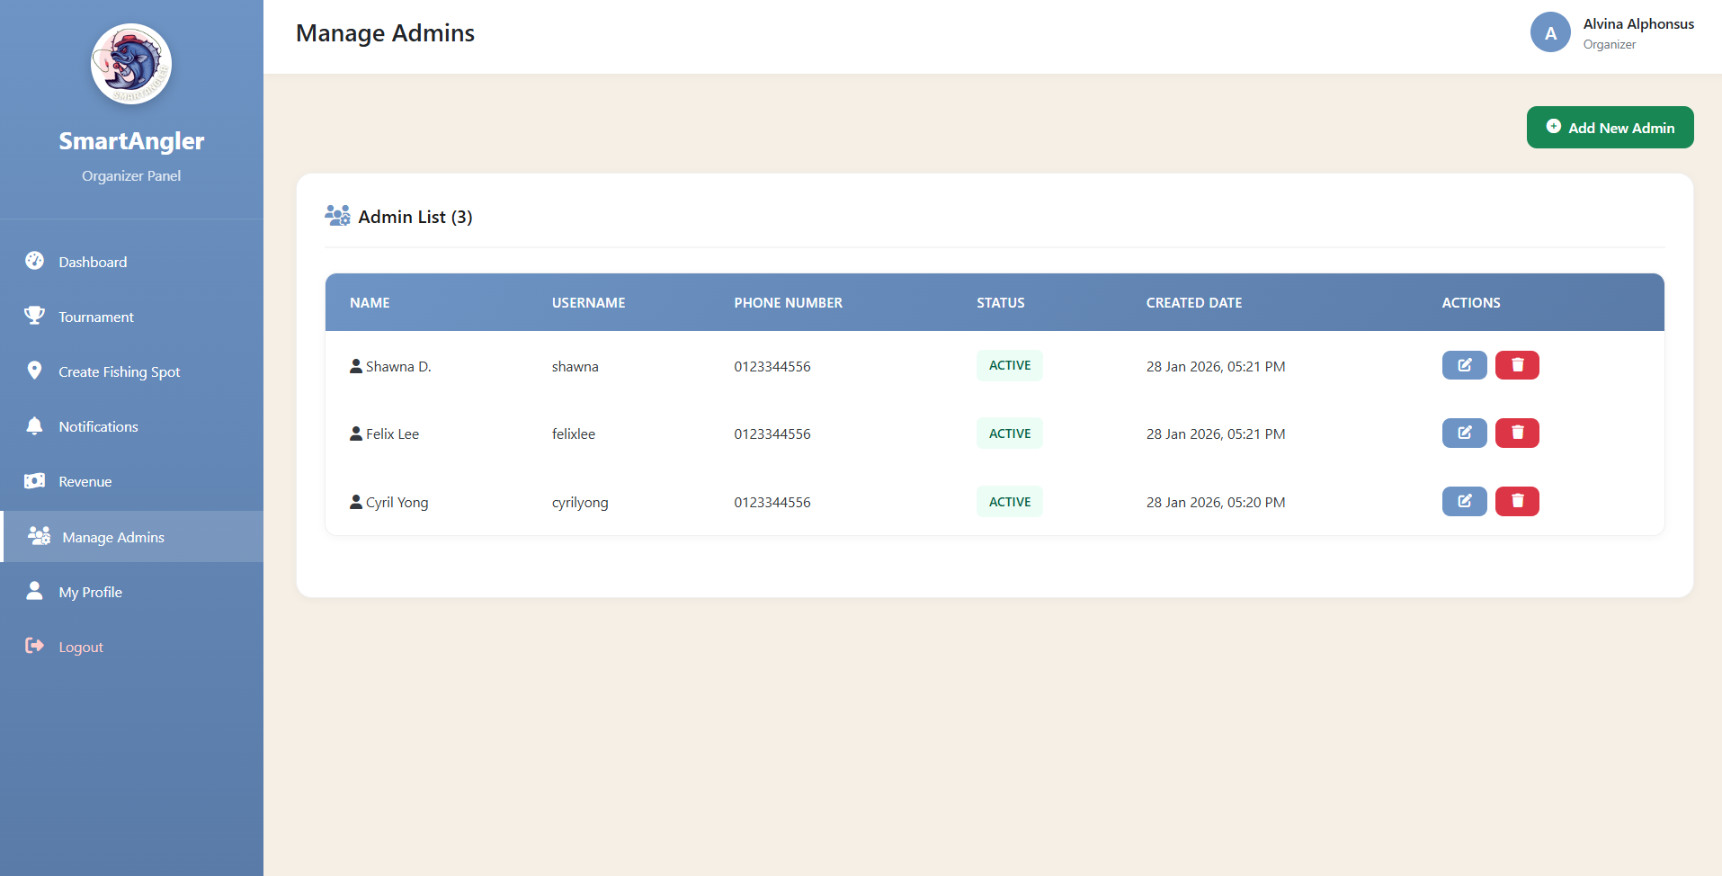

Figure 5.8: SmartAngler Admins Account Management Page

Figure 5.8 shows the SmartAngler Manage Admins Page, where organizers can view and manage all system administrators associated with their account. The page allows the organizer to add new admins, edit existing admin details, or remove admin access. This feature ensures that only authorized personnel can access and manage tournament and platform settings.

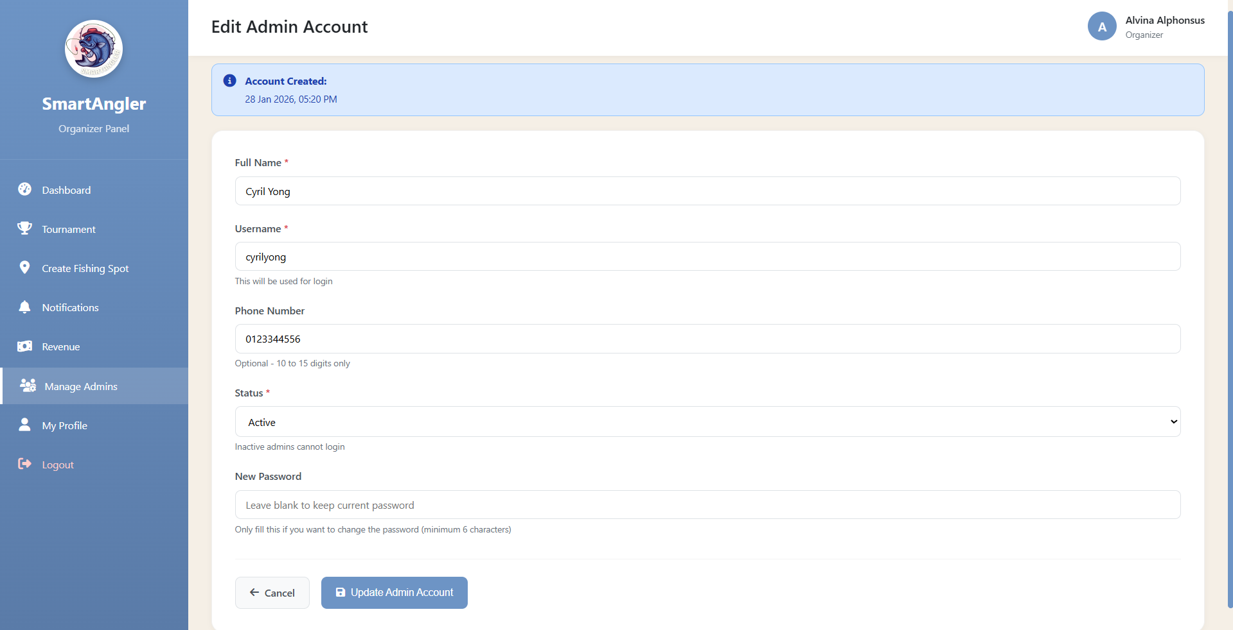

Figure 5.9: SmartAngler Edit Admins Account Page

Figure 5.9 shows the SmartAngler Edit Admins Account Page, where users can edit an administrator’s account details, such as their full name, email address, and role. The page allows the updated information to be saved, ensuring that the administrator’s account is properly updated in the system.

### 5.3.1 Admin Interface

Admin Interface is the part of the SmartAngler system used by admins, who act as workers for the organizers. Through this interface, admins can perform tasks such as creating and editing tournaments, managing participant information, recording fish catches, and maintaining all related data. It serves as the main workspace for admins to assist organizers in running events smoothly and keeping accurate records within the SmartAngler system.

1. Admin Dashboard

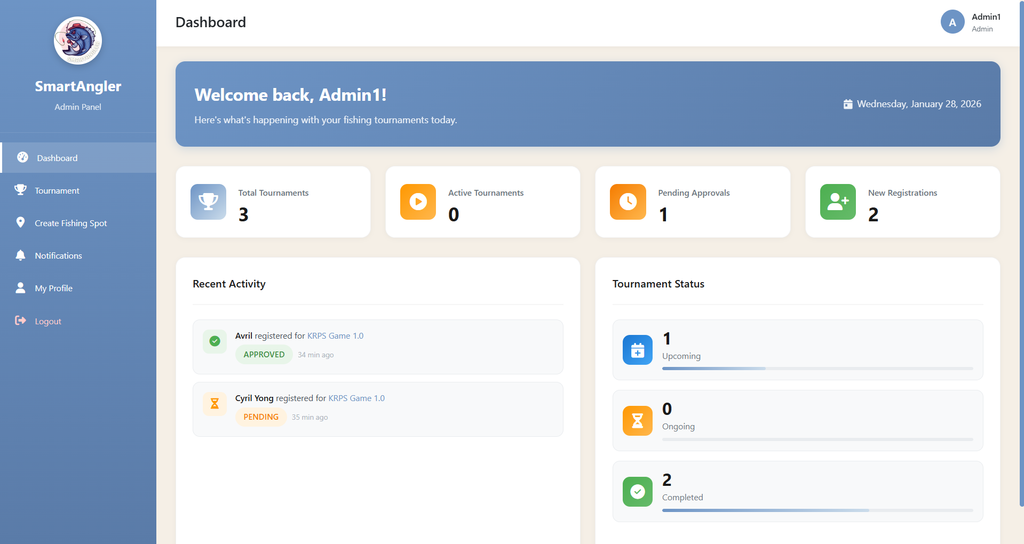

Figure 5.10: SmartAngler Admin Dashboard Page

Figure 5.10 is the main dashboard that serves as the control centre for administrators. It provides an overview of important system statistics such as the total number of tournaments, users and fishing spots, along with quick navigation to key management modules.

1. Tournament Management

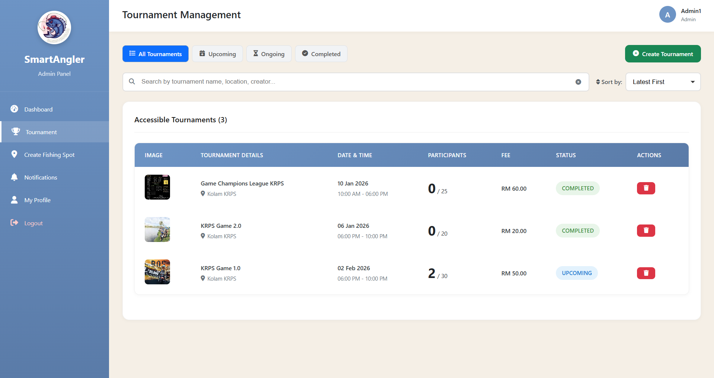

Figure 5.11: SmartAngler Tournament Management Page

Figure 5.11 is the page that allows administrators to manage all fishing tournaments. It displays a list of existing tournaments and provides options to create new ones, edit details or delete outdated tournaments.

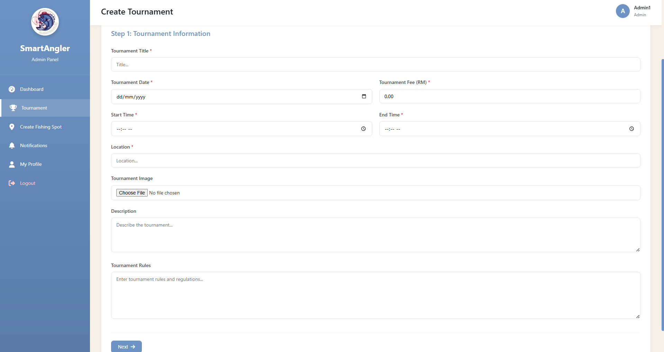

**Figure 5.12: SmartAngler Create Tournament Page (Tournament Information)**

Figure 5.12 show a form to create a tournament with information such as title, date, time, location, and description of the tournament. It ensures that all important details are filled in an organized way for smooth tournament planning. After clicking next, it will redirect to payment information page.

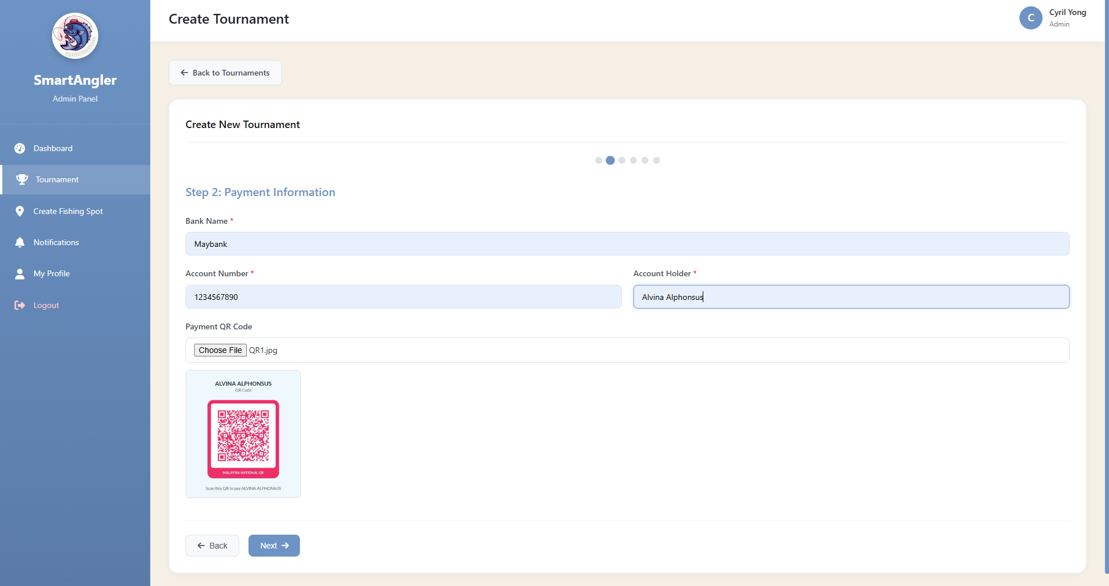

**Figure 5.13: SmartAngler Create Tournament Page (Payment Information)**

Figure 5.13 allows administrators to fill in payment information for the tournament which including bank number, account number, account holder and bank code for easy payment. This helps keep the registration process transparent and clear to participant.

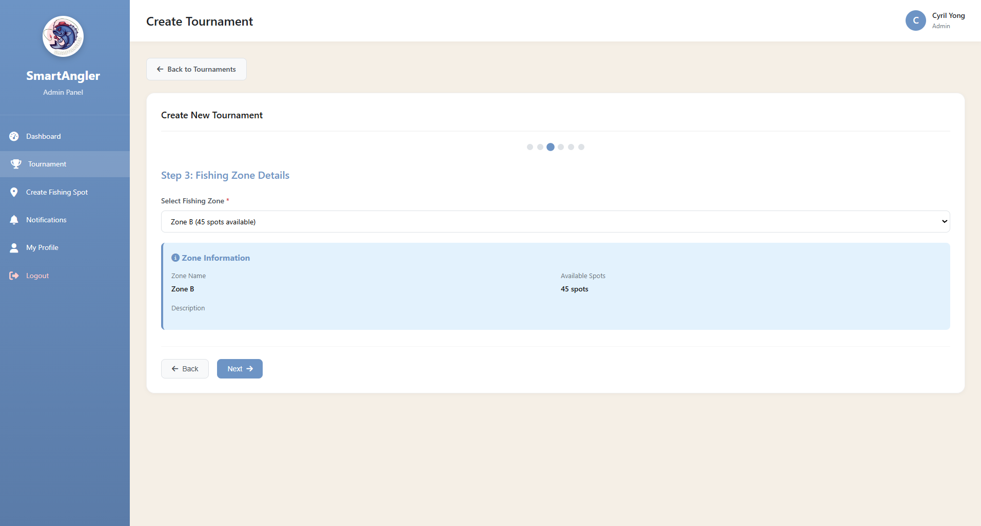

**Figure 5.14: SmartAngler Create Tournament Page (Tournament Fishing Zone)**

Figure 5.14 shows the page for selecting fishing zones for a tournament. Admin can choose from available zones based on the selected tournament date and time to make sure proper allocation of zone for the tournament game.

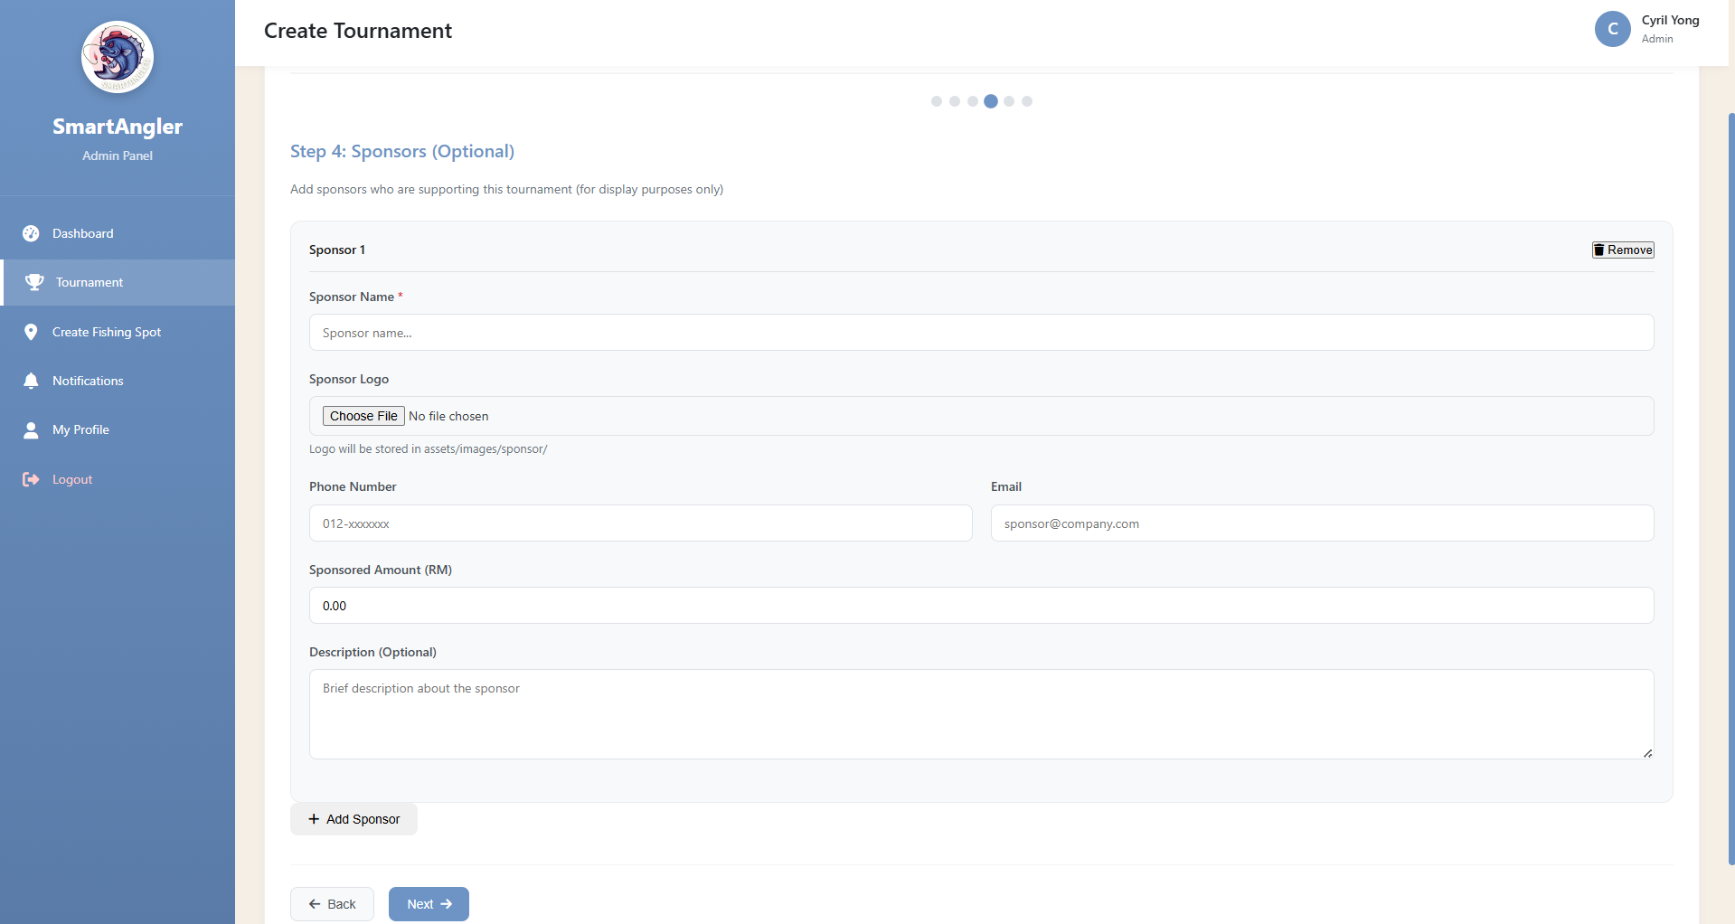

**Figure 5.15: SmartAngler Create Tournament Page (Sponsor Information)**

Figure 5.15 shows the section for adding sponsor details. Sponsors can be optionally added during tournament creation, making it easy to manage sponsorships and associate them with the event.

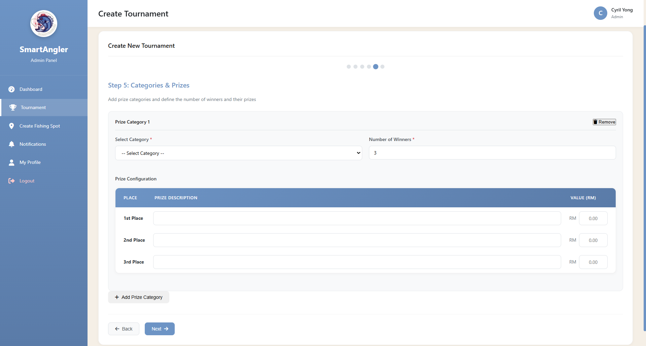

**Figure 5.16: SmartAngler Create Tournament Page (Prize Information)**

Figure 5.16 illustrates the prize management section during tournament creation. It allows administrators to select prize categories, add prizes rank and provide details such as the prize value and description. This feature ensures that all tournament rewards are clearly organized and easily managed.

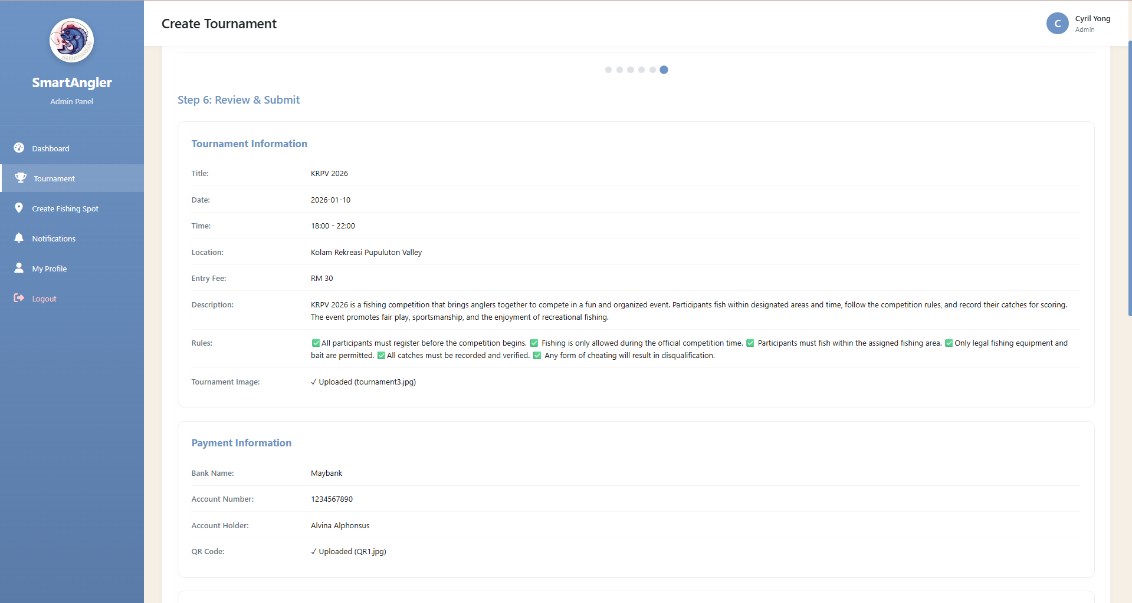

**Figure 5.17: SmartAngler Tournament Review Page 1**

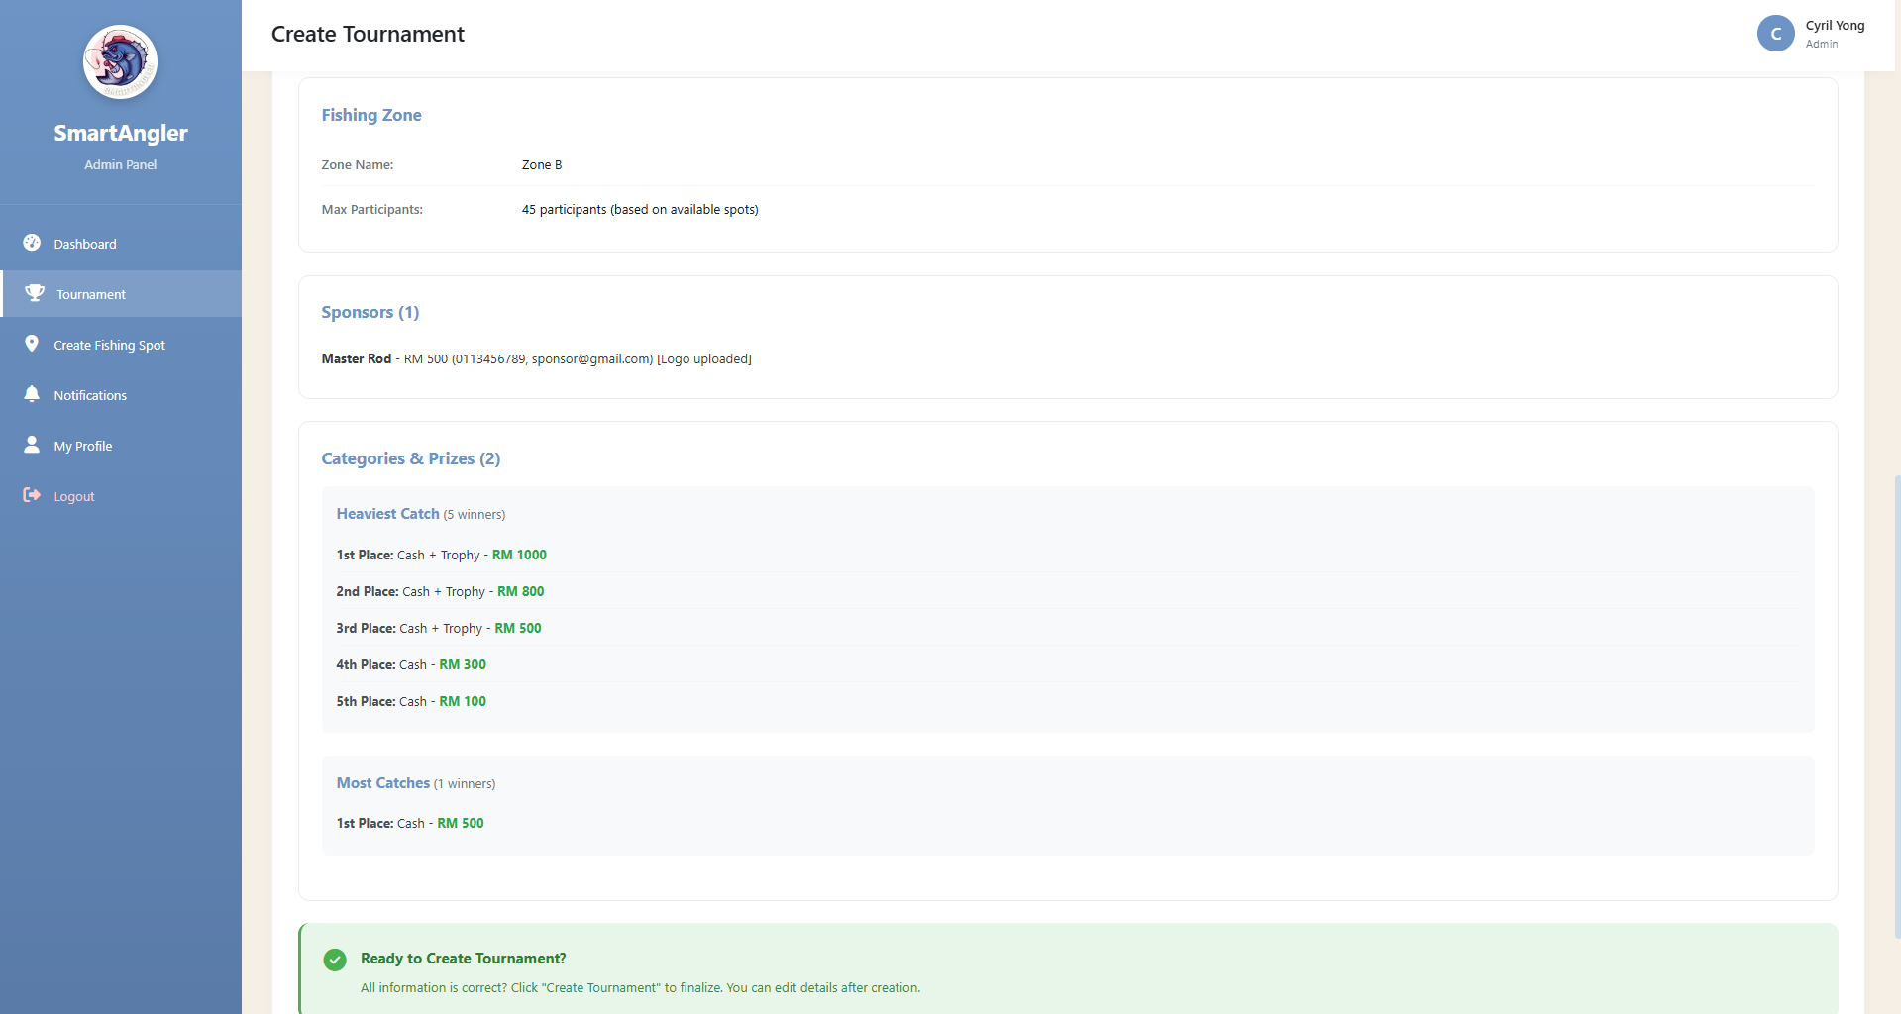

**Figure 5.18: SmartAngler Tournament Review Page 2**

Figure 5.17 and Figure 5.18 shows the confirmation screen for creating a new tournament. It will display the details of the tournament that was inserted earlier in a simple one page view. This will allow the admin to review the input data easier and finalize the tournament details before creating the tournament.

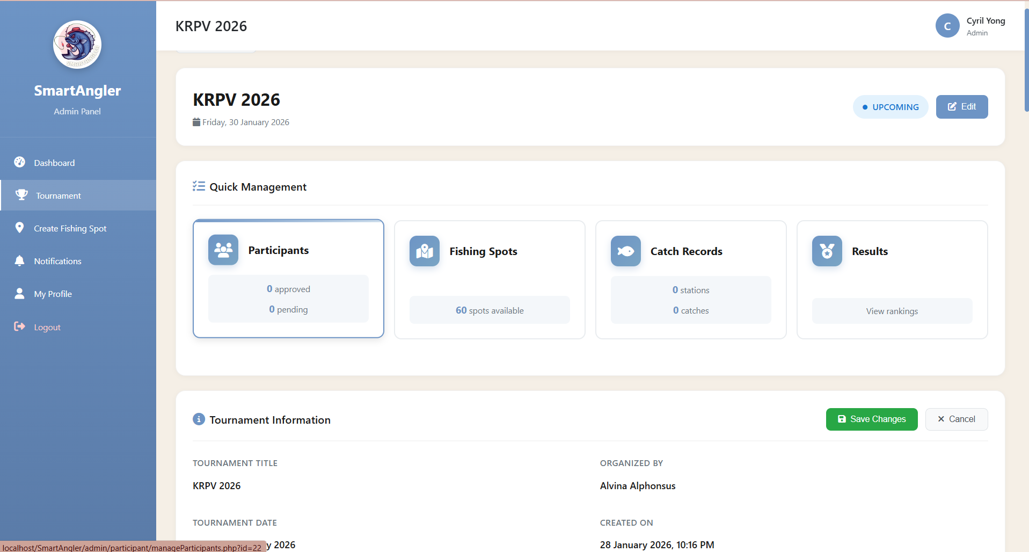

**Figure 5.19: SmartAngler Tournament Management Details Page**

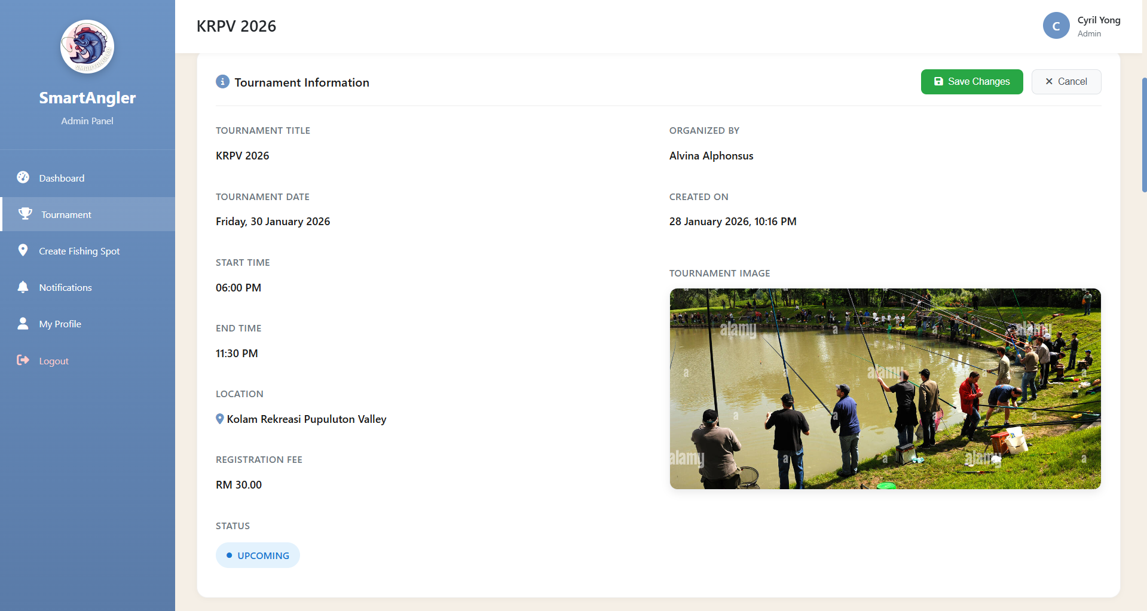

**Figure 5.20: SmartAngler Tournament Management Details Page (Tournament Details)**

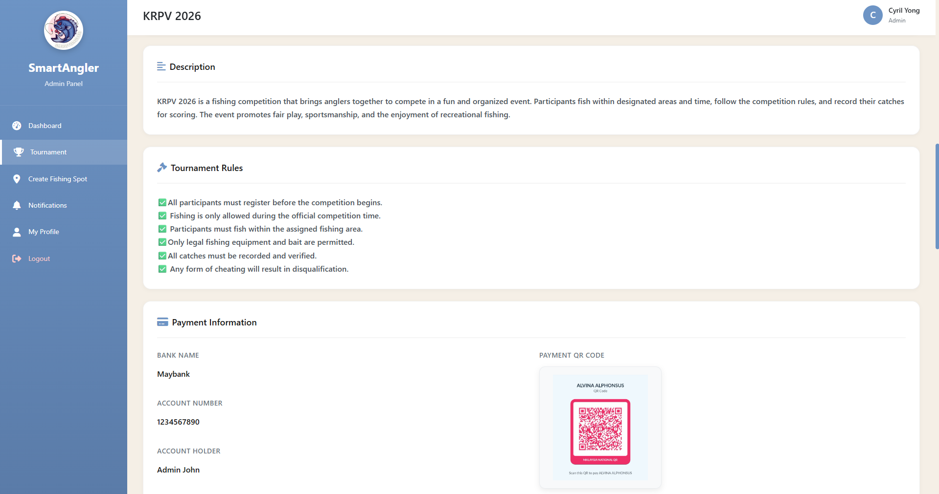

**Figure 5.21: SmartAngler Tournament Management Details Page (Payment Details)**

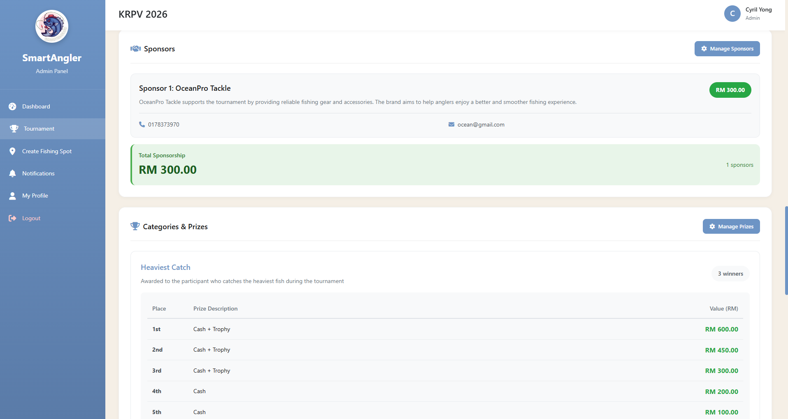

**Figure 5.22: SmartAngler Tournament Management Details Page (Sponsor and Prize Details)**

Figures 5.19 to 5.22 show the SmartAngler Tournament Management pages that appear after a tournament is created. The admin can review all tournament information in a clear and organized manner, including the general tournament details, payment information, and sponsor and prize details. These pages also allow the admin to manage and edit any aspect of the tournament as needed, providing a central hub for efficiently overseeing and updating all tournament-related data.

1. Sponsor Management

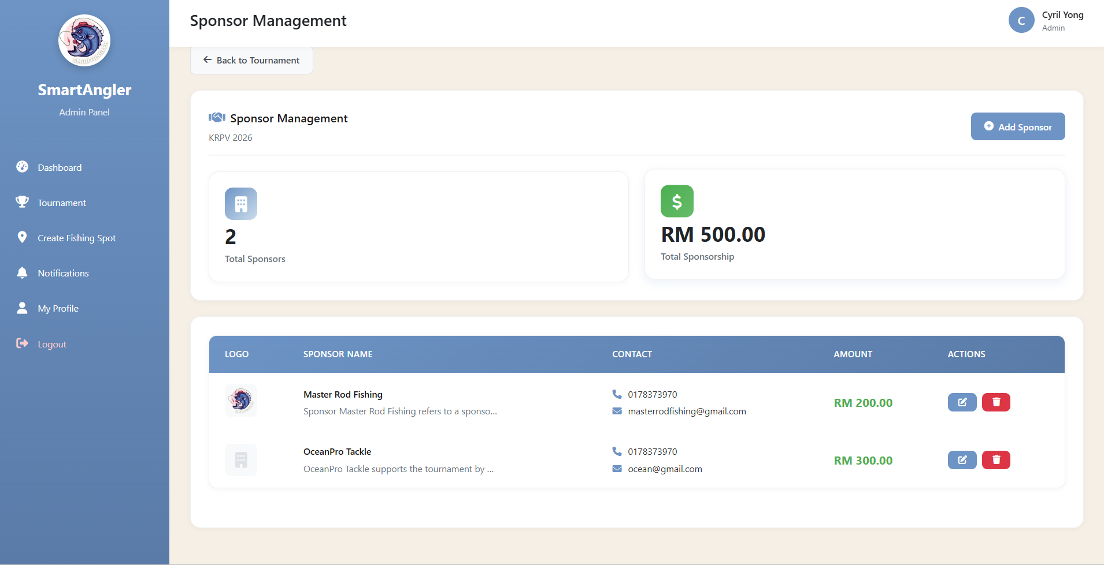

**Figure 5.23: SmartAngler Sponsor Management Details Page**

Figure 5.23 shows a list of all sponsors in a tournament. This giving admins the ability to manage their information efficiently.

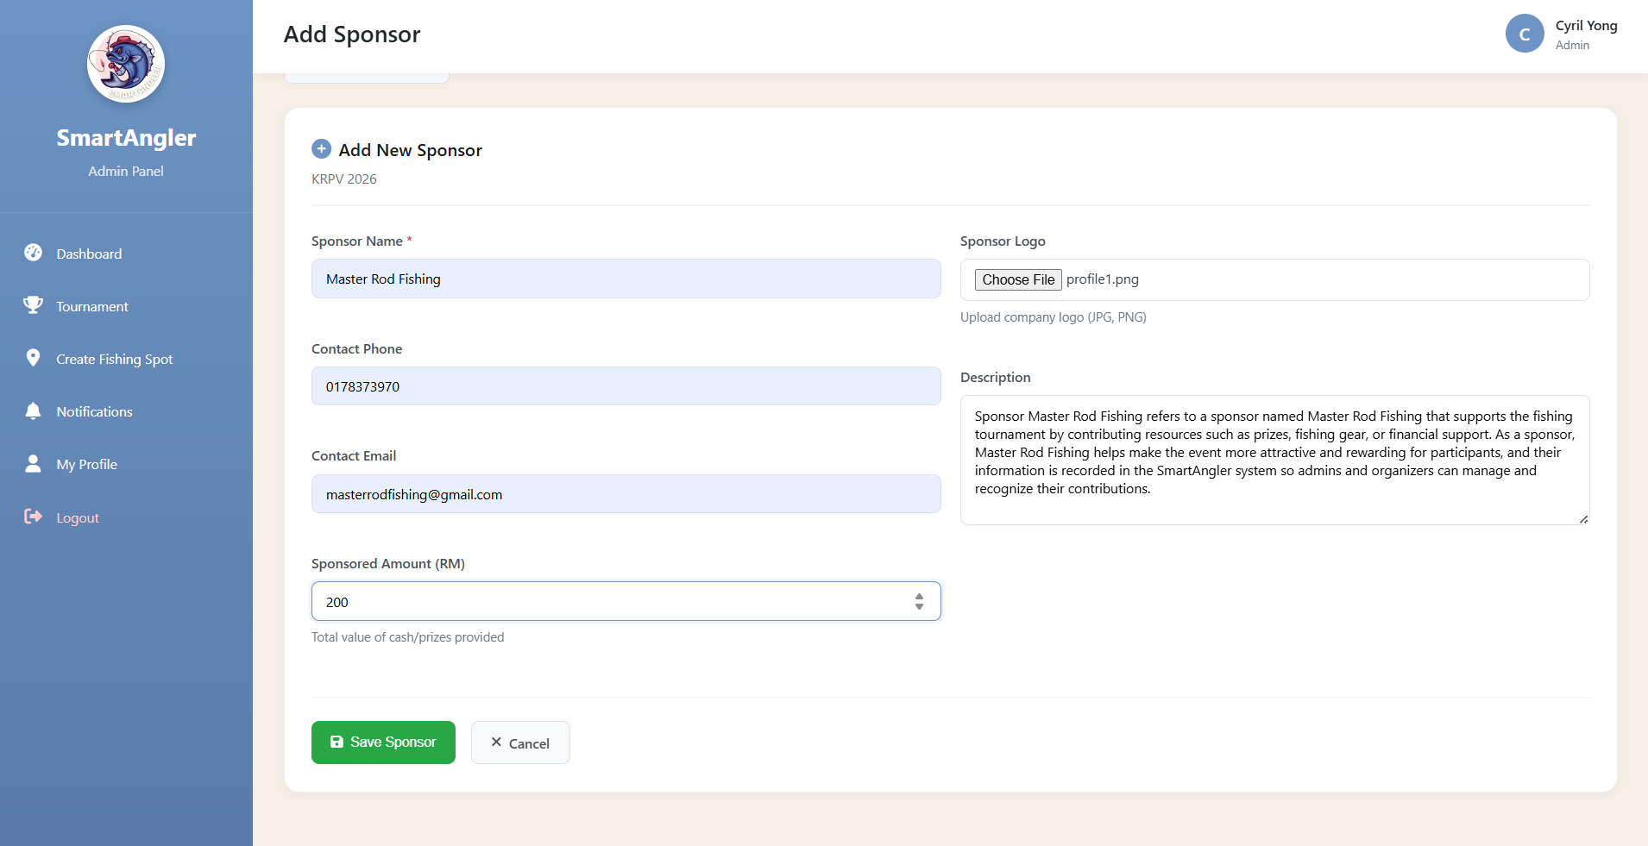

**Figure 5.24: SmartAngler Add Sponsor Details Page**

Figure 5.24 displays a form for adding new sponsors. This feature helps keep the sponsor list up to date and complete and also allows administrators to add sponsors even after a tournament has already been created.

1. Prize Management

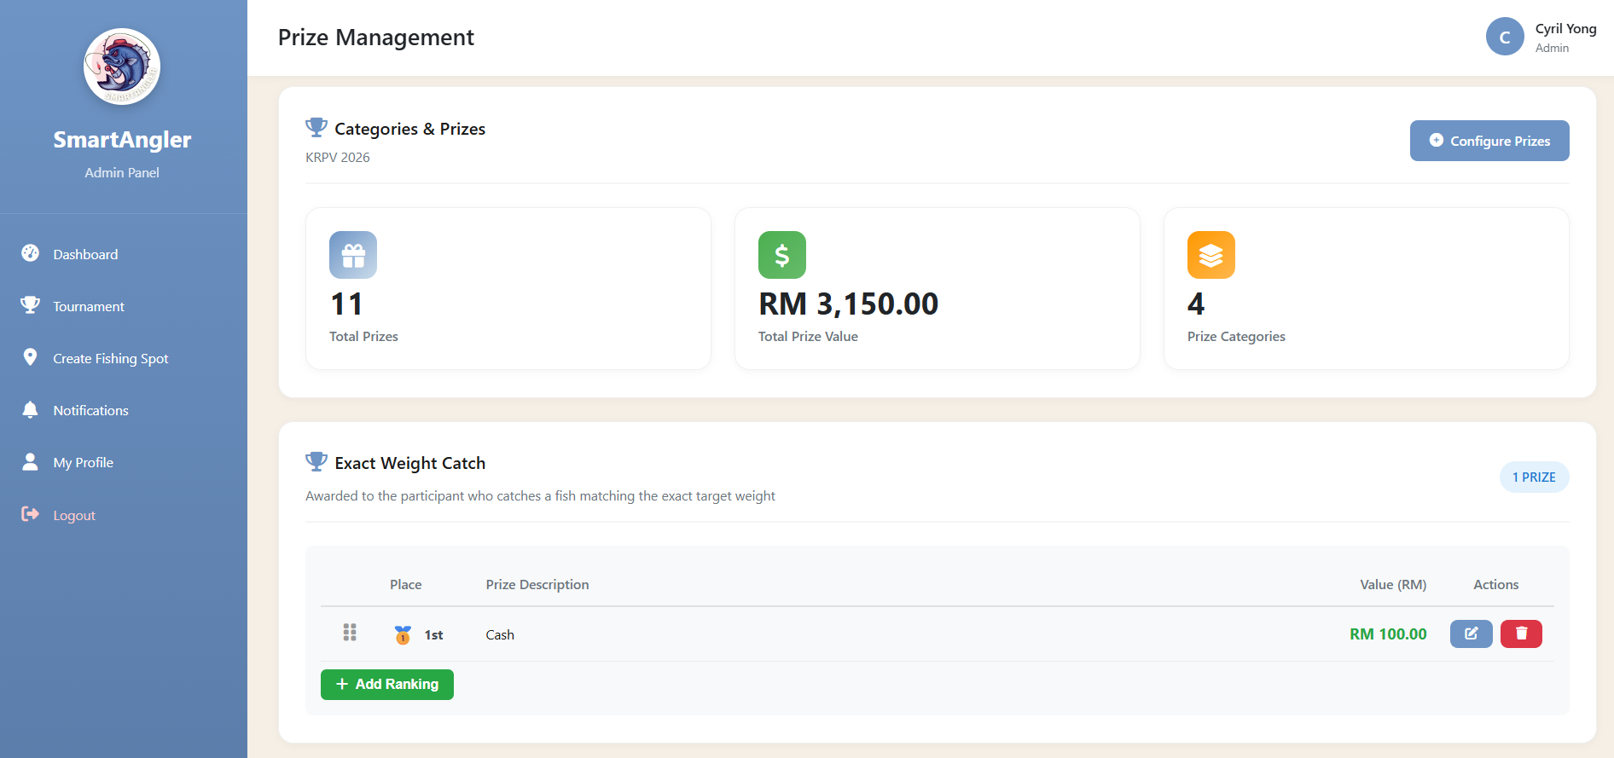

**Figure 5.25: SmartAngler Prize Management Details Page**

Figure 5.25 allows admins to review all prizes linked to tournaments. This ensuring transparency and proper prize management.

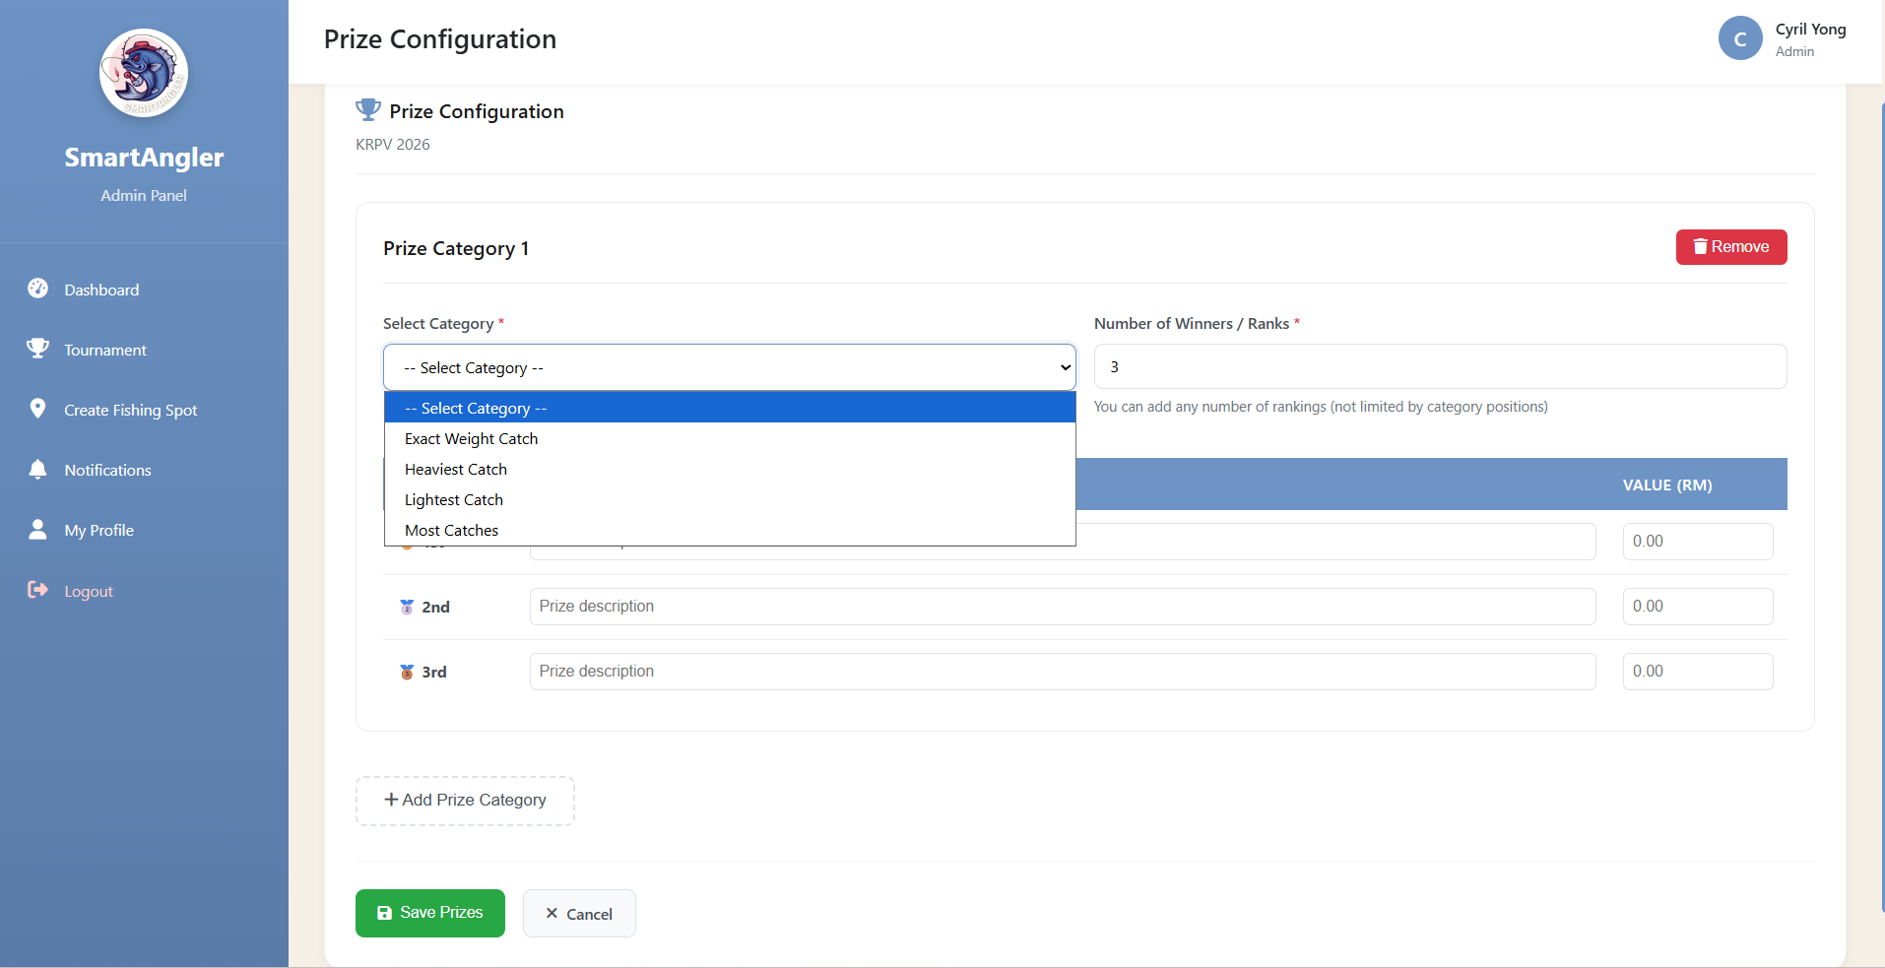

**Figure 5.26: SmartAngler Add Prize Details Page**

Figure 5.26 provides an easy way to add new prizes, including ranking and value, helping tournaments maintain a structured reward system.

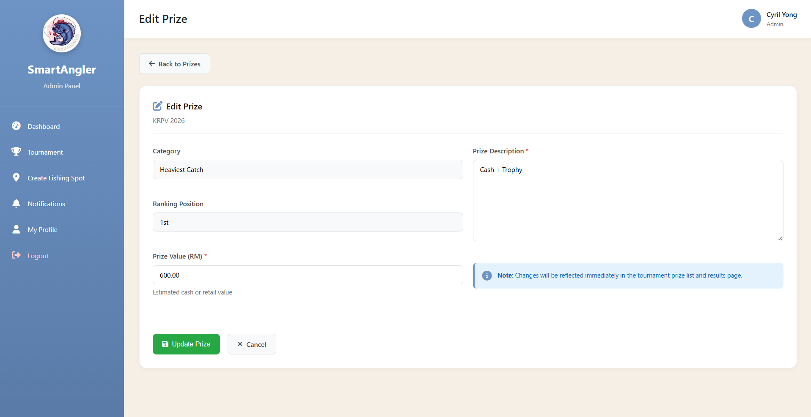

Figure 5.27: SmartAngler Edit Prize Details Page

Figure 5.27 shows the SmartAngler Edit Prize Details Page, where the admin can update prize information for a tournament. This page allows the admin to edit details such as prize value and description, ensuring that all prize information is accurate and up to date.

1. Participant Management

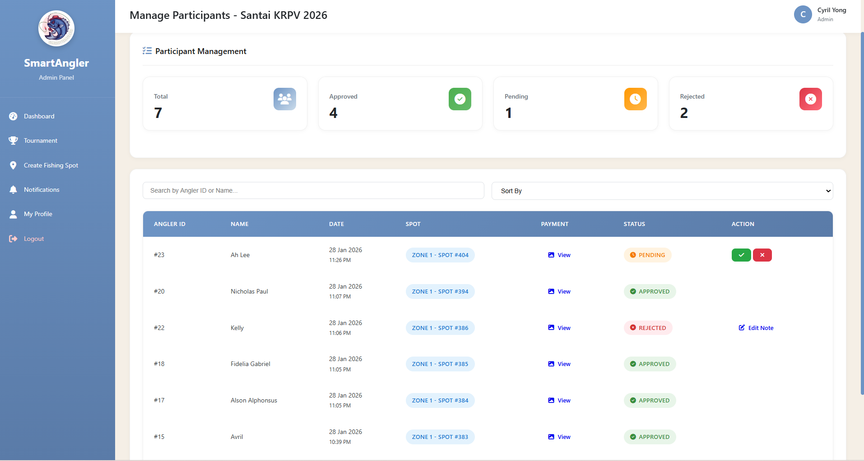

Figure 5.28: SmartAngler Manage Participants Page

Figure 5.28 shows the page where the admin manages participant approvals. This page allows the admin to view the list of registered participants, manage their registration status, and take actions such as approving or rejecting participants for the tournament.

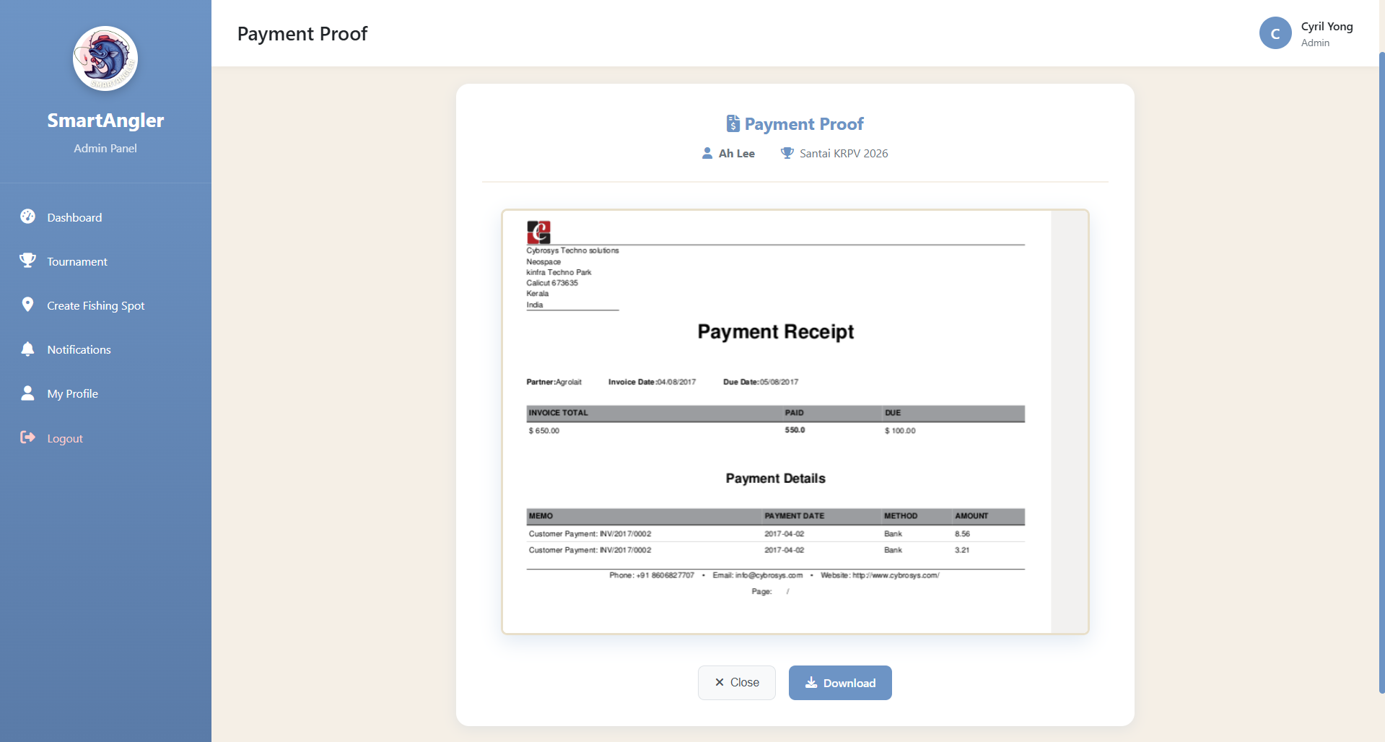

Figure 5.29: SmartAngler Payment Proof Page

Figure 5.29 shows the page where the admin reviews participant payment proof. This page allows the admin to view the uploaded payment receipt and verify the payment before approving the participant’s registration.

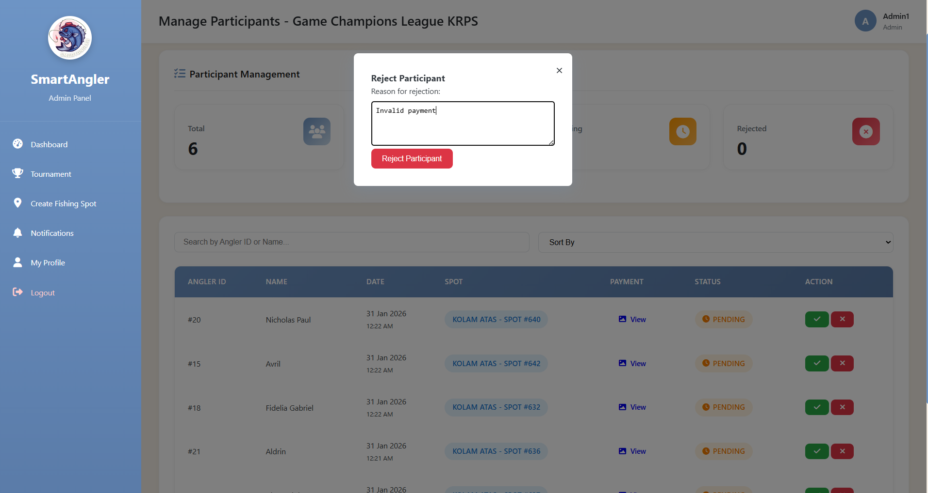

Figure 5.30: SmartAngler Reject Participant Dialog Pop Up

Figure 5.30 shows the reject participant dialog pop-up. This pop-up appears when the admin chooses to reject a participant and allows the admin to confirm the rejection action and provide a reason if required.

1. Fishing Spot Management

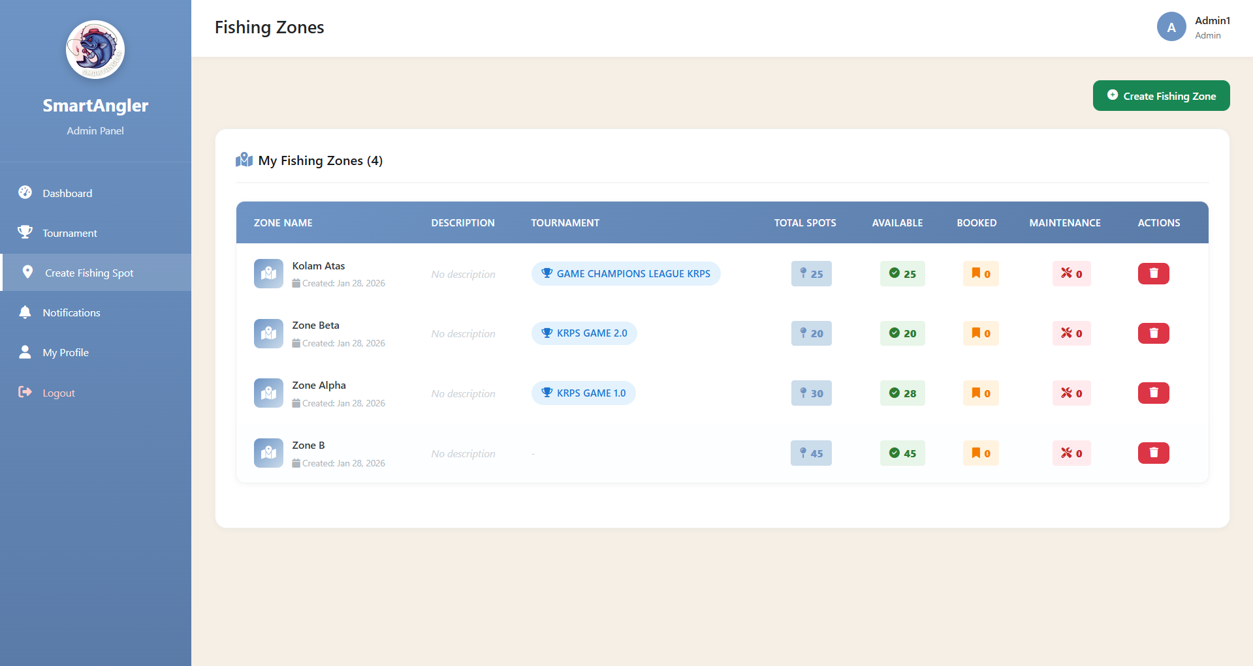

Figure 5.31: SmartAngler Fishing Zone Management Page

Figure 5.31 is the SmartAngler Fishing Spot Management Page which displays a list of all available fishing zones and allows the admin to manage, edit or remove them.

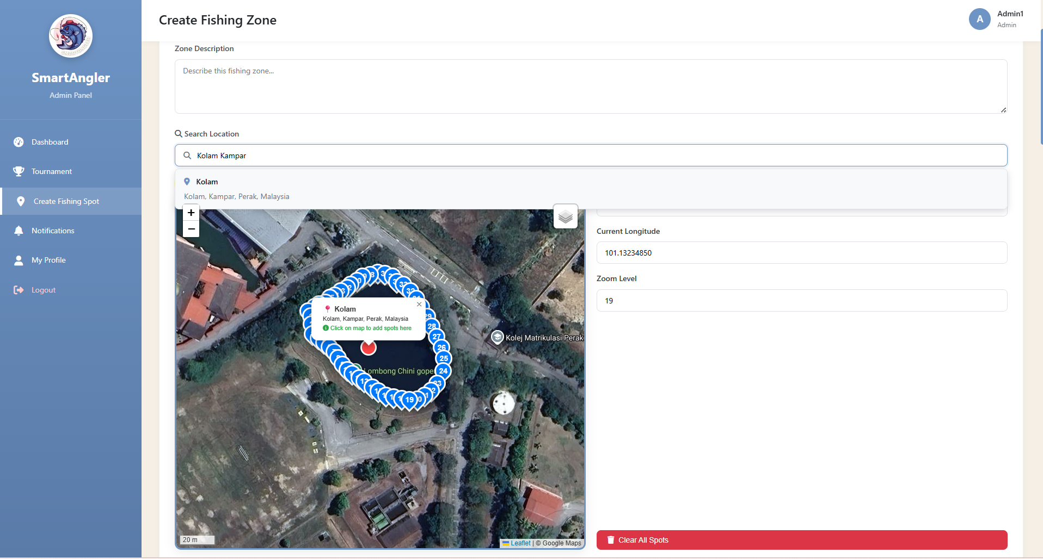

Figure 5.32: SmartAngler Add Fishing Spot Page

Figure 5.32 is the SmartAngler Add Fishing Spot Page which allows the admin to add a new fishing zone and list all available spots within that zone. The admin can click on the interactive map to mark each spot, and the system will automatically display the longitude and latitude coordinates.

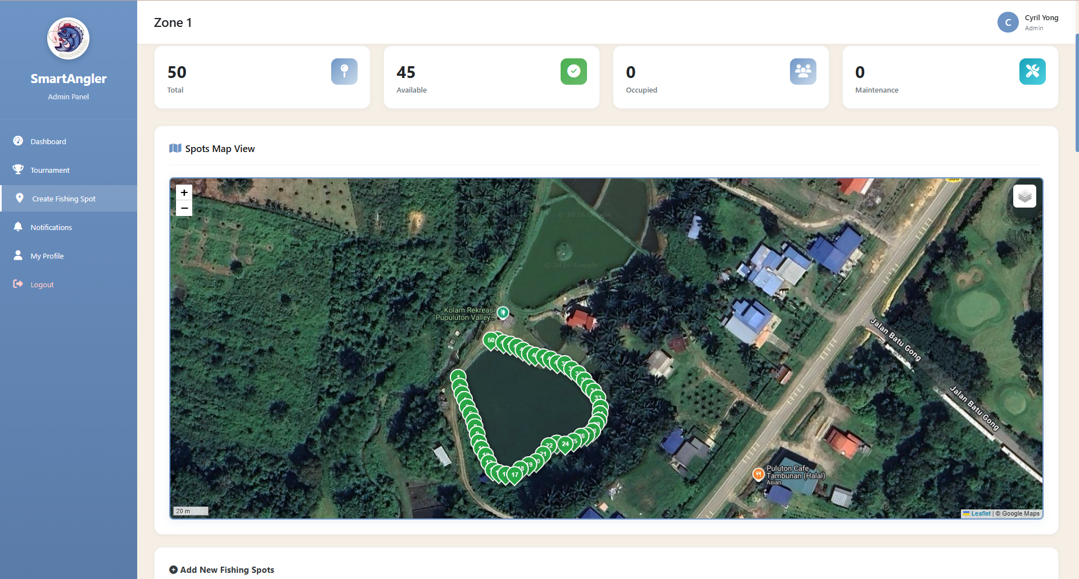

Figure 5.33: SmartAngler Fishing Zone Management Page 1

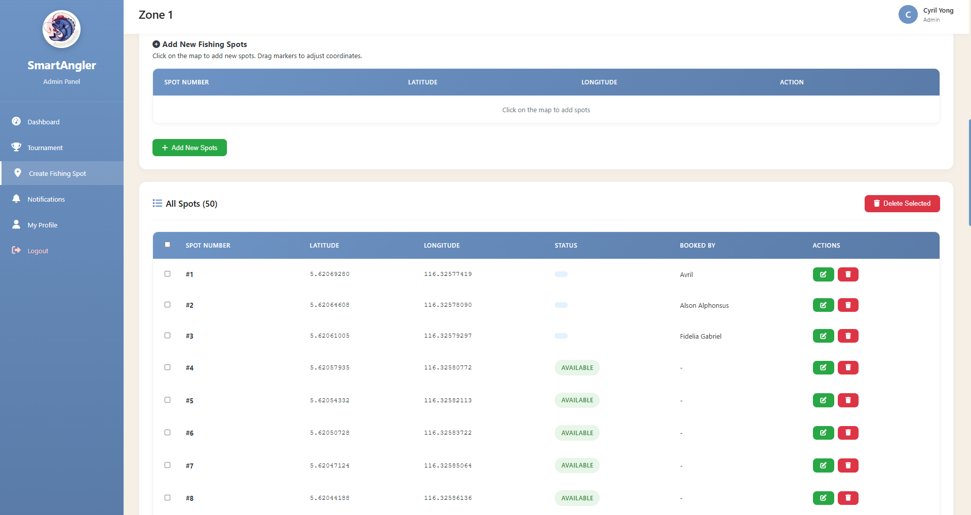

Figure 5.34: SmartAngler Fishing Zone Management Page 2

Figure 5.33 and Figure 5.34 show the pages used to manage fishing zones in the SmartAngler system. These pages allow the admin to edit fishing zone details, view the status of each fishing spot, add new fishing spots when needed, and delete existing spots.

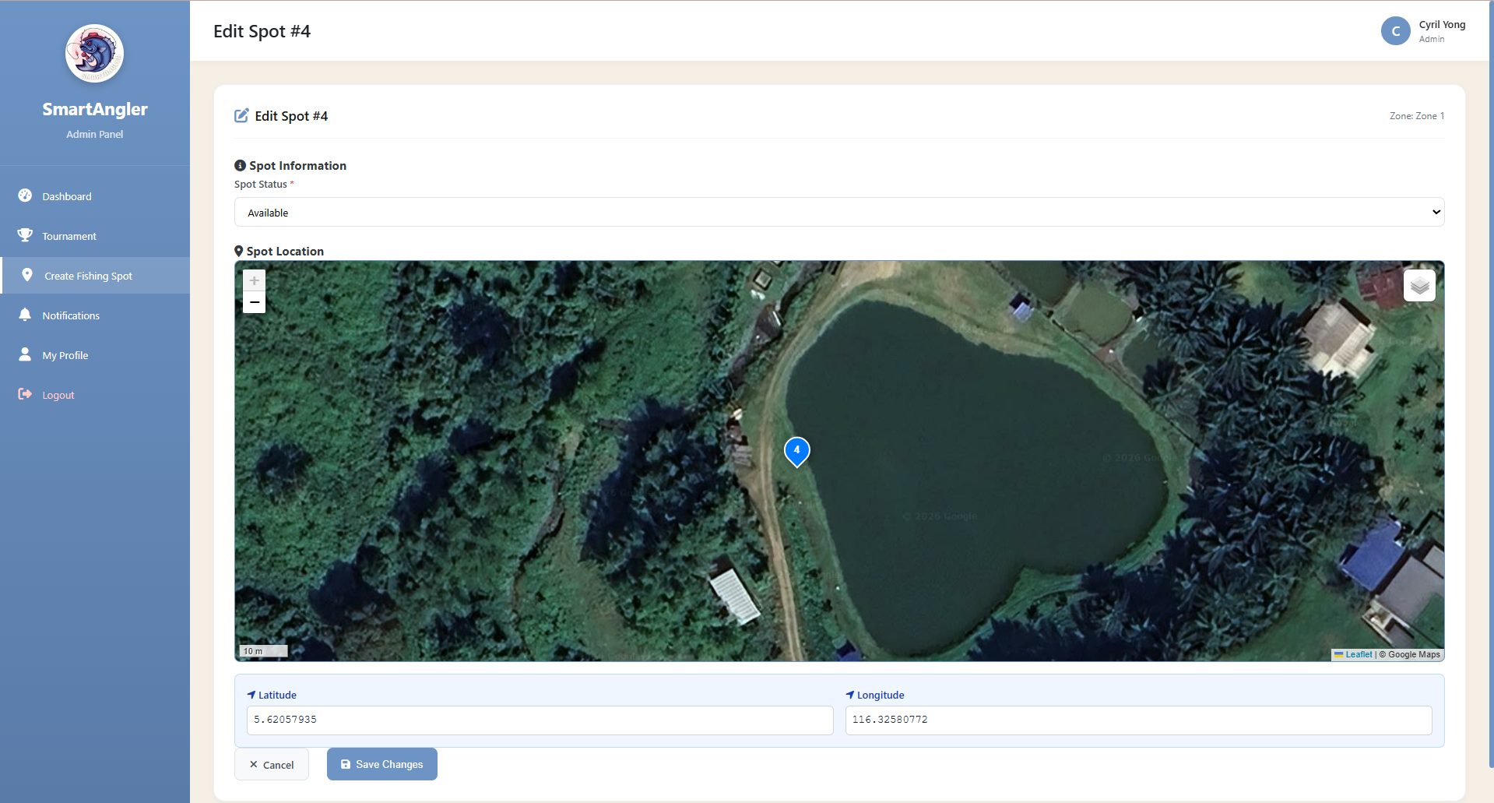

Figure 5.35: SmartAngler Edit Fishing Spot Location Page

Figure 5.35 shows the SmartAngler Edit Fishing Spot Location Page, where the admin can update the fishing spot’s location and status to ensure the information is accurate and up to date.

1. Fish Catch Record Management

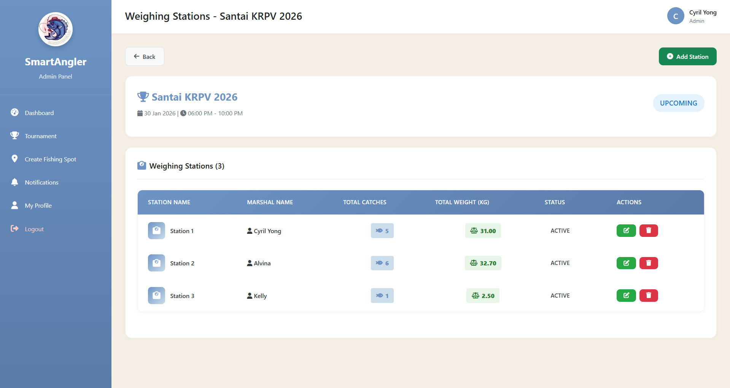

Figure 5.36: SmartAngler Weighing Station Management Page

Figure 5.36 is the page that displays the list of weighing stations available for the selected tournament. The administrator can choose a specific station to manage or view fish catch activities taking place at that location.

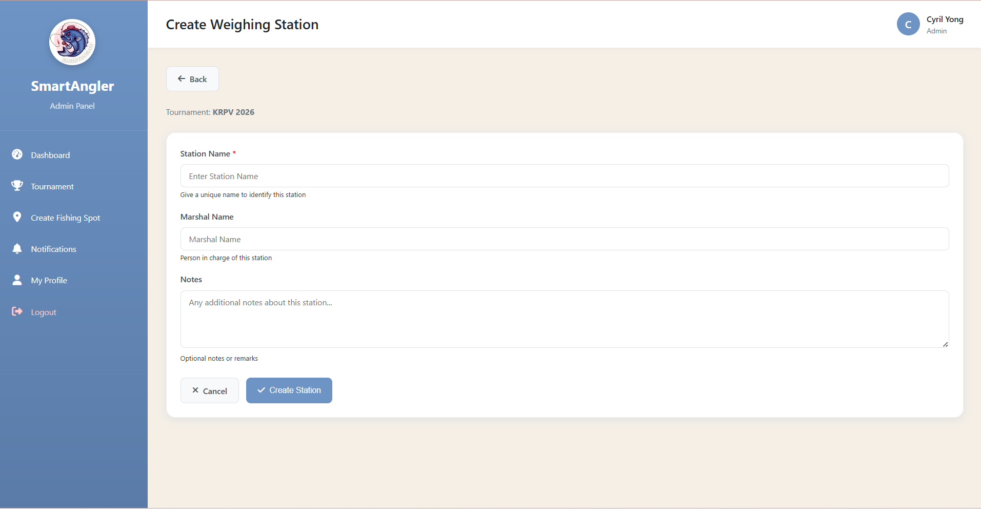

Figure 5.37: SmartAngler Create Weighing Station Page

Figure 5.37 is the page used to create a new weighing station by entering relevant details such as the station name, marshal name who responsible for managing it and notes.

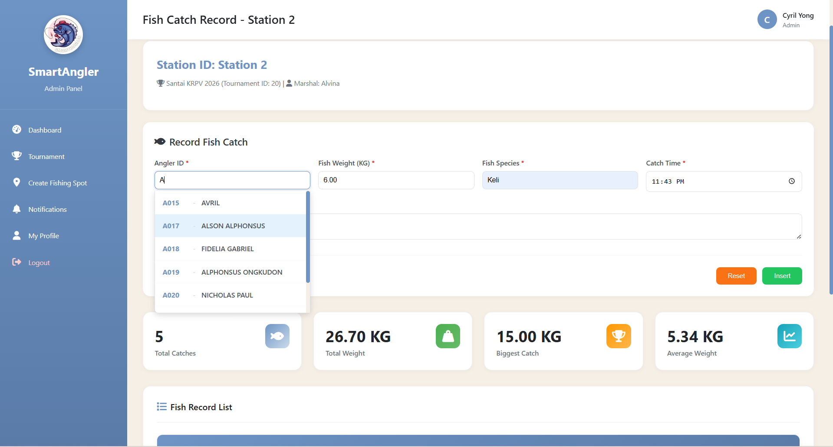

Figure 5.38: SmartAngler Fish Catch Record Page 1

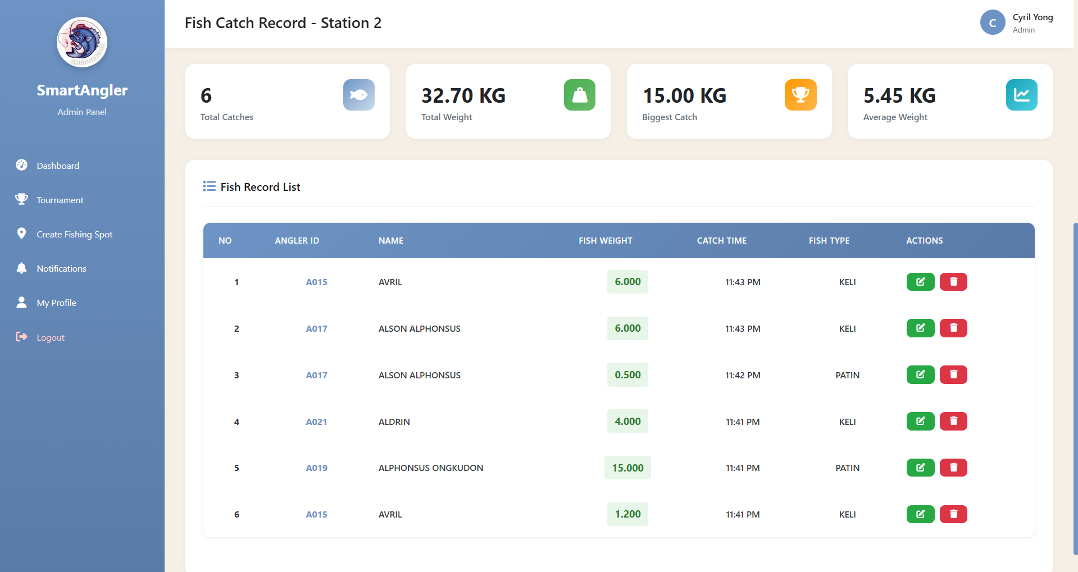

Figure 5.39: SmartAngler Fish Catch Record Page 2

Figure 5.38 and Figure 5.39 show the SmartAngler Fish Catch Record pages. These pages allow the admin to record, view, and manage fish catch details, including the participant, fish species, weight, and catch status, ensuring accurate and well-organized tournament records.

1. Result Management

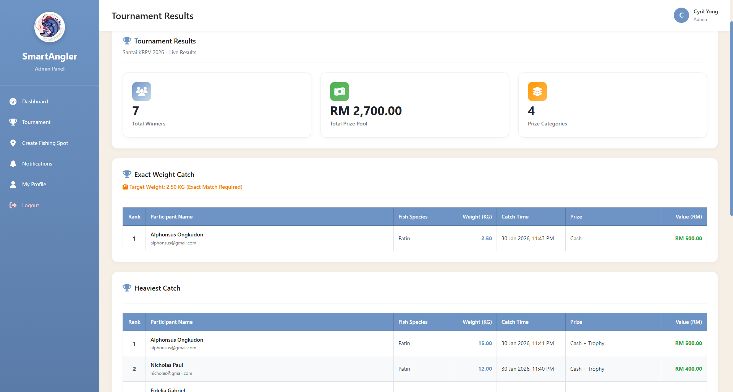

Figure 5.40: SmartAngler Live Result Management Page 1

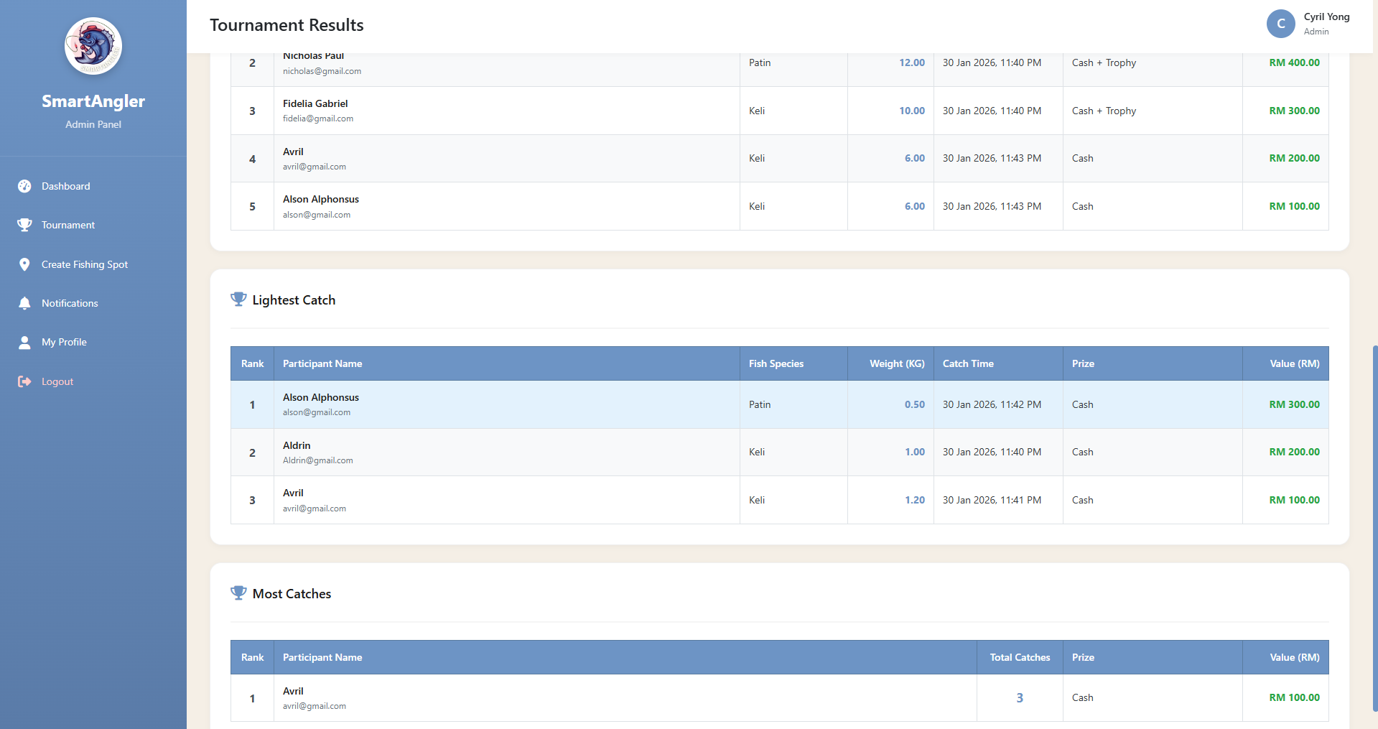

Figure 5.41: SmartAngler Live Result Management Page 2

Figure 5.40 and Figure 5.41 show the SmartAngler Live Result Management pages. These pages allow the admin to manage and update live tournament results, including participants’ scores, rankings, and catch details, ensuring that real-time results are accurately displayed and maintained throughout the event.

1. Notification Management

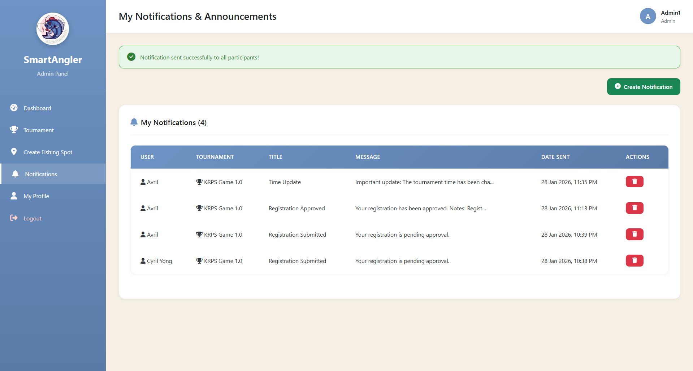

Figure 5.42: SmartAngler Notification Management Page

Figure 5.42 shows the SmartAngler Notification Management Page, where the admin can view and manage all notifications sent to users, keeping track of messages and updates in one place.

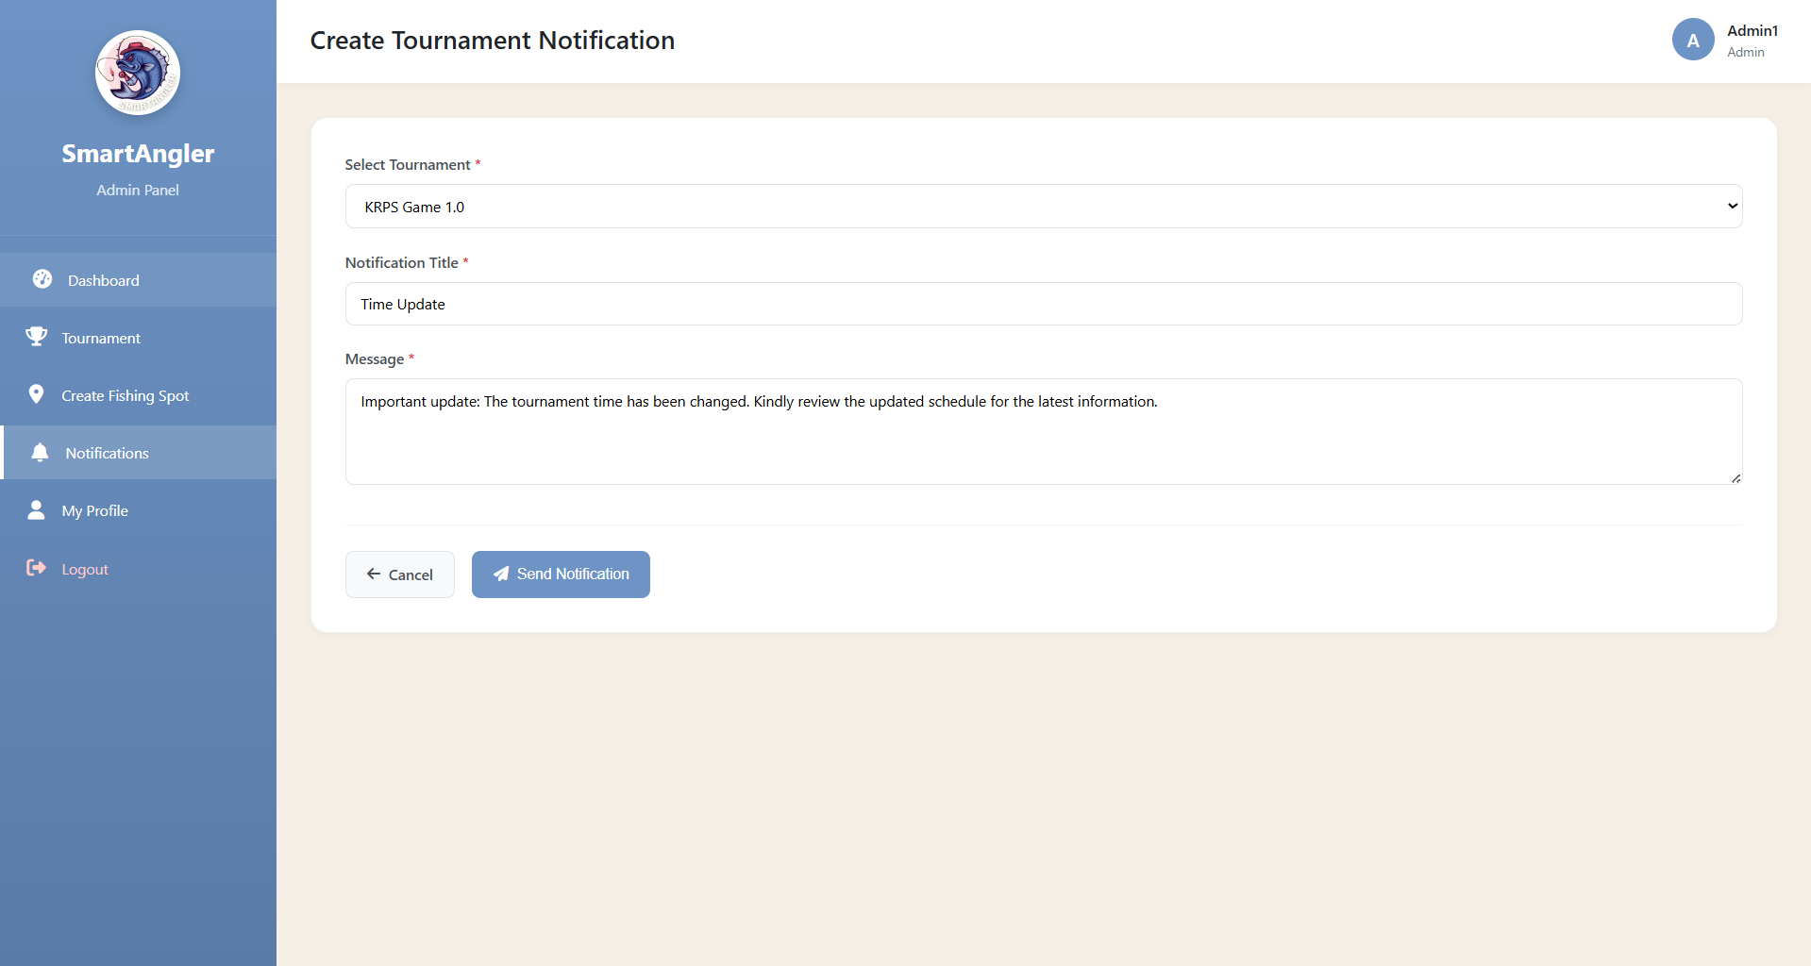

Figure 5.43: SmartAngler Create Notification Page

Figure 5.43 shows the SmartAngler Create Notification Page, where the admin can create and send new notifications to participants or other users.

### 5.3.2 User Interface

The User Interface was designed to make it simple and interactive for anglers to use the system. Users can register for tournaments, view event details and check their progress or results. The interface is easy to navigate and responsive, making it accessible on different devices. Features such as interactive maps for fishing zones and live result updates help users stay engaged and informed. Overall, the User Interface ensures that anglers can participate in tournaments smoothly while having a clear and organized view of all relevant information.

1. Angler Homepage

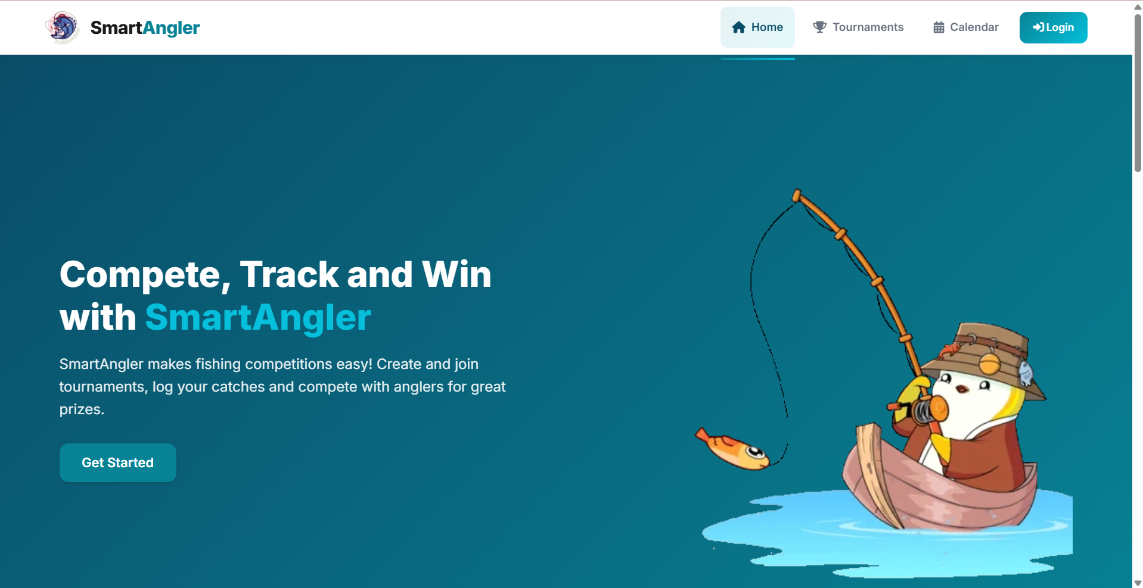

**Figure 5.44: SmartAngler Landing Page 1**

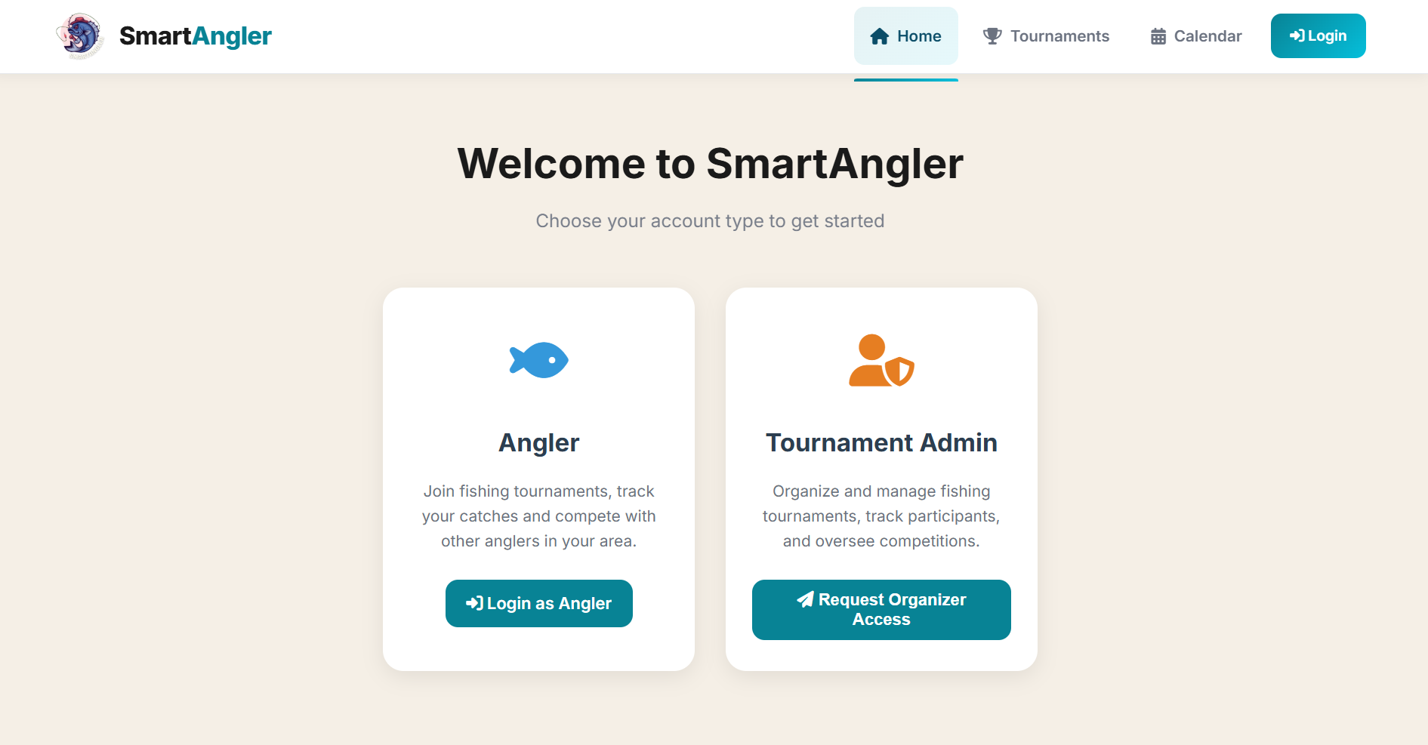

**Figure 2.45: SmartAngler Account Type Selection Page**

Figure 2.45 shows the SmartAngler Account Type Selection Page, where a user can choose their account type as either an Angler or a Tournament Organizer to access the appropriate features and functionalities in the system.

1. Angler Account Registration

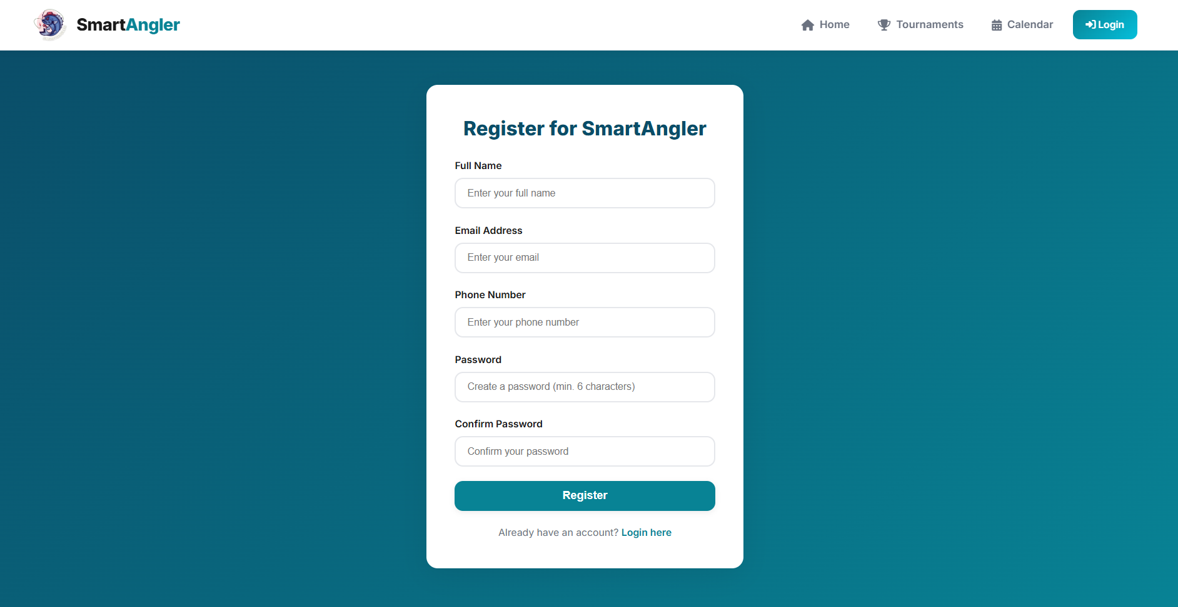

**Figure 5.46: SmartAngler User Registration Page**

Figure 5.46 is the page where anngler can register an account in the system by providing their personal details such as full name, email, phone number and password. Once registered, they can log in to access the platform’s features.

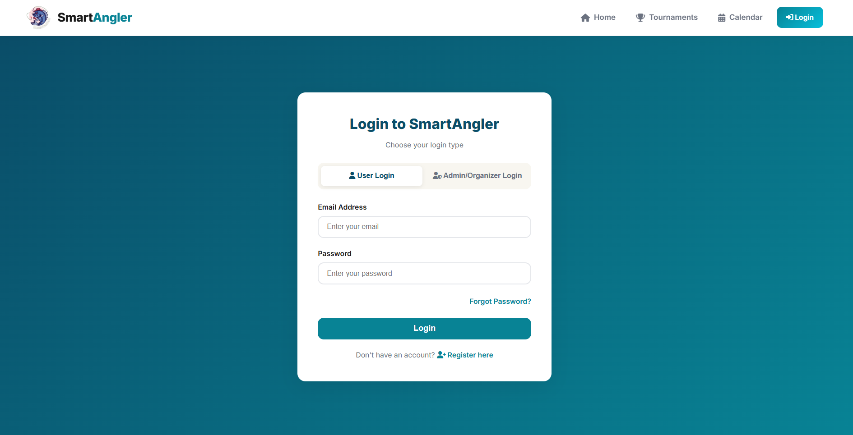

**Figure 5.47: SmartAngler User Login Page**

Figure 5.47 is the user login page where existing users enter their email and password to access their SmartAngler account. It also includes options such as password recovery or navigation to the registration page for new users.

1. Fishing Tournament Advertisement

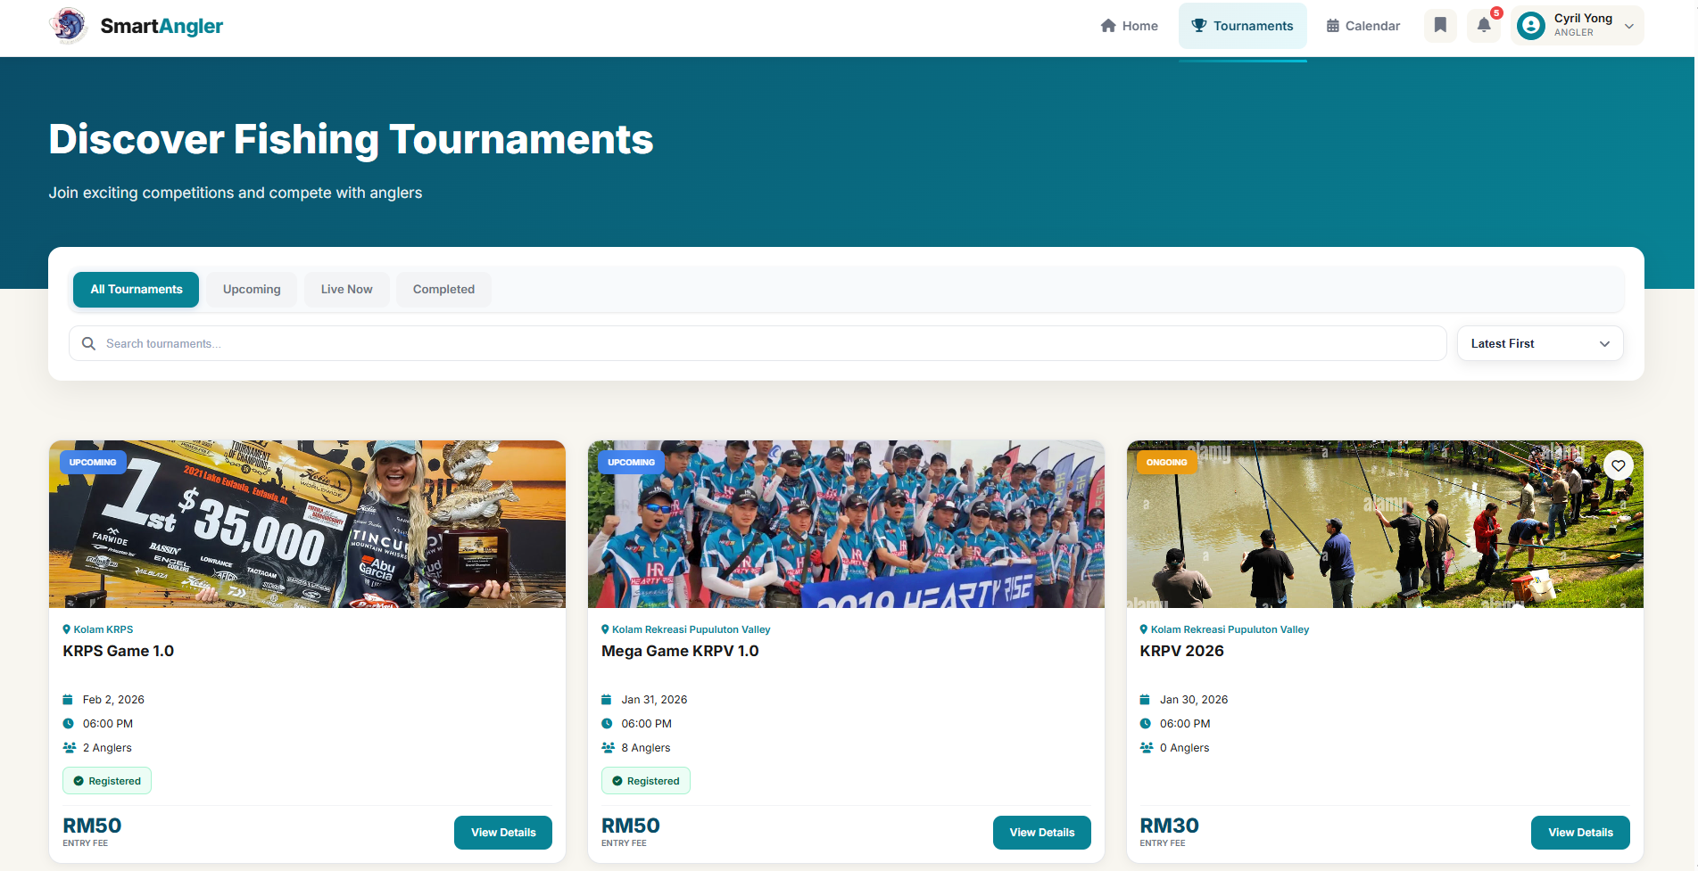

**Figure 5.48: SmartAngler Fishing Tournament Advertisement List**

Figure 5.48 shows the page that displays a list of available fishing tournaments advertised on the platform. Users can search for tournaments by tournament name or organizer name. Anglers can also filter the tournaments by status, such as upcoming, live or completed, and sort them using dropdown filters for date or price.

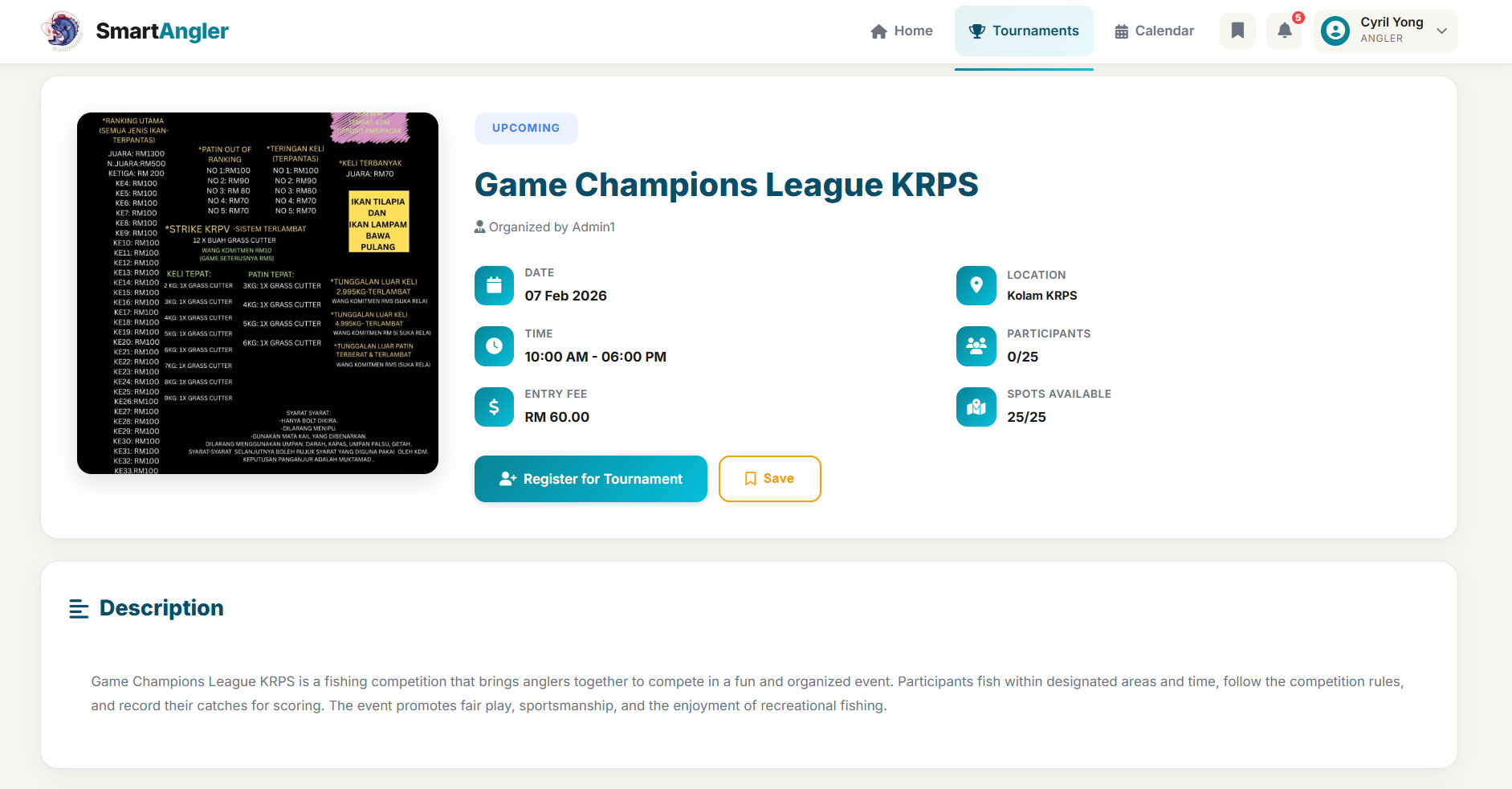

**Figure 5.49: SmartAngler Tournament Details Page 1**

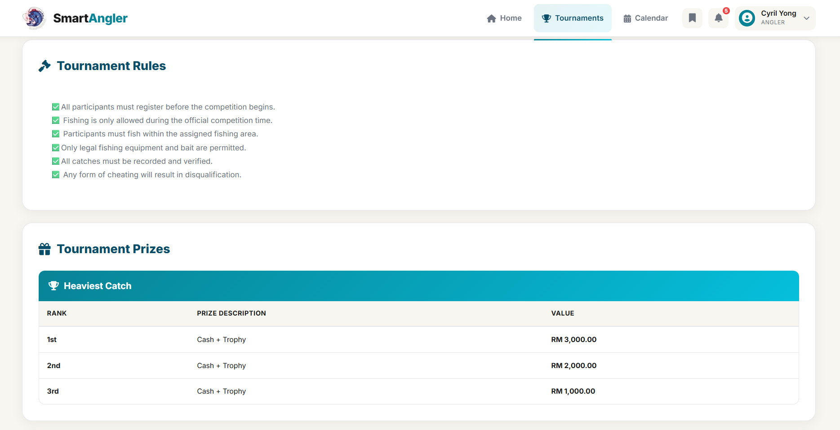

**Figure 5.50: SmartAngler Tournament Details Page 2**

Figure 5.49 and Figure 5.50 show the SmartAngler Tournament Details pages, where users can view comprehensive information about a tournament. These pages display details such as the tournament name, organizer, location, date, rules, participant list, sponsor and prizes, allowing users to understand all relevant information before registering or participating.

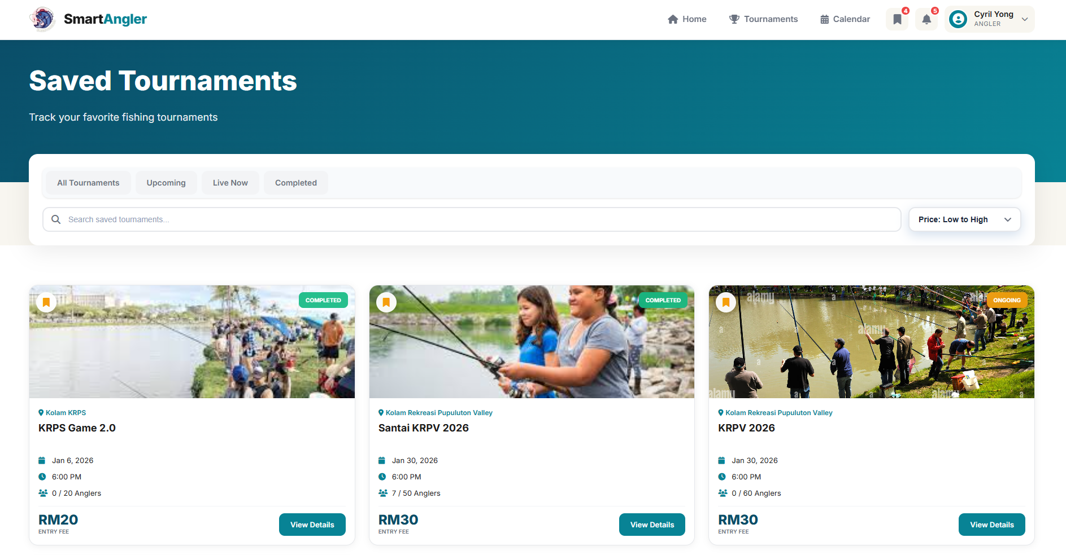

**Figure 5.51: SmartAngler Saved Tournament Advertisement Page**

Figure 5.51 allows users to save tournaments they are interested in. This provide a quick access later.

1. Tournament Registration

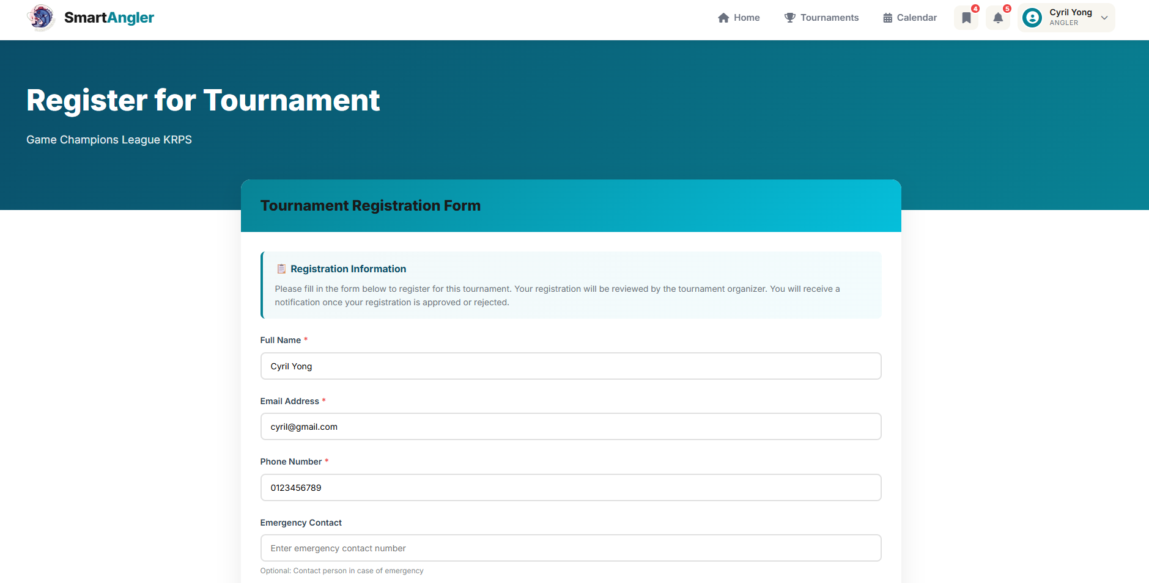

**Figure 5.52: SmartAngler Tournament Registration Page (Information Details)**

Figure 5.52 shows the form for information details where users can enter their personal and participant information required to register for a tournament.

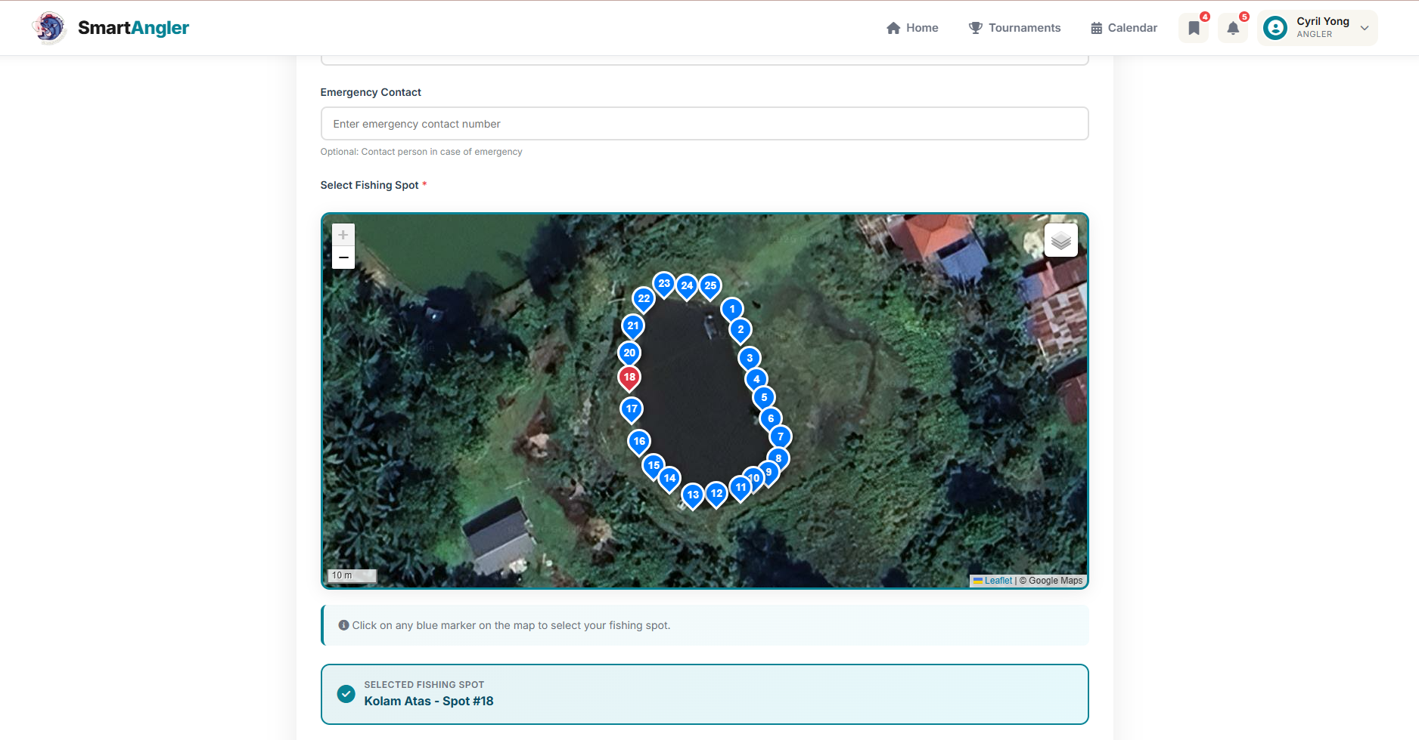

**Figure 5.53: SmartAngler Tournament Registration Page (Spot Selection)**

Figure 5.53 shows the zone map section for spot selection, where users can choose their preferred fishing spot for the tournament.

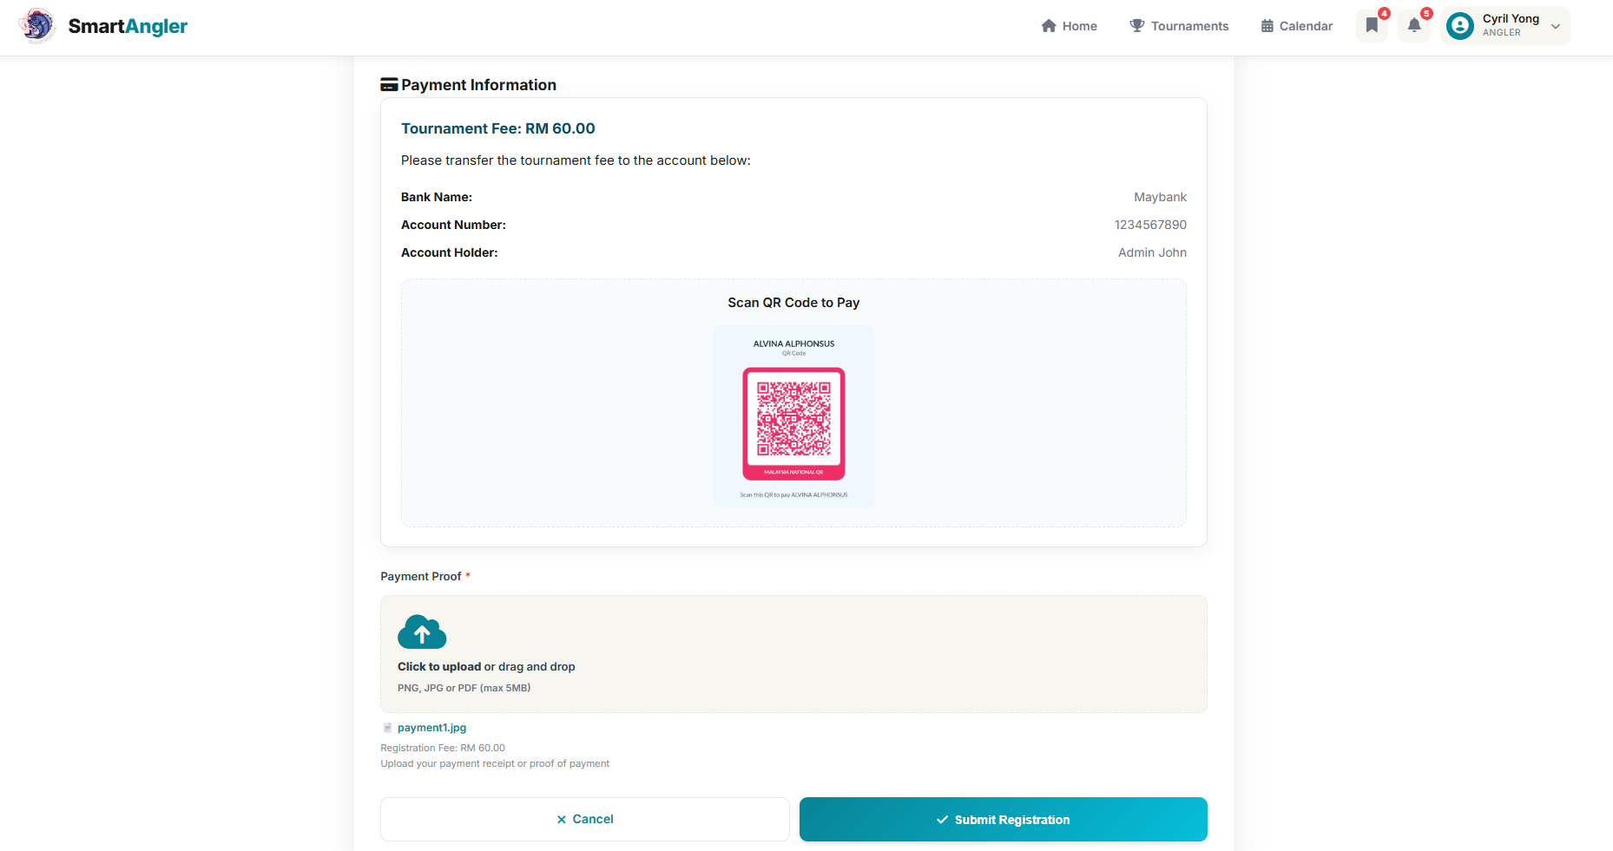

**Figure 5.54: SmartAngler Tournament Registration Page (Payment Proof)**

Figure 5.54 shows the form for payment proof, where users can upload valid proof of payment to complete their tournament registration.

1. Angler Dashboard

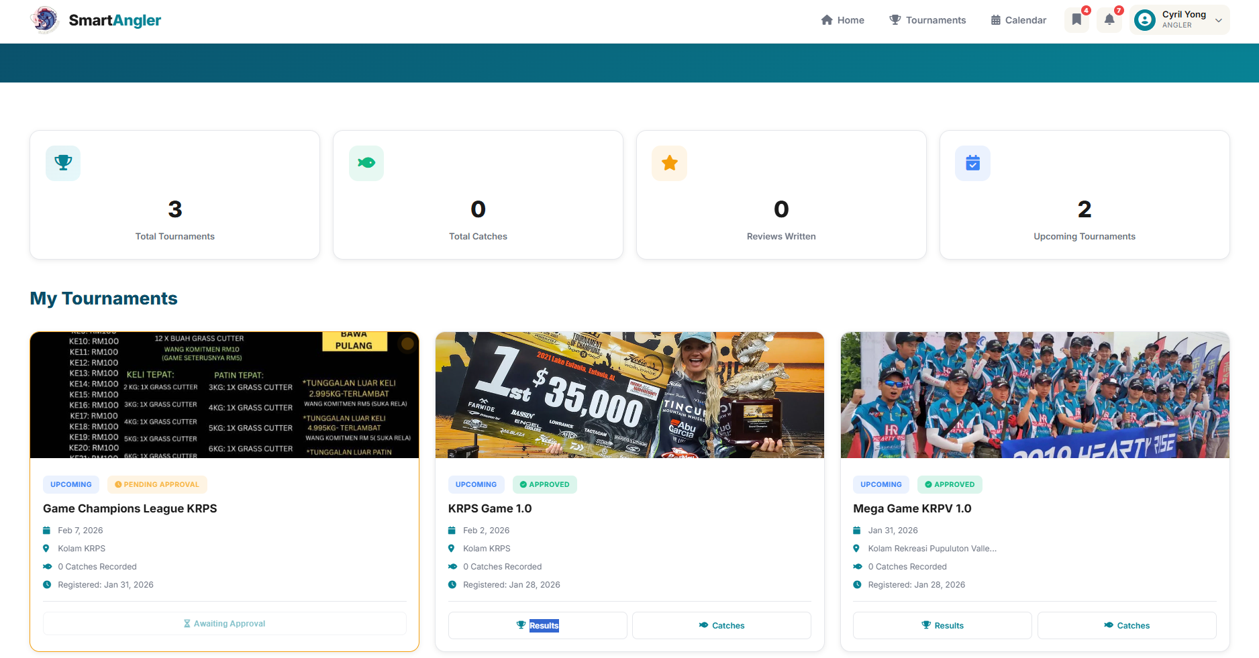

**Figure 5.55: SmartAngler User Dashboard**

Figure 5.55 shows the SmartAngler User Dashboard, where users can view a summary of their tournaments, total catches, reviews written, and upcoming tournaments. The dashboard also displays a list of the user’s registered tournaments with details such as status, dates, catch records, and quick access to results and catches, providing a clear overview of the user’s activity on the platform.

1. Angler Notification Management

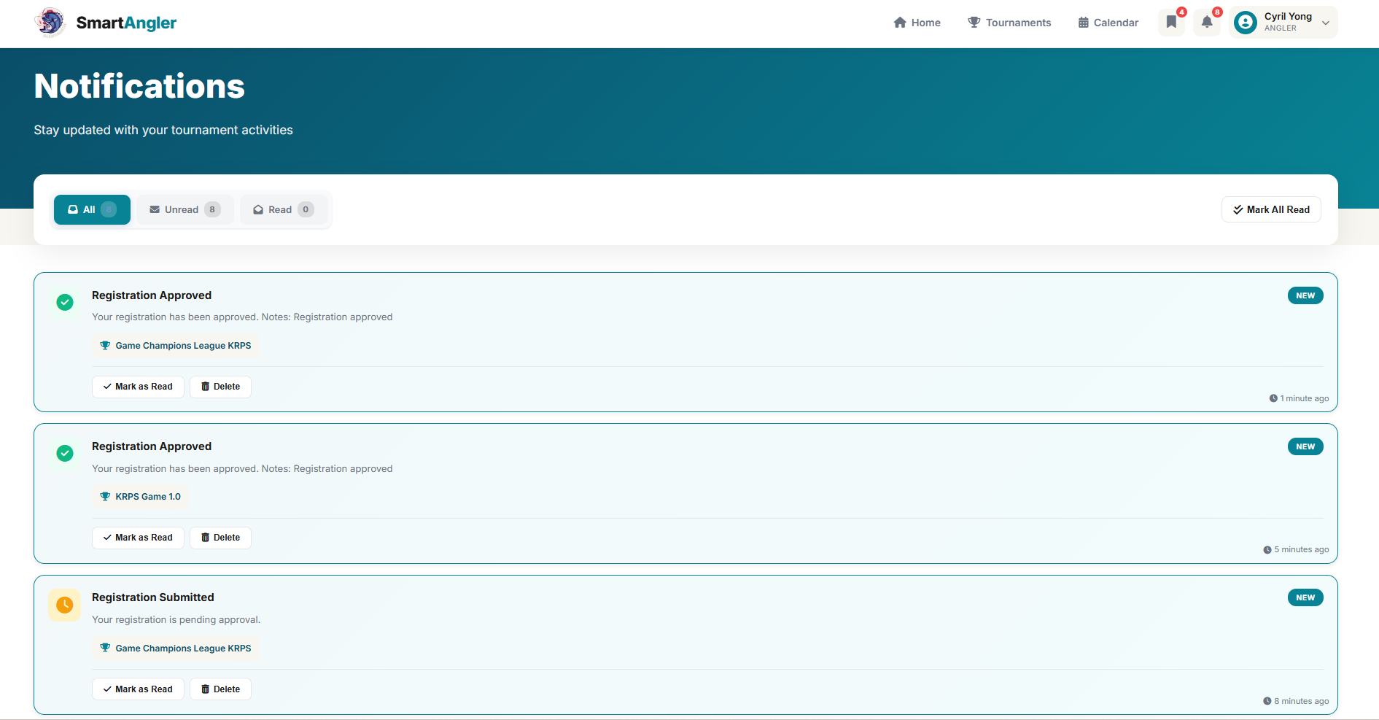

**Figure 5.56: SmartAngler User Notification Page**

Figure 5.56 displays all notifications received by the user, including tournament updates and system announcements.

1. Fish Catch Record and Live Result

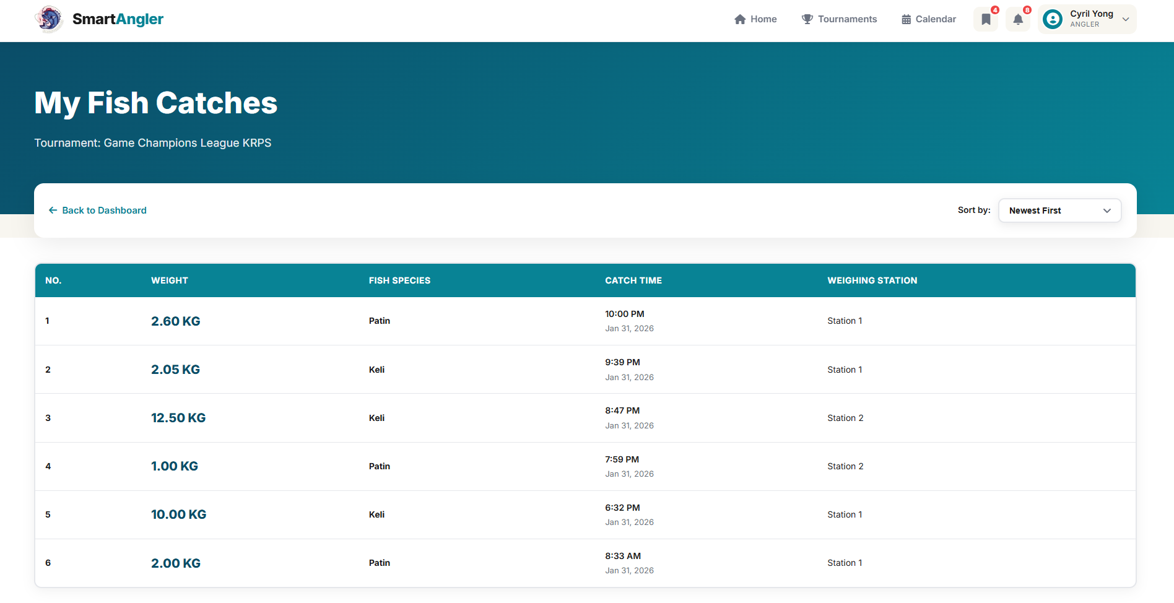

Figure 5.57: SmartAngler Fish Catch Record Page

Figure 5.57 shows the fish catch record page, where users can view all their submitted fish catches, including details such as the fish species, weight, time of catch and station where the fish was recorded. This allows participants to track their catch during the tournament.

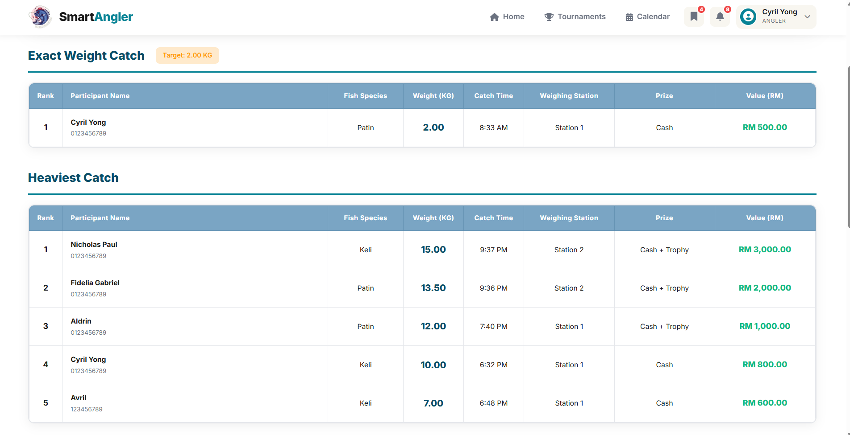

Figure 5.58: SmartAngler Live Result Page 1

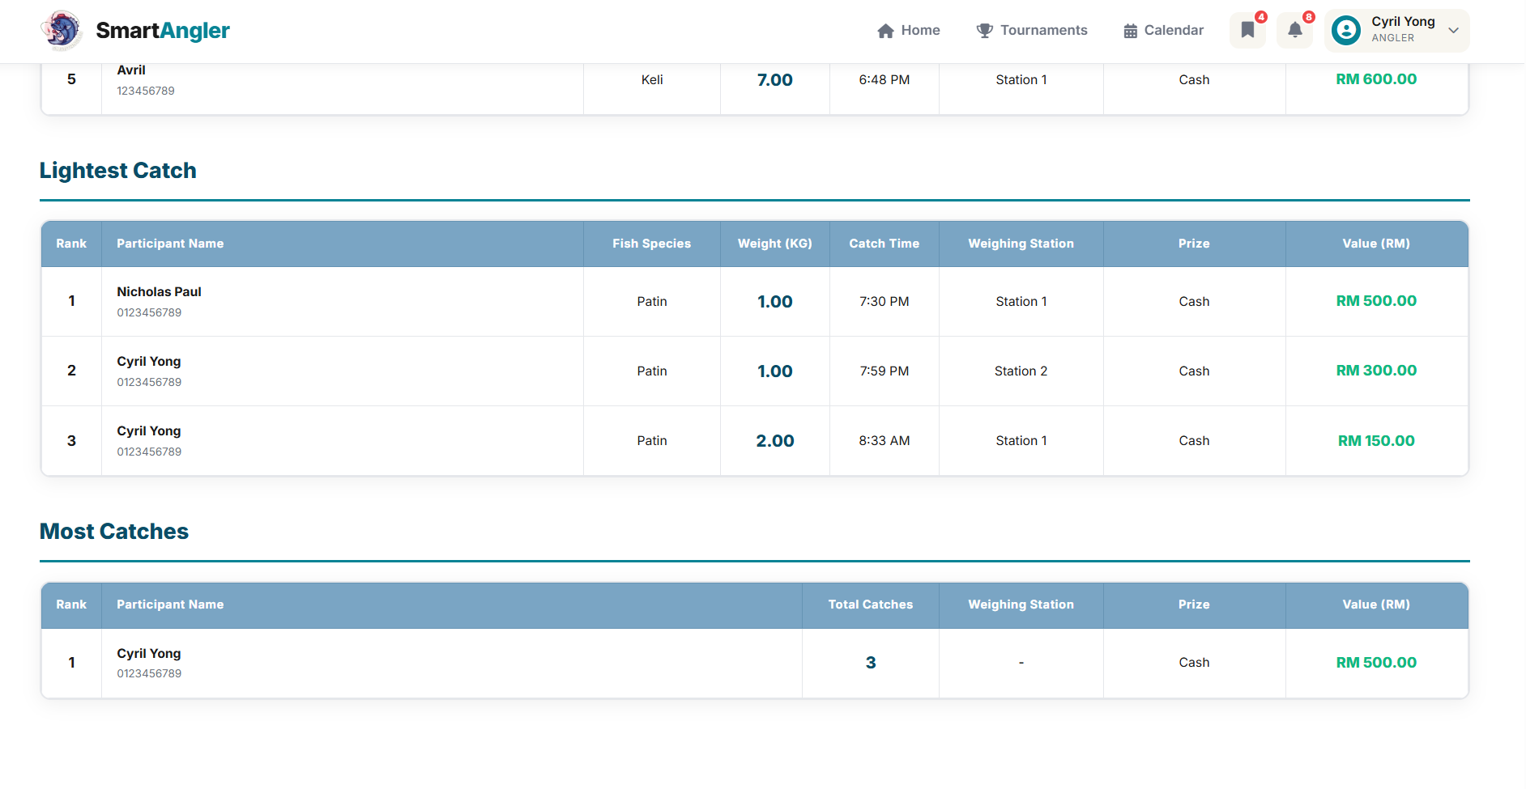

Figure 5.59: SmartAngler Live Result Page 2

Figure 5.58 and Figure 5.59 show the live result pages. It displays tournament results in real time. They show participants’ rankings based on different categories, total scores, and catch details such as species and weight, allowing users to track their performance and compare with others accurately throughout the event.

1. User Review

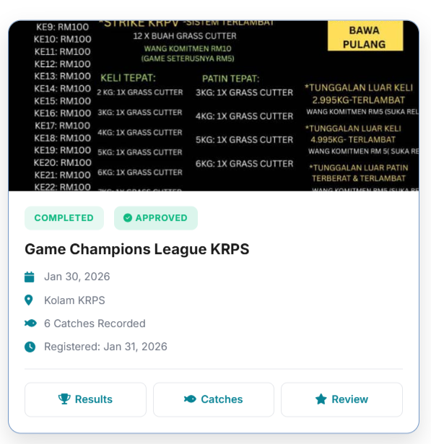

Figure 5.60: SmartAngler Tournament Review Button (Post-Tournament)

This button becomes available only after the tournament has ended and is visible exclusively to registered anglers. Once the tournament is finished, anglers can click this button to submit their reviews or feedback.

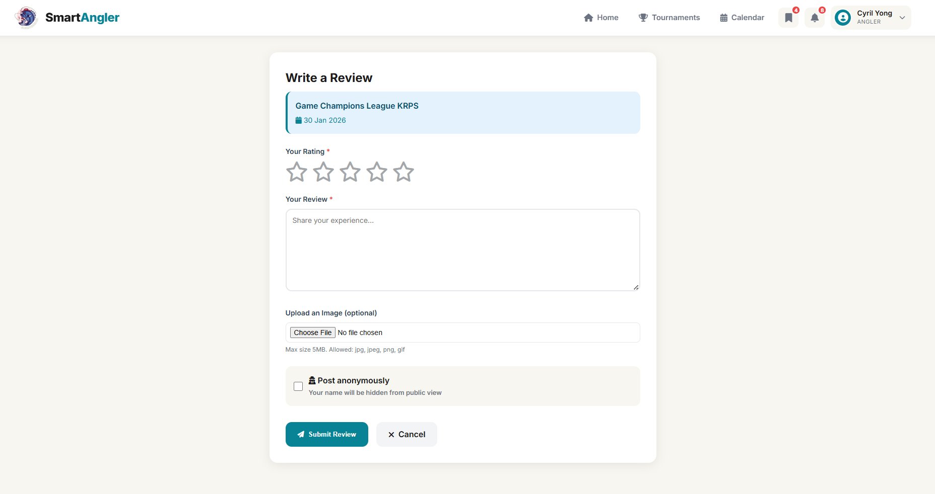

Figure 5.61: SmartAngler Review Form

Figure 5.61 shows the SmartAngler Review Form, where registered anglers can provide feedback after the tournament. Users can rate their experience, submit comments, and share suggestions, and they also have the option to post their review anonymously, helping organizers improve future events.

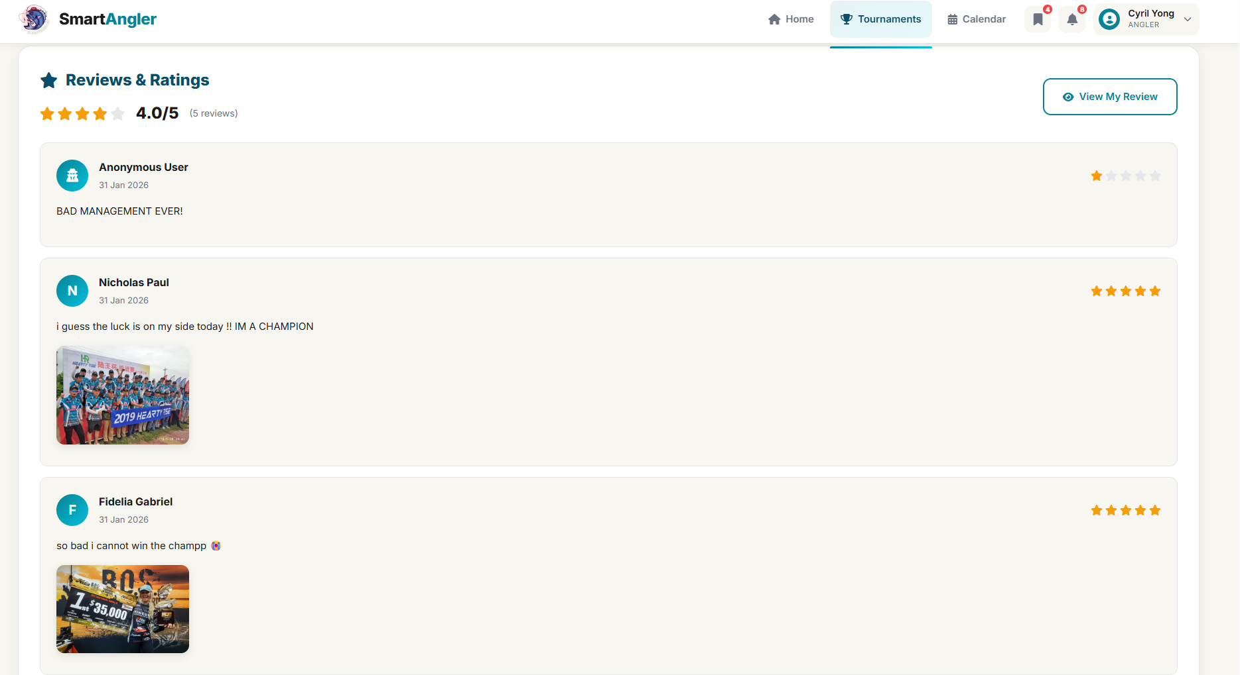

**Figure 5.62: Review List on the Tournament Ads Page**

Figure 5.62 shows the review list on tournament ads where users can view all submitted reviews for a tournament. The list displays comments, ratings, and whether the review was posted anonymously, allowing anglers to see feedback from other participants.

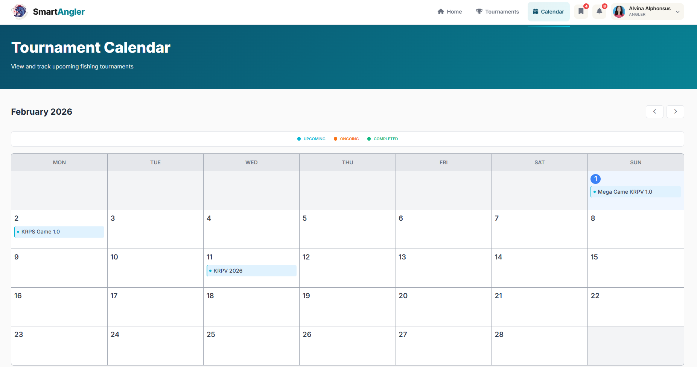

Figure 5.63: SmartAngler Calendar Page

Figure 5.63 shows tournaments in a calendar view, making it easy for users to see past, ongoing and upcoming events at a glance.

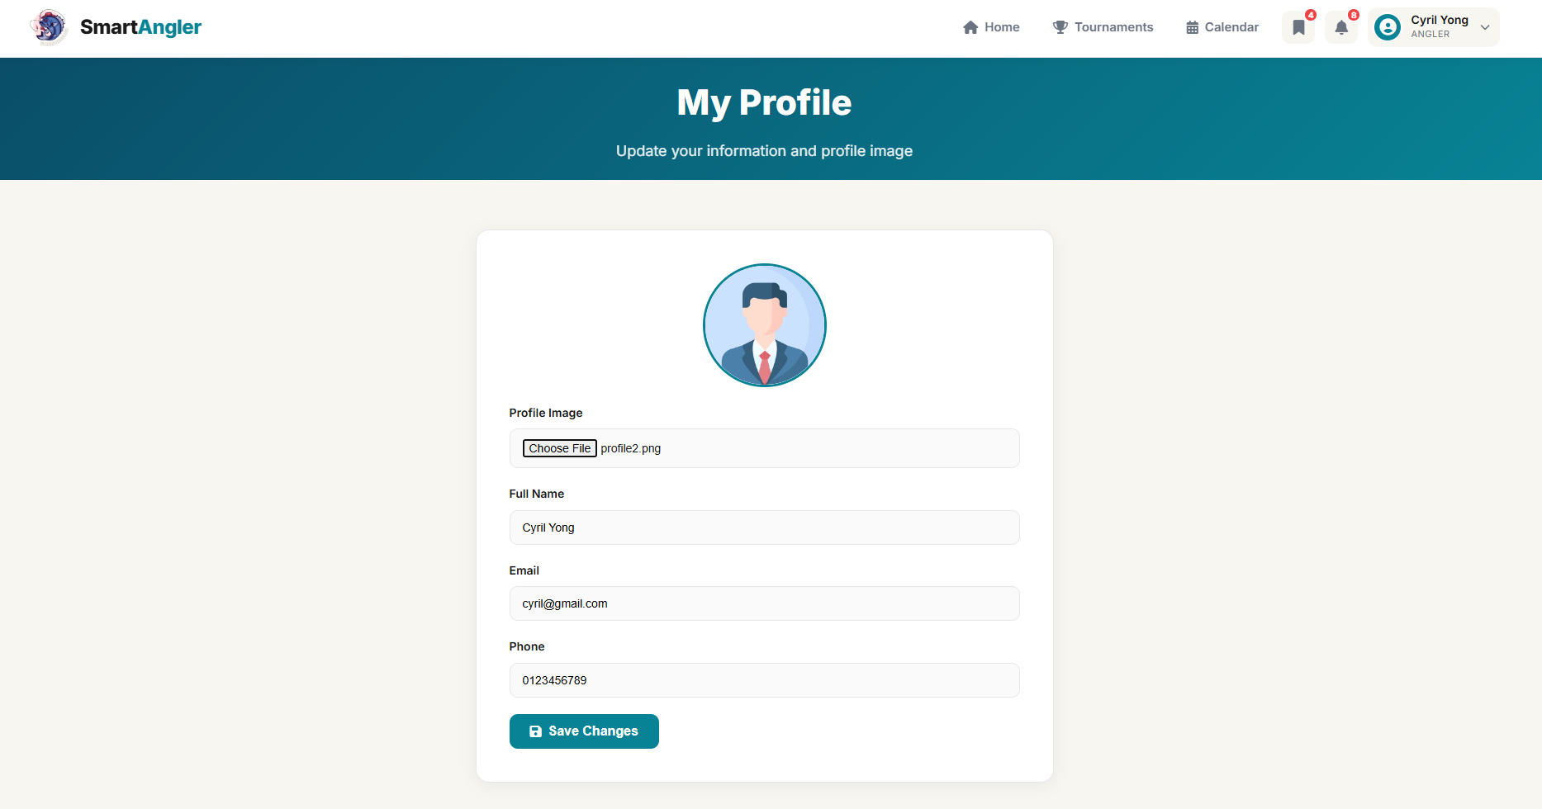

**Figure 5.64: SmartAngler User Profile Management Page**

Figure 5.64 allows users to view and edit their personal information, ensuring profiles are always accurate and up to date.

## 5.5 Database Implementation

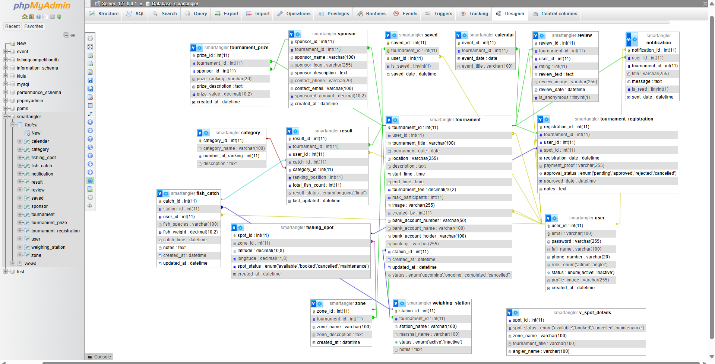

Figure 5.47: SmartAngler Table Relationship in MySQL

Figure 5.47 shows the table relationships in the SmartAngler MySQL database. The diagram shows how all tables are connected through primary and foreign keys. These relationships ensure data integrity and allowing the system to accurately link users to tournaments, tournament events to fishing spots, and fish catches to specific anglers and weighing stations. The key tables and their purposes are described below in Table 5.1.

Table 5.1: Description of SmartAngler Database Table Relationships

|  |  |  |
| --- | --- | --- |
| **No** | **Table Name** | **Description** |
| 1 | USER | Stores information about all users, including admins and anglers. Key attributes include user_id, full_name, email, role, status, and profile_image. This table is referenced in almost all other tables to track user actions and participation. |
| 2 | TOURNAMENT | Contains details of all fishing tournaments, including title, date, location, description, fee, status and associated bank account information. It links to users through user_id (organizer) and created_by (admin who created the tournament). |
| 3 | WEIGHING_STATION | Represents the weighing stations used during tournaments. Each station belongs to a specific tournament (tournament_id) and stores information about the station name, marshal and status. |
| 4 | ZONE | Represents different zones within a tournament area. Each zone is associated with a tournament and can contain multiple fishing spots. |
| 5 | FISHING_SPOT | Contains details of individual fishing spots within a zone. Each spot is linked to a zone (zone_id) and includes location coordinates and status (available, booked, maintenance). |
| 6 | TOURNAMENT_REGISTRATION | Records the registration of anglers for specific tournaments and fishing spots. Includes payment proof, approval status and optional spot assignment. |
| 7 | FISH_CATCH | Stores all fish catch records. Each record is linked to a weighing station (station_id) and an angler (user_id). Admins record fish species, weight, catch time and notes. |
| 8 | CATEGORY | Defines tournament categories such as Heaviest Catch, Most Fish and Longest Fish, along with the number of rankings. |
| 9 | RESULT | Stores the outcome of tournaments, linking each participant to their catches, categories, ranking positions, total fish count and result status. |
| 10 | REVIEW | Allows anglers to leave ratings and reviews for tournaments, optionally with images, linked to both the tournament and the user. |
| 11 | CALENDAR | Represents tournament events in a calendar format for easy tracking. Each event is linked to a specific tournament. |
| 12 | SAVED | Tracks tournaments saved by users for quick reference. |
| 13 | NOTIFICATION | Stores system-generated notifications for users about tournament updates, approvals or announcements. |
| 14 | SPONSOR | Contains details about sponsors for each tournament, including name, logo, description, contact info and contribution amount. |
| 15 | TOURNAMENT_PRIZE | Stores prizes offered for tournaments, linking them to both tournaments and sponsors, along with prize ranking, description and value. |
| 16 | v_spot_details (VIEW) | A database view that combines fishing spot, zone, tournament and angler registration information to provide an admin-friendly reporting interface. |

## 5.6 Conclusion

Chapter 5 explained the implementation of the SmartAngler system, showing how the design was transformed into a fully working application. It covered the tools and technologies used, such as PHP, HTML, CSS, JavaScript, XAMPP and GitHub, and described how they helped build a reliable, user-friendly and interactive system.

The chapter also presented the admin and user interfaces, showing how administrators can manage tournaments, fishing zones, weighing stations and fish catch records, while users can register, participate in tournaments and track their catches. The database structure and table relationships were described, demonstrating how data integrity and smooth system operation are maintained. Overall, the implementation ensures that SmartAngler provides an efficient, organized and easy-to-use platform for both administrators and anglers.

# CHAPTER 6

**TESTING AND EVALUATION**

## 6.1 Introduction

This chapter outlines the testing and evaluation phase of the SmartAngler system. The purpose of this phase is to verify and ensure that the system functions properly, meets the specified user requirements and provides a satisfactory user experience. Several testing methods were applied which are including unit testing, integration testing and usability evaluation using the System Usability Scale (SUS). These methods ensure that both of the technical reliability and usability of the system before deployment.

## 6.2 Unit Testing

The unit testing was conducted to verify and check the functionality of each of the individual modules within the SmartAngler system. Each of the component was tested independently to ensure that it performs its specific function correctly. This testing approach helps to identify early-stage bugs, logical errors and configuration issues at the component level. This therefore minimizes the possibilities of errors in the system since the different modules are tested separately and the core functions tested together before it enters the integration testing stage.

Table 6.1: Unit Testing for User Authentication Module

|  |  |  |  |  |
| --- | --- | --- | --- | --- |
| **No.** | **Test Input(s)/Criteria** | **Expected Result** | **Actual Result** | |
| **Success** | **Failure** |
| 1 | Angler registration with valid data. | Angler account is created successfully. A confirmation message is shown, and user is redirected to login page. | ✔ |  |
| 2 | Angler registers with email that already exist in the system. | An alert message appears stating "Email already exists". Registration is not completed. | ✔ |  |
| 3 | Organizer submits Request Admin Access form with complete valid data. | Request is submitted successfully. A message shown indicating "Request pending approval". Developer receives email notification | ✔ |  |
| 4 | Approved organizer registration | Organizer account is activated. Organizer receives email with login credentials. | ✔ |  |
| 5 | Organizer registration rejected. | Request status changes to "Rejected". Organizer receives email notification with rejection reason. No account is created. | ✔ |  |
| 6 | Organizer creates admin account with valid data | Admin account is created successfully. A message shown indicating admin has been added. | ✔ |  |
| 7 | Organizer creates admin account with duplicate email | An alert message appears stating "Email already exists in the system". Admin account creation is not completed. | ✔ |  |
| 8 | User login with valid credentials | User is logged in successfully and redirected to the home page. | ✔ |  |
| 9 | User login with invalid credentials | An error message is displayed, and login is not successful. | ✔ |  |
| 10 | User requests password reset with registered email | Password reset link is sent to email. A message shown "Password reset link has been sent to your email". | ✔ |  |
| 11 | User requests password reset with non-existent email | An alert message appears stating "Email not found in system". Password reset is not processed. | ✔ |  |
| 12 | User clicks logout button | User is logged out successfully. Session is terminated and user is redirected to login page. | ✔ |  |

Table 6.2: Unit Testing for Tournament Advertisement Module

|  |  |  |  |  |
| --- | --- | --- | --- | --- |
| **No.** | **Test Input(s)/Criteria** | **Expected Result** | **Actual Result** | |
| **Success** | **Failure** |
| 1 | Admin creates new tournament advertisement with complete valid data. | Advertisement is created and displayed successfully | ✔ |  |
| 2 | Admin creates new tournament advertisement with incomplete required fields. | An alert message appears at the empty field(s) and advertisement creation is not completed | ✔ |  |
| 4 | Admin views list of their posted tournament advertisements. | All advertisements created are displayed. | ✔ |  |
| 5 | Admin edits existing tournament advertisement details. | Advertisement details are updated successfully and changes are reflected immediately | ✔ |  |
| 6 | Admin deletes a tournament advertisement. | A confirmation prompt appears. After confirmation, advertisement is deleted successfully and removed from public view. | ✔ |  |
| 7 | Angler views list of tournament advertisements. | All tournament advertisements are displayed with complete information | ✔ |  |
| 8 | Angler clicks on a specific tournament advertisement to view details. | Angler is redirected to the tournament detail page. | ✔ |  |
| 9 | Angler clicks 'Save' button on a tournament advertisement. | Advertisement is saved successfully and stored in the saved list. | ✔ |  |
| 10 | Angler views their saved tournament advertisements. | All saved tournaments are displayed in a list with option to remove or view details. | ✔ |  |
| 11 | Angler removes a saved tournament advertisement. | Tournament is removed from saved list successfully. | ✔ |  |
| 12 | Angler searches for tournament advertisements by location. | Search results display only tournaments matching the selected location. | ✔ |  |
| 13 | Angler applies filters to tournament advertisements | Filtered results display tournaments based on selected filter criteria. | ✔ |  |

Table 6.3: Unit Testing for Participant Registration Module

|  |  |  |  |  |
| --- | --- | --- | --- | --- |
| **No.** | **Test Input(s)/Criteria** | **Expected Result** | **Actual Result** | |
| **Success** | **Failure** |
| 1 | Angler register for tournament with complete valid data. | Registration form is submitted successfully. A confirmation message appears stating "Registration submitted". | ✔ |  |
| 2 | Angler registers for a tournament with incomplete required fields | An alert message appears at the empty field(s) and registration is not completed | ✔ |  |
| 3 | Register for tournament that has reached maximum participants. | System displays a message indicating the tournament is full and registration is prevented. | ✔ |  |
| 4 | View list of registered tournaments. | All tournaments registered by the angler are displayed. | ✔ |  |
| 5 | Admin views list of participant registrations. | All participant registrations for their tournaments are displayed with details and status. | ✔ |  |
| 6 | Approve participant registration with valid payment proof. | Registration status changes to "Approved". Participant receives notification. | ✔ |  |
| 7 | Reject participant registration with invalid payment proof. | Registration status changes to "Rejected". Participant receives notification with rejection reason. | ✔ |  |
| 8 | View participant list for approved registrations. | All approved participants are displayed with their booking spot numbers and details. | ✔ |  |
| 9 | Angler cancels registration before approval. | A confirmation prompt appears. After confirmation, registration is cancelled. | ✔ |  |
| 10 | Angler edits registration details before approval. | Registration details are updated successfully. A confirmation message appears stating "Registration updated". | ✔ |  |

Table 6.4: Unit Testing for Fishing Spot Booking Module

|  |  |  |  |  |
| --- | --- | --- | --- | --- |
| **No.** | **Test Input(s)/Criteria** | **Expected Result** | **Actual Result** | |
| **Success** | **Failure** |
| 1 | Angler views available fishing spots for a tournament. | All available fishing spots are displayed with spot numbers and current status. | ✔ |  |
| 2 | Select booking spot from available spots. | The selected fishing spot is successfully reserved and registration is completed | ✔ |  |
| 3 | Select booking spot that is already taken. | System displays an error message and booking is not allowed | ✔ |  |
| 5 | Admin creates fishing zone. | The fishing zone is created successfully and a confirmation message indicates the zone was created successfully | ✔ |  |
| 6 | Admin add fishing spot within the zone. | The fishing spot is added successfully to the zone and a confirmation message indicates the spot was added successfully | ✔ |  |
| 7 | Admin adds fishing spot with duplicate longitude and latitude coordinates. | An alert appears indicating a spot with these coordinates already exists and the spot creation is not completed | ✔ |  |
| 8 | Admin delete fishing spot within the zone. | A confirmation prompt appears. After confirmation, fishing spot is deleted successfully from the zone. | ✔ |  |
| 9 | Admin views fishing spot booking status for their tournament. | All fishing spots are displayed along with their current status and the names of anglers who reserved spots | ✔ |  |
| 10 | Admin change fishing spot status to maintenance/unavailable. | The spot status updates to maintenance or unavailable, a confirmation message appears, and the spot is no longer bookable | ✔ |  |

Table 6.5: Unit Testing for Notification and Announcement Module

|  |  |  |  |  |
| --- | --- | --- | --- | --- |
| **No.** | **Test Input(s)/Criteria** | **Expected Result** | **Actual Result** | |
| **Success** | **Failure** |
| 1 | Admin creates tournament notification. | Notification is sent successfully to all approved participants. | ✔ |  |
| 2 | Admin creates tournament notification with incomplete required fields. | An alert appears at the bottom of the empty fields and the notification is not sent | ✔ |  |
| 3 | Admin creates notification without selecting tournament. | An alert appears indicating that a tournament must be selected and the notification is not sent | ✔ |  |
| 4 | Admin views list of sent notifications. | All sent notifications are displayed. | ✔ |  |
| 5 | Admin clicks cancel button while creating notification. | Notification creation is cancelled and the user is redirected back to the notifications page. | ✔ |  |
| 6 | Angler receives notification for tournament registration approval. | Notification appears in the notification center showing that the registration has been approved along with tournament details. | ✔ |  |
| 7 | Angler receives notification for tournament registration rejection. | Notification appears in the notification center showing that the registration has been rejected along with the reason. | ✔ |  |
| 8 | Angler receives tournament notification. | Notification appears in notification center with title and message. | ✔ |  |
| 9 | Angler views all notifications. | All notifications are displayed in chronological order with read or unread status. | ✔ |  |
| 10 | Angler marks notification as read. | Notification status changes to read and the visual indicator is updated | ✔ |  |
| 11 | Angler deletes a notification. | Notification is removed from the notification list successfully. | ✔ |  |

Table 6.6: Unit Testing for Catch Fish Log Module

|  |  |  |  |  |
| --- | --- | --- | --- | --- |
| **No.** | **Test Input(s)/Criteria** | **Expected Result** | **Actual Result** | |
| **Success** | **Failure** |
| 1 | Admin selects a tournament to record fish catches. | The tournament is selected successfully, and the list of weighing stations for that tournament is displayed. | ✔ |  |
| 2 | Admin creates weighing station with complete valid data | The weighing station is created successfully, and a confirmation message appears stating station added successfully. | ✔ |  |
| 3 | Admin creates weighing station with incomplete required fields. | An alert message appears below the missing field(s), and the station is not created. | ✔ |  |
| 4 | Admin edits existing weighing station details. | Station information is updated successfully, with a confirmation message stating station updated successfully. | ✔ |  |
| 5 | Admin deletes a weighing station. | A confirmation prompt appears, and after confirming, the station is deleted successfully. | ✔ |  |
| 6 | Admin views list of weighing stations for a tournament. | All weighing stations for the selected tournament are displayed. | ✔ |  |
| 7 | Admin selects a weighing station to record fish catch. | The admin is redirected to the fish catch recording page. | ✔ |  |
| 8 | Admin records fish catch with complete valid data. | The fish catch is recorded successfully, and the result is updated. | ✔ |  |
| 9 | Admin records fish catch with incomplete required fields. | An alert message appears below the missing field(s), and the fish catch is not recorded. | ✔ |  |
| 10 | Admin records fish catch with invalid Angler ID. | An alert message appears stating Angler ID not found or invalid Angler ID, and the record is not saved | ✔ |  |
| 11 | Admin records fish catch with invalid weight | An alert message appears stating please enter valid weight, and the fish catch is not recorded. | ✔ |  |
| 12 | Admin clicks reset button while recording fish catch. | A confirmation prompt appears, and upon confirming, all form fields are cleared. | ✔ |  |
| 13 | Admin records multiple fish catches for same angler. | All fish catches are recorded successfully. Each entry is saved separately with individual timestamps. | ✔ |  |
| 14 | Admin views fish catch statistics for a station. | All catch records for the station are displayed along with their detailed information. | ✔ |  |
| 15 | Angler views their fish catch records for a tournament. | All fish catches logged for that angler in the tournament are displayed. | ✔ |  |

Table 6.7: Unit Testing for Sponsorship and Prize Management Module

|  |  |  |  |  |
| --- | --- | --- | --- | --- |
| **No.** | **Test Input(s)/Criteria** | **Expected Result** | **Actual Result** | |
| **Success** | **Failure** |
| 1 | Admin adds a new sponsor with all required details completed | Sponsor is added successfully, and a confirmation message appears stating sponsor added successfully | ✔ |  |
| 2 | Admin edits the details of an existing sponsor | Sponsor details are updated successfully with a confirmation message. | ✔ |  |
| 3 | Admin deletes a sponsor | A confirmation prompt appears, and after confirming, the sponsor is deleted successfully | ✔ |  |
|  | Admin views the list of all sponsors | All sponsors are displayed correctly with their respective details | ✔ |  |
| 4 | Admin adds a new prize with all required information completed | Prize is added successfully, and a confirmation message appears stating prize added successfully | ✔ |  |
| 5 | Admin edits an existing prize | Prize details are updated successfully, with a confirmation message stating prize updated successfully | ✔ |  |
| 6 | Admin deletes a prize | A confirmation prompt appears, and after confirming, the prize is deleted successfully | ✔ |  |
| 7 | Admin assigns a prize to a tournament | Prize is assigned successfully, and the tournament prize list is updated | ✔ |  |
| 8 | Admin views prize distribution for a tournamen | All prizes assigned to the tournament are displayed correctly with details | ✔ |  |
| 9 | Admin attempts to assign a prize that has already been assigned | An alert appears stating prize already assigned, and the action is not completed | ✔ |  |
| 10 | Angler views sponsors for a tournament. | All tournament sponsors are displayed. | ✔ |  |

Table 6.8: Unit Testing for Result Management Module

|  |  |  |  |  |
| --- | --- | --- | --- | --- |
| **No.** | **Test Input(s)/Criteria** | **Expected Result** | **Actual Result** | |
| **Success** | **Failure** |
| 1 | Tournament has ongoing fish catch entries | Results are automatically generated and updated continuously but marked as unofficial | ✔ |  |
| 2 | Tournament catch records are incomplete | System still generates unofficial results, but alerts indicate the data is incomplete | ✔ |  |
| 3 | Admin views tournament results before tournament ends | All participants’ current rankings and provisional prize assignments are displayed, clearly marked as unofficial | ✔ |  |
| 4 | Admin edits a participant’s catch before tournament ends | Results and provisional rankings are updated automatically, and prize assignments are recalculated accordingly | ✔ |  |
| 5 | Admin deletes a participant’s catch before tournament ends | System updates provisional results automatically, recalculates rankings, and adjusts provisional prizes | ✔ |  |
| 6 | Tournament ends | When tournament end time is reached, admin clicked publish and the results status changes from Unofficial to Official. Final rankings are locked. | ✔ |  |
| 7 | System exports tournament results before tournament ends | Exported results include current rankings, total weight, and provisional prize assignments marked as unofficial | ✔ |  |
| 8 | Angler views their tournament result during tournament | Angler can see current ranking and provisional prize assignments marked as unofficial | ✔ |  |
| 9 | Angler views official published tournament results after tournament ends. | Complete final results are displayed with rankings, participant names, catches, weights and prize winners. Status shows as Official. | ✔ |  |
| 10 | Admin filters result by participant, weight or prize category | System displays updated provisional results accurately with current rankings and provisional prizes | ✔ |  |
| 11 | System handles tie-breaking in rankings. | In case of tie, system applies tie-breaking rules (e.g., earliest catch time) and assigns prizes accordingly when results are official. | ✔ |  |

Table 6.9: Unit Testing for Review Module

|  |  |  |  |  |
| --- | --- | --- | --- | --- |
| **No.** | **Test Input(s)/Criteria** | **Expected Result** | **Actual Result** | |
| **Success** | **Failure** |
| 1 | Angler submits a review for a tournament with all required fields completed | Review is submitted successfully, and a confirmation message appears | ✔ |  |
| 2 | Angler attempts to submit a review with missing required fields | An alert message appears below the empty fields, and the review is not submitted | ✔ |  |
| 3 | Admin views all reviews for a tournament | All submitted reviews are displayed with details. | ✔ |  |
| 4 | Angler edits their existing review | The review is updated successfully, and the changes are reflected in the system | ✔ |  |
| 5 | Angler deletes their own review | A confirmation prompt appears, and after confirming, the review is deleted successfully | ✔ |  |
| 6 | Angler views their submitted reviews. | All reviews submitted by the angler are displayed with tournament name, rating, comment and submission date. | ✔ |  |
| 7 | Admin filters reviews by rating. | Filtered results display only reviews matching the selected rating. | ✔ |  |
| 8 | Admin views average rating for their tournament. | Average rating is calculated and displayed based on all submitted reviews | ✔ |  |
| 9 | Admin responds to angler review. | Response is submitted successfully. Angler receives notification. Response is displayed under the original review. | ✔ |  |
| 10 | Angler submits review with rating only (no comment). | Review is submitted successfully with rating. Comment field remains optional. | ✔ |  |
| 11 | Angler submits review with comment only (no rating). | An alert message appears stating Please provide a rating. Review submission is not completed | ✔ |  |
| 12 | Angler attempts to submit review for tournament they did not participate in. | An alert message appears stating You must participate in the tournament to leave a review. Review submission is not allowed. | ✔ |  |

## 6.3 Integration Testing

Integration testing was conducted to make sure that the individual modules in the SmartAngler system work properly when they are connected and used together. While unit testing focuses on checking each module separately, integration testing examines how data and functions are shared across modules. This is significant to ensure that the system runs efficiently when users engage in actual activities in a real world environment.

In the SmartAngler system, the key area of integration testing was the interaction of the core modules with other modules. These modules include user authentication, tournament management, booking management, catch fish recording, leaderboard updates and notification handling. Table 6.10 shows the integration test cases conducted for the SmartAngler system. Based on the test results, all the integrated modules worked as per the expectations and were able to support the key functions of the system. No critical integration problems were detected during this phase. This indicates that the modules are well connected and able to operate reliably as a complete system.

Table 6.10: Integration Testing for SmartAnlger System.

|  |  |  |  |  |
| --- | --- | --- | --- | --- |
| **No.** | **Test Input(s)/Criteria** | **Expected Result** | **Actual Result** | |
| **Success** | **Failure** |
| 1 | User registers and logs into the system. | User is successfully registered and logged into the system. | ✔ |  |
| 2 | Admin creates and publishes a tournament. | Tournament is created and visible to all users. | ✔ |  |
| 3 | Angler views available tournaments . | Tournament details are displayed and the option to register is available. | ✔ |  |
| 4 | Angler selects tournament, chooses fishing spot, makes payment, uploads payment proof and submits registration. | Registration request is submitted, selected spot is reserved, and status is set to pending approval. | ✔ |  |
| 5 | Admin reviews and approves participant registration. | Registration is approved, angler is officially registered, fishing spot is secured and notification is sent to angler. | ✔ |  |
| 6 | Admin reviews and rejects participant registration. | Registration is rejected and selected fishing spot is released. | ✔ |  |
| 7 | Admin sends tournament notification. | Notification is sent to all registered anglers. | ✔ |  |
| 8 | Admin records anglers’ catch details during tournament. | Catch information is saved successfully into the database. | ✔ |  |
| 9 | Leaderboard updates after catch is recorded. | Leaderboard is updated with latest scores based on categories. | ✔ |  |
| 10 | Tournament ends and admin publishes official results. | Official tournament results are available for all users to view. | ✔ |  |
| 11 | Angler reviews the tournament they joined. | Review was submitted and the review appears in the tournament’s review section. | ✔ |  |
| 12 | User logs out of the system. | User session ends and logout is successful. | ✔ |  |

## 6.4 System Usability Scale (SUS)

System Usability Scale (SUS) was used to measure and assess the usability and user satisfaction of the SmartAngler system. SUS is a widely used standardized questionnaire that measures users’ perceptions of system usability by collecting valid data from user. It evaluates requirements aspects such as ease of use, efficiency, learnability and overall user satisfaction. The key users tested the fully functional system and completed the System Usability Scale (SUS) questionnaire. Feedback was collected from both tournament organizers and participants to evaluate the clarity of the interface and the overall user experience.

### 6.4.1 SUS Questionnaire

The System Usability Scale (SUS) questionnaire consisting of 10 questions that was used to obtain valid and effective feedback from users regarding the usability of the SmartAngler system. The rating of each statement was done on a five-point Likert scale of 1 (Strongly Disagree) to 5 (Strongly Agree).

A total of 10 participants, consisting of fishing tournament organizers or admin (5 organizers or admin) and anglers (5 anglers) has took part in the usability testing of SmartAngler. At the end of the testing, the participants were asked to answer the questionnaire of the SUS using Google Forms. The collected data were then analysed to evaluate users’ perceptions of the system’s ease of use, functionality and overall user experience. The results of the SUS evaluation are presented and discussed in this section. Below are the 10 statements included in the SUS questionnaire:

* 1. I think that I would like to use SmartAngler frequently.
  2. I found SmartAngler unnecessarily complex.
  3. I thought SmartAngler was easy to use.
  4. I think that I would need the support of a technical person to be able to use SmartAngler.
  5. I found the various functions in SmartAngler were well integrated.
  6. I thought there was too much inconsistency in SmartAngler.
  7. I would imagine that most people would learn to use SmartAngler very quickly.
  8. I found the SmartAngler system was very difficult to use.
  9. I felt very confident using SmartAngler.
  10. I needed to learn a lot of things before I could get going with SmartAngler.

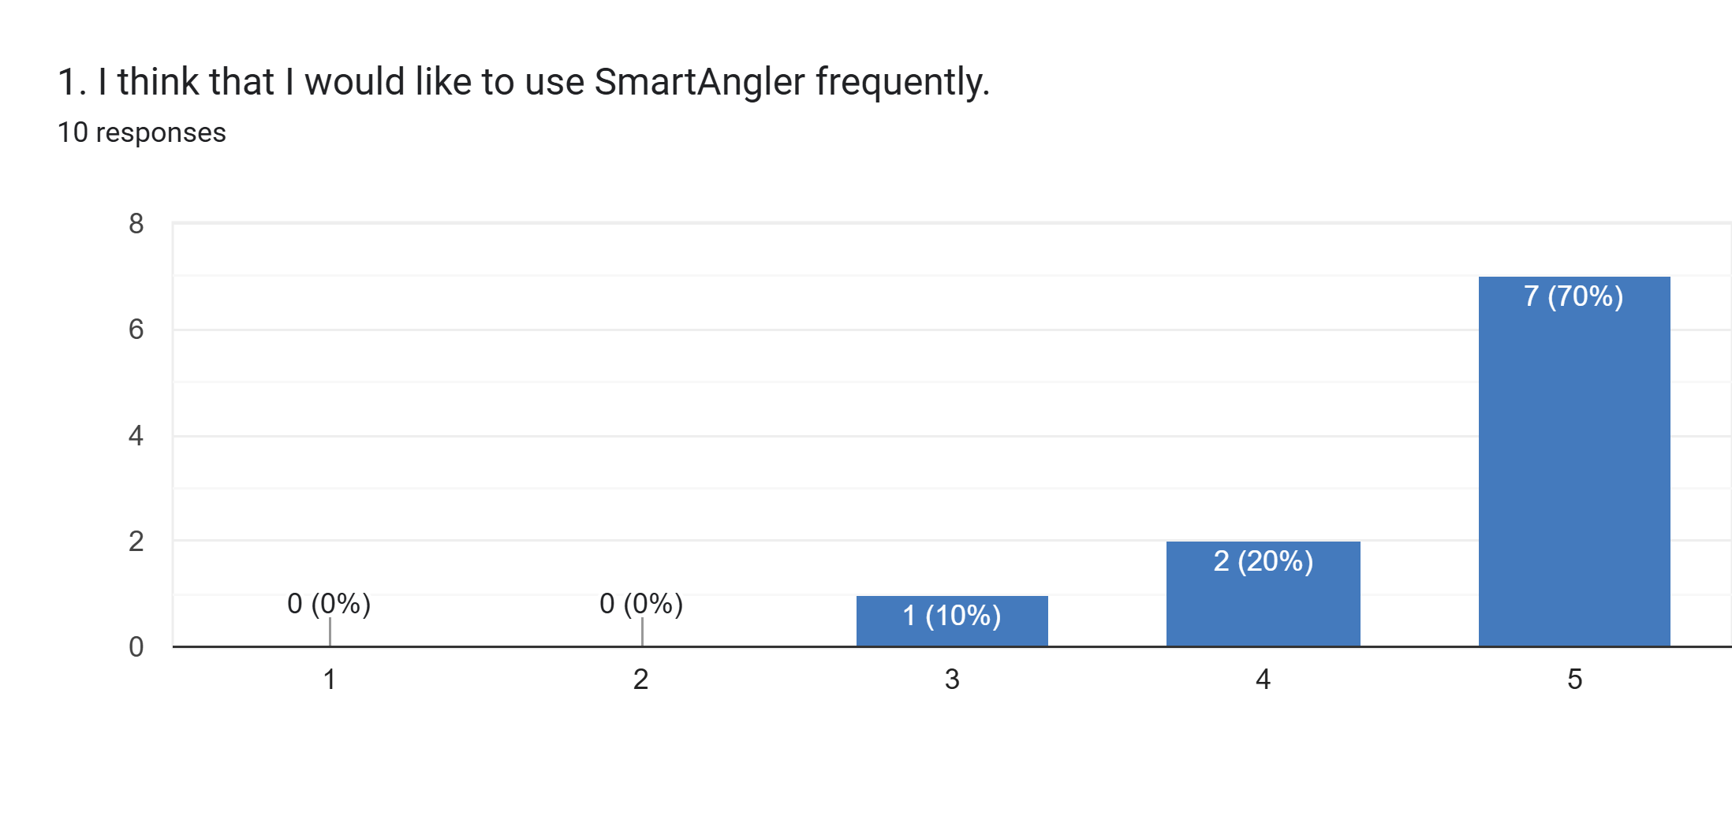

Figure 6.1: System Usability Scale (SUS) Questionnaire Question 1

Figure 6.1 shows the results for the first statement regarding users' willingness to use SmartAngler frequently. The responses reveal a positive answer toward regular use of the system. The majority of participants, seven respondents (70%), selected option 5, showing strong agreement with frequent usage. Two respondents (20%) chose option 4, while one participant (10%) gave a neutral rating of 3. None of the respondents chose the lower rating of 1 or 2 which means that no participants had negative thoughts to the regular use of the system. The overall response pattern demonstrates that users found the system valuable and practical enough to consider applying it into their regular fishing tournament activities.

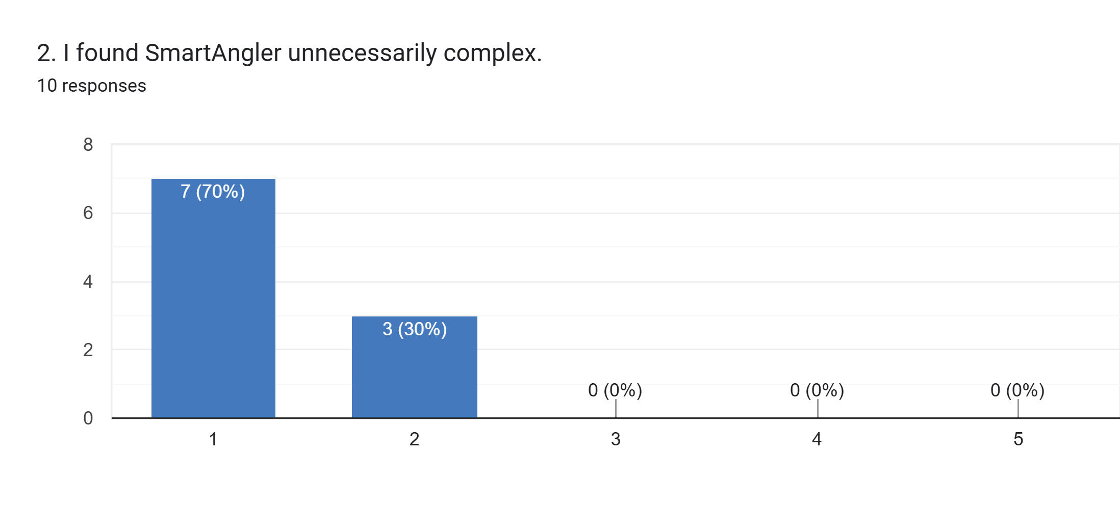

Figure 6.2: System Usability Scale (SUS) Questionnaire Question 2

The findings related to the statement on the complexity of systems can be seen in figure 6.2. This is a negatively-worded question and hence the lower the rating the more usable it is. The answers indicate that the majority of the participants did not agree with the fact that SmartAngler was unnecessarily complex. Seven respondents (70%) strongly disagreed by selecting option 1, while three participants (30%) chose option 2. Notably, none of the respondents selected options 3, 4, or 5, meaning no one agreed that the system was complex. This consistent agreement among all participants suggests that the interface and functionality of the system had been developed in the simplest way, which could be easily comprehended by users and be used without any trouble.

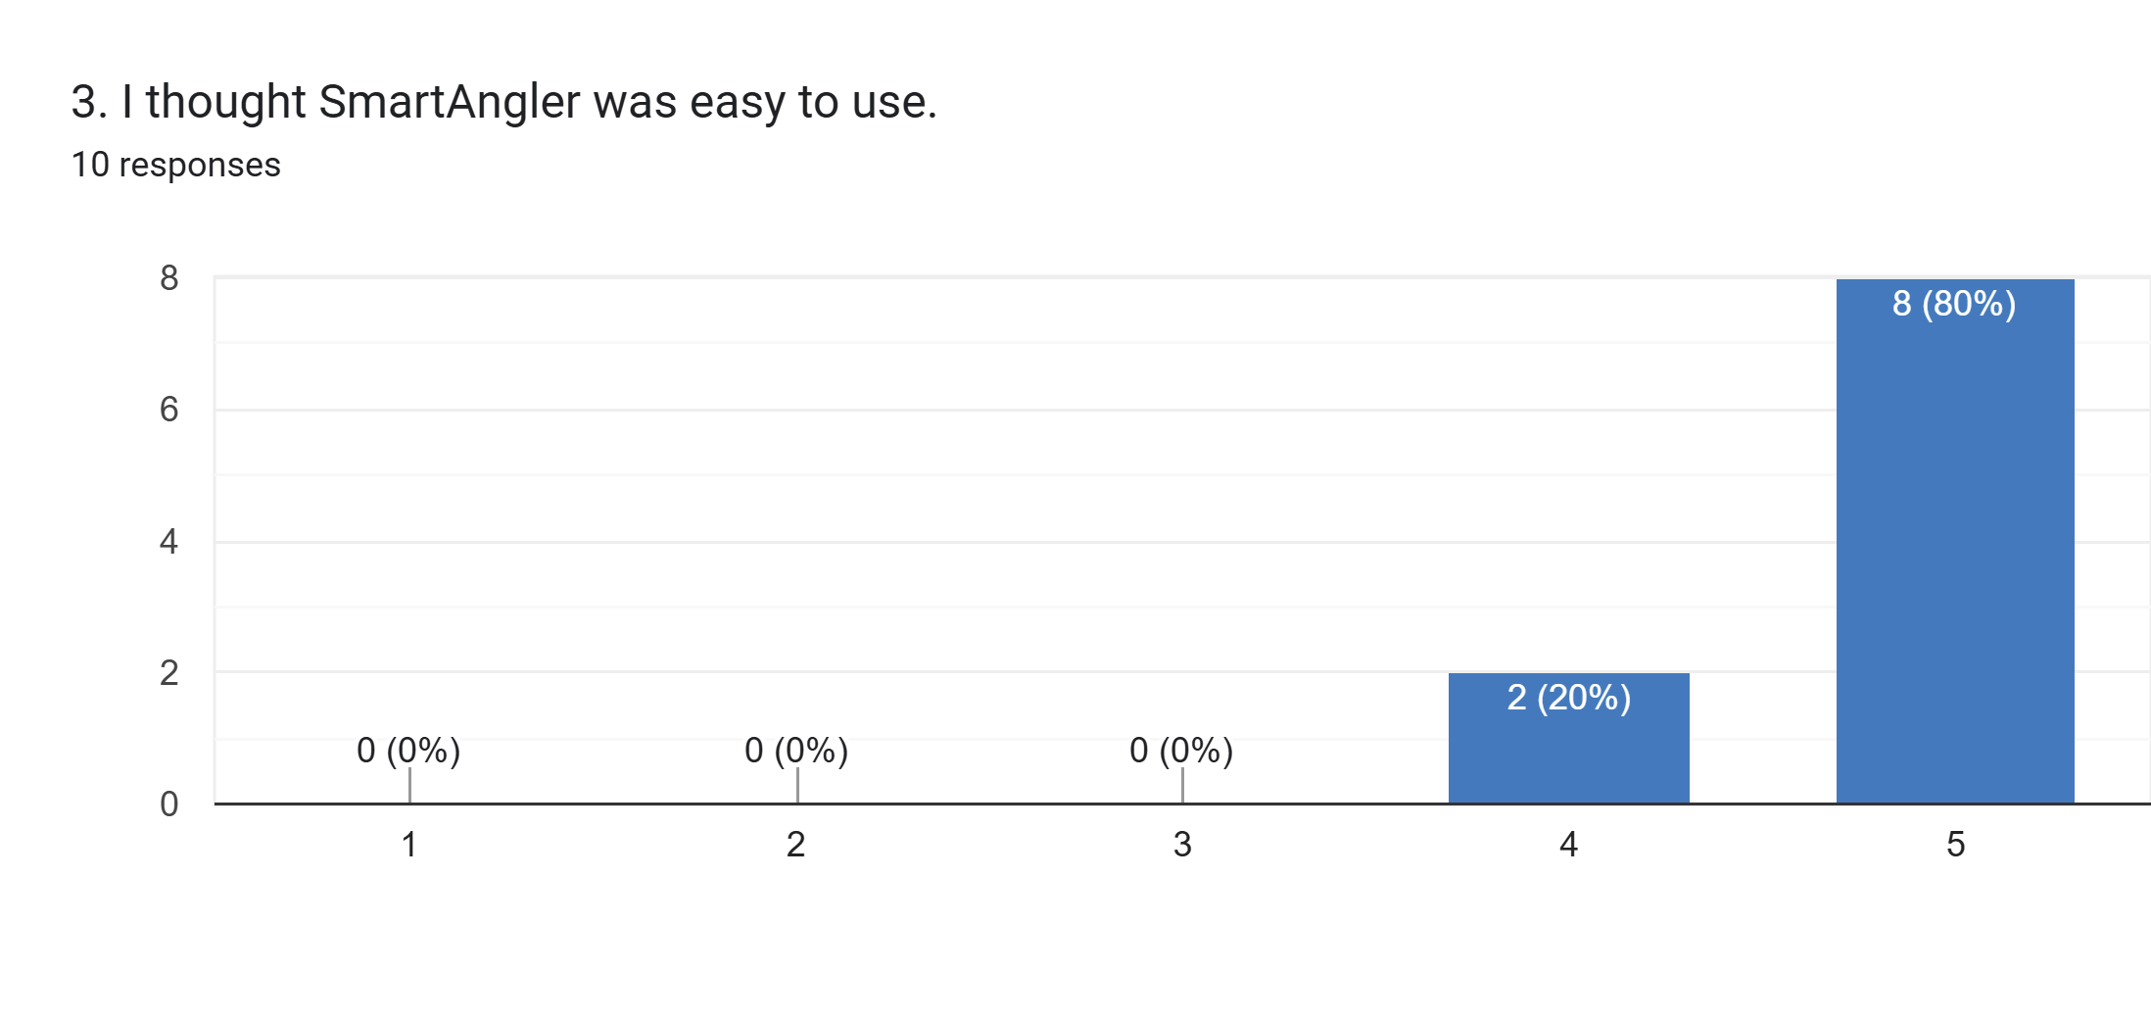

Figure 6.3: System Usability Scale (SUS) Questionnaire Question 3

Figure 6.3 displays the responses regarding the ease of use of SmartAngler. The results show strong positive feedback, with eight respondents (80%) selecting option 5, indicating they strongly agreed that the system was easy to use. Two participants (20%) chose option 4, also showing agreement. None of the respondents chose an option 1, 2 or 3, meaning that all participants found the system easy to use without any negative or neutral opinions. Such a high positive response indicates that the interface and design of the system were easy to use and understand by everyone involved.

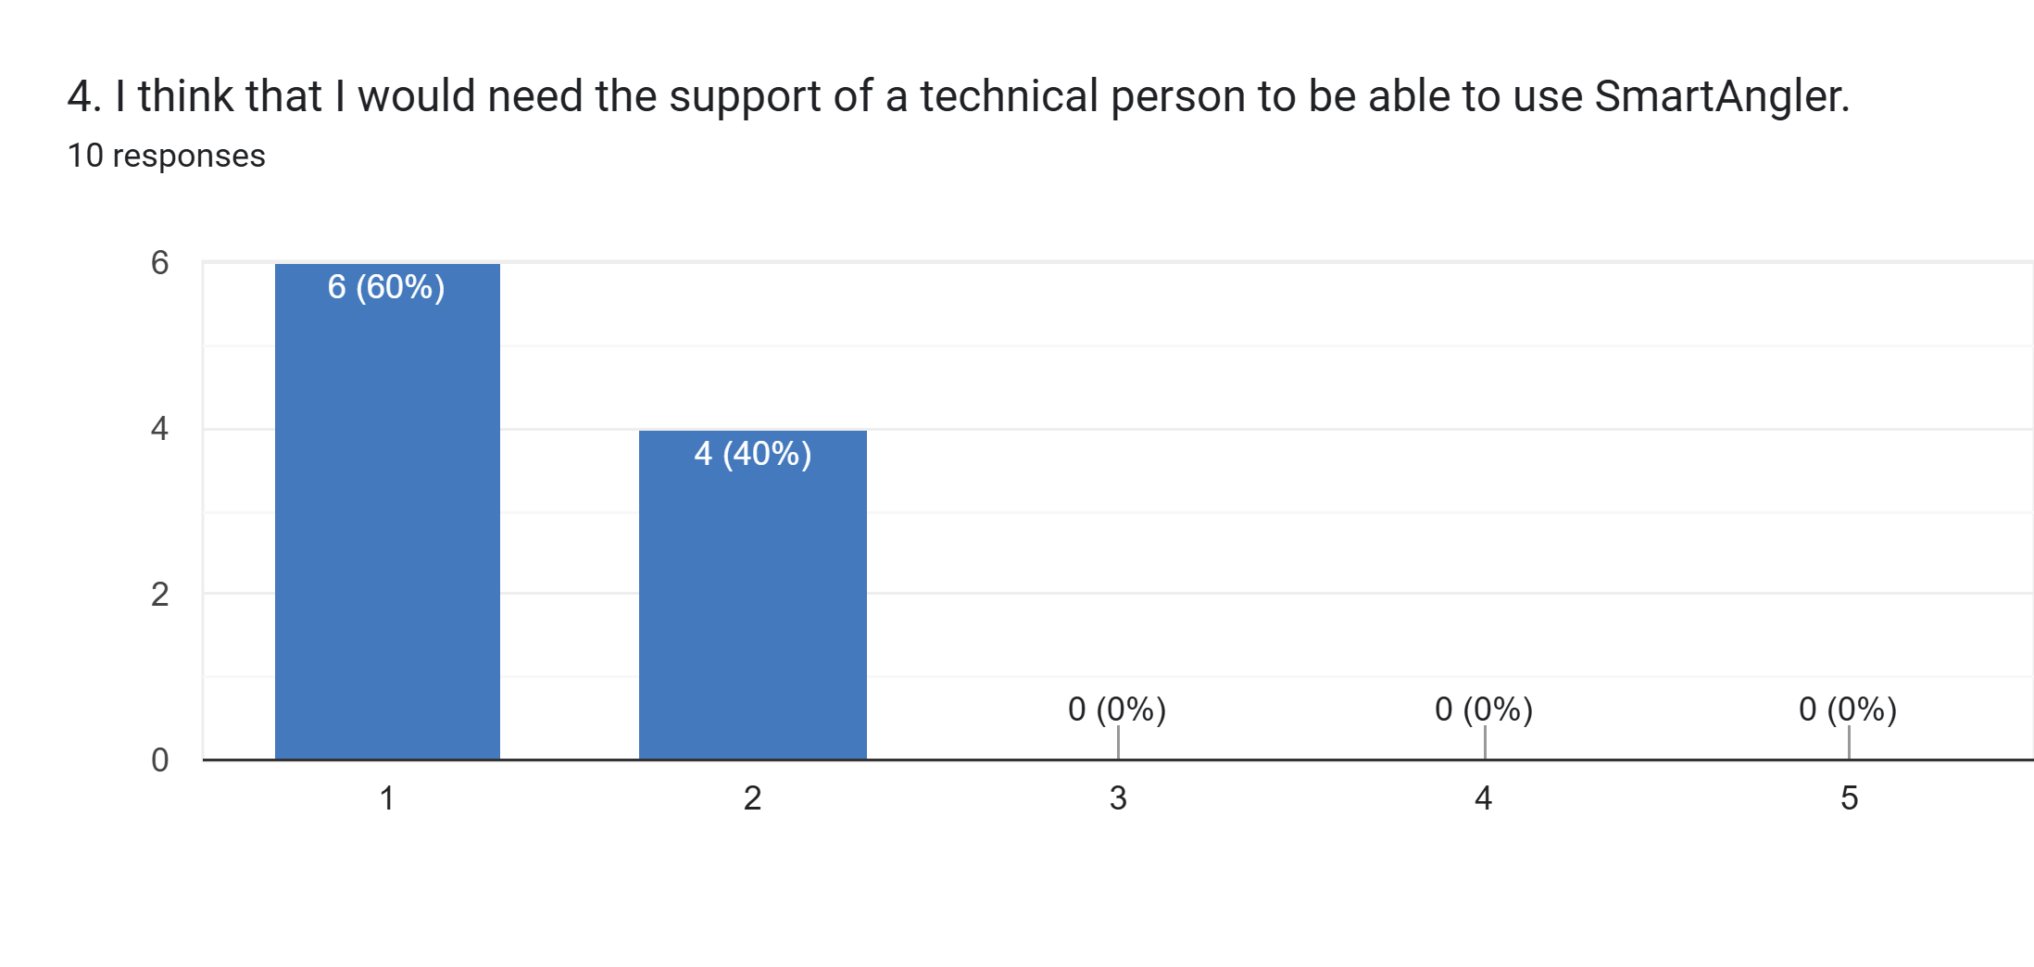

Figure 6.4: System Usability Scale (SUS) Questionnaire Question 4

The findings regarding the concerning the need for technical support are shown in Figure 6.4. In this case, lower ratings are considered to be more usable. Six respondents (60%) strongly disagreed by selecting option 1, while four participants (40%) chose option 2. No participant chose option 3, 4, or 5, indicating that all the respondents are opposed to the necessity of technical support. This demonstrates that users felt confident navigating and using the system independently without requiring technical support from expert. This reflecting that the system is accessible and has a straightforward design.

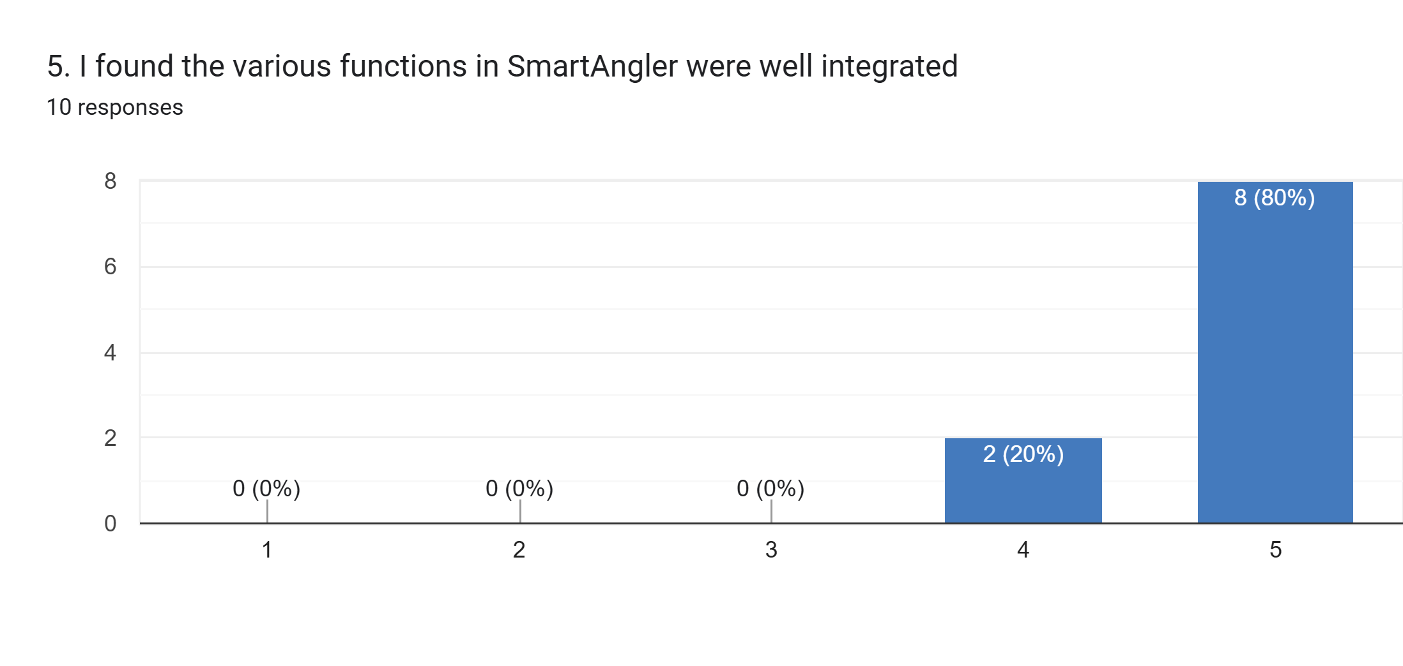

Figure 6.5: System Usability Scale (SUS) Questionnaire Question 5

Figure 6.5 displays the feedback regarding the possibility of integrating different functions of SmartAngler. The results indicate strong satisfaction, with eight respondents (80%) selecting option 5, strongly agreeing that functions were well integrated, while two participants (20%) chose option 4. No respondents selected the lower options of 1, 2, or 3. This positive feedback implies that the different features and modules of the system was successfully integrated and worked together seamlessly. This providing users with a cohesive experience throughout their interaction with SmartAngler.

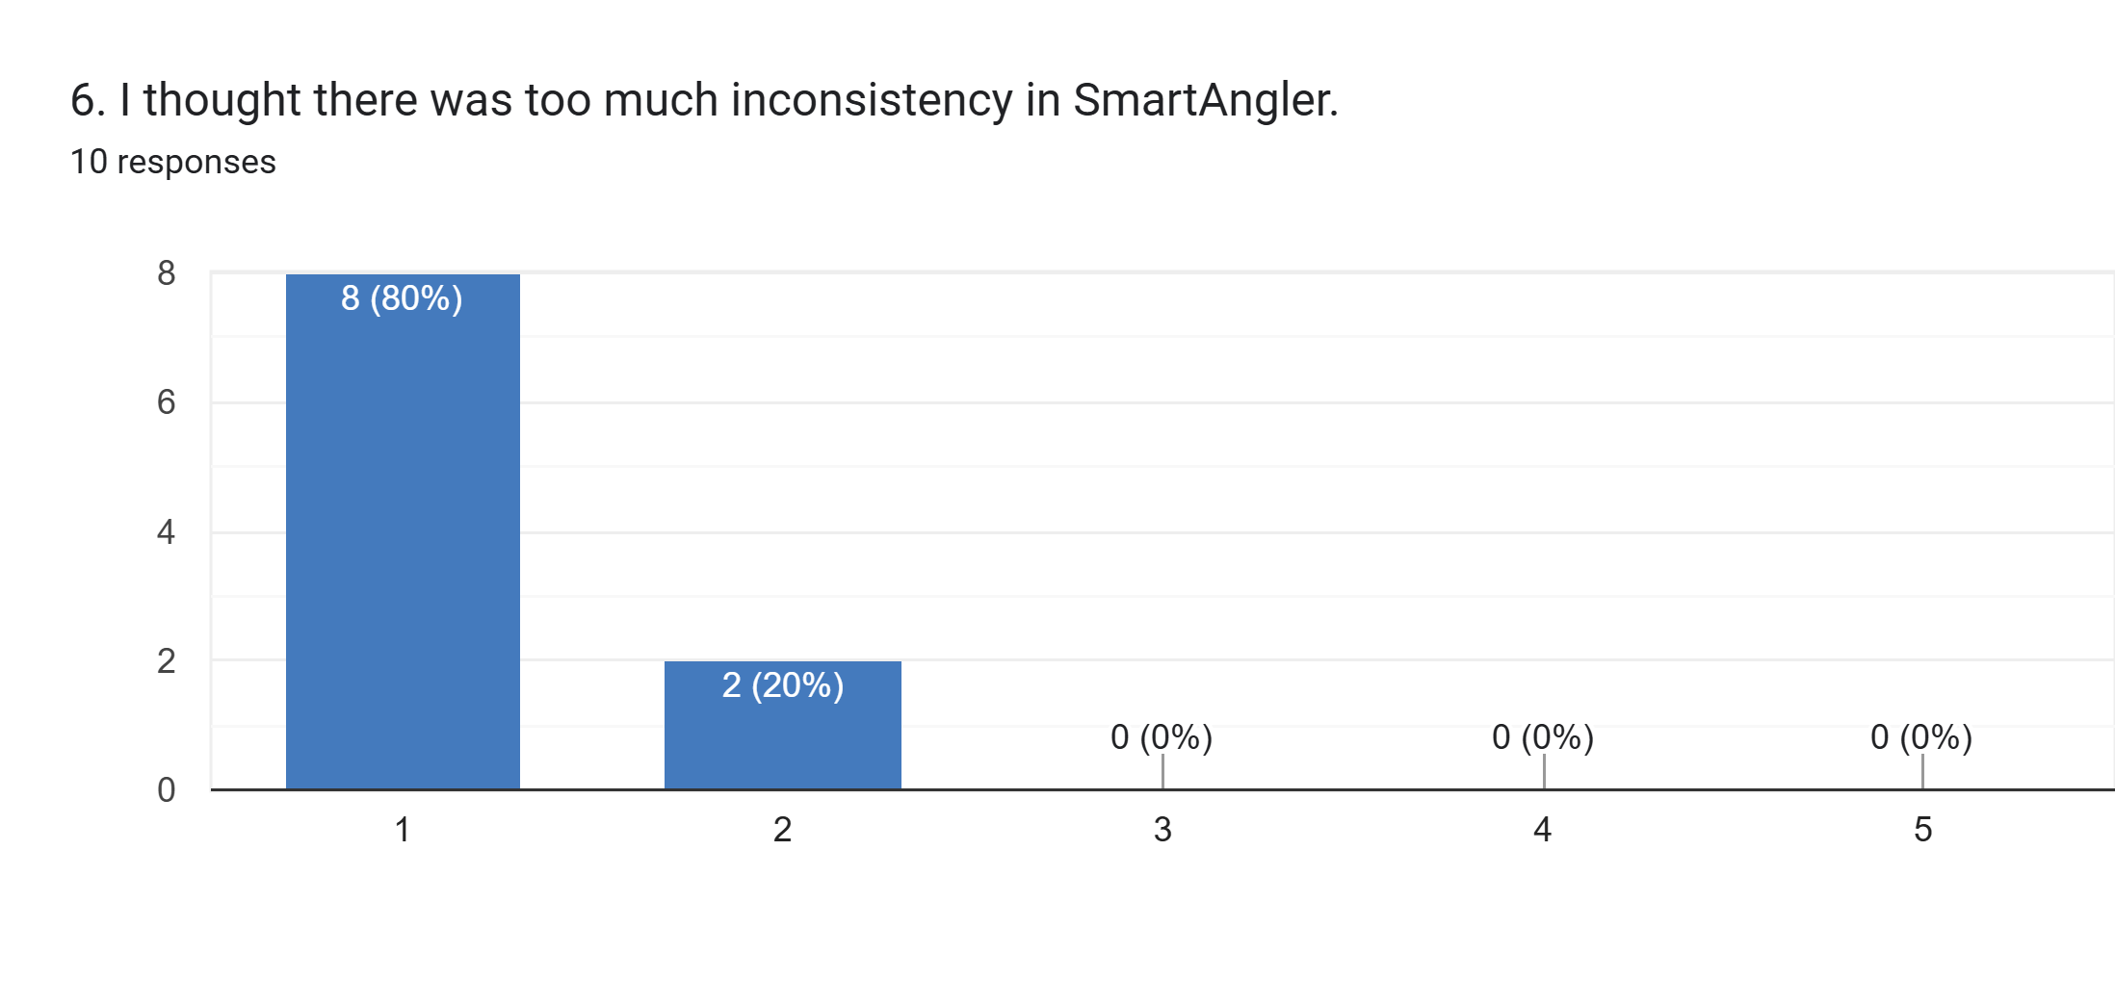

Figure 6.6: System Usability Scale (SUS) Questionnaire Question 6

Figure 6.6 presents the results regarding system consistency. Because it is a negative statement, the lower the rating, the better the performance of the system. Eight respondents (80%) strongly disagreed by selecting option 1, and two participants (20%) chose option 2. None of the respondents selected options 3, 4, or 5 which means that no one agreed with the occurrence of the inconsistency. This consistent dissatisfaction among users indicates that the system was dependable in terms of design, behavior and functionality of various features and sections.

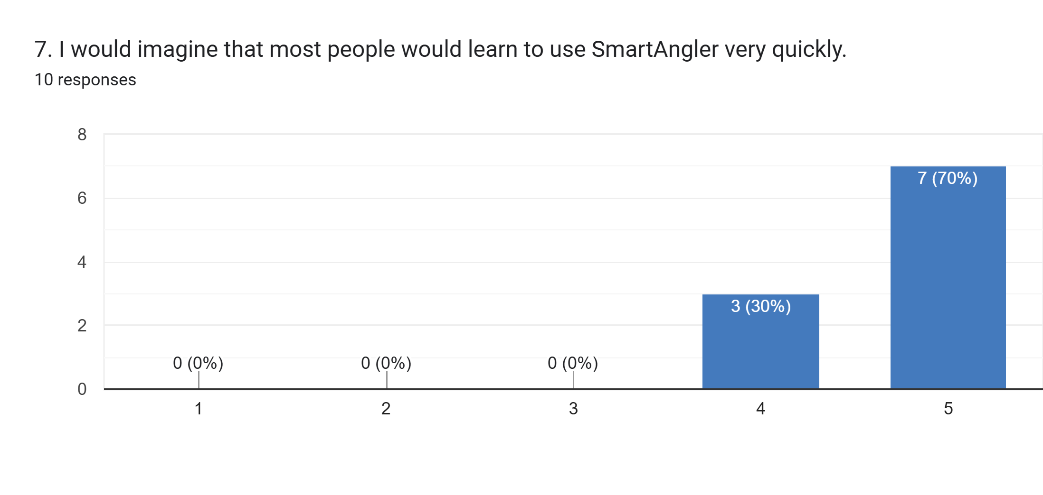

Figure 6.7: System Usability Scale (SUS) Questionnaire Question 7

Figure 6.7 displays the responses about how quickly people would learn to use SmartAngler. The findings indicate good perceptions regarding the learnability of the system. Seven respondents (70%) selected option 5, strongly agreeing that people would learn quickly, while three participants (30%) chose option 4. No respondents selected options 1, 2, or 3. This is a positive response of the users that the system was perceived to be of little learning curve and it would be available to new users who did not need much training and learning time to use it.

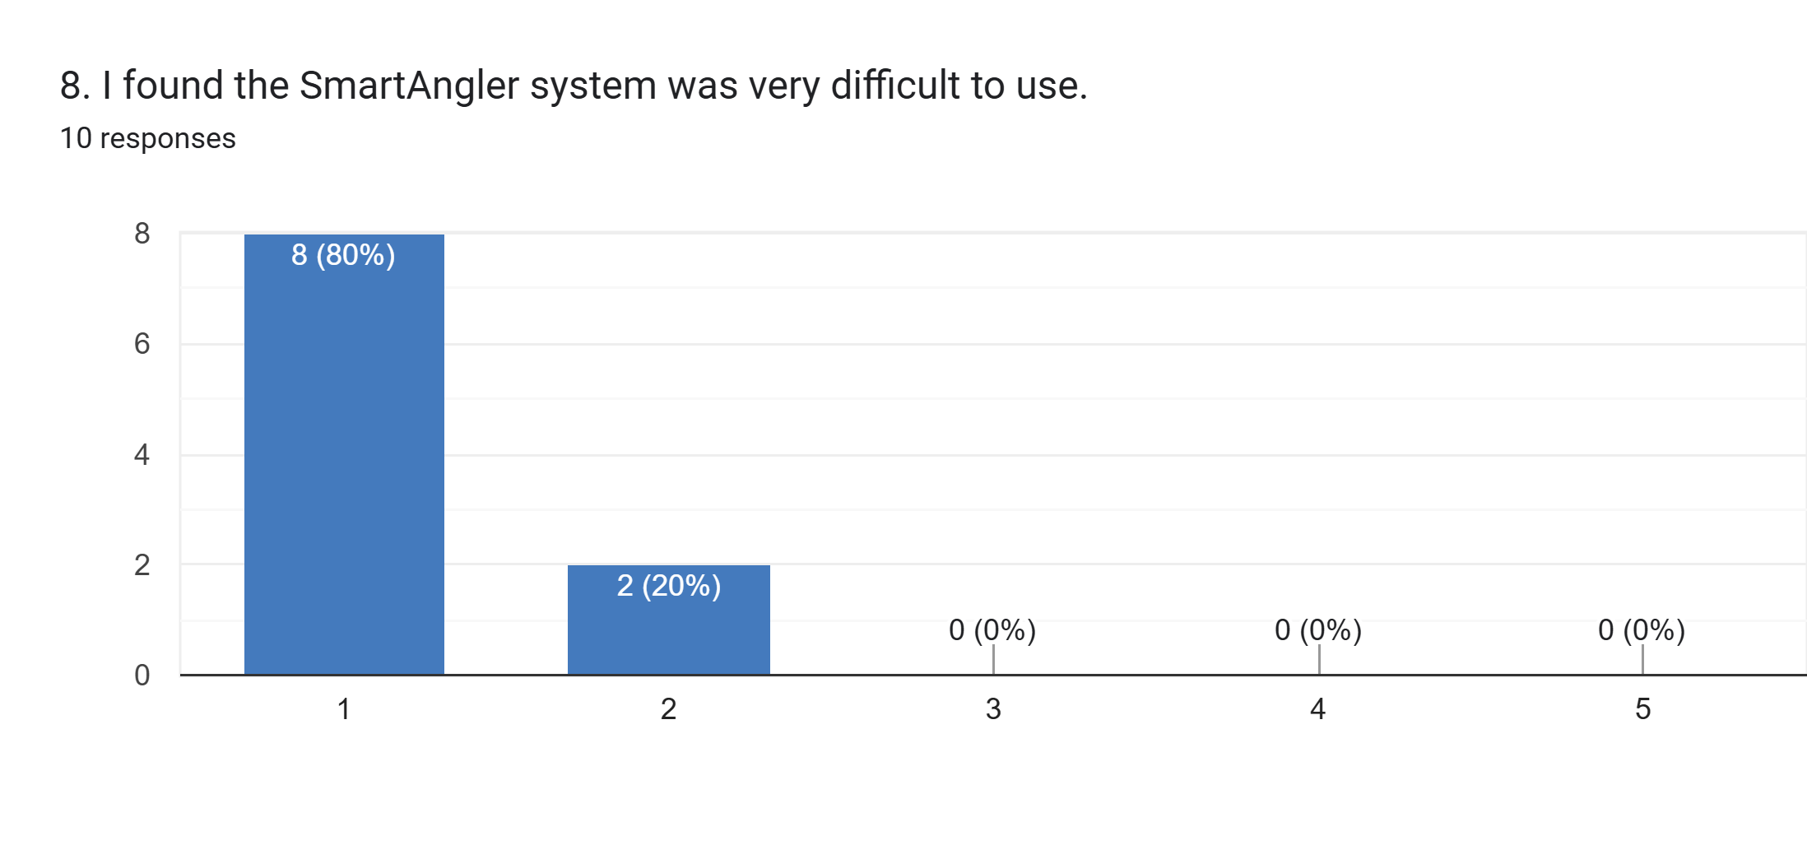

Figure 6.8: System Usability Scale (SUS) Questionnaire Question 8

Figure 6.8 shows the results concerning the difficulty of using SmartAngler. This statement is a negative statemen. Hence, the lower ratings indicate better usability. Eight respondents (80%) strongly disagreed by selecting option 1, while two participants (20%) chose option 2. None of the respondents selected options 3, 4, or 5. This complete disagreement with the statement confirms that no participants found the system difficult to use, which supports the positive results of usability in the previous questions regarding ease of use.

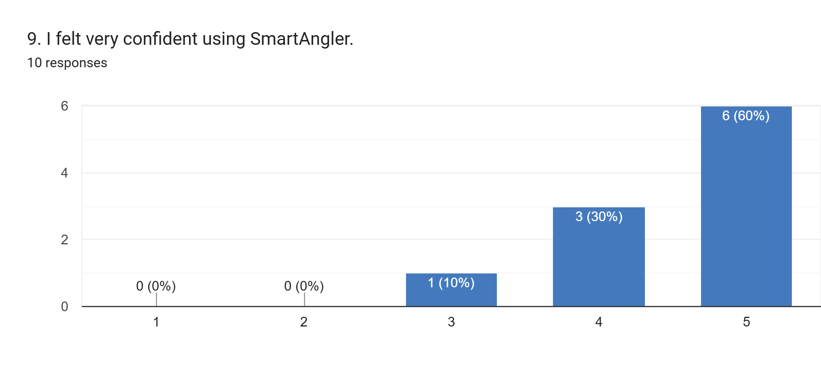

Figure 6.9: System Usability Scale (SUS) Questionnaire Question 9

Figure 6.9 presents the responses about user confidence when using SmartAngler. The results show high levels of confidence, with six respondents (60%) selecting option 5, indicating strong confidence, while three participants (30%) chose option 4. One respondent (10%) gave a neutral rating of 3. No participants selected options 1 or 2, meaning no one lacked confidence in using the system. The fact that the response frequency that consists of the higher end proves that the majority of the users felt comfortable and self-assured during the navigation and use of SmartAnglers features.

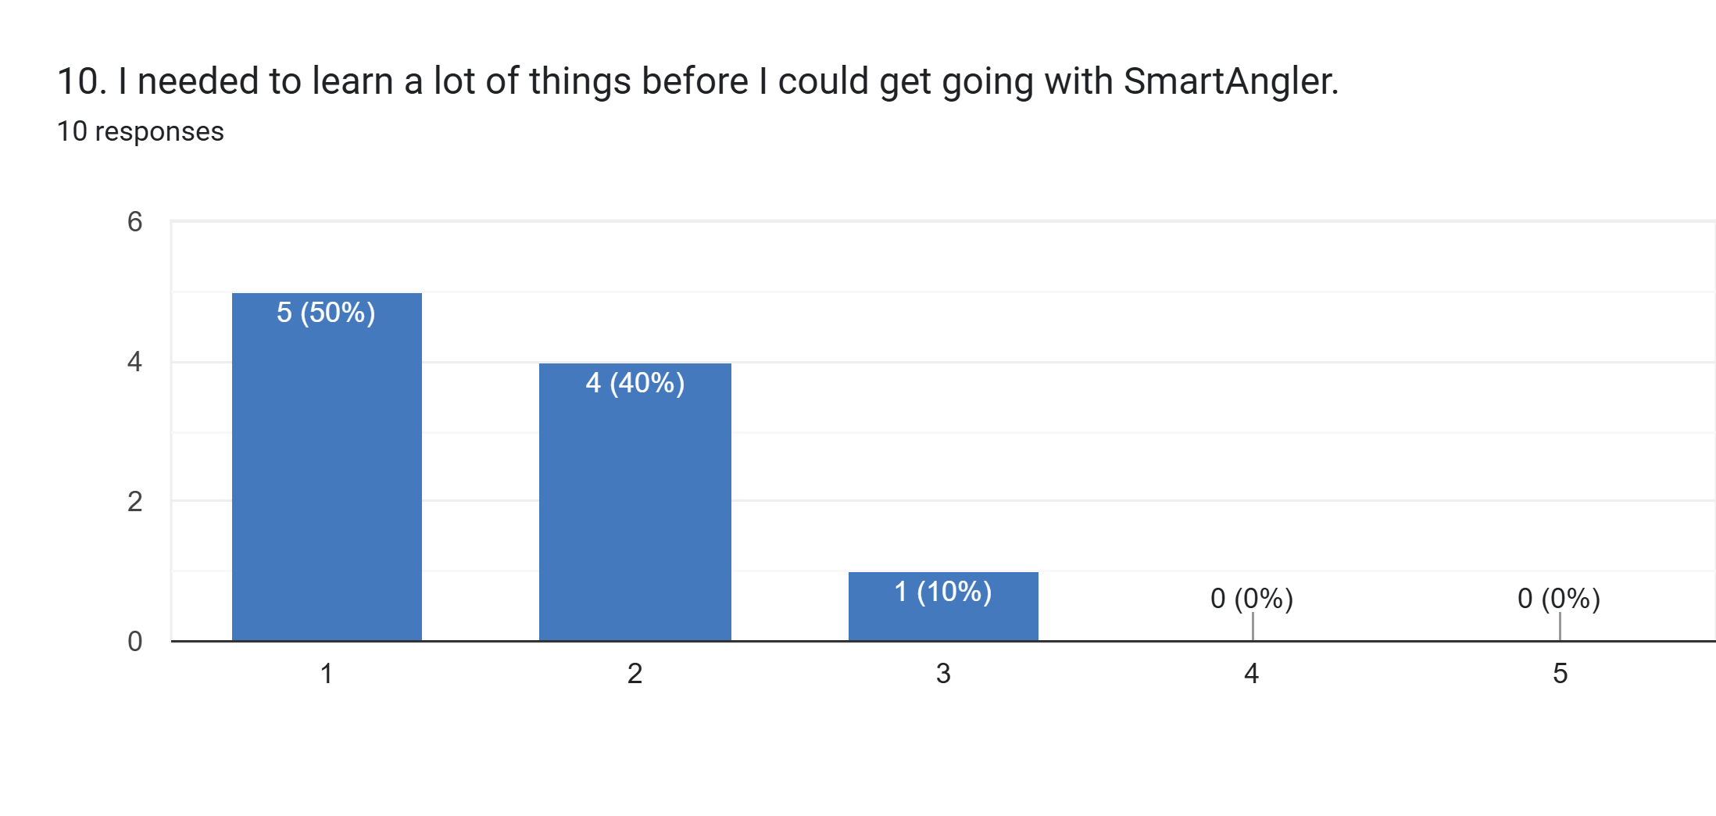

Figure 6.10: System Usability Scale (SUS) Questionnaire Question 10

Figure 6.10 displays the results regarding the learning requirements before using SmartAngler. Since this is a negative statement, lower ratings indicate better usability. Five respondents (50%) strongly disagreed by selecting option 1, and four participants (40%) chose option 2. One respondent (10%) gave a neutral rating of 3. No participants selected options 4 or 5, indicating that none of the users agreed with needing extensive learning before using the system. This feedback indicates that the system was comparatively user-friendly and did not need a large amount of prior knowledge or training to commence using it with appropriate effectiveness.

### 6.4.2 SUS Calculation

The usability of SmartAngler was evaluated using the System Usability Scale (SUS) questionnaire, which provides a standardized method for measuring the system’s overall usability. To determine the SUS score, participant responses were converted into a single score ranging from 0 to 100 using the following steps:

1. Standardize Scoring

* Odd-numbered questions (1, 3, 5, 7, 9): Positively worded statements where higher ratings indicate better usability. The contribution is calculated by subtracting 1 from the participant’s response.
* Even-numbered questions (2, 4, 6, 8, 10): Negatively worded statements where lower ratings indicate better usability. The contribution is calculated by subtracting the participant’s response from 5.

1. Summation of standard scores for all 10 questions

* The adjusted scores from all 10 questions are summed to produce a total value ranging from 0 to 40. This cumulative score reflects the overall usability perception from each participant.

1. Scaling to 100

* The total is multiplied by 2.5 to convert it into a SUS score on a 0–100 scale.

The SUS Score formula can be expressed as:

$$SUS Score=[(Q1 - 1) + (5 - Q2) + (Q3 - 1) + (5 - Q4) + (Q5 - 1) + (5 - Q6) + (Q7 - 1) + (5 - Q8) + (Q9 - 1) + (5 - Q10)] ×2.5$$

For interpretation, SUS scores are commonly classified as shown in Table 6.11:

Table 6.11: System Usability Scale (SUS) Scale Table

|  |  |  |
| --- | --- | --- |
| **Sus Score** | **Grade** | **Adjective Rating** |
| > 80.3 | A | Excellent |
| 68 – 80.3 | B | Good |
| 68 | C | Okay |
| 51 – 68 | D | Poor |
| < 51 | F | Awful |

Table 6.11 provides a benchmark for interpreting System Usability Scale (SUS) scores. It categorizes SUS results into grades and descriptive adjectives, ranging from “F: Awful” for scores below 51 to “A: Excellent” for scores above 80.3. The table enables the numeric SUS scores to be translated into meaningful information on how the user perceives the usability of a system to enable developers know whether the design is poor, average or excellent.

The final SUS score reflects the overall level of usability of the system based on users’ feedback. A high SUS score (Excellent or Good) is an indicator that users can easily use it, it is well designed with minimal usability issues. An average score (Okay) indicates that the system is viable and there might be the areas that can be enhanced to provide a better experience to the user. On the other hand, when the SUS score is low (Poor or Awful), users experience problems with the system, which means that the design, navigation or functionality of the system need to be improved significantly. Overall, the final SUS score helps developers to understand how users experience the system and guides them in making necessary usability improvements.

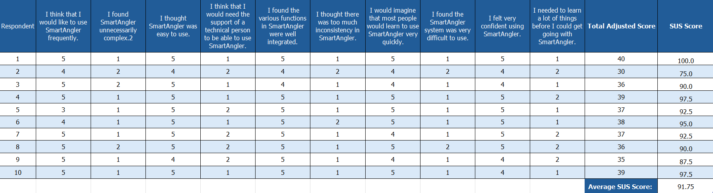

Figure 6.11: Result of the Questionnaire for System Usability Scale (SUS)

Figure 6.11 presents the actual SUS results collected from SmartAngler users. Each participant’s responses to the ten SUS questions were analyse according to standard scoring methods. Then their individual SUS scores were calculated to find the average SUS score. According to the figure, the majority of the users rated positively worded items as very high, and negatively worded items as very low, indicating that they found SmartAngler very easy to use, intuitive and well-organized. The user individual scores are ranged between 75 to 100. This indicating consistently positive feedback across all participants.

Based on the classification in Table 6.11, the average SUS score of 91.75 falls into the “A: Excellent” category. This means that, SmartAngler offers a very useful and pleasurable experience which validates that the interface, functionality and workflow of the system is well-integrated and made available. In general, the analysis indicates that SmartAngler can achieve its usability goals, and it can be used on a regular basis to organize fishing tournaments.

## 6.5 Conclusion

The testing and evaluation of SmartAngler show that the system is both reliable and user-friendly. Unit testing confirmed that all individual modules function correctly, while integration testing demonstrated that these modules work seamlessly together for real-world tasks. The System Usability Scale (SUS) evaluation revealed an average score of 91.75, classified as “Excellent”, indicating that users found the system intuitive, easy to use, and well-integrated.

# CHAPTER 7

**CONCLUSION**

## 7.1 Introduction

This chapter concludes the SmartAngler: Automated Fishing Tournament System project by reflecting on the overall development process and outcomes that the system has achieved. It provides a comprehensive summary of the system, evaluates how the project objectives were fulfilled, discusses the limitations faced during development and outlines possible future improvements that could be applied so that the system could be enhance. This chapter serves as a final reflection on the effectiveness and contribution of the SmartAngler system in improving fishing tournament management.

## 7.2 Project Summary

The SmartAngler system was developed successfully to modernise and simplify the management of fishing tournaments that are traditionally handled through manual and time-consuming processes. The system offers an organized system through which tournament organisers are able to process tournaments, sponsorships, fishing spots and results more effectively whilst the angler can register easily into tournaments, fish spots, view results and leave reviews.

The Waterfall methodology has been used throughout the development process in order to make sure that every stage, requirement analysis to the system testing was done in a systematic and organised way. This approach helped maintain clear project direction and reduced development risks. This strategy assisted in keeping the project on track and lowering the risks of development. The main functionalities including user authentication, tournament management, catch logging, result calculating and review submitting were implemented and tested successfully.

System testing and unit testing, as well as the usability test with the help of the System Usability Scale (SUS), made it possible to confirm that the SmartAngler system functions the way it is supposedly and cannot be criticized for offering an unsatisfactory user experience. The outcome of the SUS questionnaire shows that the system was easy to learn, well-organised, and useful in managing fishing tournaments. In general, the SmartAngler system was successful in fulfilling its goals by minimising the workload of people, eliminating human errors, achieving a better data organisation and boosting visibility of the tournament processes.

## 7.3 Project Limitation

Although the SmartAngler system has been able to accomplish its main objectives, the development of the system has been faced by a number of constraints throughout the project lifecycle, especially at the planning stage, design stage, and implementation stage. These were some of the limitations which influenced development of the system as well as its overall operation.

One of the primary challenges that were encountered during the planning stage was the small amount of real-world user inputs collected. Though the real fishing tournament organizers and anglers were consulted with feedback, the data gathering process was carried out in a limited academic period and the number of participants is rather small. Consequently, the system requirements might not quite reflect the varied requirements, preferences and working practices of all fishing tournaments especially one that is run at a bigger or international level.

During the design, simplicity and functionality of the system were constrained. The interface needed to be designed to be easily used by users with different levels of technical experience which required a number of compromises. This led to the simplification or removal of certain higher level features in order to keep them usable. Also, the system design was limited because it used web-based technologies, which restricted the possibility to integrate more advanced real-time solutions like live catch tracking or automated scoring.

During the implementation phase, technical constraints posed several challenges. The system also requires a fixed internet connection that can restrict its usage in isolated fishing areas where the network is weak or inaccessible. Moreover, certain operations, including catches data updates, and tournament validation, are yet to be automated by administrators. This presents the risk of human error and lag in updating the information on a tournament.

In addition, there are a few other number of limitation that were found in the implementation phase that influenced the functionality of the system and precision. The system was not able to fully integrate a 3D map with effective search and precise location selection features. This making it difficult for users to accurately search, view and identify fishing spots directly in the system. This limitation reduces the usefulness of the map feature, especially for tournaments held in large or unfamiliar locations.

Furthermore, the category selection options within the system are limited. This may restrict users from performing more detailed filtering for the result of the tournaments. Another limitation in the system is the tournament result generation process. The system is still partially inaccurate due to reliance on manual data entry for the fish catch record. This may cause delays, inconsistencies or errors in calculating final tournament results.

The other constraints are time and availability of resources. The project had been created in a constrained academic timeframe and therefore did not allow a high degree of tests and optimization. The security features were provided on a bare minimum, and the high level of data protection mechanisms could not be explored completely. Also, the system was not tested in a realistic environment that it would be used in a real fishing tournament, thus it is possible that its performance would be different when put in a real-life situation.

## 7.4 Future Work

The SmartAngler system offers a solid base upon which fishing tournaments can be managed, but there are a number of improvements that can be made in the future work in order to make it even more functional, usable, and scalable. These additions would enable the system to better facilitate real-world tournament operations and more users.

One potential enhancement is the integration of real-time features, such as live catch updates and automated leaderboard generation. By incorporating mobile device support or sensor-based data input, anglers could submit catch information directly during tournaments. This could reduce reliance on manual data entry by administrators and minimizing human error.

Future efforts may also be put into expanding the system into a mobile application to enhance accessibility particularly to users in the outdoor or remote fishing locations. Offline data storage and synchronization features could be implemented to allow users to continue using the system even when internet connectivity is limited, with data being updated once a connection is restored.

In addition, security and data management can be improved further, through the adoption of advanced authentication, role-based access control and secure data encryption. This would assist in securing sensitive user data and bring about fair and transparent management of tournaments. More comprehensive usability testing with more and a more diverse base of tournament organizers and anglers would also assist in enhancing system features and overall user experience.

Finally, future development may include analytics and reporting features, such as tournament performance analysis, angler statistics and historical data visualization. These features would provide valuable insights for organizers and participants, supporting better decision-making and long-term tournament planning.

# REFERENCES

Abdul, R., Khan, H., Gopal, P., Yogesh, P., Nitin, P., Sahebrao, K., Sharad, P., & Santosh, P. (2024). The Waterfall Model-Software Engineering. *International Journal of Research Publication and Reviews Journal Homepage: Www.ijrpr.com*, *5*(4). <https://ijrpr.com/uploads/V5ISSUE4/IJRPR25788.pdf>‌

Aftco Social. (2024). *History of Sportfishing*. AFTCO. Accessed on May 15, 2025, from https://www.aftco.com/blogs/news/history-of-sportfishing

alvina0168 Github. (2025). *GitHub - alvina0168/SmartAngler*. GitHub. <https://github.com/alvina0168/SmartAngler>

ASA Fishing. (2020). *Sportfishing in America: A Reliable Economic Force. Produced for the American Sportfishing Association by Southwick Associates via Multistate Grant #F20AP00183 awarded by the Wildlife and Sport Fish Restoration Programs of the U.S. Fish and Wildlife Service.* Accessed on May 20, 2025, from <https://asafishing.org/wp-content/uploads/2021/03/Sportfishing-in-America-economics-report.pdf>

Cabo, B. S. (2025). *IGFA Offshore World Championship Cabo - Blue Sky Cabo*. Accessed on May 15, 2025, from <https://cabofishings.com/igfa-offshore-world-championship-cabo/>

Cohen, S., & Chugh, R. (2025). Code Style Sheets: CSS for Code. *ArXiv (Cornell University)*. <https://doi.org/10.48550/arxiv.2502.09386>

Combs, K., (2024). *New technologies make tournament fishing more efficient - Bassmaster*. (2024, June 20). Bassmaster. Accessed on May 20, 2025, from <https://www.bassmaster.com/column/keith-combs/new-technologies-make-tournament-fishing-more-efficient/>

Hamid, A. (2023). The Transformative Role of Artificial Intelligence in the Event Management Industry. *Journal of International Business Economics and Entrepreneurship*, *8*(2), 98–106. <https://doi.org/10.24191/jibe.v8i2.24045>

FishPal. (n.d.). B*ookings for Everyone*. Fishpal.com. Accessed on April 24, 2025, from https://www.fishpal.com/

Harris, G. (2025). *Has the “Sport” Been Taken Out of Sportfishing?* Triton. Accessed on June 20, 2025, from <https://www.the-triton.com/2025/05/has-the-sport-been-taken-out-of-sportfishing/>

IGFA. (n.d.). International Game Fish Association Tournament Guide. Accessed on May 15, 2025, from <https://igfa.org/wp-content/uploads/2024/06/Tournament-Rules-Booklet-ENGLISHud2024.pdf>

Keepnet. (n.d.). *Catch & Release / Weigh Bay Solutions / Social Fishing*. Keepnet.co. Accessed on April 24, 2025, from https://www.keepnet.co/

Land, T. (2024,). *Fishing Tournaments Land Economic Boost For The Lake Champlain Region*. Regional Office of Sustainable Tourism. Accessed on May 20, 2025, from https://www.roostadk.com/fishing-tournaments-land-economic-boost-for-the-lake-champlain-region

Niarman. A.,, Iswandi. N.,, & Candri. A.K. (2023). Comparative Analysis of PHP Frameworks for Development of Academic Information System Using Load and Stress Testing. *International Journal Software Engineering and Computer Science*, *3*(3), 424–436. https://doi.org/10.35870/ijsecs.v3i3.1850

Reel LiveWell. (n.d.). *The #1 Fish Scoring App for Fishing Tournaments - Reel LiveWell*.  Accessed on April 24, 2025, from https://www.reellivewell.com/

Roy, S., Daniel, C., & Agrawal, M. (2023). Chapter 12 Introduction to HTML and Website Development. *FUNDAMENTALS of INFORMATION TECHNOLOGY: Textbook – English*. https://doi.org/10.5038/TKOC5299

Sabah News. (2025). *Angler wins RM50k in fishing event*. Dailyexpress.com.my; Sabah Publishing House Sdn Bhd. Accessed on April 16, 2025, from https://www.dailyexpress.com.my/news/253059/angler-wins-rm50k-in-fishing-event/

SportFishing. (2024a). *When did people start sport fishing?* The History of Sportfishing. Accessed on April 16, 2025, from  <https://thehistoryofsportfishing.com/when-did-people-start-sport-fishing/>

SportFishing. (2024b). *Evolution of Sport Fishing Gear and Tackle - The History of Sportfishing*. Accessed on May 15, 2025, from  <https://thehistoryofsportfishing.com/evolution-of-sport-fishing-gear-and-tackle/>

*TourneyX*. (n.d.). *TourneyX.com. Homepage*. Accessed on June 20, 2025, from <https://tourneyx.com/app/>

WeighBook (n.d.). *WeighBook Tournament Management System*. Accessed on June 20, 2025, from https://weighbook.com/home

Zainuddin, Z. (2025). *Royal Pahang Billfish International Challenge (RPBIC) 2025 kembali ke Kuala Rompin*. Accessed on June 16, 2025, from https://malaysiagazette.com/2025/09/14/royal-pahang-billfish-international-challenge-rpbic-2025-kembali-ke-kuala-rompin/

# APPENDICES

**APPENDIX A: TURNITIN REPORT**

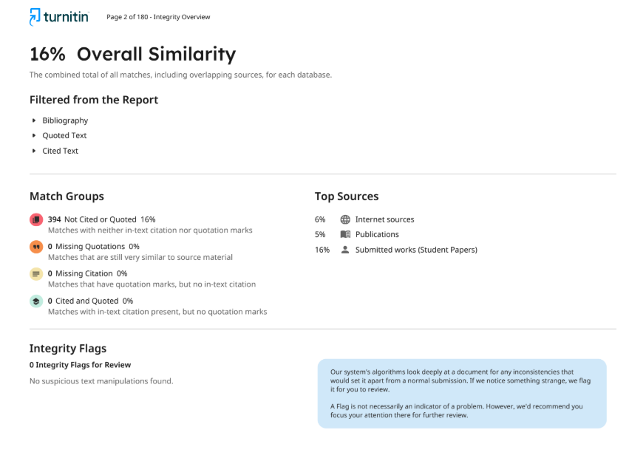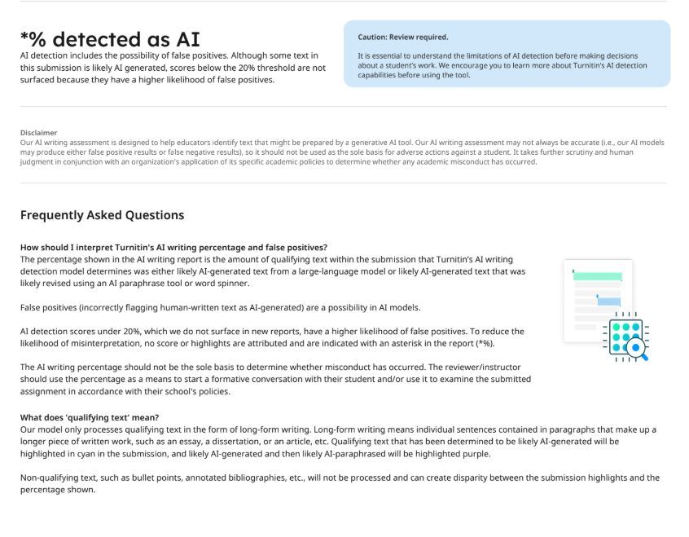

**APPENDIX B: QUESTIONNAIRES SURVEY FORM RESULT**

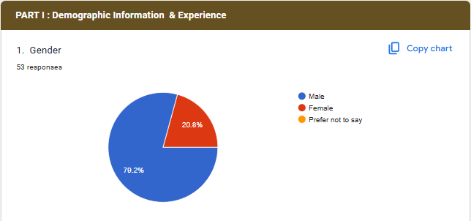

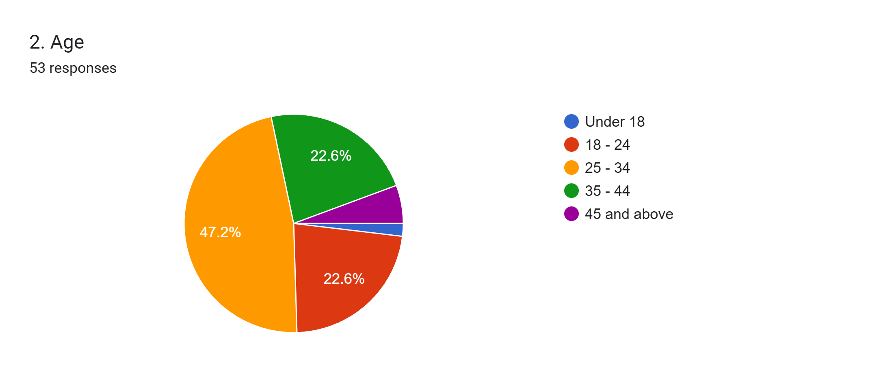

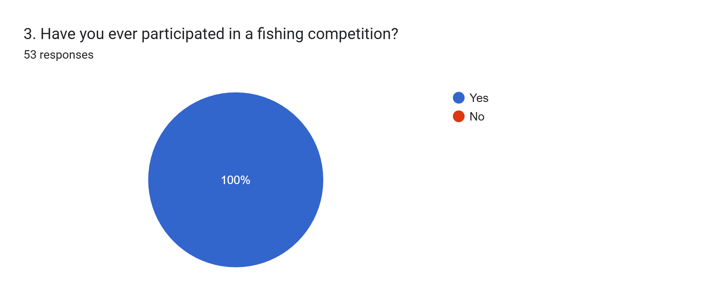



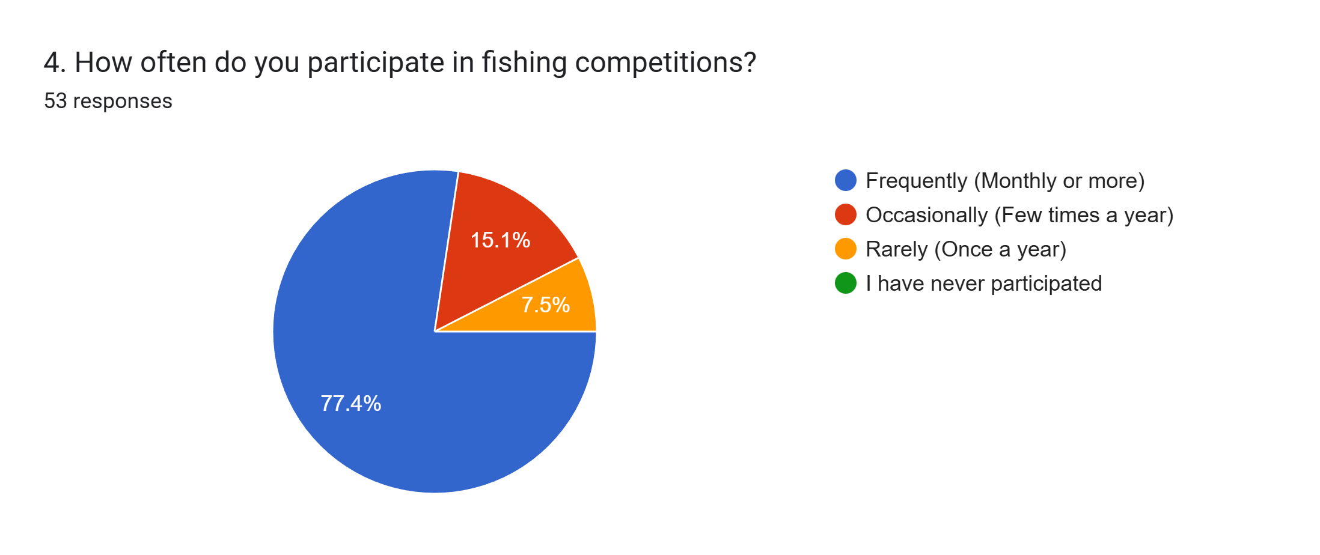

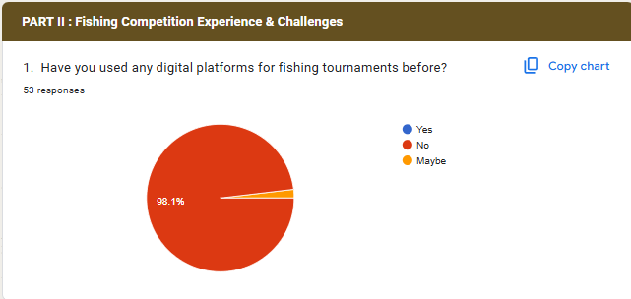

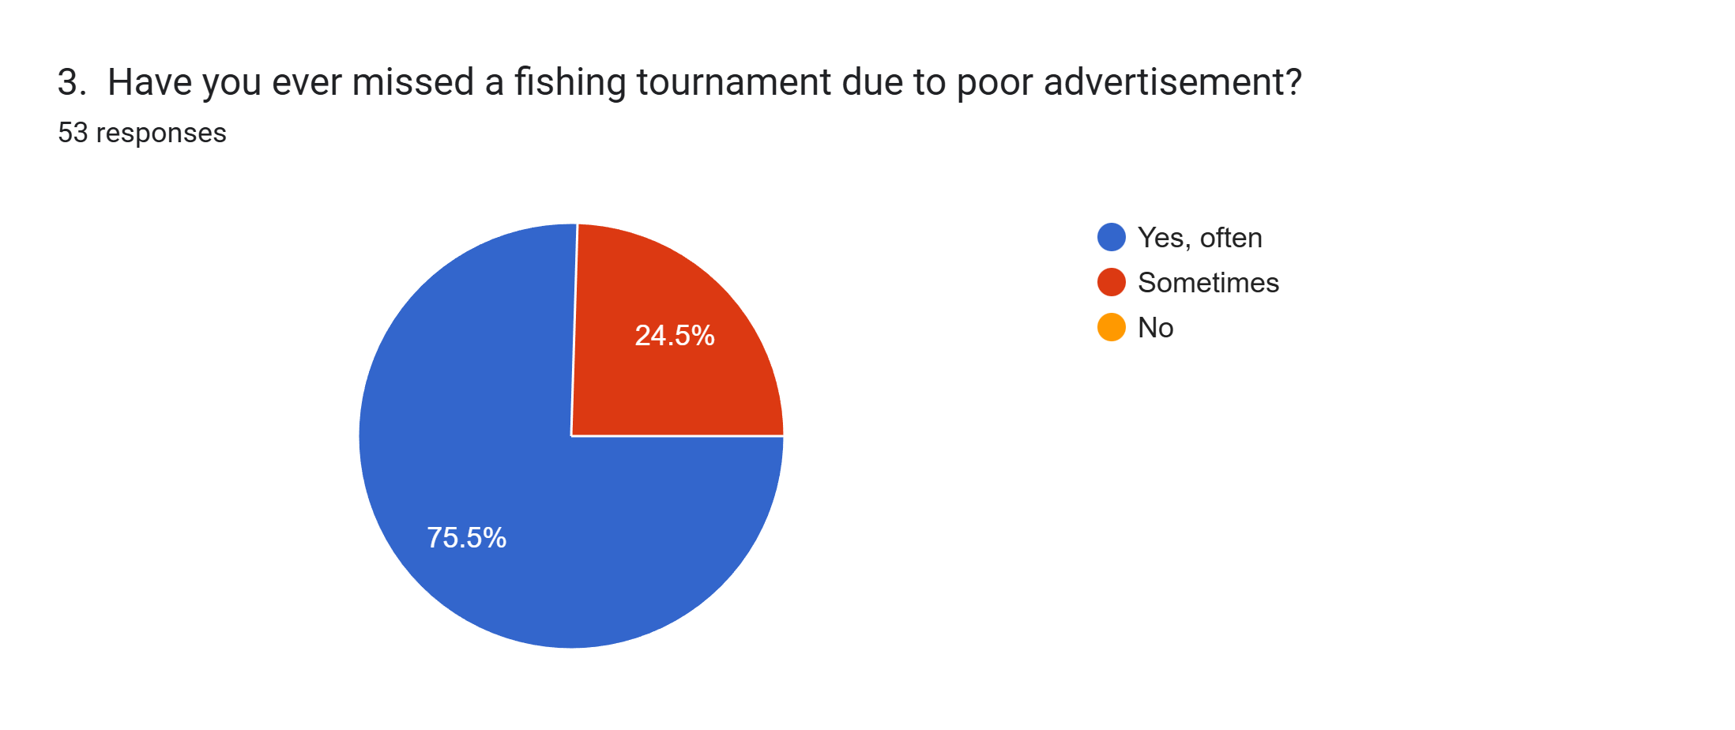

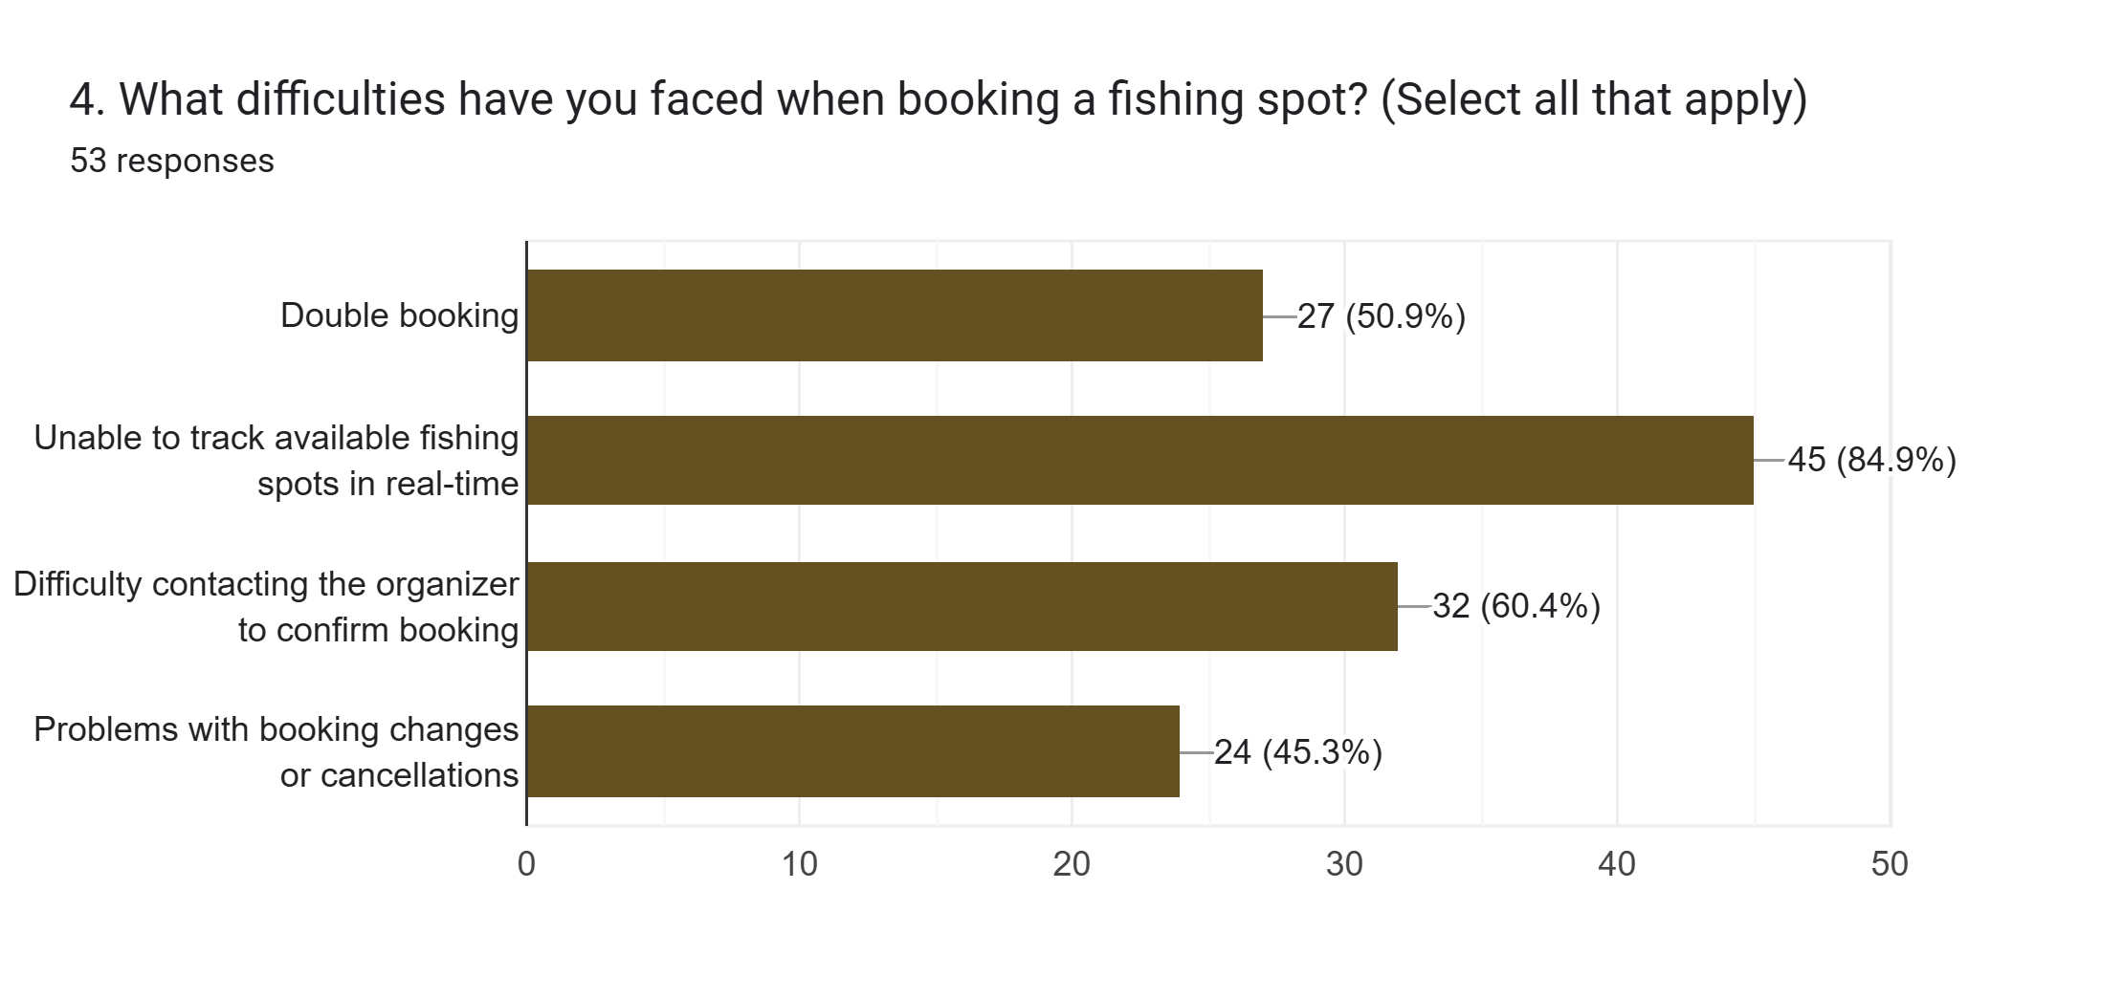

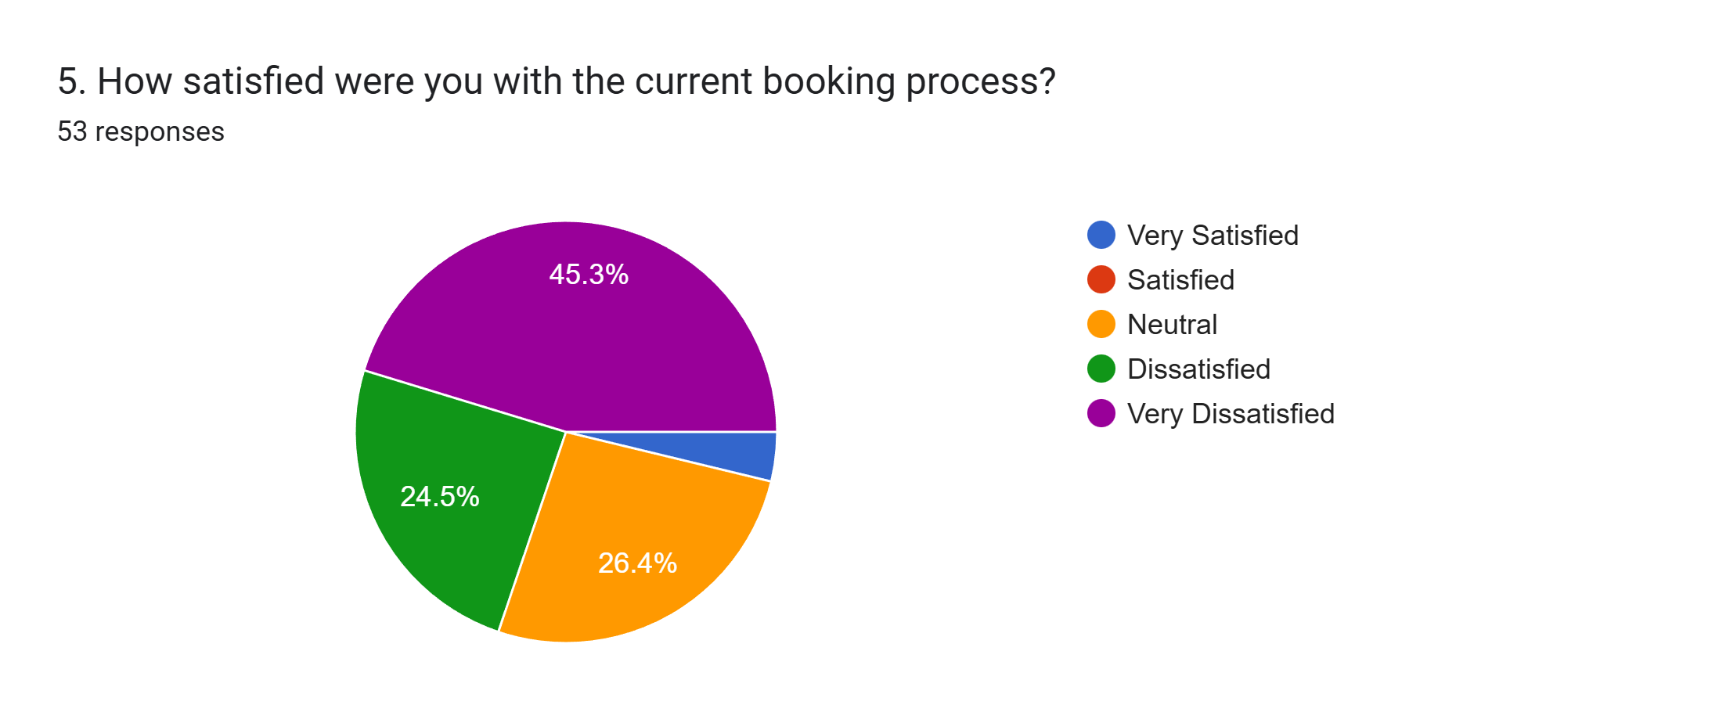

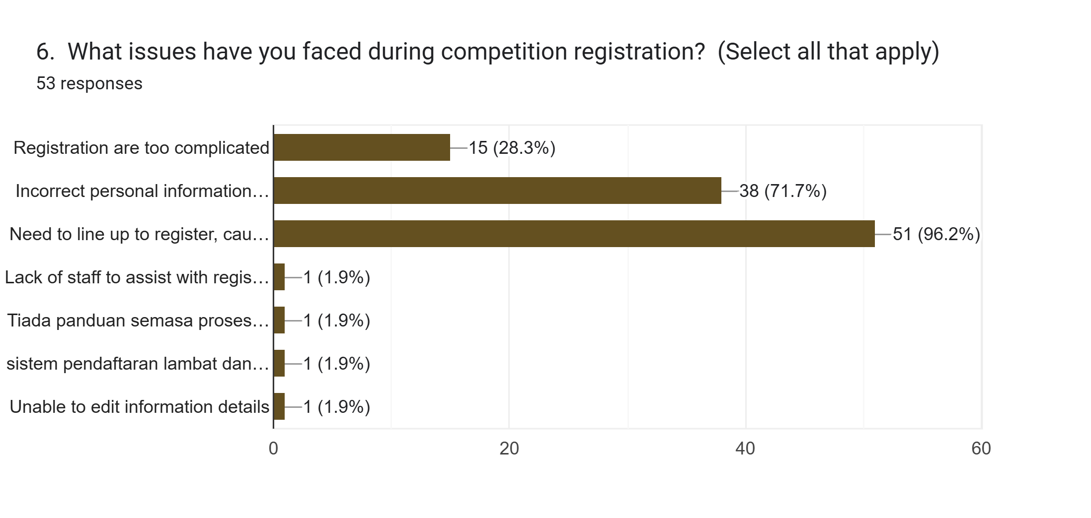

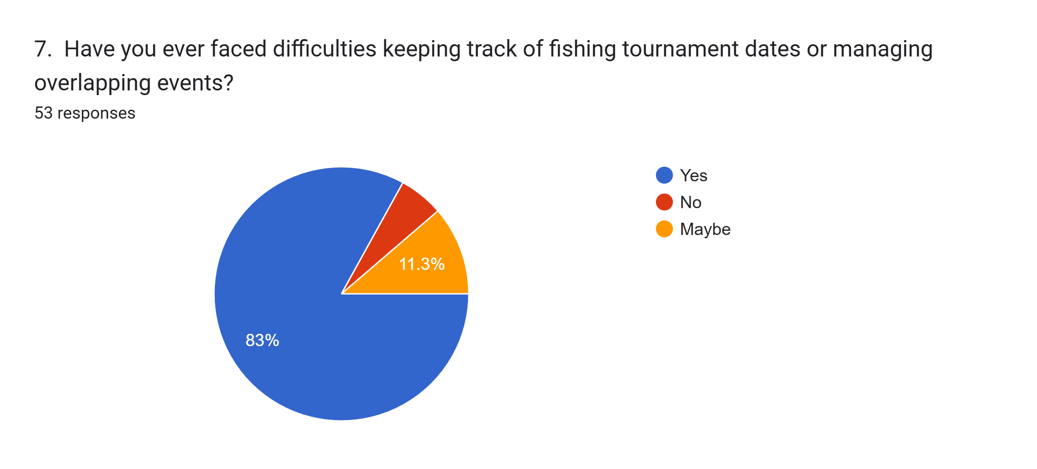

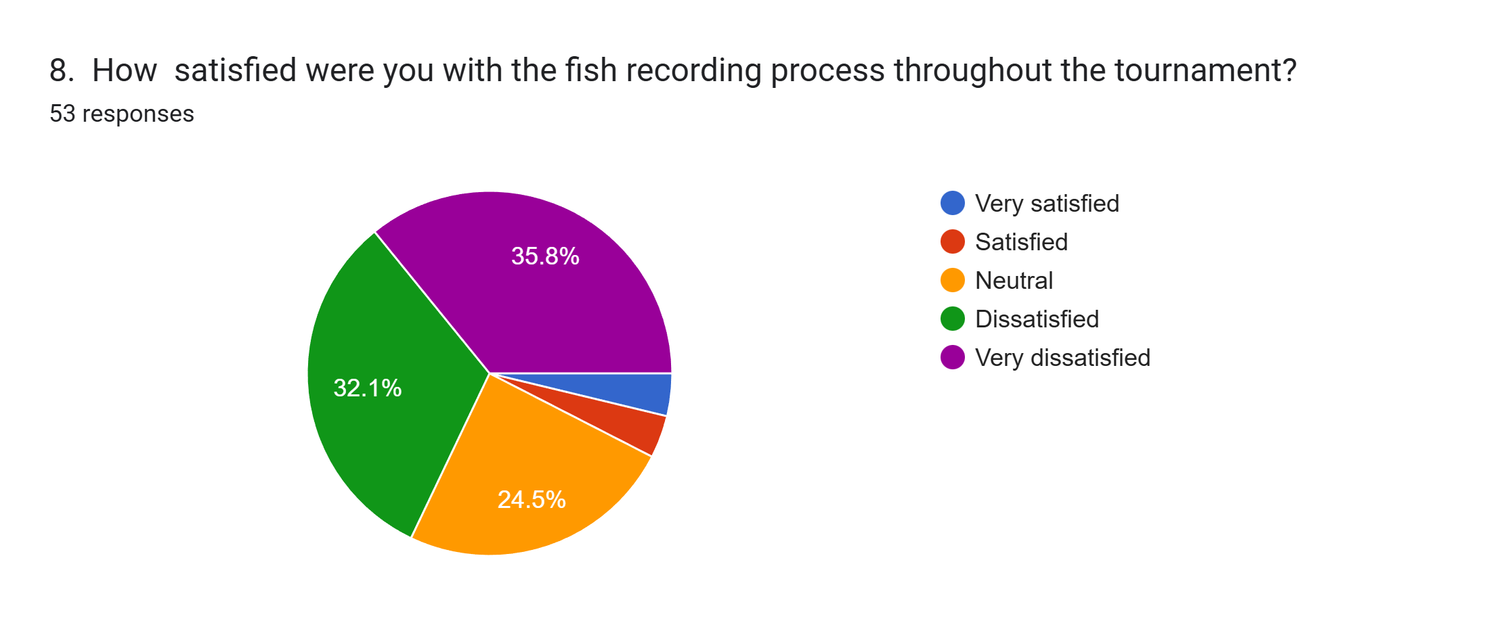

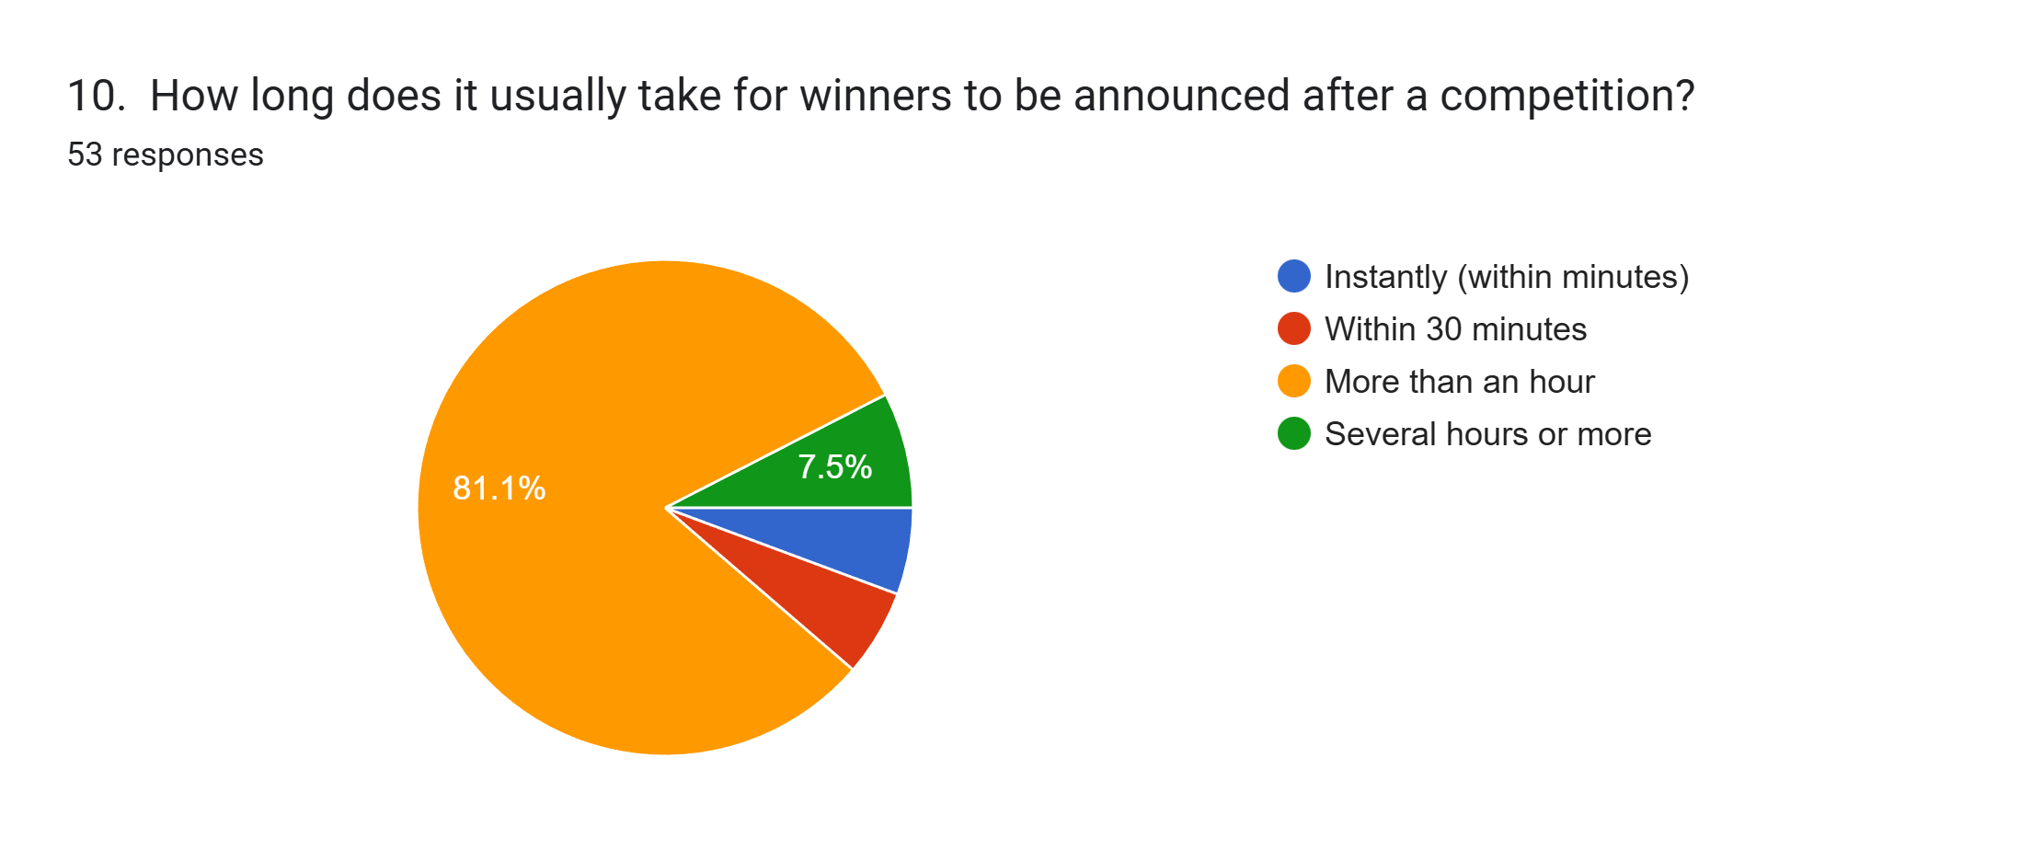

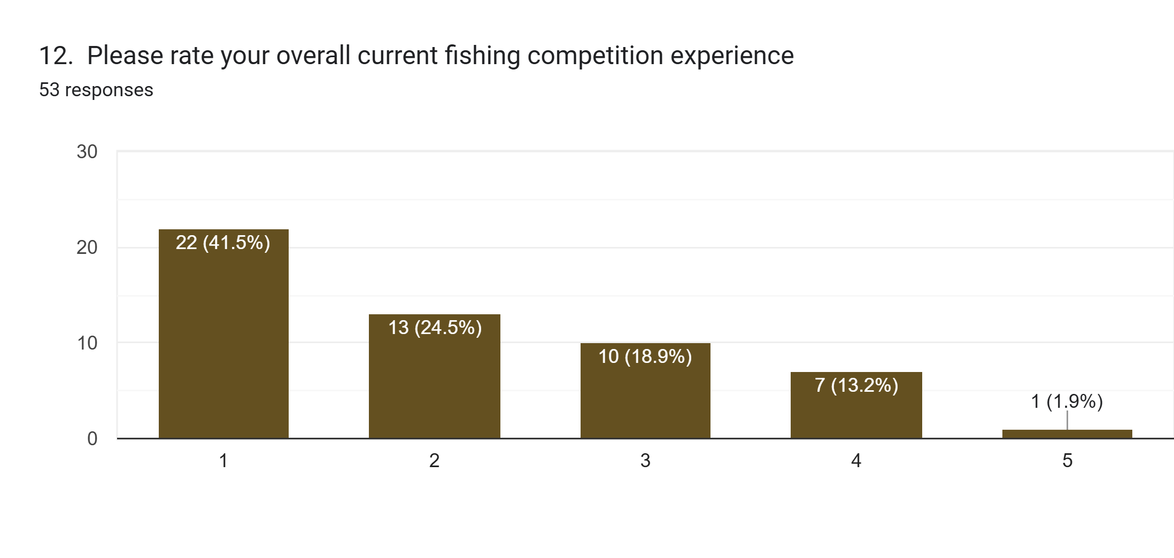

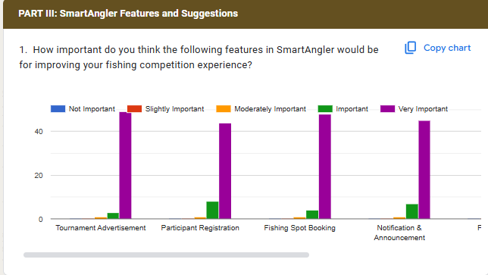

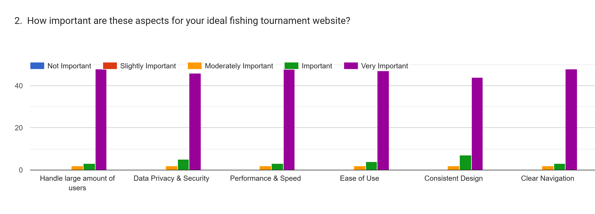

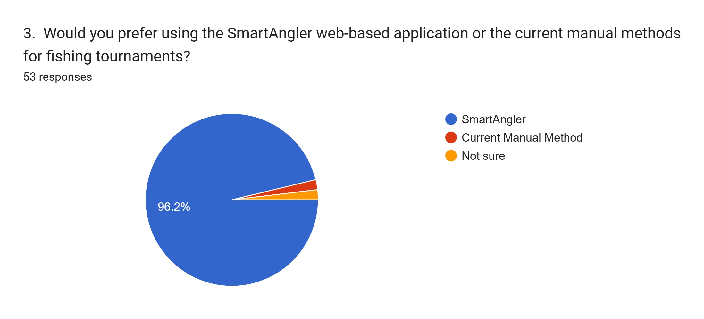

**APPENDIX C: FYP MEETING LOG**

**FYP 1 MEETING LOG**

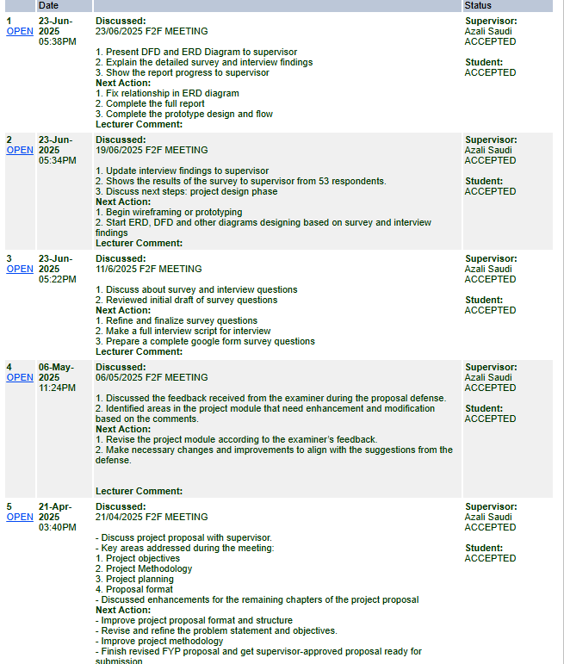

**FYP 2 MEETING LOG**

